HOME PAGE
<html>
<head>
<title>Home Page</title>
</head>
<body bgcolor="linen"
<center>
<img src="logoo.png" width="150" height="150"
style="border-radius:50%;">
<h1>ONLINE SHOPPING</h1
<h2>About Our Shop</h2>
<p>
Welcome to the <b>Online Shopping System</b>. Our store offers a wide range of
quality products, including fashionable footwear and stylish accessories, at
affordable prices. We are committed to providing a simple, secure, and convenient
shopping experience. Browse our latest collections, choose your favorite products,
and enjoy fast delivery with trusted service. Customer satisfaction is our top
priority.
</p>
<h2>Shopping Video</h2>
<video width="500" height="300" controls>
<source src="jwel.mp4" type="video/mp4">
</video>
<hr>
<a href="register.html">Register</a> |
<a href="login.html">Login</a> |
<a href="index.html">Shop Now</a>
</center>
</body>
</html>

REGISTER PAGE
<html>
<head>
<title>Register</title>
</head>
<body background="images/bg.jpg">
<center>
<img src="logoo.png" width="150" height="150"
style="border-radius:50%;">
<h1>ONLINE SHOPPING</h1>
<h2>User Registration</h2>
<form>
<table cellpadding="7">
<tr>
<td>Name</td>
<td><input type="text" placeholder="Enter Name" required></td>
</tr>
<tr> <td>Email</td>
<td><input type="email" placeholder="Enter Email" required></td> </tr>
<tr><td>Password</td>
<td> <input type="password" placeholder="Enter Password" required></td> </tr>
<tr> <td>Phone</td>
<td><input type="tel" placeholder="Enter Mobile Number"></td> </tr>
<tr> <td>Gender</td>
<td> <input type="radio" name="gender"> Male
<input type="radio" name="gender"> Female </td> </tr>
<tr> <td>Address</td>
<td> <textarea rows="4" cols="20"></textarea> </td> </tr>
<tr><td colspan="2" align="center">
<button type="button"onclick="alert('Login Successful!')"> Register </button> </td>
</tr> </tr> </table> </form> <hr>
<a href="home.html">Home</a> |
<a href="login.html">Login</a>
</center>
</body>
</html>
LOGIN PAGE
<html>
<head>
<title>Login</title>
</head>
<body background="images/bg.jpg">
<center>
<img src="logoo.png" width="150" height="150" style="border-radius:50%;">
<h1>ONLINE SHOPPING </h1>
<h2>User Login</h2>
<form>
<table cellpadding="10">
<tr> <td>Email</td>
<td> <input type="email" placeholder="Enter Email" required> </td> </tr>
<tr> <td>Password</td>
<td> <input type="password" placeholder="Enter Password" required></td> </tr>
<tr> <td colspan="2" align="center">
<button type="button"onclick="alert('Login Successful!')"> Login </button> </td> </tr>
</table> </form>
<hr>
<a href="home.html">Home</a> |
<a href="register.html">Register</a>
</center>
</body> </html>
CATEGORY PAGE
<html>
<head>
<title>Home</title>
</head>
<body bgcolor="FAF4F0">
<center>
<img src="logoo.png" width="150" height="150"
style="border-radius:50%;">
<h1>ONLINE SHOPPING</h1>
<hr>
<h2>Welcome to Online Shopping</h2>
<p>Choose your favourite shopping category. </p>
<h3>Categories</h3>
<a href="footwear.html">
<img src="shoes.jpg" width="250" height="250" alt="Footwear"></a>
<p>👟 Footwear</p>
<br>
<a href="accessories.html">
<img src="asss.jpg" width="250" height="250" alt="Accessories"> </a>
<p>👜 Accessories</p>
<hr>
<h3>Shopping Features</h3>
<ol> <li>Easy Registration</li>
<li>Secure Login</li>
<li>Latest Products</li>
<li>Online Purchase</li>
<li>Fast Delivery</li> </ol>
<hr>
</center> </body> </html>
FOOTWAER
<html>
<head><title>Footwear</title></head>
<body bgcolor="F0FAF9">
<center>
<h1>👟 Footwear Category</h1>
<hr>
<img src="shoe1.jpg" width="300" height="300">
<h3>Sports Shoes</h3>
<p>Comfortable sports shoes suitable for running, walking and daily activities.
Made with lightweight material and stylish design.</p>
<a href="purchase.html">
<button>Buy Now</button></a>
<br>
<hr>
<img src="shoe2.jpg" width="300" height="300">
<h3>Casual Shoes</h3>
<p>Trendy casual shoes perfect for everyday wear.
Provides comfort with a modern look for all occasions.</p>
<a href="purchase.html"> <button>Buy Now</button></a>
<hr>
<a href="index.html">Back to Home</a>
</center>
</body>
</html>
ACCESSORY
<html>
<head><title>Accessories</title></head>
<body bgcolor="FAF0F6">
<center>
<h1>👜 Accessories Category</h1>
<hr>
<img src="bag.jpg" width="300" height="300">
<h3>Handbag</h3><p>
Elegant handbag made with premium quality material.
Perfect for daily use, office, and special occasions.</p>
<a href="purchase.html"><button>Buy Now</button></a>
<br>
<hr>
<img src="watch.jpg" width="300" height="300"
<h3>Wrist Watch</h3>
<p>Stylish wrist watch with a modern design.
Suitable for both casual and formal wear.</p>
<a href="purchase.html">
<button>Buy Now</button>
</a>
<hr>
<a href="index.html">Back to Home</a
</center> </body> </html>

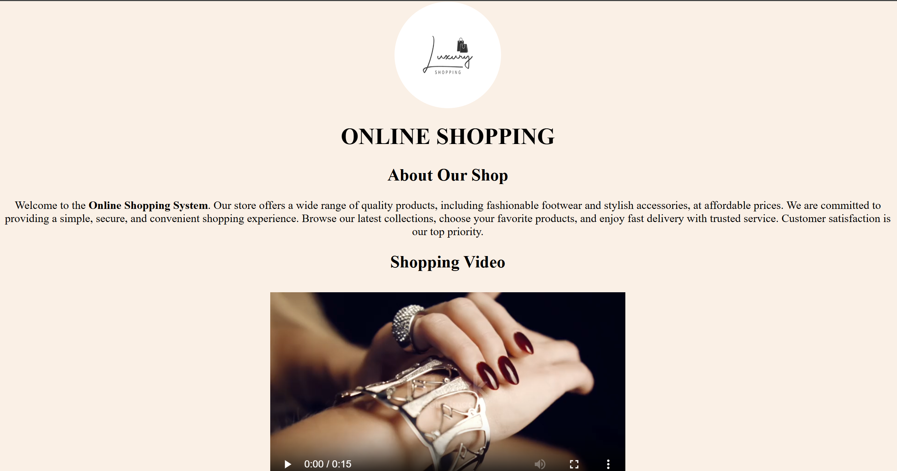

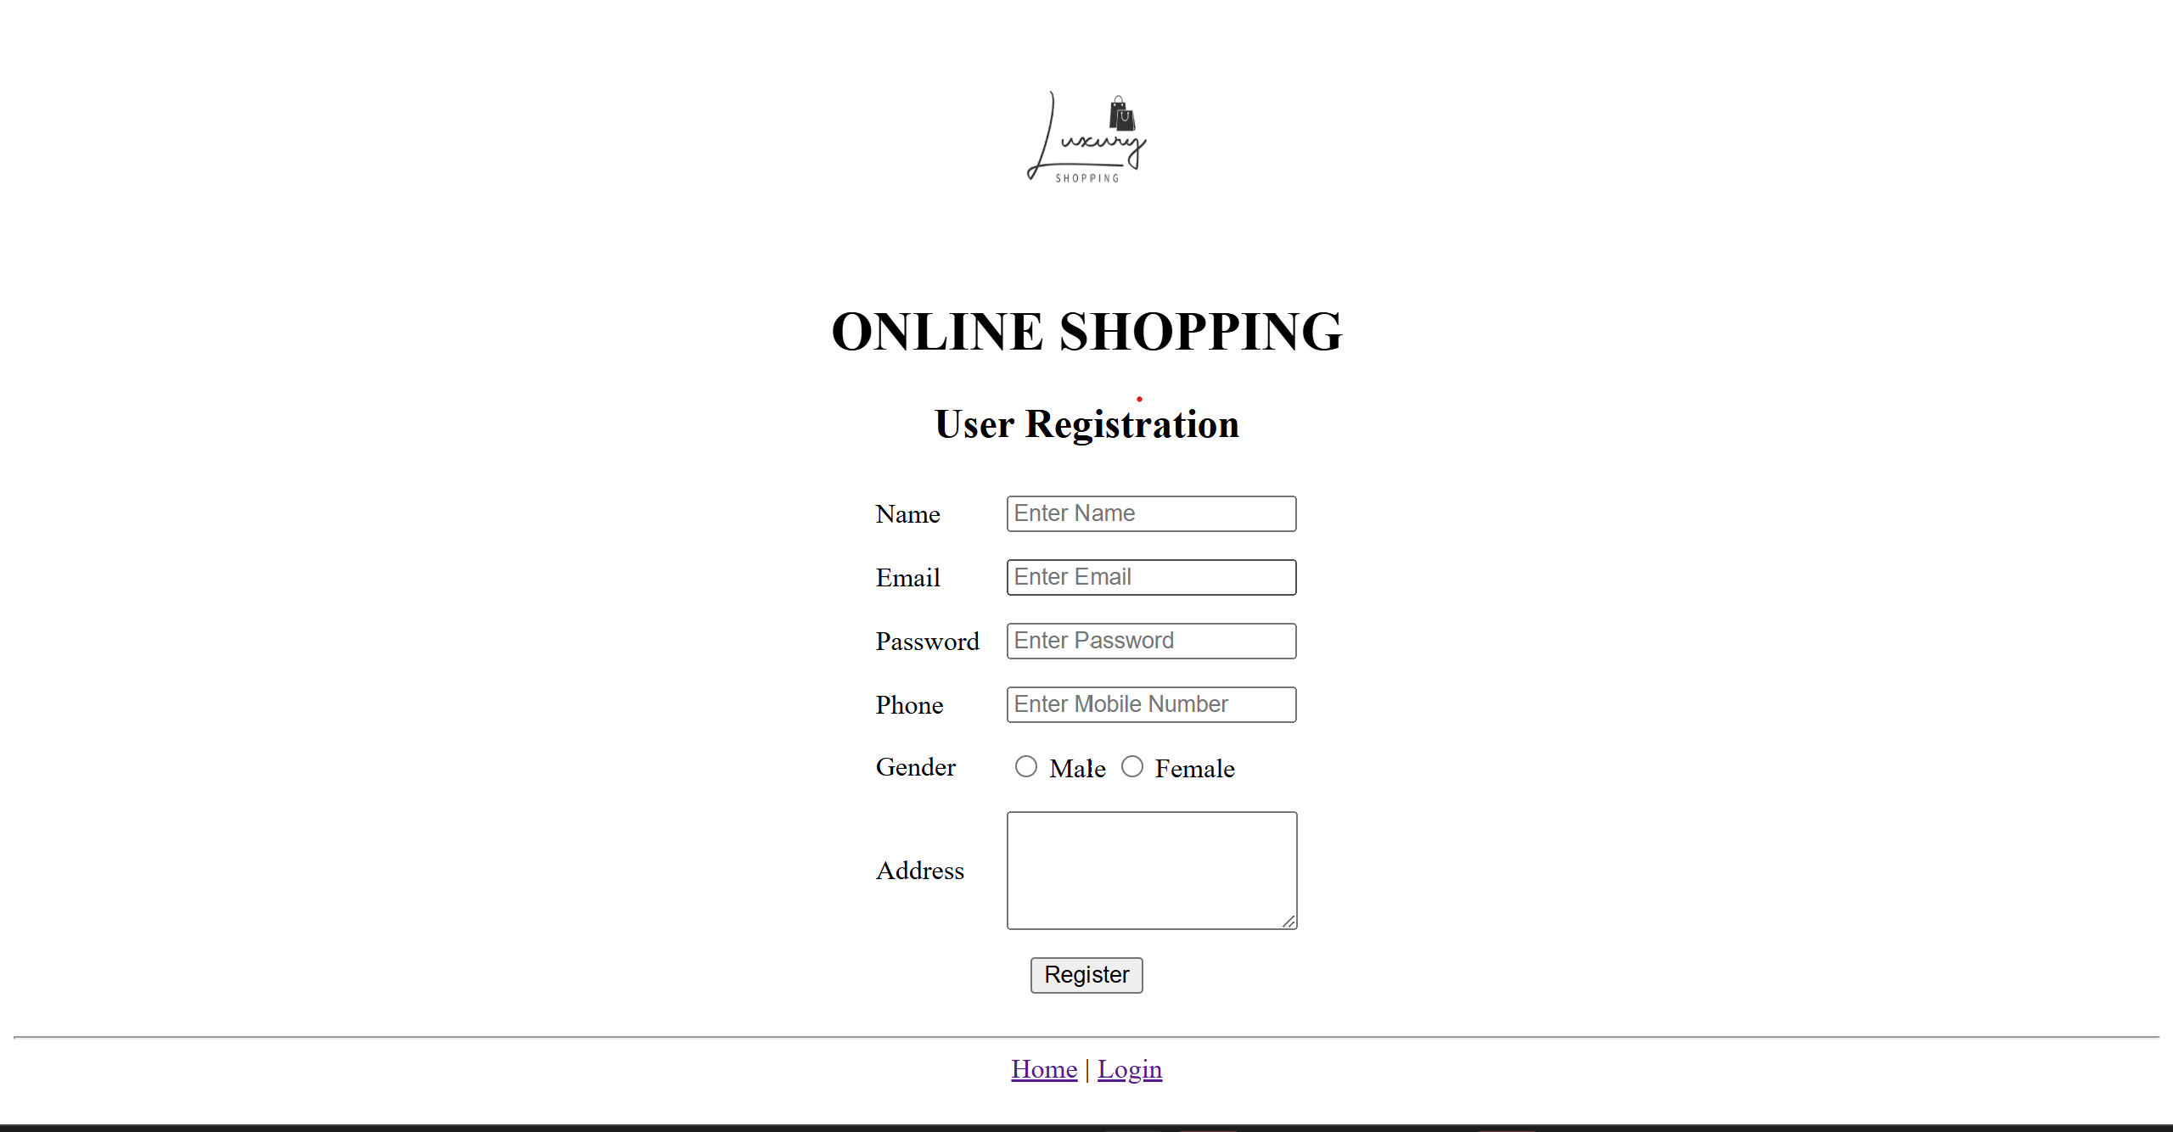

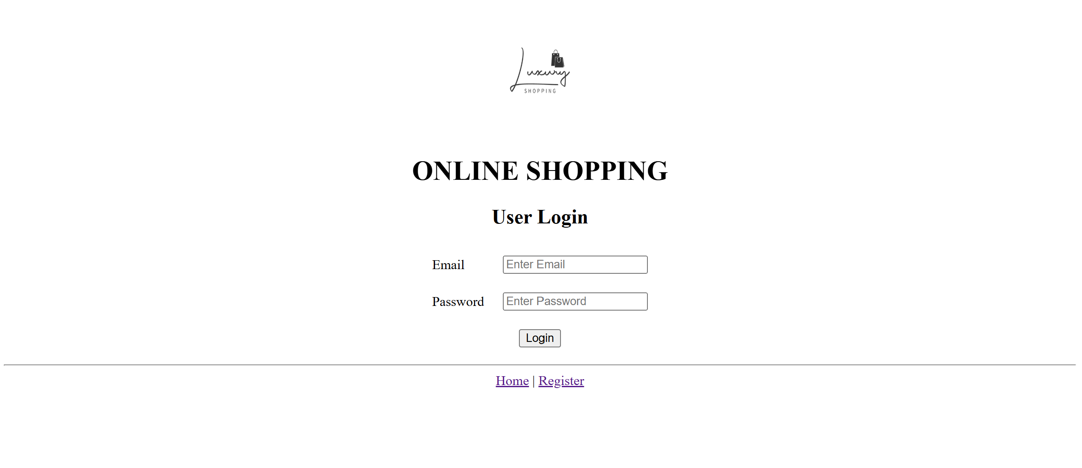

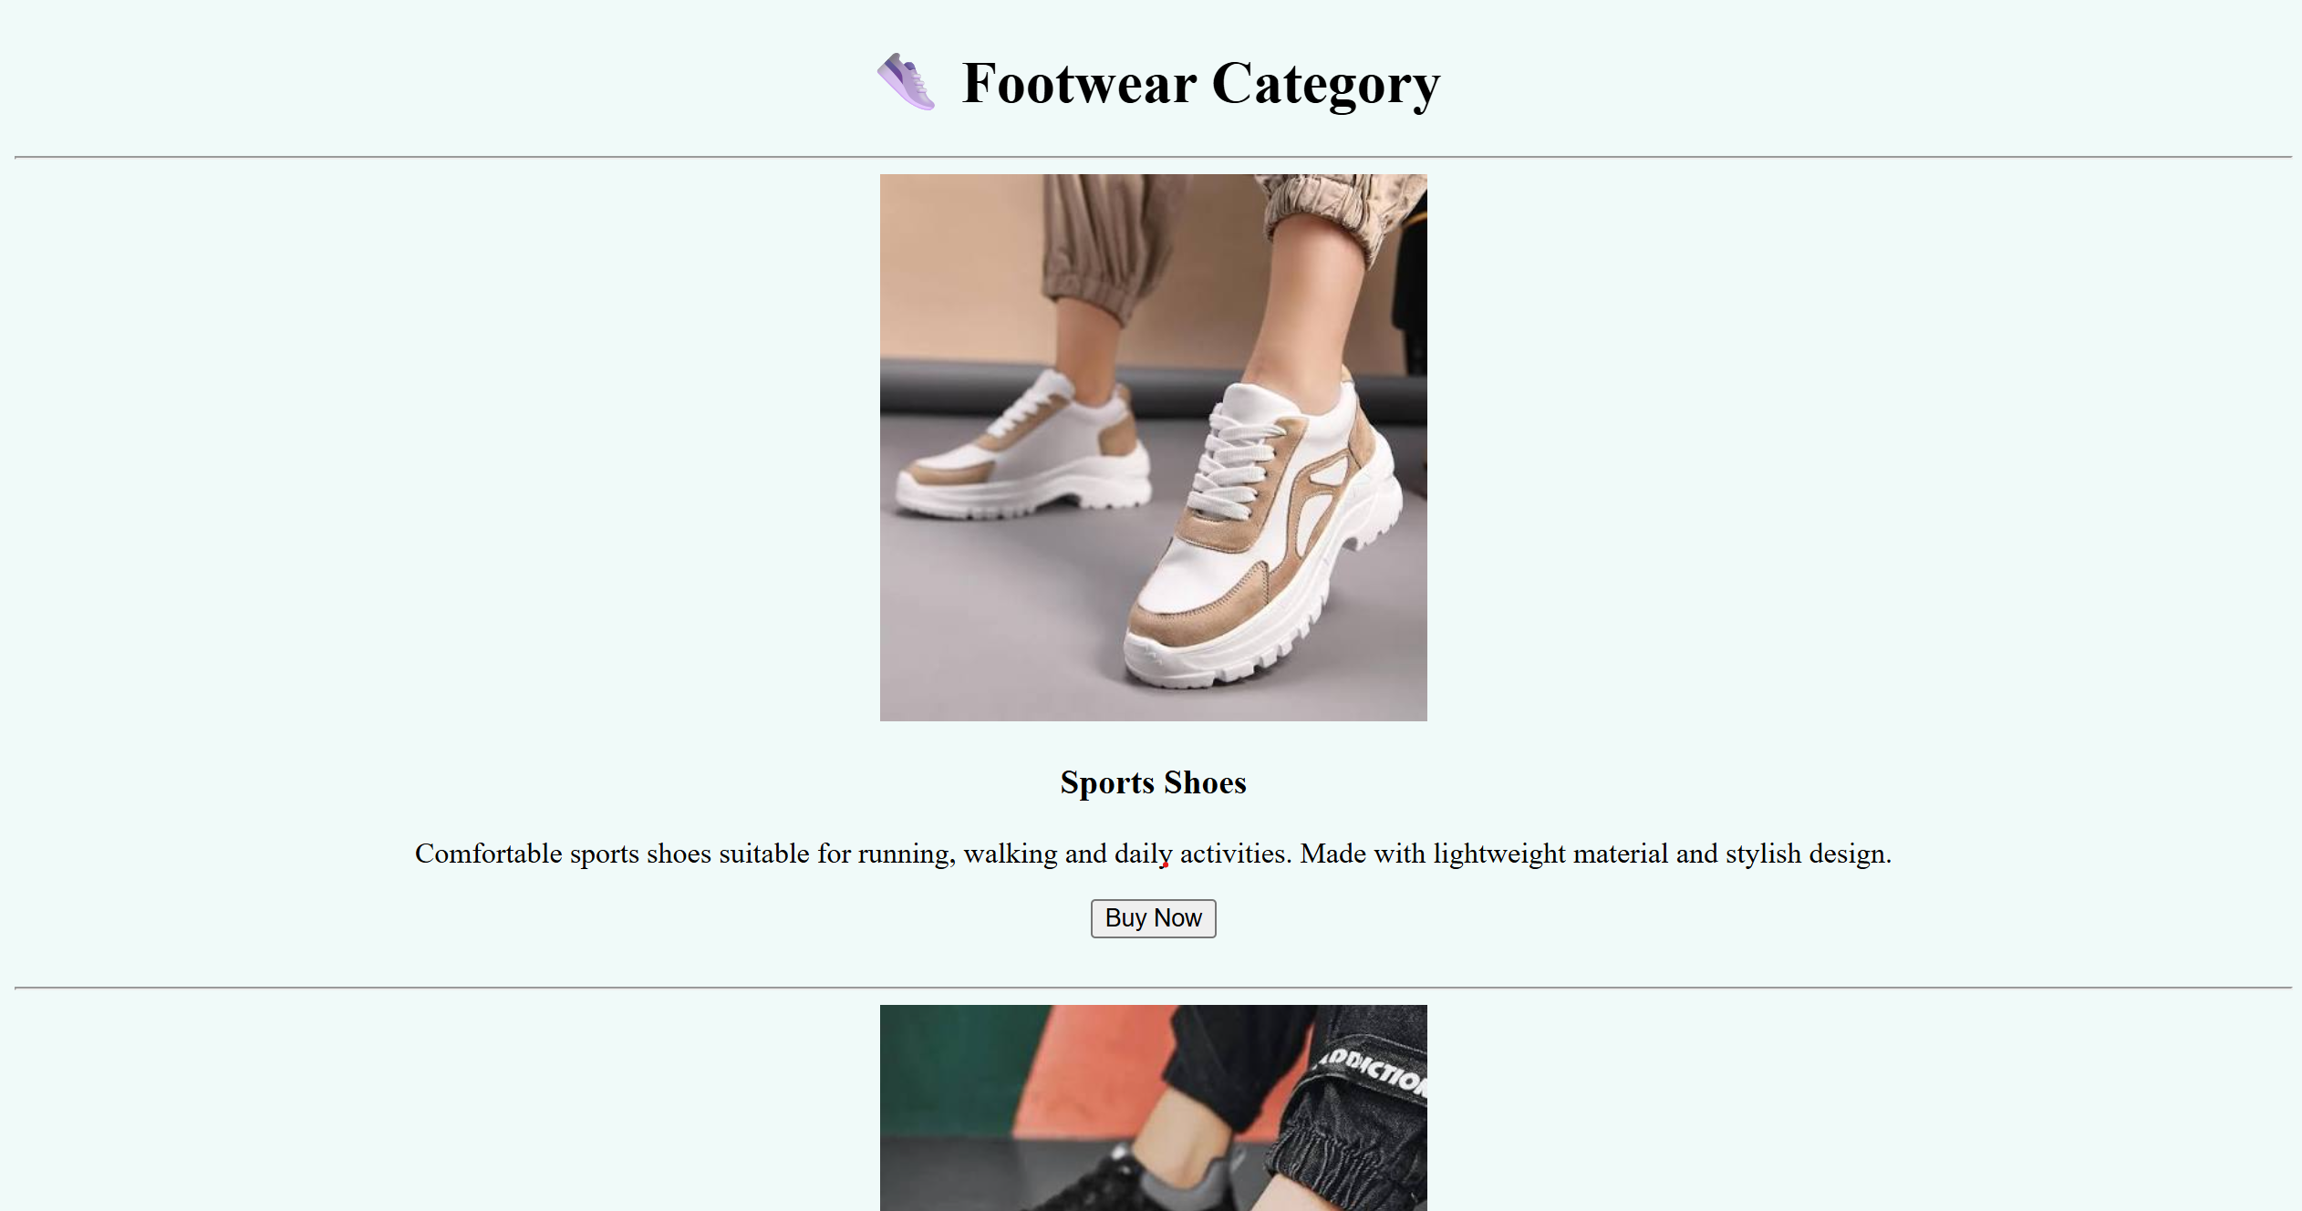

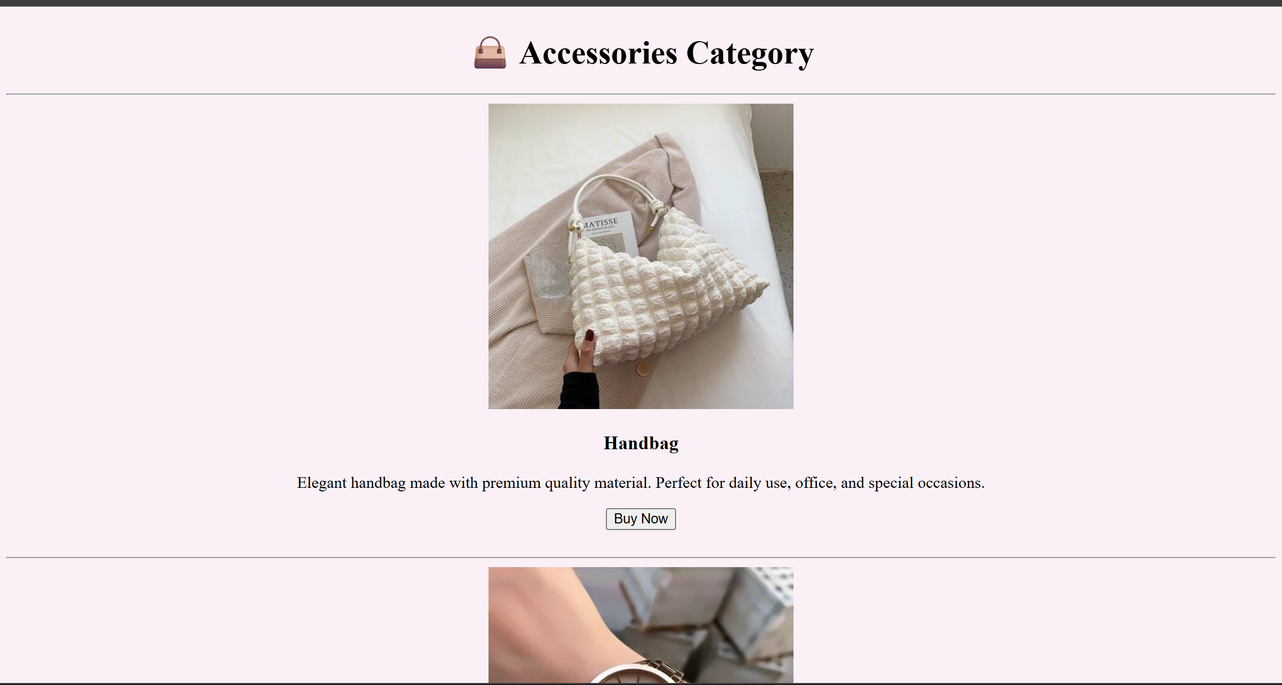

s