NC State University
Department of Electrical and Computer Engineering
ECE 463/563 (Prof. Rotenberg)
Project #2: Branch Prediction
REPORT TEMPLATE (Version 2.0)

by

<< Yazhuo Gao >>

NCSU Honor Pledge: "I have neither given nor received unauthorized aid on this project."

Student’s electronic signature: __________Yazhuo Gao________
(sign by typing your name)

Course number: _______563_______
(463 or 563 ?)

Grading Breakdown, Experiments, and Report

PART 1: BIMODAL PREDICTOR

(a) [ECE463: 25 points] or [ECE563: 20 points] Gradescope will evaluate your simulator on the four validation runs “val_bimodal_1.txt”, “val_bimodal_2.txt”, “val_bimodal_3.txt”, and “val_bimodal_4.txt”, posted on the website for the BIMODAL PREDICTOR. Gradescope will also evaluate your simulator on one bimodal predictor mystery run. Each validation run and mystery run is worth ⅕ of the points for this part (5 or 4 points each). Gradescope must say that you match all four validation runs to get credit for the experiments with the bimodal predictor, however.

(b) [ECE463: 25 points] or [ECE563: 20 points] Simulate BIMODAL PREDICTOR for different sizes (7 ≤ m ≤ 20). Use the traces gcc, jpeg, and perl.
[20 or 15 points] Graphs: Produce one graph for each benchmark. Graph title: “<benchmark>, bimodal”. Y-axis: branch misprediction rate. X-axis: m. Per graph, there should be only one curve consisting of 14 datapoints (connect the datapoints with a line).

<< INSERT GRAPH “gcc, bimodal” HERE >>
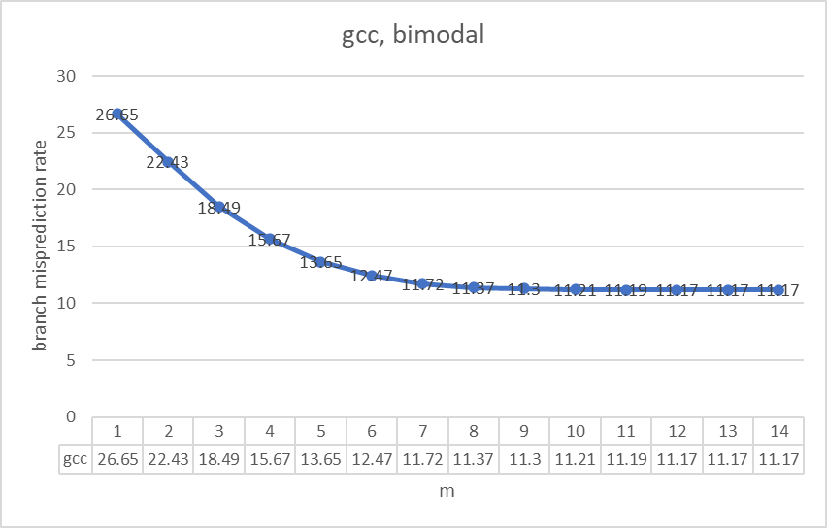

<< INSERT GRAPH “jpeg, bimodal” HERE >>
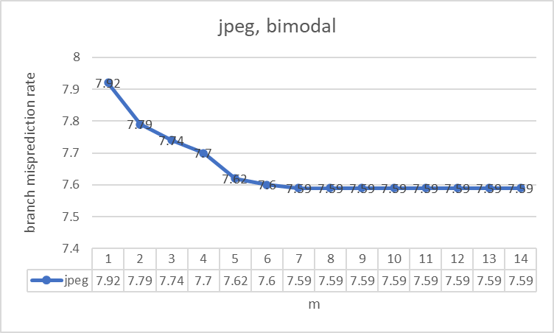

<< INSERT GRAPH “perl, bimodal” HERE >>
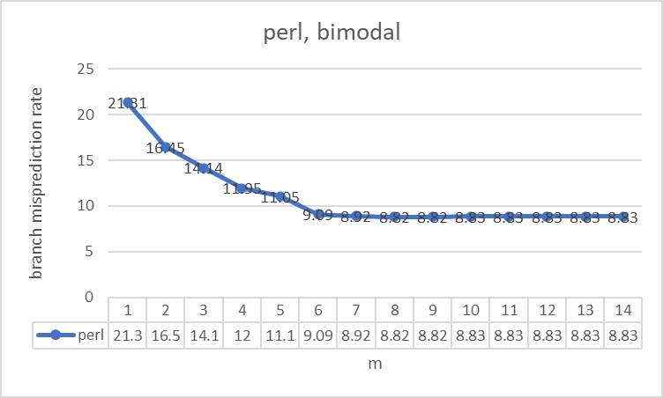

[5 points] Analysis:
1. [1 point] As the bimodal predictor’s table size increases, the branch misprediction rate __decreases__.
2. [2 points] For each benchmark, indicate the minimum value of m at which the misprediction rate bottoms-out (reaches its minimum) and indicate its minimum misprediction rate. Fill in the table below. (Use a precision of two digits after the decimal point for misprediction rate. That’s what should be in your simulator’s output file, in any case.)
Benchmark | Minimum “m” at which misprediction rate (two digits of precision after the decimal point) reaches its minimum | Minimum misprediction rate (two digits of precision after the decimal point)
gcc | m = 18 | 11.17%
jpeg | m = 13 | 7.59%
perl | m = 14 | 8.82%
3. [1 point] At some point, increasing the bimodal predictor’s table size is of no value. At this point, each static branch (i.e., each static branch PC) is allocated a dedicated ___counter___ in the table. Given that interference among different static branches is eliminated at this point, the only way to improve accuracy further is <a better prediction algorithm>.
4. [1 point] I infer that gcc has <more> static branches (i.e., unique static branch PCs) than jpeg, because gcc requires <more> table entries than jpeg before its misprediction rate bottoms-out.
PART 2: GSHARE PREDICTOR

(a) [ECE463: 25 points] or [ECE563: 20 points] Gradescope will evaluate your simulator on the four validation runs “val_gshare_1.txt”, “val_gshare_2.txt”, “val_gshare_3.txt”, and “val_gshare_4.txt”, posted on the website for the GSHARE PREDICTOR. Gradescope will also evaluate your simulator on one gshare predictor mystery run. Each validation run and mystery run is worth ⅕ of the points for this part (5 or 4 points each). Gradescope must say that you match all four validation runs to get credit for the experiments with the gshare predictor, however.

(b) [ECE463: 25 points] or [ECE563: 20 points] Simulate GSHARE PREDICTOR for different sizes (7 ≤ m ≤ 20), and for each size, i.e., for each value of m, sweep the global history length n from 0 to m. Use only the trace gcc.
[20 or 15 points] Graphs: Produce one graph for gcc. Graph title: “gcc, gshare”. Y-axis: branch misprediction rate. X-axis: n (spanning n=0 to n=20). For this graph, there should be a total of 203 datapoints plotted as 14 curves. Datapoints having the same value of m (same predictor size) are connected with a line, i.e., one curve for each value of m. Note that not all curves have the same number of datapoints; see the listing below for the number of datapoints for each of the 14 curves, m=7 through m=20. The rationale for this graph is to study the effect of global history length for each predictor size.
m=7 curve has 8 datapoints: 0 ≤ n ≤ 7
m=8 curve has 9 datapoints: 0 ≤ n ≤ 8
m=9 curve has 10 datapoints: 0 ≤ n ≤ 9
m=10 curve has 11 datapoints: 0 ≤ n ≤ 10
m=11 curve has 12 datapoints: 0 ≤ n ≤ 11
m=12 curve has 13 datapoints: 0 ≤ n ≤ 12
m=13 curve has 14 datapoints: 0 ≤ n ≤ 13
m=14 curve has 15 datapoints: 0 ≤ n ≤ 14
m=15 curve has 16 datapoints: 0 ≤ n ≤ 15
m=16 curve has 17 datapoints: 0 ≤ n ≤ 16
m=17 curve has 18 datapoints: 0 ≤ n ≤ 17
m=18 curve has 19 datapoints: 0 ≤ n ≤ 18
m=19 curve has 20 datapoints: 0 ≤ n ≤ 19
m=20 curve has 21 datapoints: 0 ≤ n ≤ 20

<< INSERT GRAPH “gcc, gshare” HERE >>
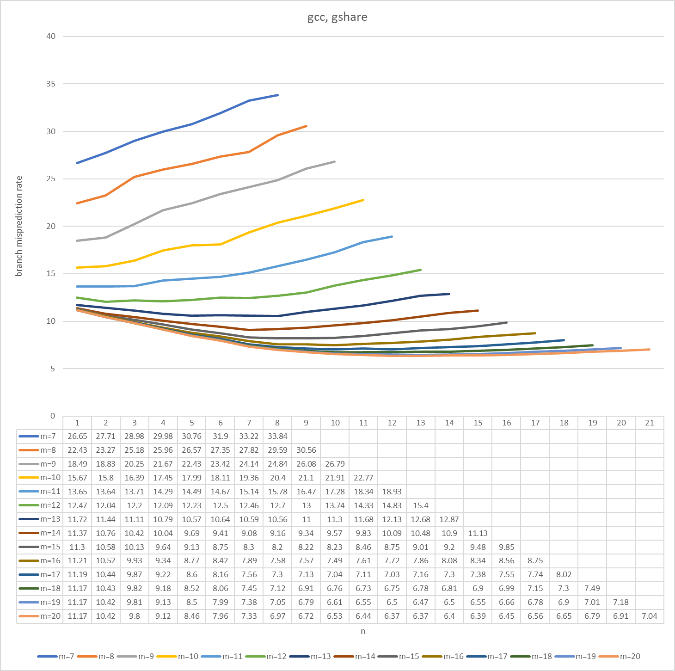

[5 points] Analysis:
Insight: With the bimodal predictor (n=0: no global history), a given static branch is predicted using only a single 2-bit counter. With the addition of global history, that single counter is specialized or multiplied into many more counters. All these counters are used by the same static branch for more specialized predictions among its dynamic instances, promising higher accuracy as long as there are adequate counters available in the table (not just for this static branch, but for all static branches). Thus, with the addition of global history, there is a need for more 2-bit counters … the key idea being that, at some point, bimodal cannot even take advantage of more counters (see your analysis section for bimodal, above) whereas gshare can. Summarizing: Gshare needs an abundance of counters and, unlike bimodal, it can exploit abundant counters for higher accuracy.
1. [0.5 points] At small table sizes, global history can <hurt> accuracy. This is because there are <too few> counters.
2. [0.5 points] At large table sizes, global history can <help> accuracy. This is because there are <abundant> counters.
3. [2.5 points] For each table size (m), indicate the smallest global history length (n) that yields the lowest misprediction rate (use a precision of two digits after the decimal point for misprediction rate; that’s what should be in your simulator’s output file, in any case), indicate what that lowest misprediction rate is, and indicate the misprediction rate for bimodal. Fill in the table below.
m | Smallest global history length (n) that yields the lowest misprediction rate (two digits of precision after the decimal point) | Lowest misprediction rate (two digits of precision after the decimal point) | Bimodal misprediction rate (i.e., for n=0)  (two digits of precision after the decimal point)
7 | 0 | 26.65 | 26.65
8 | 0 | 22.43 | 22.43
9 | 0 | 18.49 | 18.49
10 | 0 | 15.67 | 15.67
11 | 1 | 13.64 | 13.65
12 | 1 | 12.04 | 12.47
13 | 4 | 10.57 | 11.72
14 | 6 | 9.08 | 11.37
15 | 7 | 8.2 | 11.3
16 | 9 | 7.49 | 11.21
17 | 11 | 7.03 | 11.19
18 | 10 | 6.73 | 11.17
19 | 12 | 6.47 | 11.17
20 | 11 | 6.37 | 11.17
4. [0.5 points] The smallest bimodal predictor that achieves the best bimodal accuracy (lowest misprediction rate, using two digits after the decimal point, among all bimodal configurations) is as follows:
Best bimodal: m = _18_, misp. rate = _11.17%_.
5. [0.5 points] The smallest gshare predictor that achieves the best gshare accuracy (lowest misprediction rate, using two digits after the decimal point, among all gshare configurations) is as follows:
Best gshare: m = _20_, n = _11_, misp. rate = _6.37%_.
6. [0.5 points] In conclusion, with adequate predictor storage budget, gshare <rocks>.

PART 3: HYBRID PREDICTOR (ECE563 students only)

[ECE563: 20 points] Gradescope will evaluate your simulator on the two validation runs “val_hybrid_1.txt” and “val_hybrid_2.txt” posted on the website for the HYBRID PREDICTOR. Gradescope will also evaluate your simulator on two hybrid predictor mystery runs. Each validation run and mystery run is worth ¼ of the points for this part (5 points each).

