**Cinéma**

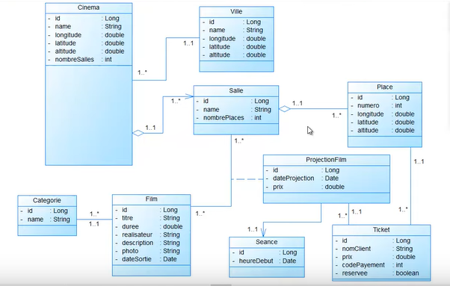

**Cinema**

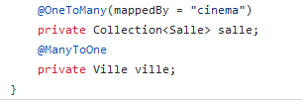

**Salle**

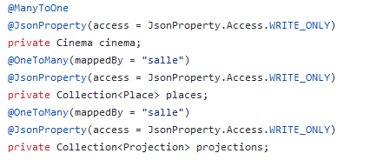

**Ville**

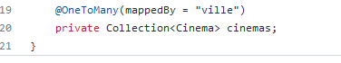

**Categorie**

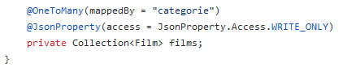

**Film**

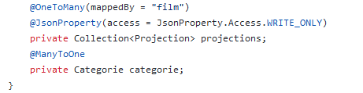

**Place**

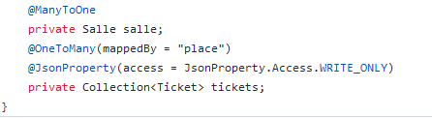 **Projection**

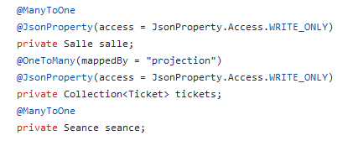

**Seance**

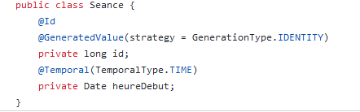

**Ticket**

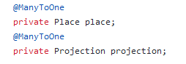

**TicketProjection**

