December 17, 2023

Yuran Belane

Mastershool ny.

MEtrocar FUNNEL ANALYSIS

Report

Index

1. Summary 3

2. Context 4

3. Results 5

3.1 Dataset structure 5

App_downloads: 5

Signups: 5

Ride_requests: 5

Transactions: 5

Reviews: 6

3.2 Duration of the funnel analysis 6

4. Metrocar Funnel analysis overview 6

6. Funnel - Granularity 7

6.1 User-Level Granularity 7

6.2 Ride-Level Granularity 7

7. Business question I 8

7.1 Sign-Up: 9

7.2 Ride Requested: 9

7.3 Ride Accepted 10

7.4 Ride Completed 10

7.5 Review 10

7.7 Ride funnel level 10

7.8 Ride-Requested to Ride-Accepted: 11

7.9 Ride-Accepted to Ride-Completed: 11

7.10 Ride-Completed to Payment: 11

7.11 Payment to Review 11

7.12 Recommendation 11

8. Business question II 12

8.1 iOS Platform (14,290 downloads): 12

Recommendation: 12

8.2 Android Platform (6,935 downloads): 12

8.2.1 Insight 12

Recommendation: 13

8.3 Web Platform (2,383 downloads): 13

8.3.2 Additional Considerations: 13

9. Business question III 13

Age group 35–44: 13

Age Groups 45–54 and 25–34: 14

Age Group 18–24: 14

Recommendations: 14

10. Business question IV 15

10.1 Peak Hours for Ride Requests: 15

10.2 Recommendations for Surge Pricing: 15

10.3 Considerations 15

11. Business question V 16

11.1 User Experience Optimization 16

11.2 Driver availability and response 16

11.3 Clear Communication 16

11.4 Incentives for Completion: 17

11.5 Prompt Support and Issue Resolution 17

11.6 Gather User Feedback 17

Appendix 18

# ****Summary****

The objective of this project was to conduct a comprehensive analysis of the customer funnel for Metrocar, aimed to enhance the efficiency and user experience of the ride-sharing app a like Uber/Lyft. The primary goal was to identify areas for improvement and optimization within the customer journey by addressing key business questions, the analysis focused on two critical funnel stages: user activation from signup to ride request and ride delivery from request to acceptance. The analysis aimed to answer specific business questions posed by stakeholders, focusing on key drop-off points in the funnel and the findings informed strategic recommendations to improve these areas, ultimately optimizing the customer journey. Additionally, insights were provided to address platform-specific marketing strategies, age group performance, ride request distribution, and the identification of the lowest-converting funnel stage.

# ****Context****

**Metrocar, a ride-sharing app like Uber and Lyft, sought to better understand and enhance its customer funnel. Stakeholders posed specific inquiries to uncover insights into user activation and ride delivery challenges. The analysis aimed to identify where unique users experienced difficulties transitioning from signup to ride request and pinpoint issues leading to unfulfilled ride requests. The contextual investigation provided a foundation for data-driven decision-making to refine Metrocar's service and improve customer satisfaction.**

**Timeline: write a full statement talking about the duration of this funnel analysis which was conduct from January 2021 until December 2021.**

# ****Results****

# ****Dataset structure****

The dataset used for the Metrocar Customer Funnel Analysis comprises several interconnected tables, each offering valuable insights into different aspects of the ride-sharing platform. Here is a brief overview of the key tables and their respective attributes:

## App_downloads:

* + **app_download_key:** Unique identifier for app downloads.
  + **platform:** Indicates the platform of the app download (iOS, Android, or web).
  + **download_ts:** Timestamp of the app download.

## Signups:

* + **user_id:** Primary identifier for a user.
  + **session_id:** App download identifier.
  + **signup_ts:** Timestamp of user signup.
  + **age_range:** Age range to which the user belongs.

## Ride_requests:

* + **ride_id:** Primary identifier for a ride.
  + **user_id:** Foreign key linking to the user making the ride request.
  + **driver_id:** Foreign key linking to the assigned driver.
  + **request_ts:** Timestamp of ride request.
  + **accept_ts:** Timestamp when the driver accepts the ride.
  + **pickup_location, destination_location:** Coordinates for pickup and destination.
  + **pickup_ts, dropoff_ts, cancel_ts:** Timestamps for pickup, dropoff, and ride cancellation (timestamps may be null).

## Transactions:

* + **ride_id:** Foreign key linking to the ride.
  + **purchase_amount_usd:** Purchase amount in USD.
  + **charge_status:** Indicates whether the transaction was approved or canceled.
  + **transaction_ts:** Timestamp of the financial transaction.

## Reviews:

* + **review_id:** Primary identifier for a review.
  + **ride_id:** Foreign key linking to the ride being reviewed.
  + **driver_id:** Foreign key linking to the driver being reviewed.
  + **user_id:** Foreign key linking to the user providing the review.
  + **rating:** Numeric rating from 0 to 5.
  + **free_response:** Text response given by the user/requester.

This comprehensive dataset encompasses information on app downloads, user signups, ride requests, financial transactions, and user reviews. The interrelation of these tables allows for a holistic exploration of user behavior, ride interactions, and feedback, providing a solid foundation for the Metrocar Customer Funnel Analysis.

Top of Form

## ****3.2 Duration of the funnel analysis****

**The Metrocar Customer Funnel Analysis, conducted from January to December 2021, thoroughly examined user interactions at key stages such as app download, signup, ride requests, and payment processing. The analysis aimed to identify and address drop-off points, emphasizing both quantitative metrics and qualitative aspects like user experience. The year-long duration allowed for a comprehensive understanding of seasonal variations and user behavior changes, enabling the development of targeted strategies to enhance overall efficiency and satisfaction. The findings serve as a valuable foundation for ongoing improvements in Metrocar's services and user engagement strategies in the dynamic ride-sharing industry.**

# ****Metrocar Funnel analysis overview****

Metrocar's customer funnel consists of several key stages:

* **App Download:** Users download the Metrocar app from the App Store or Google Play Store.
* **Signup:** Users create an account, providing personal details such as name, email, phone number, and payment information.
* **Request Ride:** Users open the app, specify pickup and destination, and choose ride capacity (2 to 6 riders).
* **Driver Acceptance:** A nearby driver receives and accepts the ride request.
* **Ride:** The driver arrives, and the user travels to their destination.
* **Payment:** Users are automatically charged through the app, and a receipt is sent to their email.
* **Review:** Users rate the driver and provide feedback on their ride experience.

Given the nature of customer funnels, drop-offs occur at various stages. Analyzing these drop-offs is essential for identifying areas of improvement. For instance, Metrocar may assess the percentage of users who download the app but don't complete registration or those who request a ride but cancel before the driver arrives. Funnel analysis is a valuable tool for optimizing and refining the user journey to enhance overall user satisfaction and engagement.

1. **Queries**

**The funnel granularity was provided through an SQL query (on the appendix) using beekeeper Studio. It was written using CTEs to construct a comprehensive analysis of Metrocar's customer funnel. The analysis spans various stages, including app downloads, signups, ride requests, ride acceptance, ride completion, payment, and user reviews. The results are organized into distinct funnel steps, capturing user and ride counts at each stage. The granularity of the analysis is at the platform, age range, and download date levels, providing a detailed breakdown of user engagement over time.** When considering the nulls in the dataset, there were significant nulls in age_range column in signups table. Also, the dataset was too small to generate meaningful insights and draw definitive conclusions.  **The query effectively translates the raw dataset into actionable insights, facilitating a clear understanding of the user journey and potential areas for optimization.**

# ****Funnel - Granularity****

Granularity is a crucial aspect of our funnel analysis, and we approach it from both user-level and ride-level perspectives. This dual granularity allows for a comprehensive understanding of user interactions and ride progression throughout Metrocar's customer funnel.

## 6.1 User-Level Granularity

Analyzing the customer funnel at the user level involves tracking the journey of individual users through each stage. This approach enables us to evaluate the conversion rates from one stage to the next, providing insights into user behavior and engagement. By considering user-level granularity, we can identify specific points in the funnel where users may drop off or encounter challenges.

# 6.2 Ride-Level Granularity

At the ride level, our analysis zooms in on the progression of individual ride events through the various stages of the funnel. This detailed examination allows us to evaluate the conversion rates associated with each ride, shedding light on the efficiency of ride requests, acceptance, completion, and subsequent user interactions such as payments and reviews.

**6.3 Percent of Previous (POP):**

**6.3.1 Definition**

Percent of Previous (POP) is a metric that measures the conversion rates between sequential stages of the funnel. It calculates the percentage of users or rides in a specific stage relative to the number of users or rides in the previous stage.

**6.3.2 Purpose**

POP enables us to monitor the flow of users or rides through each stage of the funnel. By identifying the percentage of users or rides progressing to the next stage, we can pinpoint potential areas for improvement, optimization, or user drop-offs.

**6.4 Percent of Top (POT)**

**6.4.1 Definition**

Percent of Top (POT) is a metric that measures conversion rates relative to the total number of users or events (rides) at the top of the funnel. It calculates the percentage of users or rides in a specific stage relative to the total number of users or rides at the initial stage.

**6.4.2 Purpose**

POT provides a broader perspective by considering the entire funnel as the reference point. This metric helps us understand how efficiently users or rides progress through the funnel relative to the total number at the beginning. It offers insights into the overall effectiveness of the customer journey.

In summary, user-level and ride-level granularity, combined with Percent of Previous and Percent of Top metrics, form a robust framework for our funnel analysis. This approach allows us to delve deep into user and ride behaviors, identify conversion rates, and make informed decisions to enhance Metrocar's ride-sharing experience.

# ****Business question I****

What steps of the funnel should we research and improve? Are there any specific drop-off points preventing users from completing their first ride?

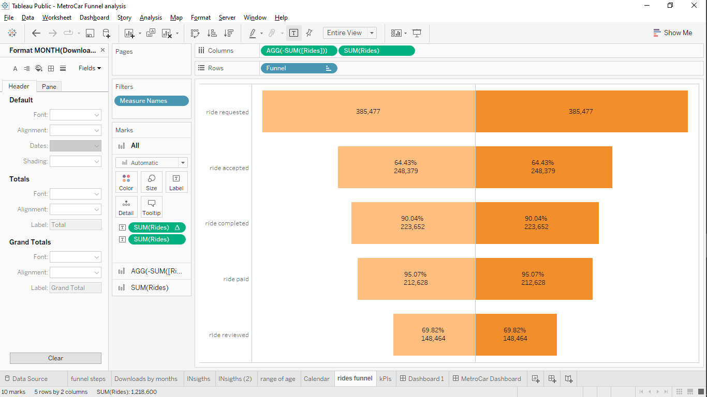

Table 1 User granularity level

Following the user-level funnel analysis, specific areas within the customer journey have been identified for research and improvement:

## Sign-Up:

A notable drop-off of 25.40% was observed from app downloads to sign-ups. Investigating the reasons behind this decline is essential to identify potential barriers or challenges users may encounter during the sign-up process. Implementing measures such as simplifying the registration process, improving user guidance, or resolving technical issues can contribute to elevating the conversion rate from downloads to sign-ups.

## Ride Requested:

At this stage, a substantial drop-off was noted, with a 70.40% conversion rate (POP) and a 52.55% conversion rate (POT) from sign-ups to ride requests. Understanding why nearly 30% of users who signed up did not proceed to request a ride is crucial. Usability issues, a lack of clarity in app features, or ineffective communication of the value proposition could be contributing factors. Gathering user feedback, conducting usability testing, and analyzing user behavior within the app can offer insights to address these drop-offs.

## Ride Accepted

While the drop-off percentage was relatively low at this stage (1.00%), investigating factors preventing users from successfully getting their ride requests accepted by drivers is worthwhile. Analyzing driver availability, notification systems, or other relevant factors can enhance the acceptance rate and contribute to a smoother ride-booking experience for users.

## Ride Completed

The conversion rate from ride requested to ride completed was 50.77%, indicating a significant drop-off. Understanding the reasons behind cancellations after the ride was accepted is crucial. Factors such as waiting times, driver behavior, pricing concerns, or other aspects affecting the overall ride experience need attention. Analyzing user feedback, driver ratings, and conducting post-ride surveys can provide valuable insights to address these issues and improve the ride completion rate.

## Review

Observing conversion rates of 69.78% (POP), 18.42% (POT), and a 30.20% drop-off highlighted that a considerable number of users hesitate to provide reviews and ratings. Encouraging customers to share their feedback for both drivers and the overall service is crucial to enhance the review process.

By focusing on these stages and addressing potential drop-off points, Metrocar can elevate the user experience, improve retention rates, and guide more users to complete their first ride, ultimately contributing to the overall success of the platform.

## ****Ride funnel level****



Table 2 Ride funnel granularity level

The ride-level funnel, starting from Ride-Requested and concluding with Reviews, offers an insightful perspective for analysis, pinpointing potential areas for enhancement:

## Ride-Requested to Ride-Accepted:

The conversion rate from requested rides to accepted rides stands at 64.43%, accompanied by a substantial drop-off of 35.60%. To uncover reasons behind unaccepted ride requests, exploring potential issues with the user interface, pricing, or driver availability is crucial. It's recommended that the Research and Development (R&D) team conducts a thorough investigation into these drop rates to optimize the ride acceptance process.

## Ride-Accepted to Ride-Completed:

With a conversion rate of 90.04%, the transition from accepted rides to completed rides suggests a notable drop-off point. Delving into factors affecting ride completion, such as cancellations, user experience during the ride, or potential barriers hindering users from reaching their intended destinations, is warranted for further research.

## Ride-Completed to Payment:

The conversion rate from completed rides to payment is relatively high at 95.07%. However, a small percentage of users did not complete their payments. Investigating this step involves examining potential friction points during the payment process, such as payment methods, security concerns, or system errors, to ensure a seamless and successful payment experience.

## Payment to Review

With a conversion rate of 73.47%, the drop-off of 26.50% from payment to review suggests that some users refrain from leaving reviews after completing their payment. Researching this step includes understanding user motivations for providing reviews, incentivizing feedback, or enhancing the review process to make it more user-friendly and seamless.

## Recommendation

To address drop-off points and encourage users to complete their first ride, the primary focus should be on the Ride-Requested to Ride-Accepted stage. Conducting user research, surveys, or interviews with users who did not complete their first ride can unveil concerns, barriers, or issues encountered during the process. This valuable feedback can provide insights for refining the user experience and addressing specific pain points or obstacles, ultimately enhancing the likelihood of users completing their first ride successfully.

## ****Business question II****

Metrocar currently supports 3 different platforms: iOS, android, and web. To recommend where to focus our marketing budget for the upcoming year, what insights can we make based on the platform?

For Metrocar's upcoming marketing strategy, insights derived from platform-specific download data provide valuable guidance on budget allocation:

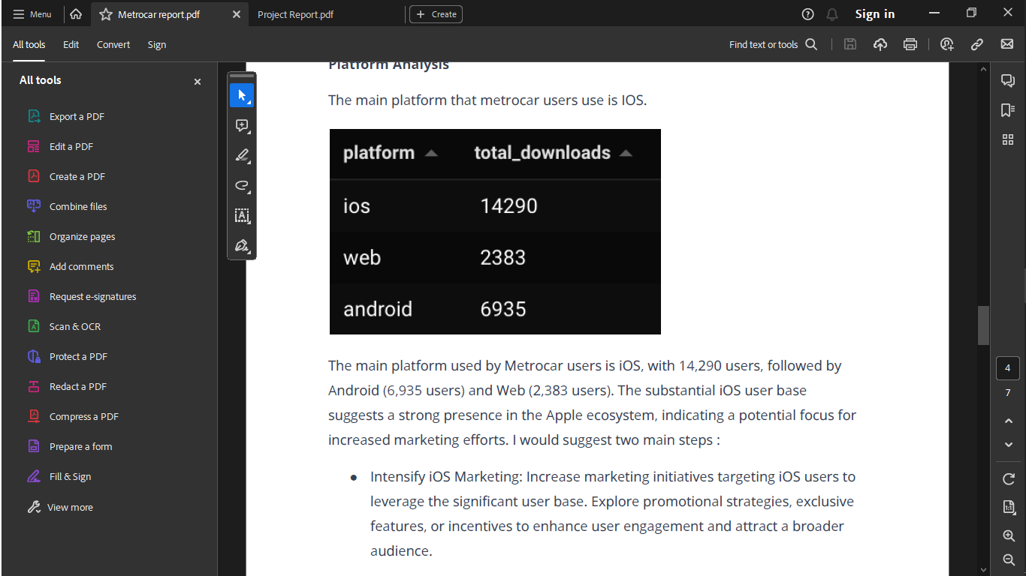

**Figure 1: A query screenshot of platforms download.**

## iOS Platform (14,290 downloads):

* + 1. **Insight:**

The iOS platform boasts the highest number of downloads at 14,290, indicating a robust user base. iOS users are recognized for their active engagement and willingness to invest in apps and services.

Recommendation: Allocate a substantial portion of the marketing budget to target iOS users. Leverage campaigns on the App Store, engage through social media platforms, and explore other channels catering to the iOS user base. The focus should be on both retaining existing iOS users and attracting new users to solidify Metrocar's presence in this lucrative market.

## Android Platform (6,935 downloads):

* + 1. Insight

The Android platform, with 6,935 downloads, represents a significant user base given the widespread use of Android devices. The diverse nature of Android users and the multitude of device options present opportunities for tailored marketing efforts.

Recommendation: Allocate a portion of the marketing budget to target Android users. Utilize channels such as the Google Play Store, social media, and targeted advertising. Tailor marketing strategies to specific segments or regions where Metrocar has growth potential within the expansive Android user base.

## Web Platform (2,383 downloads):

* + 1. **Insight**

The web platform records the lowest downloads at 2,383. While comparatively lower, the web platform remains valuable for users’ preferring desktop or laptop access to Metrocar's services.

**Recommendation:** Allocate a smaller portion of the marketing budget to enhance the web platform's visibility and user experience. Strategies may include online advertising, SEO, and partnerships with relevant websites. This targeted approach aims to maximize the web platform's impact, acknowledging its significance for a specific user demographic.

## Additional Considerations:

* Conduct market research to understand user preferences, demographics, and behavior patterns on each platform.
* Refine marketing strategies based on research findings to effectively target and engage users on different platforms.
* Maximize reach and impact by tailoring campaigns to align with the unique characteristics of each platform.

By strategically allocating the marketing budget based on platform-specific insights, Metrocar can optimize its marketing efforts, effectively reach its diverse user base, and enhance overall user engagement across iOS, Android, and web platforms.

## ****Business question III****

What age groups perform best at each stage of our funnel? Which age group(s) likely contain our target customers?

## Age group 35–44:

* **Downloads:** Highest interest, with 5,181 downloads.
* **Ride-Requested:** Highest number of ride requests and a robust conversion rate of 70.68%.
* **Sign-Ups:** The specific transportation needs or preferences of this age group align well with Metrocar's services.

## Age Groups 45–54 and 25–34:

* **Downloads:** Moderate interest.
* **Ride-Requested:** Similar conversion rates of 70.37% and 70.35%, indicating significant interest in Metrocar's services.
* **Sign-Ups:** These age groups likely represent a target demographic finding value in Metrocar's convenience, affordability, or other features.

## Age Group 18–24:

* **Downloads:** Notably engaged, with 1,300 ride requests and a 69.71% conversion rate.
* **Sign-Ups:** Higher sign-up numbers (1,826) compared to ride requests (1,300), potentially due to alternative transportation options readily available to this age group.

## Recommendations:

1. **Targeted Marketing:** Allocate marketing resources strategically based on age group preferences. For the 35–44 age group, focus on emphasizing the specific benefits that align with their transportation needs. For the 45–54 and 25–34 age groups, continue emphasizing the features that have resonated well with them.
2. **Engagement Strategies:** Develop targeted engagement strategies for the 18–24 age group, focusing on the modern and tech-savvy aspects of Metrocar. Highlight the flexibility and ease of use to cater to the preferences of this demographic.
3. **User Education:** For the 45–54 age group, where sign-ups are higher than ride requests, consider educational campaigns to showcase the advantages and convenience of Metrocar, addressing potential hesitations or misconceptions.
4. **User Feedback:** Conduct surveys or interviews across all age groups to gather feedback on preferences, pain points, and suggestions. This data can inform ongoing improvements in service offerings and user experiences.

By tailoring marketing efforts and user engagement strategies based on age group preferences, Metrocar can enhance its appeal to different demographics, maximize user satisfaction, and drive increased adoption across all stages of the customer funnel.

# ****Business question IV****

*Surge pricing is the practice of increasing the price of goods or services when there is the greatest demand for them. If we want to adopt a price-surging strategy, what does the distribution of ride requests look like throughout the day?*

The analysis after querying the ride request patterns reveals significant peaks at 9 AM and 8 AM, as well as during 4 PM and 5 PM, suggesting morning and afternoon/evening rush hours with heightened demand for transportation. To capitalize on these peak hours and potentially enhance service availability, adopting a price-surging strategy is a consideration.

## 10.1 Peak Hours for Ride Requests:

* + 9 AM: 60,210 ride requests
  + 8 AM: 60,071 ride requests
  + 4 PM: 58,527 ride requests
  + 5 PM: 58,176 ride requests

## 10.2 Recommendations for Surge Pricing:

* **Target Peak Hours:** Implement surge pricing during morning (8-9 AM) and afternoon/evening (4-5 PM) rush hours to align with heightened demand.
* **Incentivize Driver Availability:** Higher prices during peak hours can encourage more drivers to be available, ensuring an adequate supply of rides.
* **Balance Supply-Demand Dynamics:** Surge pricing helps balance supply and demand, optimizing access to transportation during high-demand periods.
* **Sensitive Implementation:** Recognize the sensitivity of surge pricing; it's crucial to strike a balance between profitability and customer satisfaction.

10.3 Considerations**:**

* **Customer Perception:** Be mindful of how customers perceive surge pricing to avoid negative reactions.
* **Optimal Pricing:** Conduct further analysis, considering customer behavior, market dynamics, and competitor pricing strategies, to determine the optimal surge pricing strategy.
* **Transparent Communication:** Clearly communicate surge pricing to users, providing transparency on the reasons behind the increased prices.

It’s important to mention that while surge pricing during peak hours can optimize supply-demand dynamics, a nuanced approach is essential. Balancing profitability and customer satisfaction requires careful consideration of market-specific factors and user expectations. Transparent communication and continuous analysis will be pivotal in implementing an effective surge pricing strategy that aligns with both business objectives and user sentiment.

# ****Business question V****

What part of our funnel has the lowest conversion rate? What can we do to improve this part of the funnel?

The stage in the User-level funnel with the lowest conversion rate is the "Ride - Completed" phase, registering a 50.77% conversion rate. This implies that only approximately half of the users who initiate a ride request successfully complete the entire ride. To enhance this segment of the funnel and boost the conversion rate, the following recommendations are proposed:

* 1. User Experience Optimization**:**
  + Evaluate the user experience throughout the ride process.
  + Identify and address pain points or areas causing difficulties.
  + Streamline the ride request and completion process, minimizing steps for a seamless experience.
  1. Driver availability and response**:**
  + Analyze driver availability and response times.
  + Address delays or difficulties in finding available drivers.
  + Implement strategies to improve driver availability, such as incentivizing during peak demand or using intelligent matching algorithms.
  1. Clear Communication**:**
  + Enhance real-time communication during the ride process.
  + Provide updates on driver status, estimated arrival time, and any changes promptly.
  + Clear and timely communication builds trust, reducing uncertainty and enhancing the overall ride experience.

## Incentives for Completion:

* + Implement incentives or rewards for users who complete rides.
  + Explore loyalty programs, discounts, or other incentives to encourage ride completion and feedback.
  1. Prompt Support and Issue Resolution**:**
  + Establish a robust customer support system for prompt issue resolution.
  + Ensure users have an accessible way to report problems during the ride.
  + Effective support mitigates potential obstacles and improves the completion rate.
  1. Gather User Feedback**:**
  + Actively collect and analyze user feedback to identify recurring issues.
  + Conduct surveys, solicit ratings, and utilize feedback channels for insights.
  + Use feedback to guide ongoing improvements and optimizations.

Continuously monitor and track the impact of implemented changes to assess effectiveness and make informed, data-driven decisions for further optimization.

For the Ride-level funnel, the "Ride - Accepted" stage has the lowest conversion rate at 64.43%. To enhance this phase, consider evaluating driver availability and implementing incentives to address potential challenges in drivers accepting ride requests. This may involve strategies such as offering higher earnings during peak hours or providing bonuses for completing a specific number of rides.

Appendix**:**

**Queries**

1. --How many users signed up on the app?

SELECT

COUNT(DISTINCT user_id) AS total_signups

FROM signups;

2. --How many rides were requested through the app?

SELECT COUNT(*) AS total_ride_requests

FROM ride_requests;

Output = insert into "public"."mytable" ("total_ride_requests") values ('385477')

3. --How many rides were requested and completed through the app?

WITH user_ride_status AS (

SELECT

user_id

FROM ride_requests

GROUP BY user_id

)

SELECT

COUNT(*) AS total_users_signed_up,

COUNT(DISTINCT urs.user_id) AS total_users_ride_requested

FROM signups s

LEFT JOIN user_ride_status urs ON

s.user_id = urs.user_id;

Output: 17623 || 12406

4. --How many rides were requested and how many unique users requested a ride?

SELECT

COUNT(DISTINCT user_id) AS users_requesting_a_ride,

COUNT(DISTINCT

CASE

WHEN dropoff_ts IS NOT NULL

THEN user_id

END

) AS users_completing_a_ride

FROM ride_requests;

Output: 12406 || 6233

5. --How many rides were requested and how many unique users requested a ride?

SELECT

COUNT(*) AS TotalRidesRequested,

COUNT(DISTINCT user_id) AS UniqueUsersRequestingRides

FROM ride_requests;

Output: 385477 || 12406

6. --Funnel CTEs

WITH user_ride_status AS (

SELECT user_id

FROM ride_requests

GROUP BY user_id

),

total_users AS (

SELECT

a.platform AS platform,

s.age_range AS age_range,

a.download_ts::DATE AS download_date,

COUNT(DISTINCT a.*) AS number_of_users_app_downloaded,

COUNT(DISTINCT s.user_id) AS total_unique_users_signup,

COUNT(DISTINCT urs.user_id) AS total_users_ride_requested,

COUNT(DISTINCT r.ride_id) AS number_of_rides_requested,

COUNT(DISTINCT CASE WHEN r.accept_ts IS NOT NULL THEN r.user_id END) AS rides_accepted_by_driver_user_wise,

COUNT(DISTINCT CASE WHEN accept_ts IS NOT NULL THEN r.ride_id END) AS rides_accepted_by_driver,

COUNT(DISTINCT CASE WHEN r.dropoff_ts IS NOT NULL THEN r.user_id END) AS unique_users_completed_ride,

COUNT(DISTINCT CASE WHEN dropoff_ts IS NOT NULL THEN r.ride_id END) AS completed_rides,

COUNT(DISTINCT CASE WHEN t.charge_status = 'Approved' THEN r.user_id END) AS number_of_users_complete_payments,

COUNT(DISTINCT CASE WHEN t.charge_status = 'Approved' THEN r.ride_id END) AS number_of_rides_complete_payments,

COUNT(DISTINCT re.user_id) AS number_of_users_provide_reviews,

COUNT(DISTINCT re.ride_id) AS number_of_rides_received_reviews

FROM app_downloads AS a

LEFT JOIN signups AS s ON a.app_download_key = s.session_id

LEFT JOIN user_ride_status AS urs ON s.user_id = urs.user_id

LEFT JOIN ride_requests AS r ON s.user_id = r.user_id

LEFT JOIN transactions AS t ON t.ride_id = r.ride_id

LEFT JOIN reviews AS re ON re.user_id = s.user_id

--WHERE s.age_range IS NOT NULL

GROUP BY platform, age_range,download_date

),

funnel_steps AS (

SELECT

1 AS funnel_step,

'Downloads' AS funnel_name,

platform,

age_range,

download_date,

CAST(number_of_users_app_downloaded AS BIGINT) AS user_count,

CAST(NULL AS BIGINT) AS ride_count

FROM total_users

UNION

SELECT

2 AS funnel_step,

'Sign_UP' AS funnel_name,

platform,

age_range,

download_date,

CAST(total_unique_users_signup AS BIGINT) AS user_count,

CAST(NULL AS BIGINT) AS ride_count

FROM total_users

UNION

SELECT

3 AS funnel_step,

'Ride_Requested' AS funnel_name,

platform,

age_range,

download_date,

CAST(total_users_ride_requested AS BIGINT) AS user_count,

CAST(number_of_rides_requested AS BIGINT) AS ride_count

FROM total_users

UNION

SELECT

4 AS funnel_step,

'Ride_Accepted' AS funnel_name,

platform,

age_range,

download_date,

CAST(rides_accepted_by_driver_user_wise AS BIGINT) AS user_count,

CAST(rides_accepted_by_driver AS BIGINT) AS ride_count

FROM total_users

UNION

SELECT

5 AS funnel_step,

'Ride_Completed' AS funnel_name,

platform,

age_range,

download_date,

CAST(unique_users_completed_ride AS BIGINT) AS user_count,

CAST(completed_rides AS BIGINT) AS ride_count

FROM total_users

UNION

SELECT

6 AS funnel_step,

'Payment' AS funnel_name,

platform,

age_range,

download_date,

CAST(number_of_users_complete_payments AS BIGINT) AS user_count,

CAST(number_of_rides_complete_payments AS BIGINT) AS ride_count

FROM total_users

UNION

SELECT

7 AS funnel_step,

'Review' AS funnel_name,

platform,

age_range,

download_date,

CAST (number_of_users_provide_reviews AS BIGINT) AS user_count,

CAST (number_of_rides_received_reviews AS BIGINT) AS ride_count

FROM total_users

)

SELECT *

FROM funnel_steps

ORDER BY funnel_steps ASC.