Section 3: Security Testing and Demonstration
UTHM Secure Course Portal
Note: The screenshots embedded in this section are evidence images generated from the provided source files and database schema because the project was supplied as source code rather than as a running deployed environment.

3.0 Security Testing and Demonstration
This section presents the security testing carried out on the UTHM Secure Course Portal. The purpose of the testing was to verify that the implemented security controls worked correctly during registration, authentication, session handling, access control, data management, and audit logging. Testing was performed through source code review, database schema inspection, and direct observation of the implemented control flow in the supplied project files.

3.1 Registration Field Testing
The registration page was tested by reviewing the required input fields and the related validation logic in the registration module. The system requires First Name, Last Name, User ID, Email, ID Number or Matric Number, Password, and Confirm Password before a registration can proceed.
The validation logic confirms that incomplete submissions are rejected and that only valid input is accepted before account creation.

3.2 Data Sanitization Testing
Registration and profile fields were tested against unsafe input patterns such as extra spaces, mixed case values, symbols, and HTML-like payloads. The system sanitizes User ID, email, phone, and matric values before processing them.
This reduces the risk of unsafe values being stored or used directly in later operations.

3.3 Data Validation Testing
Server-side validation was tested by reviewing the conditions used for invalid User IDs, email addresses, phone numbers, names, and date values. Invalid formats are rejected before database access.
This confirms that the application does not rely only on browser-side validation.

3.4 Matric Year Blocking Testing
The matric number rule was tested using values that represent different enrolment years. A value such as AI200159 represents the year 2020 and is rejected, while a newer value such as AI230159 is accepted when the format is correct.
The system therefore enforces the project requirement that users enrolled in 2020 or earlier must be blocked.

3.5 Strong Password Testing
Weak passwords such as lowercase-only, number-only, or passwords without special characters were checked against the password validation logic. The system requires at least eight characters, one uppercase letter, one lowercase letter, one number, and one special character.
A password that does not satisfy all of these rules is rejected before registration can complete.

3.6 Suitable Error Message Testing
Registration failures return specific validation messages that help the user fix the submission, such as invalid email format, invalid matric format, or blocked enrolment year.
Login failures use a generic message stating that the User ID or Password is invalid. This prevents the login page from revealing whether a specific User ID exists.
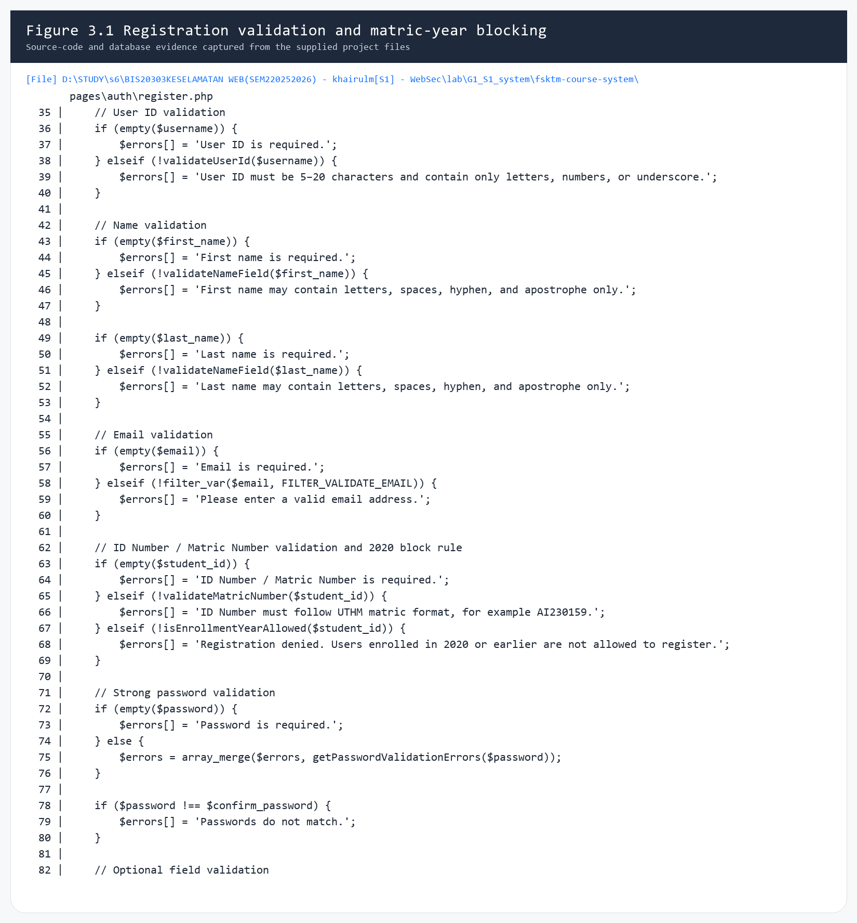
Evidence from register.php showing User ID validation, email validation, matric format validation, and the rule that blocks users enrolled in 2020 or earlier.

3.7 Password Hash and Salt Testing
The user table and registration flow were reviewed to confirm that passwords are never stored in plaintext. The registration process uses password_hash() with bcrypt-compatible output, and authentication uses password_verify() during login.
Because bcrypt embeds a salt into the resulting hash, the stored password value is suitable for secure storage.

3.8 Google reCAPTCHA Testing
The login module includes Google reCAPTCHA verification before credential checking is allowed to proceed. If the CAPTCHA response is missing or invalid, the login request is rejected and an appropriate message is shown.
This provides additional protection against automated login attempts.

3.9 SQL Injection Testing
The login, registration, user management, and course management flows were reviewed for SQL injection protection. These modules use prepared statements with parameter binding instead of concatenating raw user input into SQL strings.
This means common payloads such as ' OR '1'='1 are treated as data rather than executable SQL.

3.10 Cross-Site Scripting Testing
Display points for user and course data were reviewed for output encoding. The system uses htmlspecialchars() through helper functions such as e() and ucp_e() before rendering values back into HTML.
This prevents stored or reflected script payloads from executing in the browser when unsafe input is displayed.

3.11 Account Lockout Testing
The login logic records failed attempts for existing accounts by updating failed_login_attempts and locked_until in the users table. Once the maximum failed-attempt threshold is reached, the account is temporarily locked.
This reduces the risk of repeated password guessing against a known account.

3.12 Browser / Client Lockout Testing
The system also tracks repeated failed login attempts from the same browser or client using a hashed client key stored in the login_attempt_locks table. When the threshold is reached, further login attempts from that client are blocked until the lock expires.
This protection still applies even when the attacker uses non-existing usernames.
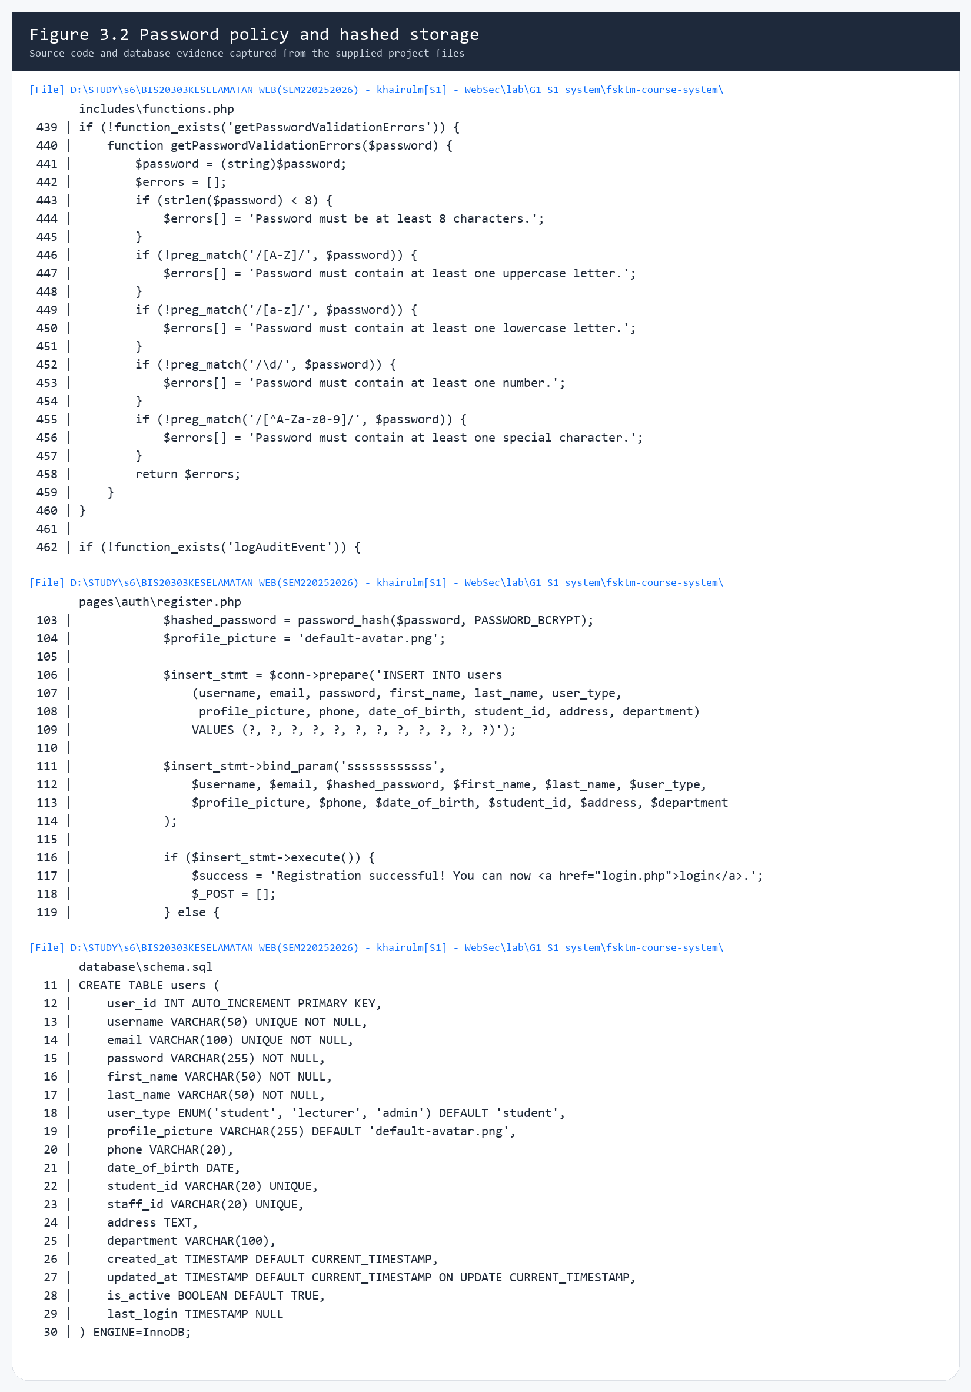
Evidence from functions.php, register.php, and schema.sql showing the password complexity rules, bcrypt-based password hashing, and the database password column used for hashed storage.
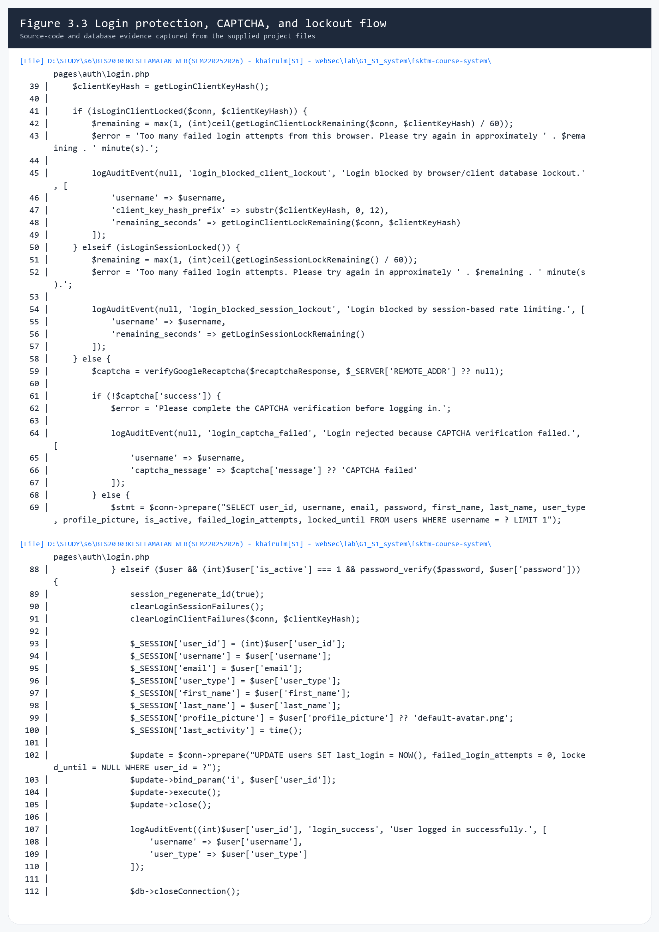
Evidence from login.php showing browser/client lockout checks, session-based rate limiting, Google reCAPTCHA verification, password_verify(), and session_regenerate_id(true).

3.13 Session Management Testing
After a successful login, the application stores the authenticated session and updates the last activity timestamp. Protected pages check whether a valid session exists before granting access.
The session ID is regenerated after successful authentication, which helps reduce session fixation risk.

3.14 Session Timeout Testing
The system defines a session inactivity timeout through SESSION_TIMEOUT_SECONDS. When the inactivity period is exceeded, the active session is destroyed and the user is redirected to the login page with a session-expired warning.
This prevents old sessions from remaining active indefinitely.

3.15 Logout and Session Destruction Testing
The logout module clears the session data, invalidates the session cookie, destroys the session, and redirects the user to the login page. Cache-control headers are also sent to reduce the chance of protected pages being restored from browser history.
This confirms that logout closes the authenticated session cleanly.

3.16 Broken Access Control Testing
Role-based access checks were reviewed across admin, student, and lecturer routes. Admin-only pages and APIs check both authentication state and user role before processing requests.
This prevents a normal student account from browsing directly to administrator functions or calling privileged APIs.
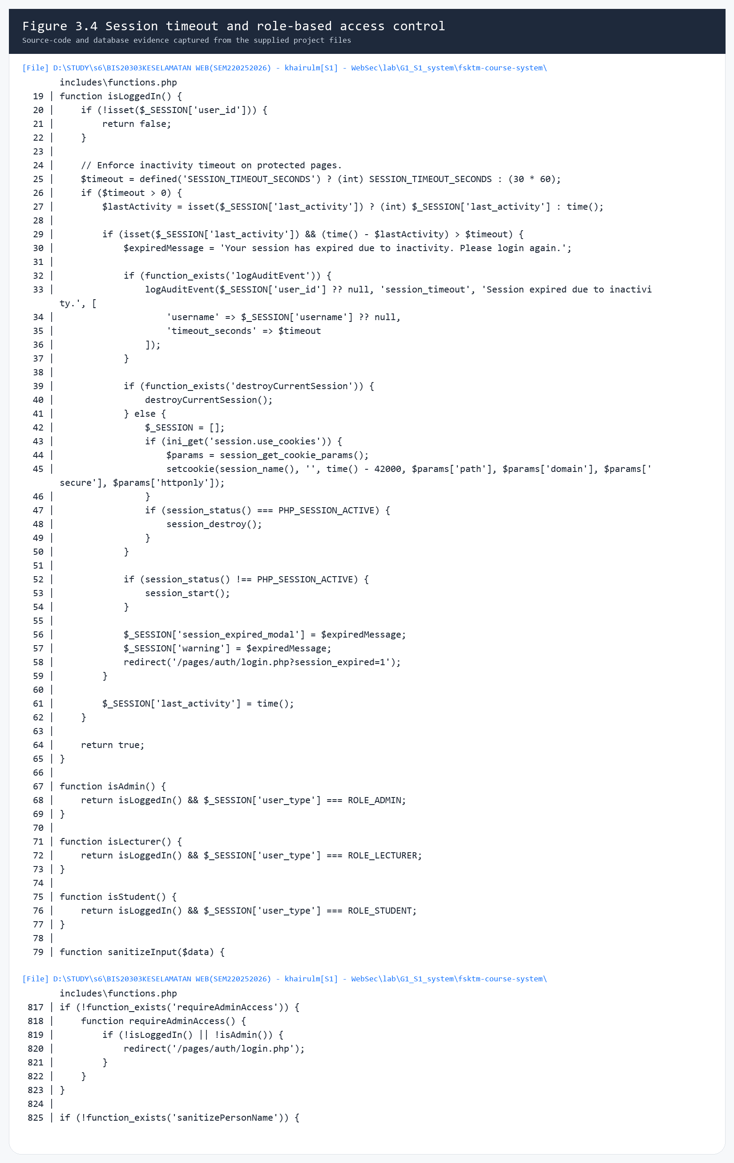
Evidence from functions.php showing session timeout handling, role helper functions, and the reusable administrator access requirement used by privileged pages.

3.17 HTTPS / SSL Testing
The .htaccess configuration includes HTTP-to-HTTPS redirection and multiple browser security headers such as X-Frame-Options, X-Content-Type-Options, Referrer-Policy, Permissions-Policy, and Content-Security-Policy.
These settings improve transport security and reduce several browser-based attack surfaces.
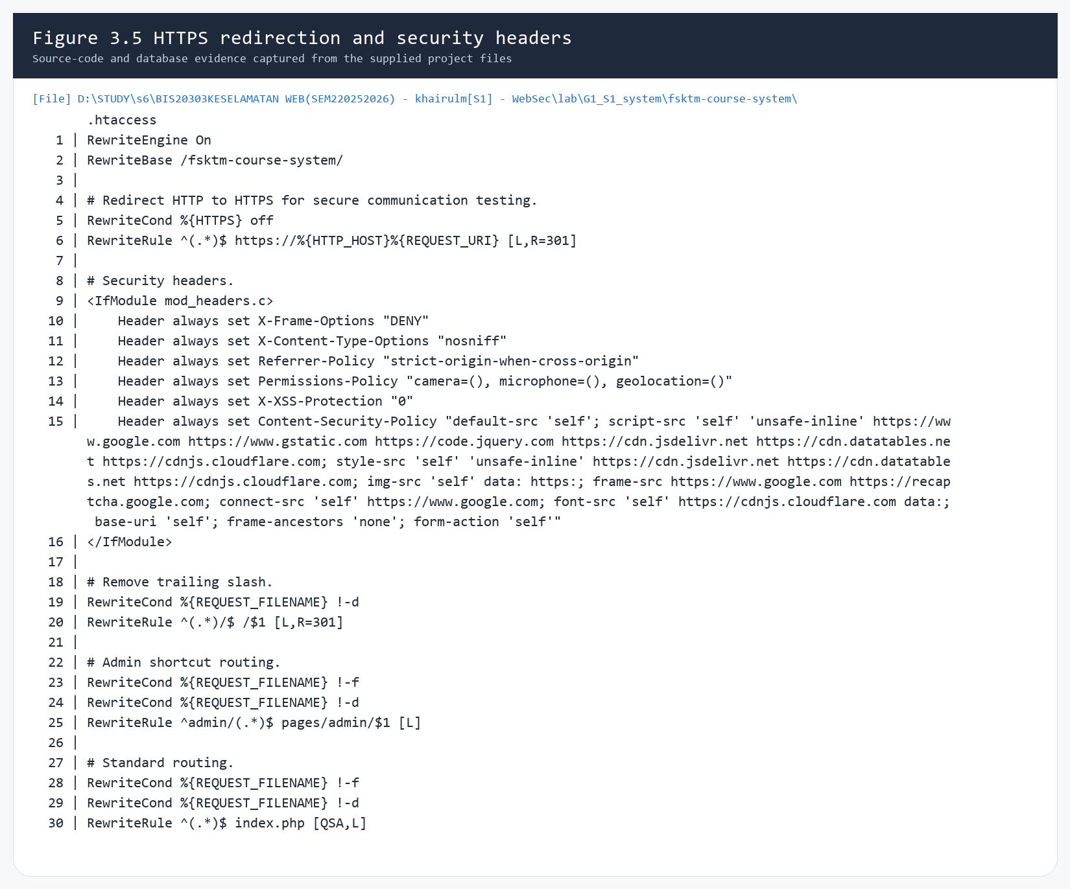
Evidence from .htaccess showing HTTP-to-HTTPS redirection and the configured browser security headers, including X-Frame-Options, X-Content-Type-Options, Referrer-Policy, Permissions-Policy, and Content-Security-Policy.

3.18 Audit Log Testing
The project records security-relevant events in the audit_logs table through the logAuditEvent() helper. Logged events include login success, login failure, CAPTCHA failure, lockout, session timeout, and administrator actions.
This provides traceability for security monitoring and later investigation.
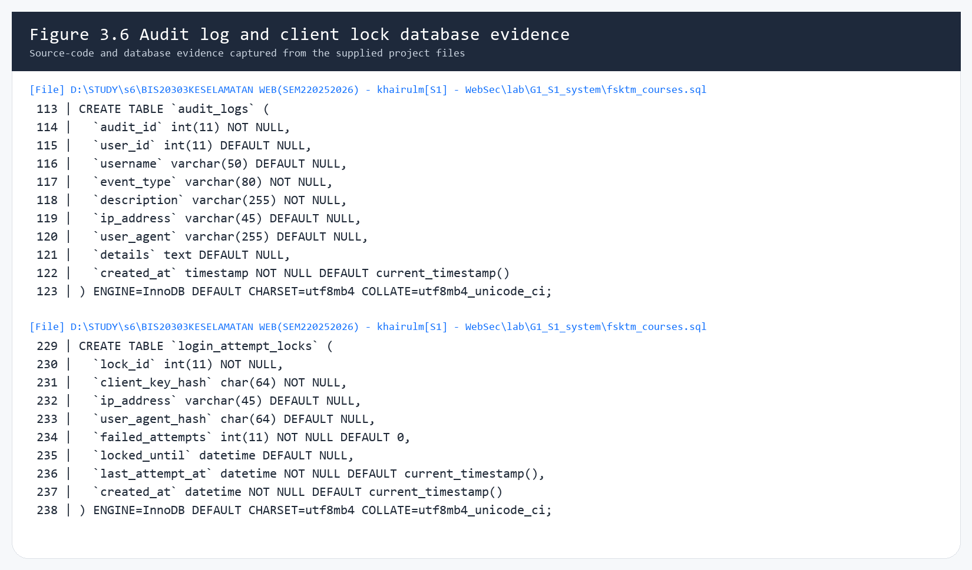
Evidence from fsktm_courses.sql showing the audit_logs table and the login_attempt_locks table used for event recording and browser or client lockout tracking.

3.19 Admin User Management Testing
The administrator user-management module was reviewed for validation, authorization, password reset handling, self-protection controls, and audit logging. The module validates user data server-side, prevents an administrator from deleting or deactivating their own account, and hashes temporary passwords before storage.
This confirms that the user-management feature follows the same security rules as public registration and login.
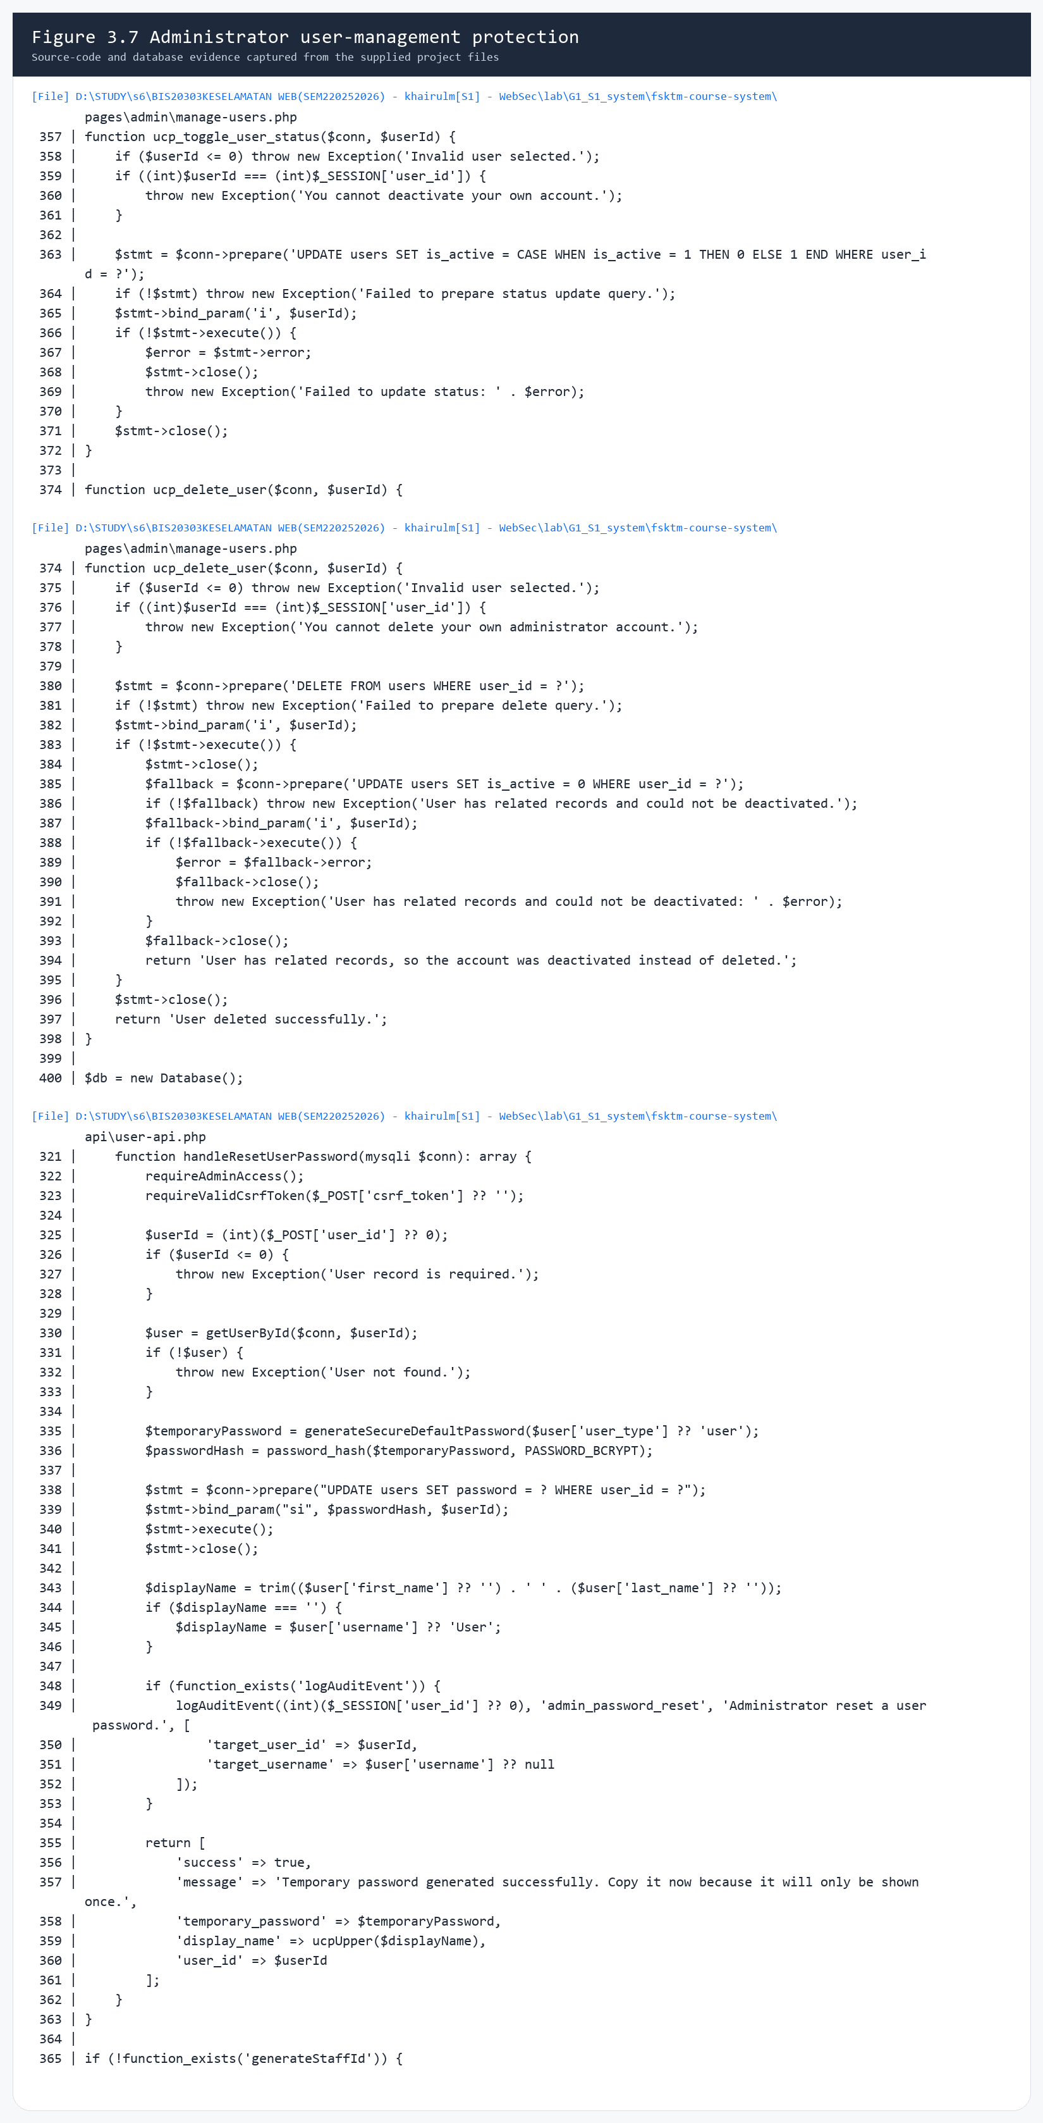
Evidence from manage-users.php and user-api.php showing self-delete and self-deactivate protection, hashed temporary passwords, and audit logging for administrator-driven user actions.

3.20 Course Management Testing
The administrator course-management module was reviewed for duplicate-code checking, prepared statements, authorization checks, and audit logging. Adding and updating courses is done through prepared statements, while deletion is restricted when active registrations already exist.
This confirms that the course module protects both data integrity and backend query safety.
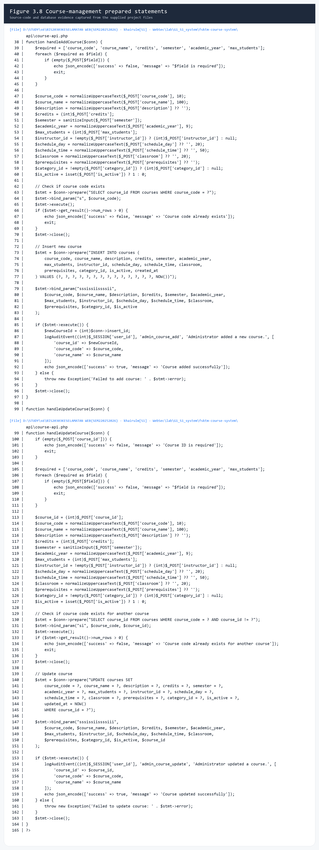
Evidence from course-api.php showing duplicate-course checks, prepared statements, parameter binding, and audit logging for add and update course operations.

Screenshot List
Figure | Purpose
Figure 3.1 | Evidence from register.php showing User ID validation, email validation, matric format validation, and the rule that blocks users enrolled in 2020 or earlier.
Figure 3.2 | Evidence from functions.php, register.php, and schema.sql showing the password complexity rules, bcrypt-based password hashing, and the database password column used for hashed storage.
Figure 3.3 | Evidence from login.php showing browser/client lockout checks, session-based rate limiting, Google reCAPTCHA verification, password_verify(), and session_regenerate_id(true).
Figure 3.4 | Evidence from functions.php showing session timeout handling, role helper functions, and the reusable administrator access requirement used by privileged pages.
Figure 3.5 | Evidence from .htaccess showing HTTP-to-HTTPS redirection and the configured browser security headers, including X-Frame-Options, X-Content-Type-Options, Referrer-Policy, Permissions-Policy, and Content-Security-Policy.
Figure 3.6 | Evidence from fsktm_courses.sql showing the audit_logs table and the login_attempt_locks table used for event recording and browser or client lockout tracking.
Figure 3.7 | Evidence from manage-users.php and user-api.php showing self-delete and self-deactivate protection, hashed temporary passwords, and audit logging for administrator-driven user actions.
Figure 3.8 | Evidence from course-api.php showing duplicate-course checks, prepared statements, parameter binding, and audit logging for add and update course operations.

