Heuristic Analysis

1) Custom Score 1

Score: Own_move / (Opponent_move+0.01)

This approach assess how well this move will increase the (own move)/(opponent move) ratio. Which not only measuring the absolute difference between number of own move and opponent moves, but also measure the relative difference. The reason I use a constant of 0.01 is because if a move eliminates the opponent to zero, the division will be invalid, a constant can off set this. This constant should be close to 0, and 0.01 is very sufficient for this purpose. Other small constant will work as well. If the opponent move become zero, the score will become 100 times the number of own move, which is very large number to indicate this is a winning move.

2) Custom Score 2

Score: Sum of available own moves after all possible actions.

This heuristic not only search the available own moves for the current board, but it also search one move further. For any given board, it find out all the possible moves, and for each possible move, it calculate the number of available secondary level moves after this move. In the end it sum up the number of all the secondary level moves as the score.

3) Custom Score 3

Score: Blank spaces – Sum of opponent moves for all possible actions

This heuristic is similar to the custom score 2. The only difference is that, instead of summing up all the secondary level own moves, it sums up all the secondary level (blank spaces – opponent moves) as the score.

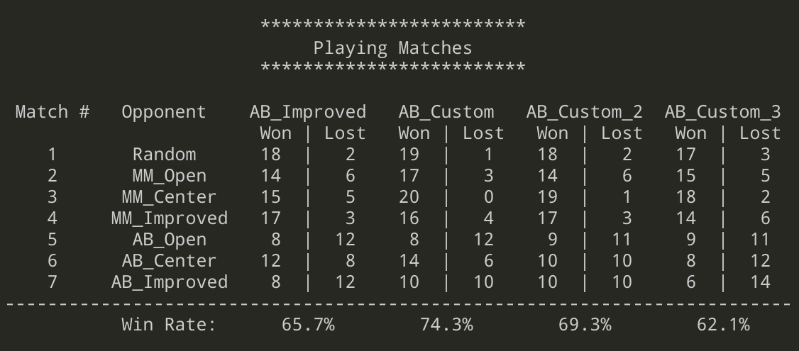

Analysis:

1) Overall the Custom score method #1 has a highest win rate among all heuristics. Its win rate (74.3%) is higher than the AB_Imporved (65.7%).

2) The AB_Improved only measure the difference between own moves and opponent move, but in my ultimate heuristic, it takes into account that how significantly a move is going to reduce the opponents’ move.

For example, in a case (A) where own moves is 4, and number of opponent move is 2, while case (B) has an own move of 3 and opponent move of 1. By using the AB_Improved, the difference between own move and opponent move are both 2. But using my ultimate heuristic, case (B) is better than case (A), because (B) limits the opponents’ move to one third of its own move. This heuristic not only taking the difference between own move and opponent move into account, but also considers how significantly the move change the (own move)/(opp move) ratio, which maximizes the chances of winning.

3) Compare to the other 2 custom scores, given the possible moves as n, the complexity of custom score 1 is O(n) while custom score 2 and 3 is O(n^2) since they search one level further. Custom score 1 is also better considering the complexity.