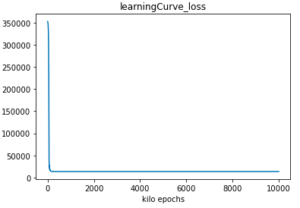1.(b)

|  |  |
| --- | --- |
| network architecture | 16-32-32-16-8-2 |
| training RMS error | 5.61 |
| testing RMS error | 5.05 |

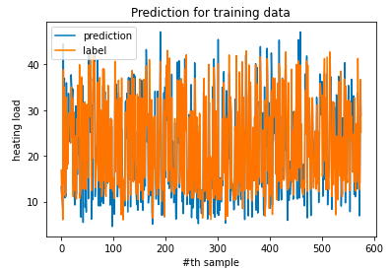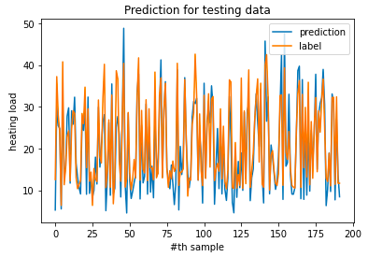

1.(c) now, use only one feature.

|  |  |
| --- | --- |
| Only use feature i | Rmse |
| 0 | 10.27 |
| 1 | 9.91 |
| 2 | 19.58 |
| 3 | 3.50 |
| 4 | 7.73 |
| 5 | 19.58 |
| 6 | 19.57 |
| 7 | 9.80 |

Says that feature 3 influence the energy load significantly.

2.(b)-1

|  |  |
| --- | --- |
| network architecture | 34-32-32-32-16-2-1 |
| training RMS error | 137.46384934448383 |
| testing RMS error | 39.84352940287776 |

2.(b)-2

|  |  |
| --- | --- |
| network architecture | 34-32-32-32-16-3-1 |
| training RMS error | 166.4136425267278 |
| testing RMS error | 50.774510206073835 |

2.(c)-1 2.(c)-1

