Strict Reservation Objective Summary
Purpose: compare strict Class 1 reservation with pooled FCFS and study the reservation parameter Q.
Main capacity objective: booked-slot utilization. This is booked appointment slots on service days divided by available slots. No-shows count as booked slots; cancellations that free the slot before service do not.

Objective Functions Tested
- Booked-slot utilization: booked slots / available slots.
- Weighted booked-slot score: w1 times Class 1 booked-slot contribution plus Class 2 booked-slot contribution.
- Net booked-slot score: weighted booked-slot score minus c * Q / S.
- Served-rate scores remain diagnostics for access, not the main capacity objective.

Current Parameters
Main setting: w1 = 1.5, c = 0.05, w2 = 1. The sweep uses equal class arrival rates 20, 25, 35, and 50, with Class 1 advantaged, symmetric, and disadvantaged behavior cases.

Results So Far
At the symmetric baseline with lambda1=lambda2=25 and c=0.05, the best Q in the cached sweep is 24. The mean strict-minus-FCFS score difference is 0.0844, classified as win.
Across the best-Q rows for the headline setting, classifications are: loss: 1, win: 11.
Interpretation: booked-slot utilization directly shows whether strict reservation leaves protected capacity empty. It does not tell us whether booked slots became completed visits, so average completed-visit utilization should still be checked separately.

Figure 1
Net booked-slot score difference by Q and equal class arrival rate, using the symmetric behavior case and c = 0.05.
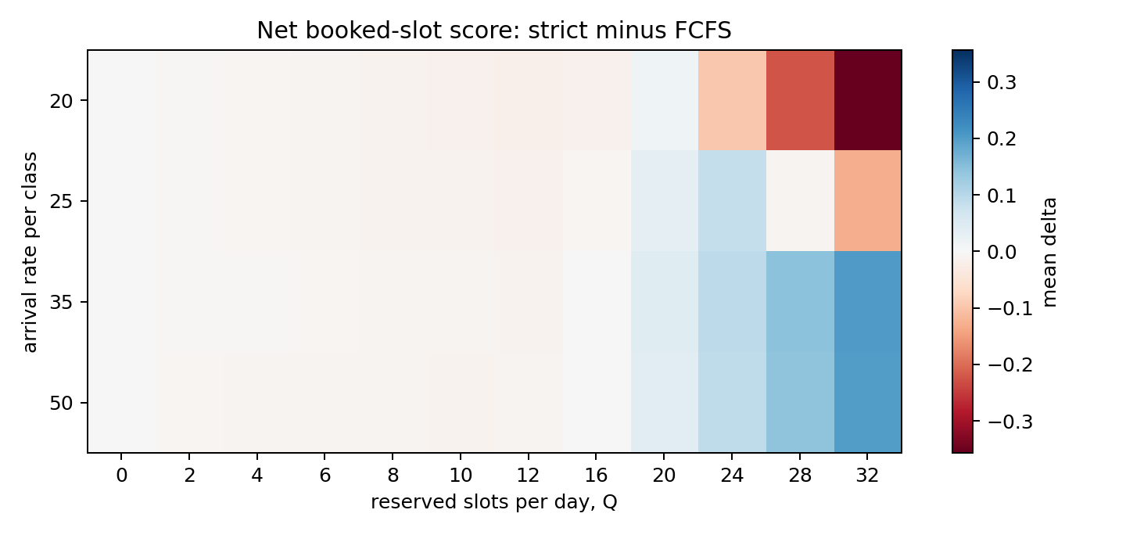

Figure 2
Sensitivity to the slot-cost penalty at lambda1=lambda2=25. Higher c makes large Q harder to justify.
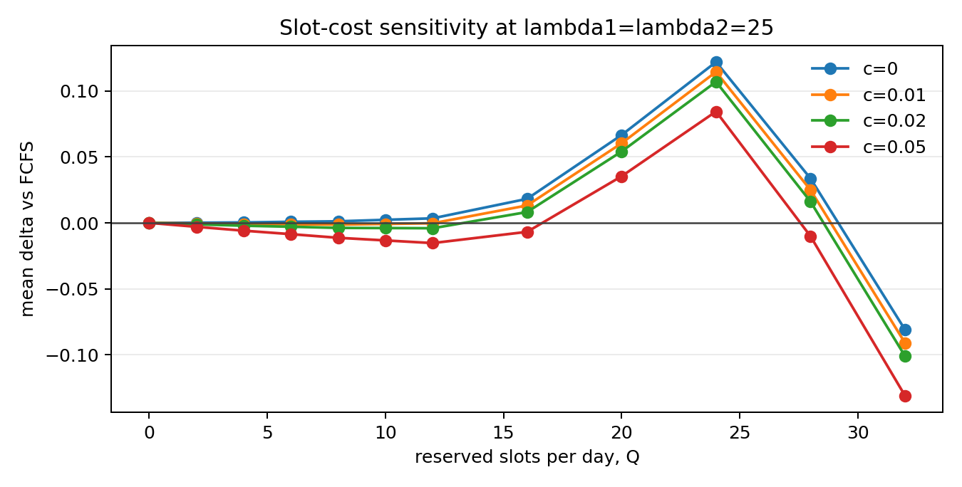

Next Step
Use notebook 12 to vary w1, c, demand, behavior case, and Q. Compare booked-slot results with served rate and completed-visit utilization before selecting a policy parameter.

