Strict Class 1 Reservation vs FCFS: Utilization, Service-Rate, and Waiting-Time Tradeoffs
Short preliminary decision memo for review

Executive Summary
- Bottom line: these 5-seed results are preliminary. Near the baseline, strict reservation does not beat FCFS on the utilization-first objective once the service-rate guardrail is checked.
- Baseline setting: lambda_1=lambda_2=25, total lambda=50, S=32 slots/day, H=14 days, seeds 5101-5105.
- Study A objective is U_util = rho^booked. At baseline it selects Q=0; strict-minus-FCFS booked utilization is +0.000; feasible=True.
- Study B objective is U_wait_util with w1=1.5, c=0.05, gamma=0.05. At baseline it selects Q=0; strict-minus-FCFS utility is +0.000; feasible=True.
- The wait penalty does not change the selected baseline Q relative to Study A.
- Service-rate guardrails matter: cells marked with x in the heatmaps fail min(served_rate_1, served_rate_2) >= 0.55 and should not be interpreted as operational wins.
- Across the 12 demand/behavior scenarios, the two studies select the same Q in 4 cases. Differences mostly occur when wait reduction and Class 1 priority favor large Q but the service-rate guardrail flags infeasibility.
- Decision point: decide whether booked-slot utilization is the right primary capacity target, or whether completed visits and Class 2 access should receive stronger constraints before choosing Q.

1. What The Policy Changes
Pooled FCFS uses one common appointment pool. Strict Class 1 reservation protects Q slots per day for Class 1. Class 1 can use protected slots first and then general slots. Class 2 can only use general slots. Unused protected slots remain empty.
The objective functions in this memo are after-the-fact scoring rules. They do not change the simulation policy.

2. Why Utilization Alone Is Not Enough
Booked utilization rho^booked measures whether service-day appointment slots were booked. It includes no-shows because those slots were occupied on the schedule. Attended utilization rho^attended measures completed visits. Served rate measures completed visits divided by arrivals.
A high booked-utilization value can still be unacceptable if one class has poor service. For that reason, all best-Q decisions are checked against min(served_rate_1, served_rate_2) >= 0.55.

3. Study A: Utilization-First With Guardrails
Main objective used to choose Q:
U_util = rho^booked = booked service-day slots / available measured slots
The guardrail is not part of the score; it determines whether the selected Q is operationally acceptable.
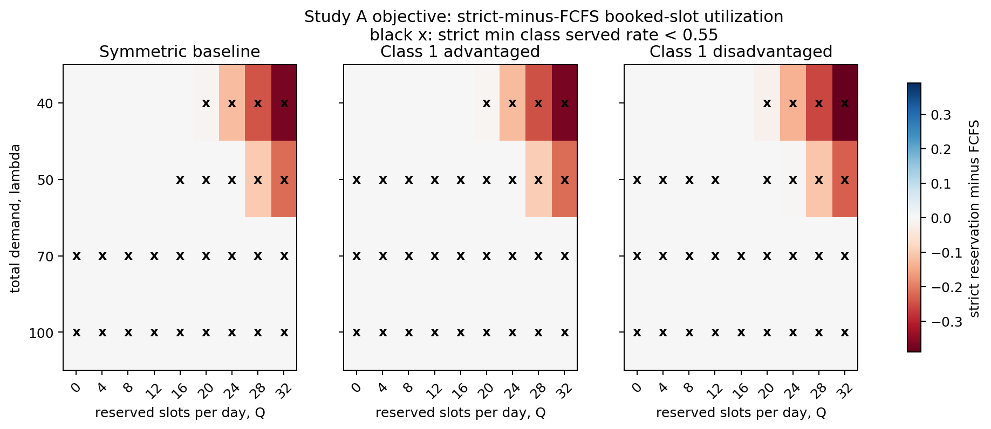
Figure 1. Study A objective: strict-minus-FCFS booked-slot utilization. Black x marks cells where the strict-reservation run violates the served-rate threshold.

4. Study B: Wait-Adjusted Utility With Guardrails
Main objective used to choose Q:
U_wait_util = U_weighted_booked(w1,w2) - c Q/S - gamma tau_bar_w/H, with w1=1.5, w2=1.0, c=0.05, gamma=0.05.
This score rewards booked capacity, gives Class 1 extra weight, penalizes protected capacity, and penalizes longer offered waits.
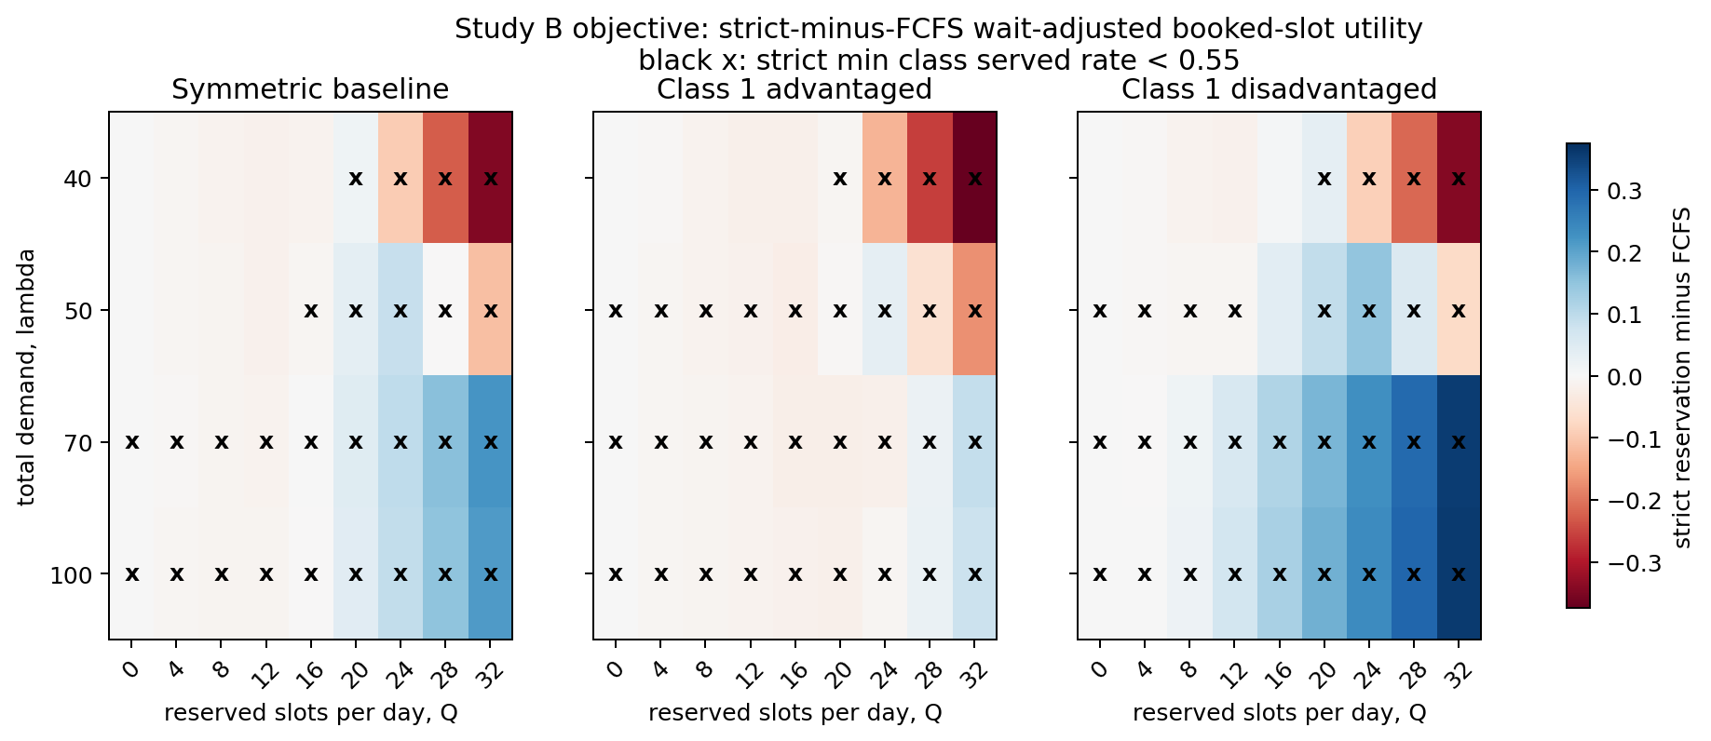
Figure 2. Study B objective: strict-minus-FCFS wait-adjusted booked-slot utility. Black x marks cells where the strict-reservation run violates the served-rate threshold.

5. Preliminary Results And Best-Q Comparison
Baseline policy comparison:
policy | Q | booked utilization | attended utilization | Class 1 served rate | Class 2 served rate | minimum class served rate | average offered delay | Study A objective | Study B objective | feasible under served-rate threshold?
Pooled FCFS | 0 | 1.000 | 0.912 | 0.586 | 0.583 | 0.582 | 5.419 | 1.000 | 1.233 | yes
Study A/B selected Q=0 (same booking rule as FCFS) | 0 | 1.000 | 0.912 | 0.586 | 0.583 | 0.582 | 5.419 | 1.000 | 1.233 | yes
Strict reservation, smallest positive Q=4 | 4 | 1.000 | 0.912 | 0.587 | 0.582 | 0.582 | 5.419 | 1.000 | 1.227 | yes
Best-Q comparison by study:
scenario | best Q under Study A | Study A feasible? | best Q under Study B | Study B feasible? | do studies agree? | main reason if they differ
Symmetric baseline, lambda=40 | 0 | yes | 0 | yes | yes | same selected Q
Symmetric baseline, lambda=50 | 0 | yes | 0 | yes | yes | same selected Q
Symmetric baseline, lambda=70 | 0 | no | 32 | no | no | wait/cost penalty changes ranking
Symmetric baseline, lambda=100 | 0 | no | 32 | no | no | wait/cost penalty changes ranking
Class 1 advantaged, lambda=40 | 0 | yes | 0 | yes | yes | same selected Q
Class 1 advantaged, lambda=50 | 0 | no | 24 | no | no | wait/cost penalty changes ranking
Class 1 advantaged, lambda=70 | 0 | no | 32 | no | no | wait/cost penalty changes ranking
Class 1 advantaged, lambda=100 | 0 | no | 32 | no | no | wait/cost penalty changes ranking
Class 1 disadvantaged, lambda=40 | 0 | yes | 16 | yes | no | wait/cost penalty changes ranking
Class 1 disadvantaged, lambda=50 | 16 | yes | 16 | yes | yes | same selected Q
Class 1 disadvantaged, lambda=70 | 0 | no | 32 | no | no | wait/cost penalty changes ranking
Class 1 disadvantaged, lambda=100 | 0 | no | 32 | no | no | wait/cost penalty changes ranking
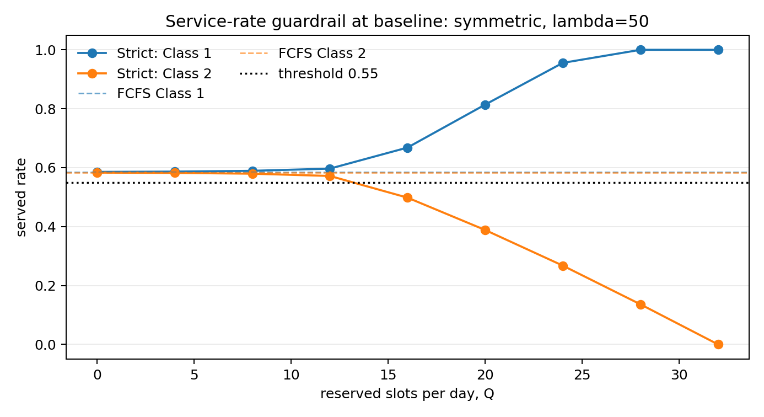
Figure 3. Service-rate diagnostic at the baseline scenario. Dashed lines are FCFS benchmarks; the dotted line is the 0.55 threshold.
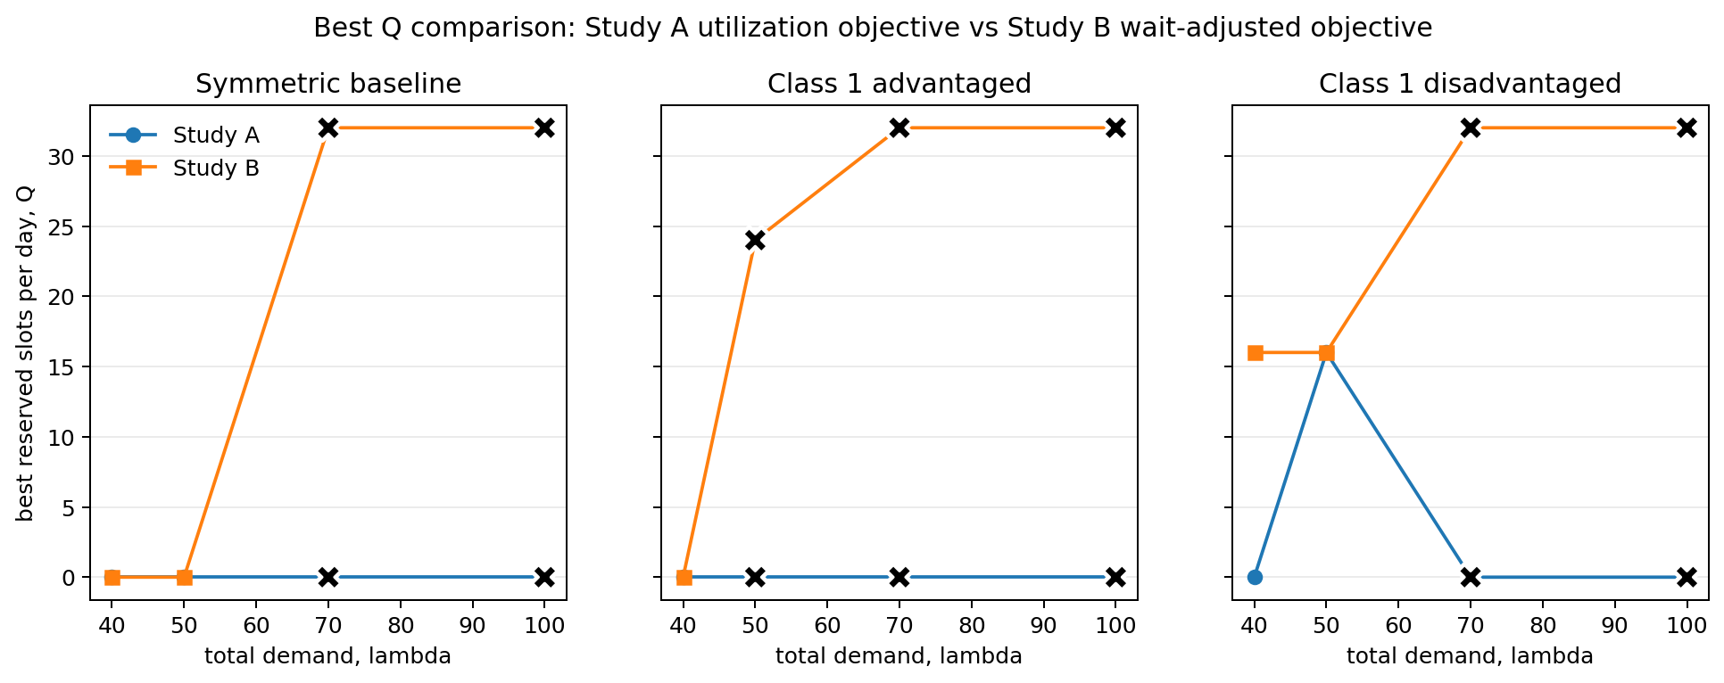
Figure 4. Best Q under each study. Black X markers with a white outline mark infeasible selected Q values.
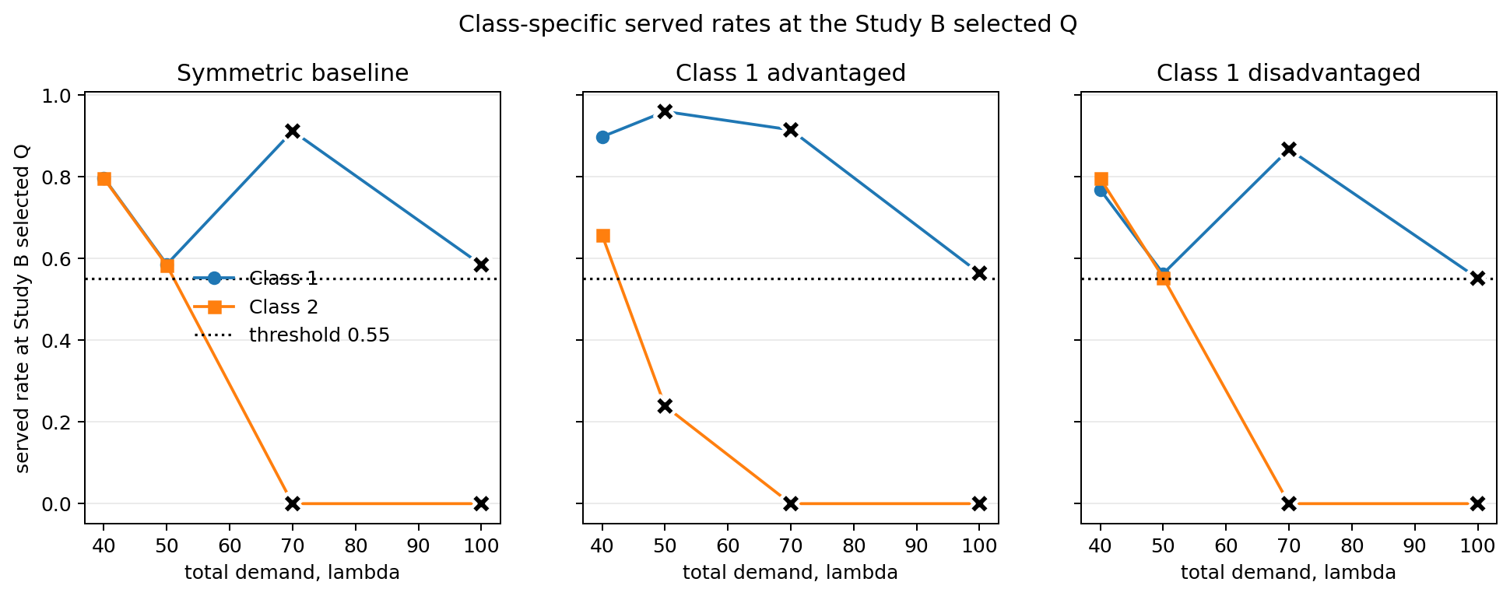
Figure 5. Class-specific served rates at the Study B selected Q. Class 1 and Class 2 are shown on the same axes; black X markers with a white outline mark infeasible selected Q values.
Summary comparison: the two studies agree in 4 of 12 scenarios. Study A is the more operationally defensible first-pass rule because it directly tests slot use and does not reward Class 1 access gains that come with large Class 2 service-rate losses. Study B is useful for studying priority and wait tradeoffs, but only after the service-rate guardrail is enforced.

6. Sensitivity To w1, c, gamma, And served_rate_min
study | w1 | c | gamma | served_rate_min | best Q | strict beats FCFS? | binding constraint or main failure mode
B: wait-adjusted | 1.500 | 0.000 | 0.000 | 0.550 | 12 | yes | none
B: wait-adjusted | 1.500 | 0.000 | 0.020 | 0.550 | 12 | yes | none
B: wait-adjusted | 1.500 | 0.000 | 0.050 | 0.550 | 12 | yes | none
B: wait-adjusted | 1.500 | 0.000 | 0.100 | 0.550 | 12 | yes | none
B: wait-adjusted | 1.500 | 0.050 | 0.000 | 0.550 | 0 | no | objective does not beat FCFS
B: wait-adjusted | 1.500 | 0.050 | 0.020 | 0.550 | 0 | no | objective does not beat FCFS
B: wait-adjusted | 1.500 | 0.050 | 0.050 | 0.550 | 0 | no | objective does not beat FCFS
B: wait-adjusted | 1.500 | 0.050 | 0.100 | 0.550 | 0 | no | objective does not beat FCFS
B: wait-adjusted | 1.500 | 0.100 | 0.000 | 0.550 | 0 | no | objective does not beat FCFS
B: wait-adjusted | 1.500 | 0.100 | 0.020 | 0.550 | 0 | no | objective does not beat FCFS
B: wait-adjusted | 1.500 | 0.100 | 0.050 | 0.550 | 0 | no | objective does not beat FCFS
B: wait-adjusted | 1.500 | 0.100 | 0.100 | 0.550 | 0 | no | objective does not beat FCFS
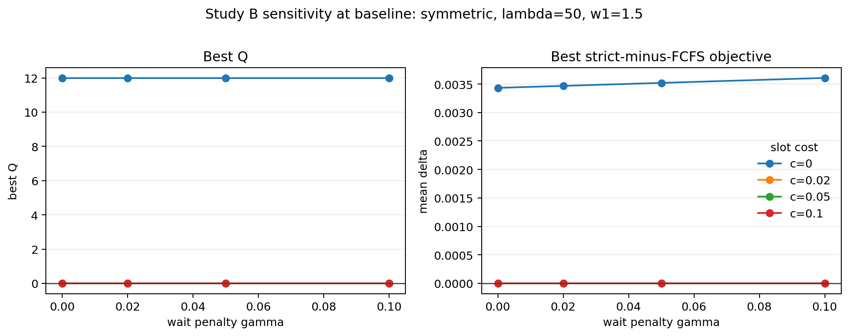
Figure 6. Study B sensitivity at the baseline scenario. The plotted objective is the best strict-minus-FCFS wait-adjusted utility for each gamma and slot-cost value.

7. Decision Points Before Finalizing
- Confirm whether the service-rate floor should be 0.55 or higher.
- Decide whether booked utilization is sufficient, or whether attended utilization should be a hard constraint because no-shows do not produce visits.
- Decide whether Class 2 service-rate loss should have its own explicit threshold.
- Rerun with more seeds before treating any Q recommendation as final.

Audit Notes
- Existing DOCX old-objective terms found: False.
- Old net-priority plot files found and not reused: True.
- booked_slot_utilization available in metrics layer/output: True.
- Class offered-delay totals available: True.
- Class service-rate guardrails computable: True.
- Each study uses exactly one main objective for best-Q selection.

