Strict Reservation Objectives: Baseline Results
Baseline: symmetric behavior, lambda_1=lambda_2=25, S=32, H=14, seeds 5101-5105

Purpose
We compare strict Class 1 reservation to pooled FCFS for different values of Q. In this memo, utilization means booked-slot utilization.

Objective Functions
1. Weighted utilization, to maximize:
U(Q) = w1 rho1(Q) + w2 rho2(Q)
2. Weighted waiting time, to minimize:
T(Q) = [w1 sum tau_offered,1(Q) + w2 sum tau_offered,2(Q)] / [w1 offered1(Q) + w2 offered2(Q)]
Current weights: w1=1.5, w2=1.
Served-rate check: flag any Q where Class 1 or Class 2 served rate is below 50%.

FCFS Reference
Policy | Q | Class 1 utilization contribution | Class 2 utilization contribution | Weighted utilization | Class 1 wait | Class 2 wait | Weighted wait | Class 1 served rate | Class 2 served rate
Pooled FCFS | 0 | 0.755 | 0.497 | 1.253 | 5.420 | 5.418 | 5.419 | 0.586 | 0.583

How To Read The Plots
The plots are intentionally visual. They do not select an optimal Q. Use the curves to decide where the objective looks strongest and compare that point to the dashed FCFS reference.
Black X markers show Q values where at least one class has served rate below 50%. Those points can still be inspected, but they should be treated as flagged.

Objective 1 Plot
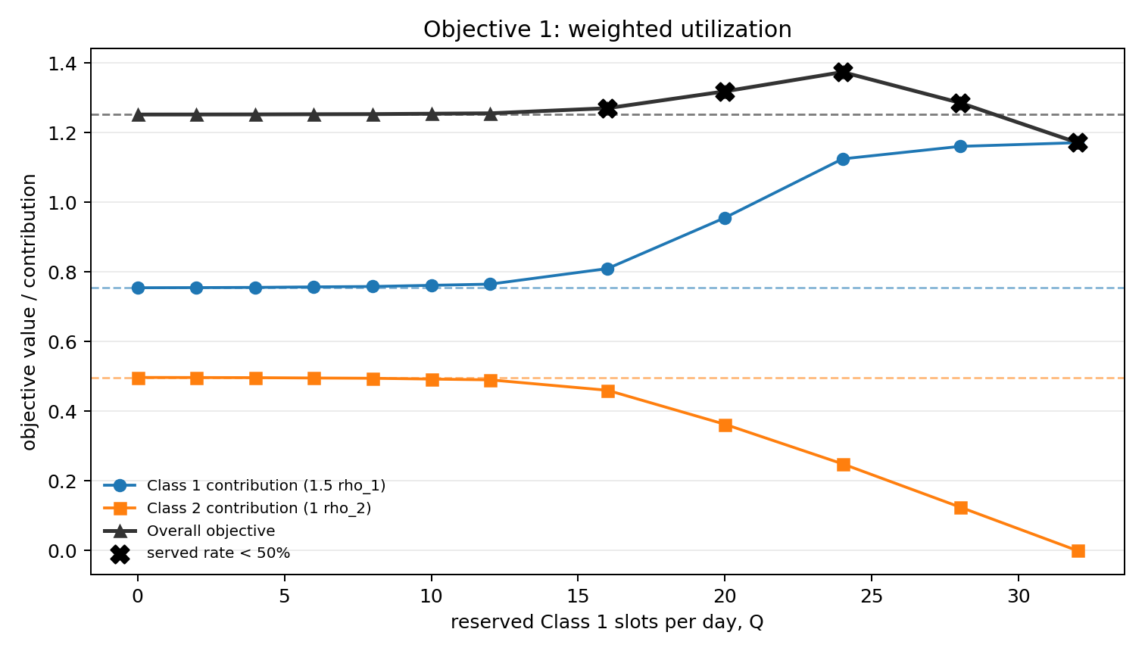
Class lines show each weighted utilization contribution. The overall line is U(Q)=w1 rho1(Q)+w2 rho2(Q). Dashed lines are FCFS references.

Objective 2 Plot
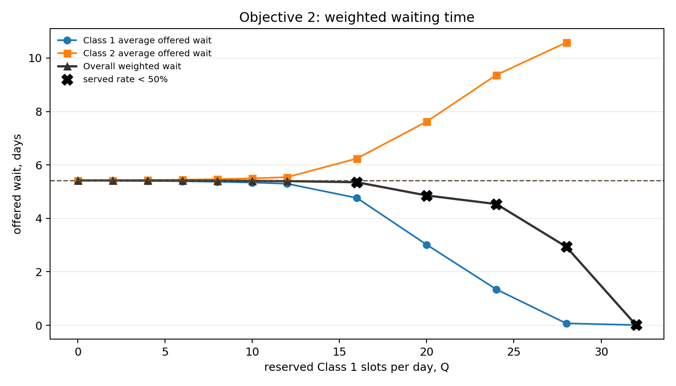
Class lines show average offered wait by class. The overall line is the weighted average offered wait T(Q). Lower values are better. Dashed lines are FCFS references.

Served-Rate Flags
Q | Class 1 served rate | Class 2 served rate | Minimum served rate
16 | 0.668 | 0.498 | 0.498
20 | 0.814 | 0.388 | 0.388
24 | 0.956 | 0.267 | 0.267
28 | 1.000 | 0.136 | 0.136
32 | 1.000 | 0.000 | 0.000

Data Snapshot
Q | U(Q) | T(Q) | Class 1 served rate | Class 2 served rate | Flag
0 | 1.253 | 5.419 | 0.586 | 0.583 | no
2 | 1.253 | 5.418 | 0.586 | 0.583 | no
4 | 1.253 | 5.416 | 0.587 | 0.582 | no
6 | 1.253 | 5.413 | 0.588 | 0.581 | no
8 | 1.254 | 5.409 | 0.589 | 0.579 | no
10 | 1.255 | 5.404 | 0.593 | 0.576 | no
12 | 1.256 | 5.395 | 0.597 | 0.572 | no
16 | 1.271 | 5.352 | 0.668 | 0.498 | yes
20 | 1.319 | 4.857 | 0.814 | 0.388 | yes
24 | 1.374 | 4.535 | 0.956 | 0.267 | yes
28 | 1.286 | 2.938 | 1.000 | 0.136 | yes
32 | 1.172 | 0.009 | 1.000 | 0.000 | yes

Next Step
Repeat the same two objective plots and tables across equal arrival rates (lambda_1=lambda_2 in 20, 25, 35, 50) to see how demand changes the shape of the curves and the served-rate flags.

