Strict Reservation Visual Objectives
Baseline: symmetric behavior, lambda_1=lambda_2=25, S=32, H=14, seeds 5101-5105

Purpose
This memo is exploratory and visual, not a policy recommendation. It compares strict Class 1 reservation to pooled FCFS for different values of Q. It uses booked-slot utilization.

Objective Functions
In this memo, utilization means booked slots divided by available slots. The first function is weighted utilization:
U(Q) = w1 rho1(Q) + w2 rho2(Q)
The second function is weighted offered waiting time:
T(Q) = [w1 sum tau_offered,1(Q) + w2 sum tau_offered,2(Q)] / [w1 offered1(Q) + w2 offered2(Q)]
Current weights: w1=1.5, w2=1.
Served-rate flag: yes when the lower class served rate is below 50%.

Current Parameters
Scenario: symmetric baseline. Demand: lambda_1=lambda_2=25. Capacity: S=32 slots per day. Horizon: H=14 days. Seeds: 5101-5105. Q grid: 0, 4, 8, 12, 16, 20, 24, 28, 32.

How To Read The Plots
Dashed horizontal lines show the pooled FCFS reference. On the served-rate plot, black X markers are placed on the class line that is below 50%.
Weighted offered waiting time must be read together with served rates. A low offered waiting time is not necessarily good if it happens because one class stops receiving offers.

Figure 1. Weighted booked-slot utilization
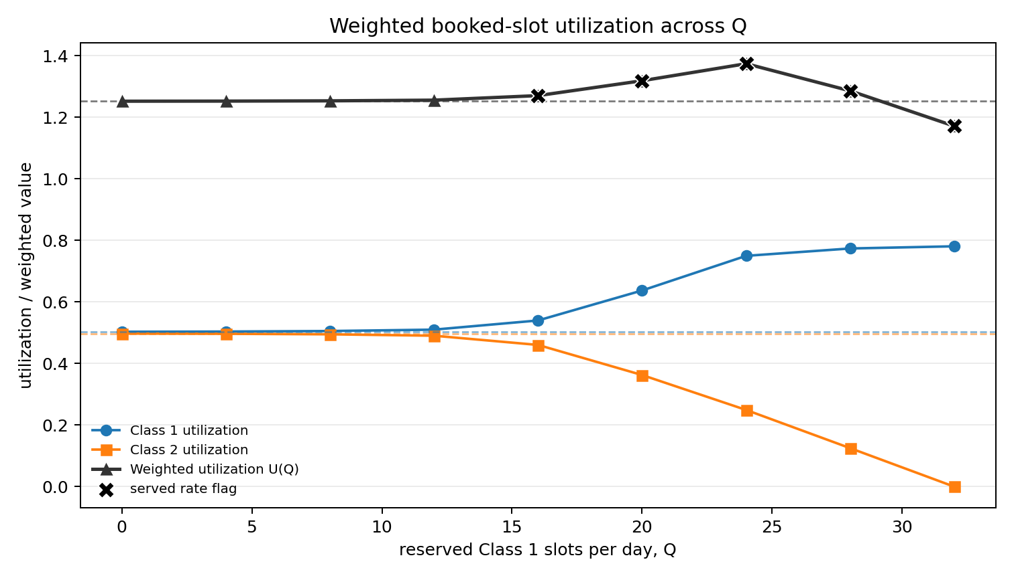
Class lines show raw utilization by class. The dark line shows U(Q). Dashed lines show the pooled FCFS reference.

Figure 2. Weighted offered waiting time
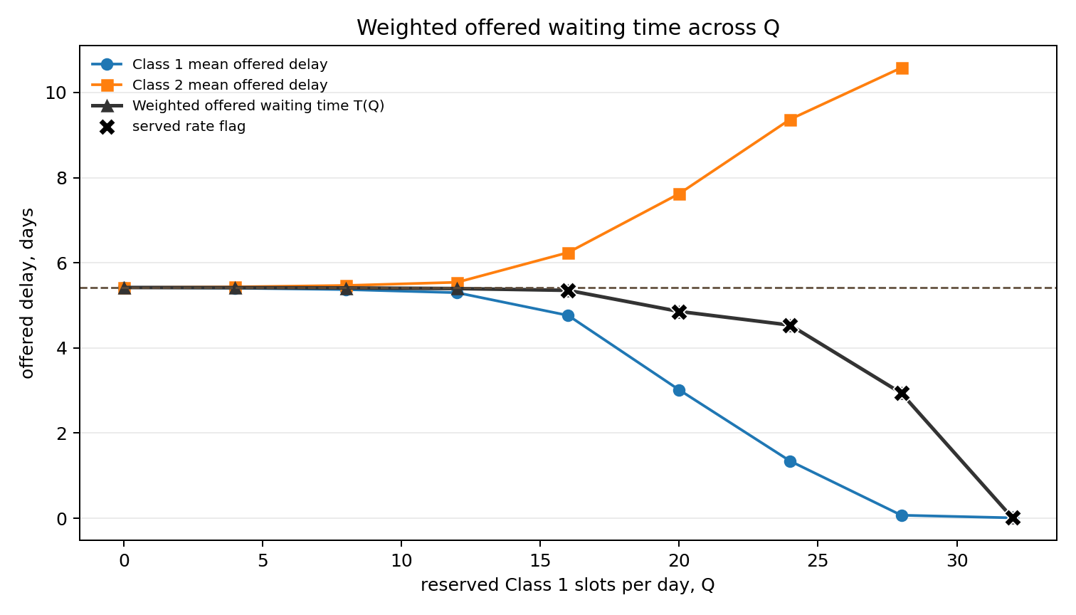
Class lines show mean offered delay by class. The dark line shows T(Q). Missing class delay values mean that class had no offered patients in that slice.

Figure 3. Served rates
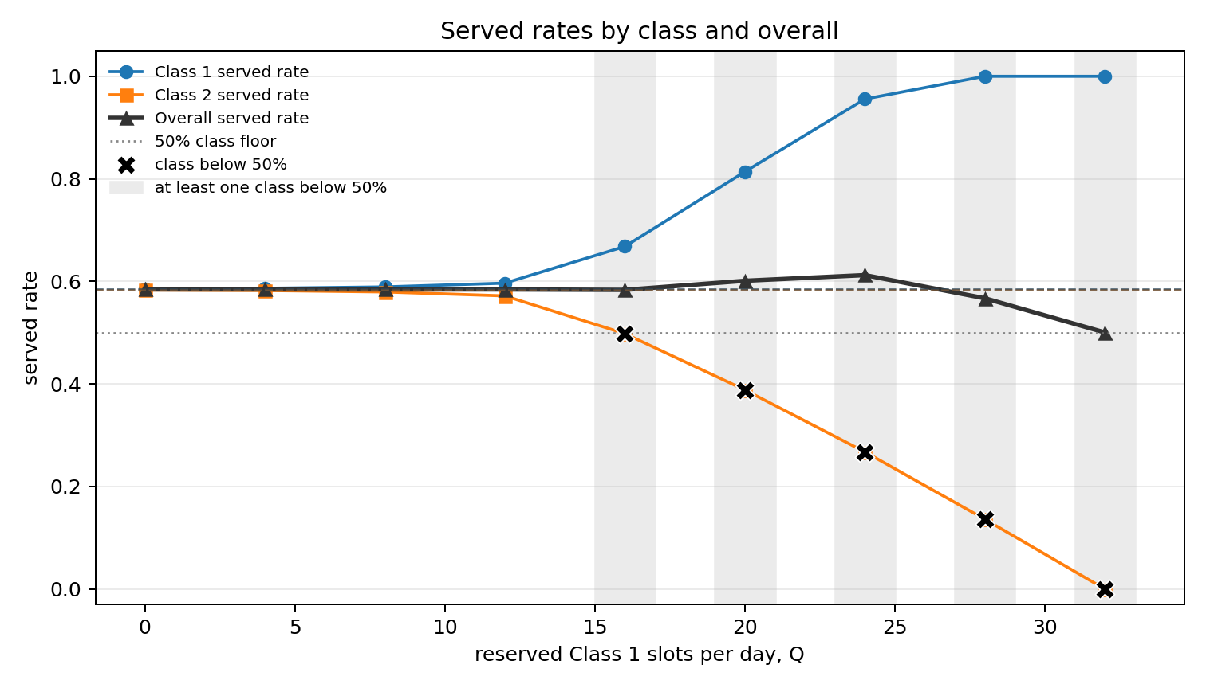
This plot shows why the waiting-time objective must be read with served rates. The overall served rate stays near or above 50%, but Class 2 service falls below 50% as Q increases.

Served-Rate Flag Table
Q | Class 1 served rate | Class 2 served rate | minimum class served rate | served-rate flag
0 | 0.586 | 0.583 | 0.582 | no
4 | 0.587 | 0.582 | 0.582 | no
8 | 0.589 | 0.579 | 0.579 | no
12 | 0.597 | 0.572 | 0.572 | no
16 | 0.668 | 0.498 | 0.498 | yes
20 | 0.814 | 0.388 | 0.388 | yes
24 | 0.956 | 0.267 | 0.267 | yes
28 | 1.000 | 0.136 | 0.136 | yes
32 | 1.000 | 0.000 | 0.000 | yes

Small Data Snapshot
Q | weighted utilization U(Q) | weighted offered waiting time T(Q) | Class 1 offered delay | Class 2 offered delay | served-rate flag
0 | 1.253 | 5.419 | 5.420 | 5.418 | no
4 | 1.253 | 5.416 | 5.404 | 5.434 | no
8 | 1.254 | 5.409 | 5.371 | 5.468 | no
12 | 1.256 | 5.395 | 5.298 | 5.542 | no
16 | 1.271 | 5.352 | 4.764 | 6.241 | yes
20 | 1.319 | 4.857 | 3.014 | 7.623 | yes
24 | 1.374 | 4.535 | 1.341 | 9.371 | yes
28 | 1.286 | 2.938 | 0.070 | 10.581 | yes
32 | 1.172 | 0.009 | 0.009 |  | yes

Next Step
Repeat the same visual analysis for equal arrival rates lambda_1=lambda_2 in 20, 25, 35, and 50.

