Question 1. In Figure 3 of [1], we tried to draw out the result in Figure 3 (b) from 3 (a) based on the Attractor algorithm. However, we could not get the same output as Figure 3(b) and we are wondering that maybe we make some mistakes due to misunderstanding of the algorithm. So, the detailed computation steps have been listed as follows, could you please give us some comments?
To simplify the problem, we only calculate the value change of one edge to illustrate our computation process as in below figure.
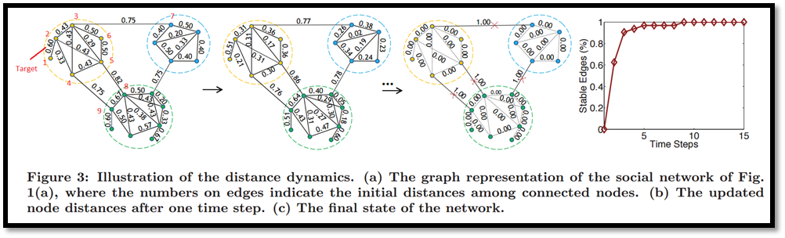
Figure 1. Computing Steps from [1]. Vertices related to target edge have been labeled with ID 1 to 9 and the target edge is (1, 2).

Question 2. In Algorithm 1 of [1], we are confused by the step “Initialization of distances” which is ranged from Line 2 to 11. In order to explain our puzzle clearly, a simple graph is used to show the computing process.
Below, it is the sample graph and snapshot of part in Algorithm 1 of [1].
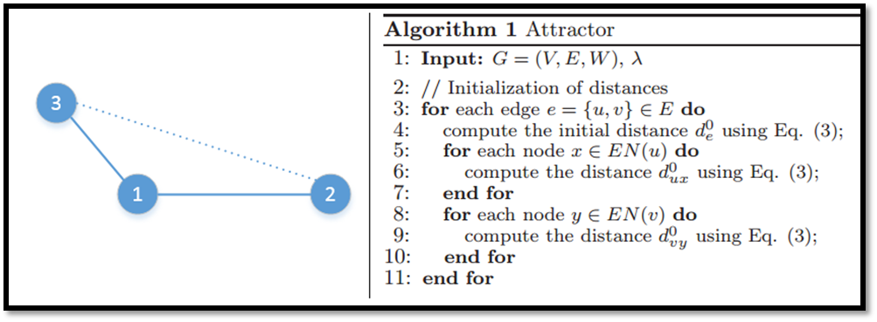
Figure 2. Illustration of algorithm. (a) Sample Graph. The solid lines are the actual edges, while the dash line is the virtual edge which is not in the topology of graph. (b) Initialization of distances in Algorithm 1.
Computing steps:
Initial States
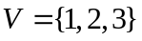, 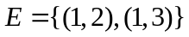
For edge 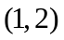:
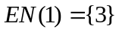, 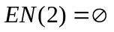.
Then, after compute the distance of edge, we need to calculate the distance between vertex of edge and corresponding 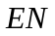.
Based on line 5 and line 6 in Figure 2(b), we need to calculate the distance of edge 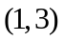 . However, this edge would be calculated later with the out loop because edgeis in edge . Then the edges are calculated duplicate with same value.
So, I am wondering whether it is a typo in line 6 and line 9. We need to change 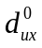 to 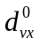 in line 6. And for line 9, it should also be changed. Then, it means that we would calculate the distance of the virtual edge shown in Figure 2(a) when execute line 6 and line 9.

Reference
[1]. Shao J, Han Z, Yang Q, et al. Community Detection based on Distance Dynamics[C]//Proceedings of the 21th ACM SIGKDD International Conference on Knowledge Discovery and Data Mining. ACM, 2015: 1075-1084.

