### **1. ER图（实体关系图）**

### erDiagram

### USER ||--o{ FILE : "1:N"

### USER ||--o{ SHARE : "1:N"

### USER ||--o{ RECYCLE : "1:N"

### USER {

### bigint id PK

### varchar(50) email

### varchar(50) nickname

### varchar(100) password

### varchar(10) salt

### bigint total_space

### bigint used_space

### datetime create_time

### datetime last_login_time

### tinyint status

### }

### FILE ||--o{ FILE : "1:N"

### FILE {

### bigint id PK

### bigint user_id FK

### bigint file_pid

### varchar(255) file_name

### varchar(10) file_type

### varchar(32) file_md5

### bigint file_size

### varchar(255) file_path

### tinyint folder_type

### tinyint status

### datetime create_time

### datetime update_time

### }

### SHARE ||--o{ SHARE_FILE : "1:N"

### SHARE {

### bigint id PK

### bigint user_id FK

### varchar(50) code

### tinyint valid_type

### datetime expire_time

### datetime create_time

### int view_count

### }

### SHARE_FILE {

### bigint id PK

### bigint share_id FK

### bigint file_id FK

### }

### RECYCLE {

### bigint id PK

### bigint user_id FK

### bigint file_id FK

### datetime delete_time

### }

### SYSTEM_CONFIG {

### varchar(50) key PK

### varchar(500) value

### }

### mermaid-diagram-2025-04-18-001857

### **2. 核心类图**

### classDiagram

### class User {

### +Long id

### +String email

### +String password

### +String nickname

### +Long totalSpace

### +Long usedSpace

### +login()

### +register()

### +resetPassword()

### }

### class File {

### +Long id

### +Long userId

### +String fileName

### +String fileMd5

### +Long fileSize

### +String filePath

### +upload()

### +download()

### +preview()

### +share()

### }

### class Share {

### +Long id

### +Long userId

### +String shareCode

### +Date expireTime

### +generateLink()

### +cancelShare()

### }

### class Recycle {

### +Long id

### +Long fileId

### +Date deleteTime

### +recover()

### +deletePermanently()

### }

### class AdminService {

### +manageUser()

### +updateSystemConfig()

### +auditFiles()

### }

### User "1" *-- "0..*" File

### User "1" *-- "0..*" Share

### User "1" *-- "0..*" Recycle

### Share "1" *-- "1..*" File

### AdminService --> User

### AdminService --> File

### mermaid-diagram-2025-04-18-001505

### **3.流程图**

### sequenceDiagram

### participant User

### participant Frontend

### participant Backend

### participant Storage

### User->>Frontend: 选择文件

### Frontend->>Backend: 预检查(MD5校验)

### Backend-->>Frontend: 返回秒传结果/需上传

### alt 需要上传

### Frontend->>Backend: 分片上传请求

### Backend->>Storage: 存储分片

### Backend-->>Frontend: 返回分片上传结果

### loop 所有分片

### Frontend->>Backend: 上传后续分片

### end

### Frontend->>Backend: 合并分片请求

### Backend->>Storage: 合并文件

### Backend->>Database: 保存文件元数据

### else 秒传

### Backend->>Database: 创建文件引用

### end

### Backend-->>Frontend: 上传完成

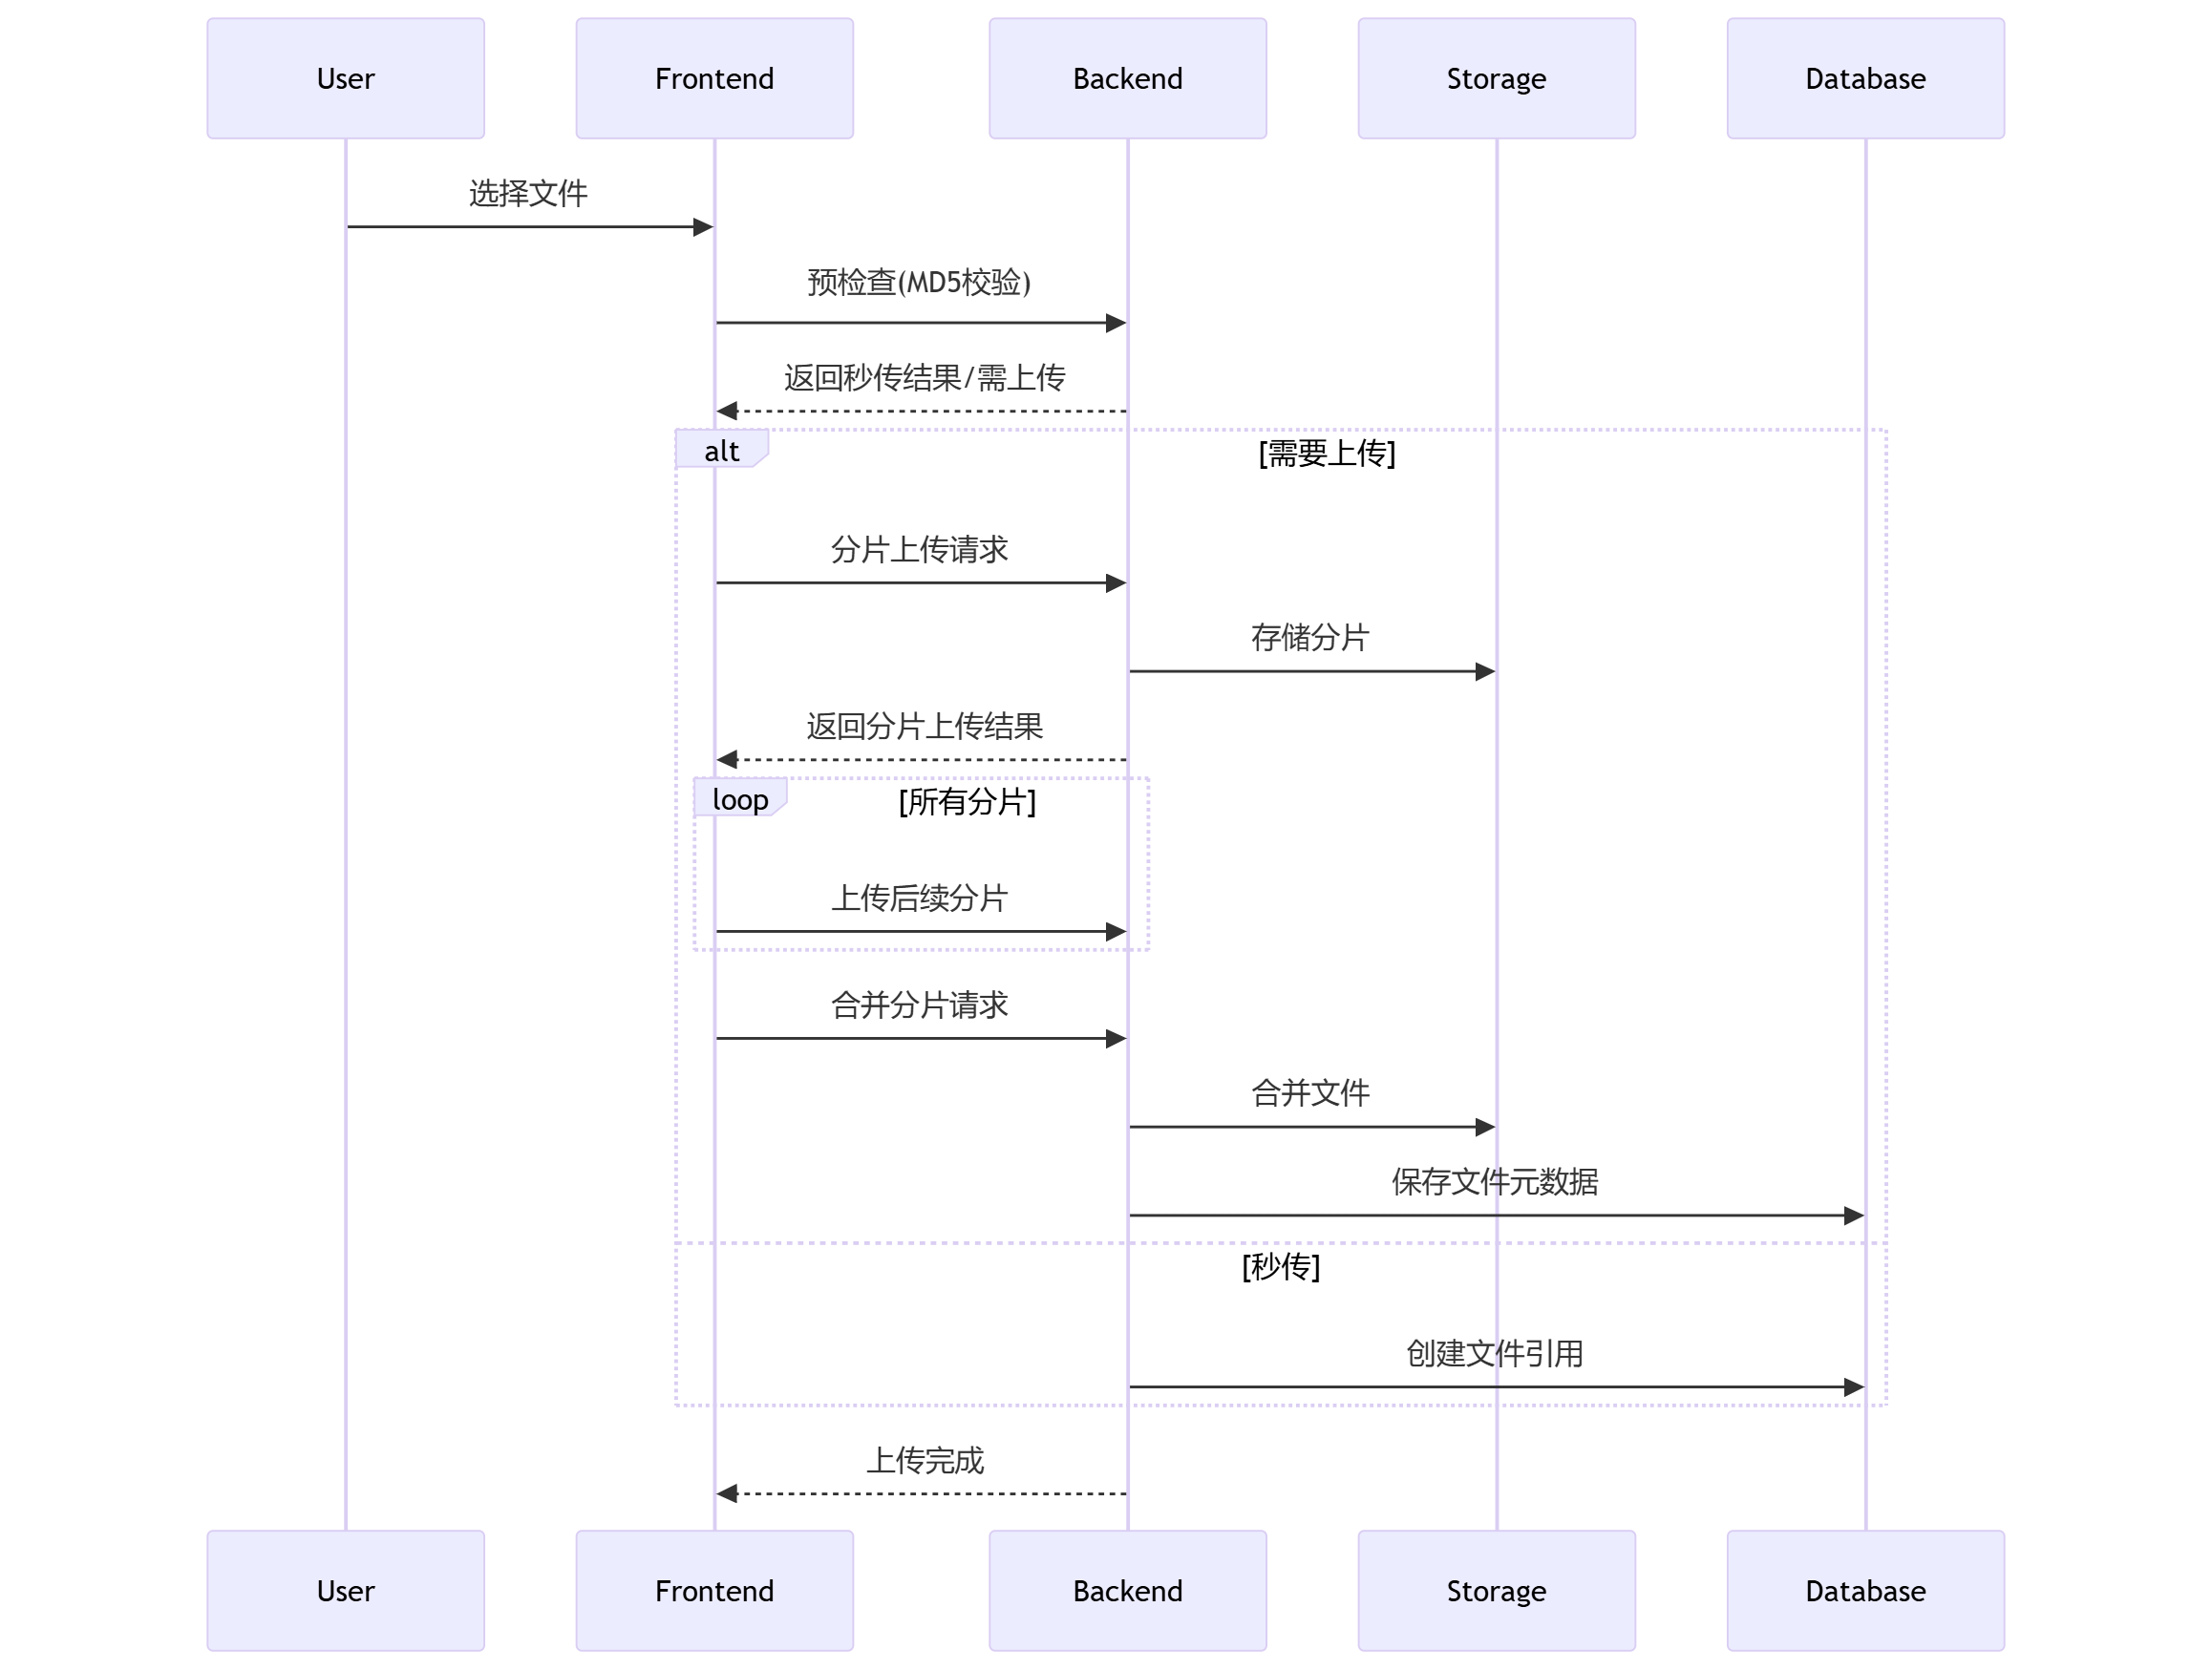

### **4.数据字典**

