### CSC125 – C# Programming

### Chapter 1: Intro to Visual Studio Assignment

#### Purpose

The purpose of this assignment is to show me that you have a working MS Visual Studio environment.

#### Instructions

Watch the “IntrotoVisualStudio.mp4” video. Create your first Windows Form App. Include the following on the form:

* A label that contains your name as the text
* A button that has a click event associated with it. When you click on the button display a Message Box with some text
* Some color changes

#### When you are done

* Take a screenshot of your work. Something like this:

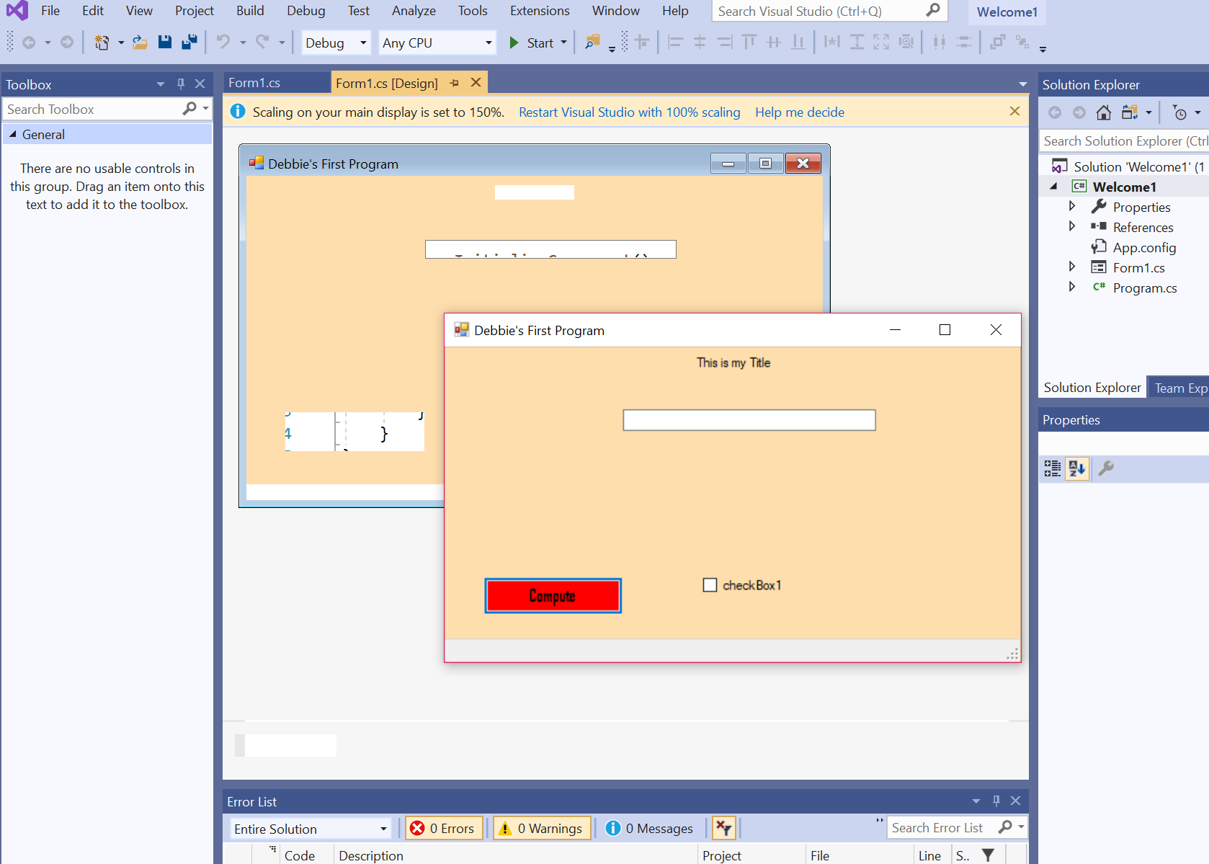

* Paste the screenshot in this document.
* Upload your Word document to Canvas.