Manual for EGFAnalysisTimeFreq Dispersion Software

Huajian Yao

University of Science and Technology of China
September, 19, 2015

This matlab GUI software is used for extract group and phase velocity dispersion curves from surface wave empirical Green’s function (EGF) or cross-correlation function (CF) from ambient noise. The dispersion analysis is based on an imaging analysis technique (Yao, van der Hilst, de Hoop, 2006, GJI; Yao et al., 2005, PEPI；Yao et al., 2011, C.R.Geoscience), which automatically traces the dispersion curve on the phase (or group) velocity-period image. The original image analysis for two-station phase velocity analysis was written when I was an undergraduate student at Univ of Science and Technology of China in 2001. Then this idea was used to process ambient noise derived EGF for phase velocity dispersion analysis when I was a graduate student at MIT in 2005. Since the development of Matlab (from version 5.3), I have rewritten this software for several times to enhance the efficiency and accuracy. The current version allows for individual, semi-automatic, and automatic dispersion analysis for both group and phase velocities. If there are any questions, comments, and bug reports, please feel free to email hjyao@ustc.edu.cn or huajianyao@gmail.com. Thank you.

1. Plot Panel

As shown in Figure 1, the top left figure shows the station distribution (triangles) and topography (background image with brown color for high elevation and green/blue for low topography). (After MATLAB R2020b version, the original drawing code may not be supported, we fixed this in the latest version.) The topography data is in topomap.mat, with about 1/6 = 0.1667 degree resolution. The bottom (largest) figure shows the phase (or group) velocity versus period image, which allow for human interactive dispersion pick. If the dispersion is picked for some station pair, a blue line will be plotted on the map.

The right middle figure shows the EGF for the input station A and B (see info in Station Info Box and the location in the top left figure with red triangle for station A and blue for station B). The top black trace is the stack of the positive and negative time EGF (so-called the symmetric component). The bottom red part of the trace shows the signal (within group velocity window set in Wave Window in Settings) and the red part for noise (150 s long, right after the signal window). The top right figure shows the signal to noise ratio (SNR) between the signal window and noise window. The SNR, which is period/frequency dependent, is defined as: SNR(f) = (maximum amplitude of envelope around frequency f in the signal window "Wave Window") /(mean amplitude of envelope of 150 s long noise window right after signal window). In some cases, the EGF/CF records are too short and there is no noise window, then no SNR information will be plotted and all periods are assumed to have good SNR. In semi-automatic processing case (Processing panel), only the SNR for the symmetric component is shown since we only measure the dispersion for the symmetric component. However, for individual processing case (Single EGF Processing panel), SNR for the positive or negative time EGFs can be also shown if you choose ‘Group V Image A->B’, ‘Group V Image B->A’, ‘Phase V Image A->B’, or ‘Phase V Image B->A’, which means that you want to measure EGF from positive time EGF (A->B) or negative time EGF (B->A). If SNR is larger than the threshold (value in SNR box in Processing), blue circles will also be plotted on the curve (see Figure 1). SNR is used to help determine whether the dispersion within some period range is reliable or not when you perform individual or semi-automatic dispersion analysis. For automatic dispersion analysis, only the dispersion data at periods with SNR larger than the min SNR can have the possibility to be saved.

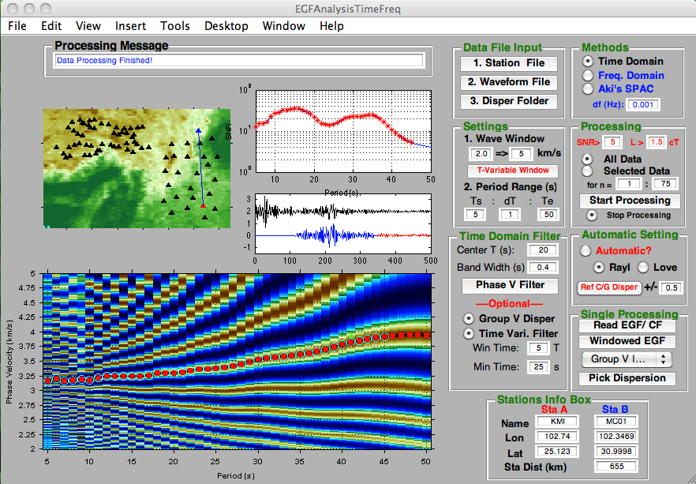

Figure 1. EGFAnalysis GUI interface

2. Dispersion Analysis Panel

2.1 Semi-automatic dispersion processing

Step 1: set Data File Input panel

Step 1.1: first click 1. Station File to input station file, e.g., SETibetArraySta-YA.txt, it has the format “Station_Name Network_Name Latitute Longitude” shown as the following:
KMI CDSN 25.123 102.740
MC01 YA 30.9998 102.3469
MC02 YA 30.3811 103.4289
MC03 YA 30.0024 102.4891
……
Then it will show the stations (black triangles) on the topographic background image.

Step 1.2: click 2. Waveform File to input the list file containing all EGF filenames, e.g., EGFfiles-YA.txt, which has the format like:
GFcn.KMI-MC01_10-50s_10Mon.dat
GFcn.KMI-MC02_10-50s_10Mon.dat
GFcn.KMI-MC03_10-50s_10Mon.dat
GFcn.KMI-MC04_10-50s_10Mon.dat
GFcn.KMI-MC05_10-50s_10Mon.dat
……
The list file must be within the folder of EGF/CF data files.
After you input the list file, you will see a question dialog box (‘Data Type’) that lets you choose the type of input data (‘EGF’ or ‘CF’).

The EGF or CF data file is like
1.0274000e+02 2.5123000e+01
1.0234690e+02 3.0999800e+01
0.0000000e+00 5.9195591e-02 -5.9195591e-02
1.0000000e+00 1.7064567e-01 8.1567466e-02
2.0000000e+00 2.1271425e-01 2.1372974e-01
3.0000000e+00 1.6251044e-01 2.6998996e-01
… … …
with the format
Lon (station A) Lat (station A) Elevation (A)
Lon (station B) Lat (station B) Elevation (B)
Time (t=0) G_{AB}(t) G_{BA}(t)
Time (t=dt) G_{AB}(t) G_{BA}(t)
Time (t=2dt) G_{AB}(t) G_{BA}(t)
……

The elevation data on the first two lines are optional. If they exist, the horizontal station distance will be corrected based on their elevation as D_{c} = sqrt(D^2 + dh^2), where D is the great circle distance between A and B, dh is the height difference between two stations. G_{AB}(t) is the EGF from source A to station B while G_{BA}(t) is from source B to station A. Here t is positive with unit in second.

The CF has 90 degree phase difference from that of EGF. When CF data is read, this code takes the Hilbert transform of CF to obtain EGF. (One can also get EGF from CF by taking negative time-derivative, however, this will modify the amplitude information of the original CF.

Step 1.3: click 3. Disper Folder to select the folder where the dispersion data file will be saved.

Step 2: set Methods panel

Compared to the old EGFAnalysis code I have written, the new code will do "Single processing", "semi-automated processing", and "automated processing" using 3 different methods (time domain, frequency domain, Aki's SPAC method). You need to select one for the next step processing.

For using time domain method (Yao et al., 2006), you need to set Time Domain Filter, such as filter bandwidth (s) with respect to central period (e.g., 20 s). The central period will change from starting period (Ts) to ending period (Te) with period interval (dT) (see Period Ranges (s) in Settings panel). For frequency domain and Aki's SPAC method, you need to set df (Hz), which is frequency spacing/resolution when you do the data processing. The default value is 0.001 Hz. The Aki's SPAC method is not that stable for dispersion measurements if the data quality is bad. So I do not prefer to use it for really data processing, but you can play with this method.

Step 3: set Settings panel

Step 3.1: in 1. Wave Window part, set minimum group velocity v₁ (left edit box) and maximum group velocity v₂ (right edit box) to window the original EGF for dispersion analysis. The travel time corresponding to group velocity v₁ or v₂ is D_{c}/v₁ or D_{c}/v₂, respectively, where D_{c} is the (corrected) inter-station distance. The window function has value 1 between time window [D_{c}/v₂ D_{c}/v₁] and cosine taper of length min(Tc, 20) seconds on both sides. You can also set period-dependent group velocity window for time-variable filtering analysis by clicking T-Variable Window. Then a question dialog window will appear to let you choose whether or not to input a file of the reference group velocity window at various periods. The input period-dependent group velocity window file (e.g., refWinDisp.txt) has the format of (Period(s) V(km/s) GV1(km/s) GV2(km/s)) as following:
5 2.8 1.4 4.3
8 3.0 1.5 4.4
10 3.1 1.6 4.5
15 3.7 2.0 5.0
20 3.7 2.0 5.0
25 3.7 2.0 5.0
30 3.7 2.0 5.0
35 3.7 2.0 5.0
40 3.7 2.0 5.0
45 3.7 2.2 5.2
50 3.8 2.5 5.5
100 3.8 2.5 5.5
The third and fourth columns give the minimum and maximum group velocities at each period (first column). The second column gives reference group velocities, not used in the codes. After the reference group velocity window file is read, the lower figure panel will show the group velocity range at different periods. If the GV1 at some periods are less than v1 set above, GV1 will take v1 value in the real processing. Similarly, if GV2 are larger than v2 set above, Gv2 will take v2 value. Therefore, if period-dependent group velocity window is set, the codes will obtain different time windows [D_{c}/GV2 D_{c}/GV1] for windowing the signal at different periods and performing time-variable phase velocity analysis, instead of using a uniform time window [D_{c}/v₂ D_{c}/v₁]. Applying time-variable window will help to suppress noise or other phases before and after the main surface waves, and therefore enhance the accuracy of the phase velocity dispersion measurements.

However, if Time Vari. Filter (also Group V Disper) in Time Domain Filter panel is chosen, the automatic processing will not use the period-dependent window set here, but will use the period-dependent window from the direct group travel times. But in semi-automatic processing, you can choose among these three window schemes (uniform window, input period-dependent window, period-dependent window based on group velocities). Note the period-dependent window scheme is only valid for ‘Time Domain’ method.

Step 3.2: in 2. Period Range part, set the starting period Ts, period interval dT, and ending period Te. The periods for dispersion analysis will thus be Ts:dT:Te.

Step 4: set Filter Design panel

Step 4.1: set test central period Tc (in edit box Center T(s)) and band width dT_{f} (in second) (in Band Width (s) edit box) for band pass filtering. The signal will be bandpass filtered between [Tc-0.5dT_{f} Tc+0.5dT_{f}] for central periods interested. Tc here is just a test period and it will change to different values in the dispersion analysis within the period range (given by Ts:dT:Te in 2. Period Range in Settings)
Step 4.2: click Phase V Filter set filter parameter for phase velocity analysis. It will let you input the sampling frequency of the EGF/CF data in Hz and Kaiser window filtering parameter (usually set to the value between 6 – 9, and the phase velocity measurements is not very sensitive to this value). Then it will show the time and frequency domain Kaiser window.
Step 4.3: set group velocity dispersion and time-variable filtering analysis. This step is optional. If Group V Disper is chosen, group velocity dispersion curve will also be picked and saved. If Time Vari. Filter is chosen, time-variable filtering analysis for phase velocities will take effect based on the group velocities (group travel times) obtained. You will also need to set the period-dependent window time length (Win Time, which is set as the number of periods) and minimum window time length (Min Time, in seconds) centered at the group travel time of each period.

Step 5: set Processing panel

Step 5.1: set min SNR value (SNR edit box, see ‘1. Plot Panel’ about the detail of calculating SNR) and minimum ratio value (R) of L/CT (station distance/wavelength) for dispersion analysis. The periods with higher SNR than min SNR will be shown as red stars in the upper right figure and also as the light blue circles in the bottom figure of velocity-period image in the dispersion analysis (see Figure 1). In some cases, the EGF/CF records are too short and there is no noise window, then no SNR information will be plotted and all periods are assumed to have good SNR. SNR values help user access the reliability of dispersion measurements. When SNR are low in some period range, we usually discard the dispersion measurements in that period range. For full automatic dispersion analysis, only dispersion data points with SNR larger than min SNR can have the possibility to be saved. The minimum L/CT ratio will give the maximum period for dispersion analysis that can be saved in the dispersion data file. It is usually set to be 2 – 3, in order to satisfy the time-harmonic expression of surface wave propagation in the far field. In the near field the Green’s function has the expression of the zeroth-order Hankel function of the second kind. But the phase difference between the zeroth-order Hankel function of the second kind and the time-harmonic expression of surface wave at far field is negligibly small for distance larger than one wavelength. However, for time-domain based dispersion analysis, the side lobes of positive and negative CF/EGF will tend to affect the main lobe, which makes dispersion analysis not very reliable. Also when the distance is too short, the travel time is also very small, therefore small measurement error in travel times will give large errors in group or phase velocities. Therefore, we usually require the inter-station distance is at least 2 wavelengths apart.

Step 5.2: select All Data or Selected Data. If All Data is selected, after Start Processing button is pressed, the code will start from the first EGF data file in the EGF file list (see Step 1.2) and go through all the files for dispersion analysis. If Selected Data is chosen, you can specify the starting and ending index number of files in the EGF file list by setting the ‘for loop’ under Selected Data. After you set this, just press Start Processing to start the user-interactive semi-automatic or fully automatic dispersion analysis for group and phase velocity analysis. Full automatic dispersion analysis will take effect only when Automatic? in Automatic Setting is chosen. In this part, only semi-automatic dispersion analysis is illustrated.

If Group V Disper is chosen in Time Domain Filter panel, the bottom figure will first show the group velocity-period wave envelope amplitude image for group velocity analysis (Figure 2). If you want to obtain the group velocity dispersion curve, just click ‘Yes’ on the ‘Dispersion Curve’ question dialog box. Then crosshairs will show on the GUI interface for you to identify points in the figure by positioning the cursor with the mouse. Use left click to select points on the image and right click to select the last point. Then based on the points you selected, the code will automatically search for one dispersion curve (black curve in Figure 2) with local maximum image point values (here, the amplitude of envelope) closest to the clicked points. If the dispersion curve is very smooth and continuous, you just need one right click on the image close to the maximum value region (brown area) to get the dispersion curve. On the dispersion curve, points with higher SNR are depicted as yellow open circles (Figure 2). Then the user need to input the starting and ending periods for saving the dispersion data in the input dialog box, with the help of SNR values. The final saved dispersion points are shown as solid light blue circles. After this a question dialog ‘Revise dispersion data’ will be shown for you to continue (‘Yes’) or go back to revise the dispersion curve (‘No’). Sometime, you will see two or three vertical lines in the velocity image (see Figure 3), with the yellow dashed line corresponding to station distance = 2*wavelength, line blue dashed line for station distance = wavelength, and red line for station distance = R*wavelength, with R the minimum ratio of station distance/wavelength set in Processing panel (see also Step 5.1). The maximum period for saving dispersion data is corresponding to this red line. The file storing group velocity dispersion data has the name GDisp.XXXX where XXXX denotes the original EGF or CF file name.

Note: the group velocity dispersion analysis uses Gaussian window in the frequency domain: G(f, fc, A) = exp{-A*(f-fc)^2/fc^2) where f is the frequency, fc is the central frequency, and A is the filter coefficient which depends on inter-station distance. The values of A is currently set as:
A = [0 100 250 500 1000 2000 4000 20000;
5 8 12 20 25 35 50 75]
where the first row is distance and the second row gives the value of A at the corresponding distance based on values from a number of reference papers.

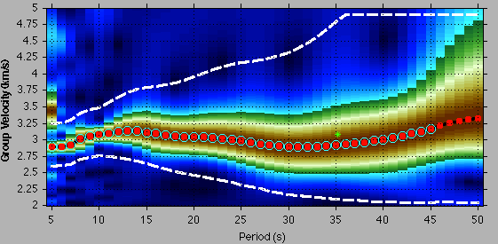
Figure 2. Group velocity dispersion analysis. The black curve shows the traced dispersion curve with blue open circles for periods with SNR > 5 and red solid circles for final periods saved for group velocity dispersion data. Horizontal axis is period (s). Vertical axis is group velocity (km/s). The two white dashed lines show for the time-variable group velocity window for the phase velocity analysis using a time-variable filtering analysis.

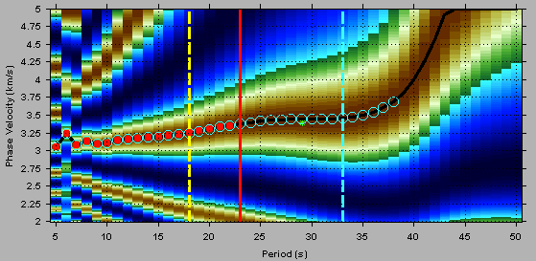
Figure 3. Phase velocity dispersion analysis. Horizontal axis is period(s). Vertical axis is phase velocity (km/s). Yellow dashed line: station distance > 2*wavelength, light blue line: station distance > 1*wavelength, red line: station distance > R*wavelength (R=1.5 here, set in the Processing panel). Light blue circles show good SNR (>5) periods and the red dots are final saved dispersion points.
［NOTE: in the new version, the group dispersion curve if picked will be shown as the magenta color line and the points that have been picked will be plot as cyan circles. The group dispersion can be used a reference for phase velocity dispersion pick. We also compute the group velocity dispersion curve from the picked phase velocity dispersion (g = c + k*dc/dk) shown as the green line to compare with the picked group velocity dispersion.］

After the group velocity dispersion curve is obtained, a ‘Time-variable filtering type’ question dialog box (Figure 4) will be shown which let you choose the time-variable window type for phase velocity dispersion analysis.

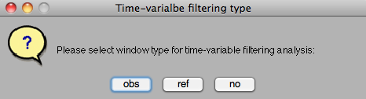
Figure 4. ‘Time-variable filtering type’ question dialog box

You can choose ‘obs’ (based on the obtained group velocities and window parameters set in Time Domain Filter), ‘ref’ (based on the input reference period-dependent group velocity window set in T-Variable Window in Settings), or ‘no’ (using the uniform group velocity window set in 1. Wave Window in Settings. If ‘obs’ or ‘ref’ is selected, two white dashed lines will be shown on the group velocity - period image (Figure 2) corresponding to period-variable group velocity window for the next step phase velocity analysis. Then the phase velocity - period image will show for phase velocity dispersion analysis (see Yao et al., 2006 for the detail) similar as the group velocity dispersion analysis. There are multiple phase velocity dispersion branches on the image (brown regions) due to 2*pi ambiguity, but there is only one correct. Based on the values of each branch, you need to select the desired dispersion points on the image (left click to select and right click to finish). In some cases, dispersion curve may be not very continuous. In this case we must be very cautious and select only the most continuous part with higher SNR to avoid mistakes or large errors. The saved dispersion points are shown as light blue circles (Figure 3) with the file name CDisp.XXXX where XXXX denotes the original EGF or CF file name. If the dispersion saved seems not ideal, you can go back to re-do the dispersion pick by selecting ‘Yes’ in the ‘Revise dispersion data’ question dialog, or ‘No’ to continue for another inter-station path, or ‘Stop’ to stop the entire semi-automatic dispersion processing.

The saved dispersion data has the format:

102.740000 25.123000
100.421500 29.045000
10.0 3.140 0.000 1
11.0 3.148 0.000 1
12.0 3.136 0.000 1
13.0 3.162 0.000 1
14.0 3.192 0.000 1
15.0 3.226 0.000 1
16.0 3.210 0.000 1
17.0 3.204 0.000 1
18.0 3.194 0.000 1
19.0 3.174 0.000 1
20.0 3.176 0.000 1
21.0 3.198 0.000 1
22.0 3.224 0.000 1
23.0 3.246 0.000 1
24.0 3.266 0.000 1
25.0 0.000 0.000 0
26.0 0.000 0.000 0
27.0 0.000 0.000 0
28.0 0.000 0.000 0
29.0 0.000 0.000 0
30.0 0.000 0.000 0
31.0 0.000 0.000 0
32.0 0.000 0.000 0
33.0 0.000 0.000 0
34.0 0.000 0.000 0
35.0 0.000 0.000 0
36.0 0.000 0.000 0
37.0 0.000 0.000 0
38.0 0.000 0.000 0
39.0 0.000 0.000 0
40.0 0.000 0.000 0
41.0 0.000 0.000 0
42.0 0.000 0.000 0
43.0 0.000 0.000 0
44.0 0.000 0.000 0
45.0 0.000 0.000 0
46.0 0.000 0.000 0
47.0 0.000 0.000 0
48.0 0.000 0.000 0
49.0 0.000 0.000 0
50.0 0.000 0.000 0

The first two lines are: Lon (station A) Lat (station A)
Lon (station B) Lat (station B)
and the following lines are: Period (s) Phase/group velocity standard_error N.
For all periods Ts:dt:Te, only when N=1, we have measurements. Otherwise (N=0), the velocity will be 0.000. The standard error is not estimated here, but this option is useful when you measure dispersion from monthly EGF/CF, and then calculate the standard errors from all monthly measurements.
Note: In the latest version, the third column is SNR value of each period.

2.2 Automatic dispersion analysis

The code can automatically pick the reasonable dispersion curve using some complicated criteria for each wave type.

For phase velocity dispersion, you can check functions
NewDisper = AutomaticDisperLove(RawDisper, SampleF, MinTWidth, SNR, minSNR, MaxTCal) or NewDisper = AutomaticDisperRayl(RawDisper, SampleF, MinTWidth, SNR, minSNR, MaxTCal) for the detailed info. Hui Huang at MIT wrote these two functions. r_dcdt in the code is important. And maybe it will change for different area. For automatic picking, "Delta T" in Settings box has to be set to 1 or 0.5 (s).
Note: In the latest version, we made some modification and this limitation no longer exists, “Delta T” can be set arbitrarily based on your data.

For automatic group velocity dispersion pick, currently I only use SNR as the criteria. Other criteria, such as the smoothness of the dispersion curve, could be included in the future, similar as for automatic phase velocity dispersion analysis.

For the automatic processing to work on, you first need to set parameters similarly as steps in 2.1, and then choose ‘Automatic ?’ and wave type (Rayl for Rayleigh waves, Love for Love Waves) in the Automatic Setting panel. Then input reference phase or group velocity dispersion files (and its perturbation range) (e.g., ref_RayPhaseVdisp.txt and ref_RayGroupVdisp.txt) by clicking Ref C/G Disper button. The reference phase velocity dispersion and its range are shown as the blue line and blue dashed lines, respectively, in the bottom figure panel as shown in Figure 5. If Group V Disper in Time Domain Filter is chosen, you need also input reference group velocity dispersion and its range, show as green lines in Figure 5.

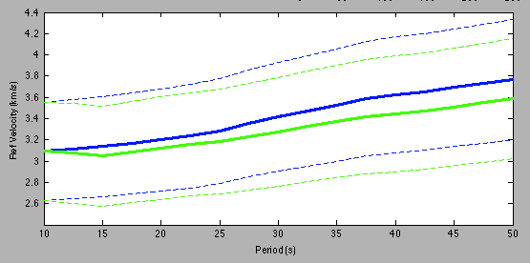
Figure 5. Reference phase and group velocity dispersion curves (solid lines) and their perturbation ranges (dashed lines) with blue for phase velocity and green for group velocity.

The reference phase and group velocity dispersion files have the following format:

10.0000 3.0917
12.5000 3.1129
15.0000 3.1372
17.5000 3.1683
20.0000 3.2016
22.5000 3.2348
25.0000 3.2875
27.5000 3.3574
30.0000 3.4160
32.5000 3.4703
35.0000 3.5274
37.5000 3.5855
40.0000 3.6242
42.5000 3.6521
45.0000 3.6915
47.5000 3.7304
50.0000 3.7639
The left column is period, and the right is phase velocity. Then you need to give the range of perturbation for phase velocity dispersion auto-pick, with default value +/- 0.5 km/s with respect to the reference values.

You can also give the reference values like this:
10.0000 3.0917 0.4638
12.5000 3.1129 0.4669
15.0000 3.1372 0.4706
17.5000 3.1683 0.4752
20.0000 3.2016 0.4802
22.5000 3.2348 0.4852
25.0000 3.2875 0.4931
27.5000 3.3574 0.5036
30.0000 3.4160 0.5124
32.5000 3.4703 0.5206
35.0000 3.5274 0.5291
37.5000 3.5855 0.5378
40.0000 3.6242 0.5436
42.5000 3.6521 0.5478
45.0000 3.6915 0.5537
47.5000 3.7304 0.5596
50.0000 3.7639 0.5646
The third column gives the perturbation range without using the default value in the box.
Of course, the period range of processing in the "Settings" has to be in within the reference period range given here.

Add(Version 2024)
2.2.1 3D Reference Dispersion
In the latest version (V 2024), we add the option to calculate reference dispersion based on 3D phase and group velocity. Instead of using a single reference dispersion file for the whole study area, the 3D Reference mode allows you to calculate reference dispersion between each station pair, thereby the branch of phase velocity dispersion can be identified more accurately.

You can click 3D Ref C/G Disper Great Circle, then select the packaged .mat file(e.g., RaylTB.mat).
The .mat file includes six MATLAB matrices:
'disperT_m', 'lat_m', 'lon_m', 'disp3D_phase', 'disp3D_group' and 'ref_range'
'disperT_m', 'lat_m', 'lon_m', 'disp3D_phase', 'disp3D_group' correspond to the dispersion period, latitude, longitude, reference phase velocity, and reference group velocity for each data point, respectively. The format is latitude points * longitude points * number of periods.
'ref_range' represents the tolerance range, with a format of number of periods * 2. (The first column is the period and the second column is reference values (percentage))

After all parameters are correctly set, click Start Processing in Processing panel for fully automatic dispersion analysis. The codes will first find the most likely dispersion curve by comparing with the reference dispersion curve and then perform joint SNR and smoothness analysis to refine the range of dispersion data (red dots) to be finally saved in the output file. If you like to stop the automatic procession in the middle, just click the radio button Stop Processing in the Processing panel.

2.3 Dispersion processing for individual EGF/CF

In Single Processing panel, it allows for dispersion analysis for individual EGF or CF. You first need to set parameters in Filter Design, Settings, and Processing (SNR and minimum ratio between L/CT) panels.

2.3.1 Input EGF or CF data
First you need to click Read EGF/CF to input EGF/CF data file, e.g., GFcn.KMI-MC01_10-50s_10Mon.dat in the data folder, and then choose the data type (EGF or CF) for the input data. The EGF waveform will be shown on the bottom figure, with the red (positive time) part the EGF from ‘source’ A to ‘receiver’ B and the blue (negative time) part the EGF from ‘source’ B to ‘receiver’ A. If the input data is CF, the code will convert CF to EGF using the Hilbert transform.

2.3.2 Window EGF
Click Window EGF, the code will automatically window the positive and negative EGF as well as the time-symmetric component using the group velocity window defined in 1. Wave Window in Settings panel. The windowed EGF is shown as the red and blue solid traces for the positive and negative traces, and black trace for the symmetric component, in the bottom figure panel.

2.3.3 Group Velocity or Phase Velocity dispersion analysis
In the pop-up menu Phase Img xxxx, you are able to show Time-Period phase or group envelope image for the positive, negative, and symmetric component EGF on the bottom figure. Horizontal axis is period (s) and vertical axis is time (sec). Brown color show for larger values (e.g., peak or the envelope peak of the filtered waves).

Then the code will do both filtering for group velocity analysis (using Gaussian filter) and for phase velocity analysis (Kaiser window filter) using the parameters. The top right figure shows the SNR for the positive, negative, and symmetric component. High SNR periods will be also plotted as red stars. Then you need to choose whether to use time-variant filtering analysis or not by choosing the options (‘obs’, ‘ref’ or ‘no’) in the time-variable filter type question dialog (Figure 4), similar as that in the semi-automatic analysis. You can choose ‘obs’ (based on the obtained group velocities and window parameters set in Time Domain Filter), ‘ref’ (based on the input reference period-dependent group velocity window set in T-Variable Window in Settings), or ‘no’ (using the uniform group velocity window set in 1. Wave Window in Settings. ‘Obs’ option works only when group velocity dispersion is picked first (e.g., first Group V Img A+B, then Pick Dispersion, then Phase V Img A+B, finally Pick Dispersion).

2.3.4 Pick dispersion curve
You can pick phase or velocity dispersion curve on the phase v image or group v image obtained from 2.2.3 by clicking Pick Dispersion. The pick procedure is the same as that in the semi-automatic dispersion processing.

References

Yao, H., van der Hilst R.D., and de Hoop, M.V., 2006. Surface-wave array tomography in SE Tibet from ambient seismic noise and two-station analysis : I - Phase velocity maps. Geophys.J. Int., Vol. 166(2), 732-744, doi: 10.1111/j.1365-246X.2006.03028.x.
Yao, H. , Xu G., Zhu L.,and Xiao X., 2005. Mantle structure from inter-station Rayleigh wave dispersion and its tectonic implication in Western China and neighboring regions. Phys. Earth Planet. Inter., 148(1), 39-54.

Yao, H., Gouedard, P., McGuire, J., Collins, J. and van der Hilst, R.D., 2011. Structure of young East Pacific Rise lithosphere from ambient noise correlation analysis of fundamental- and higher-mode Scholte-Rayleigh waves, Comptes Rendues Geoscience de l'Académie des Sciences, 343，571–583，doi:10.1016/j.crte.2011.04.004

