“The critical difference between CRF and MEMM is that the latter uses per-state exponential models for the conditional probabilities of next states given the current state, whereas CRF uses a single exponential model to determine the joint probability of the entire sequence of labels, given the observation sequence. Therefore, in CRF, the weights of different features in different states compete against each other.”

This means that in the MEMMs there is a model to compute the probability of the next state, given the current state and the observation. On the other hand CRF computes all state transitions globally, in a single model.

The main motivation for this proposal is the so called Label Bias Problem occurring in MEMM, which generates a bias towards states with few successor states.
Zoals gebeurt bij -um en -que

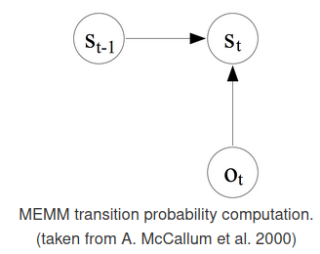
MEMM: the probability of the next state is only dependent on the observation (i.e., the sequence of words) and the previous state.

The idea of CRF is to drop the local per state normalization of MEMM, and replace it by a global per sequence normalisation.

A Conditional Random Field can be seen as an undirected graphical model, or Markov Random Field, globally conditioned on (X), the random variable representing observation sequence.

\(X\) is a random variable over data sequences to be labeled, and \(Y\) is a random variable over corresponding label sequences.

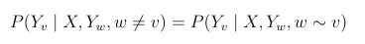
The random variables \(X\) and \(Y\) are jointly distributed, but in a discriminative framework we construct a conditional model \(p(Y \mid X)\) from paired observation and label sequences:

Thus, a CRF is a random field globally conditioned on the observation \(X\). This goes already in the direction of what the MEMM doesn’t give us, states globally conditioned on the observation.

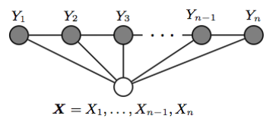
The simplest and most common graph structured in NLP, which is the one used to model sequences is the one in which the nodes corresponding to elements of \(Y\) form a simple first-order chain, as illustrated in the figure below:

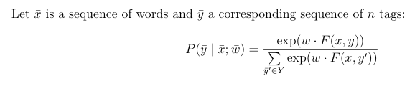

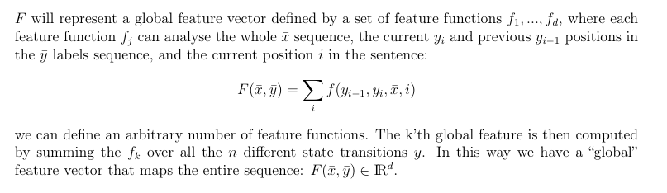

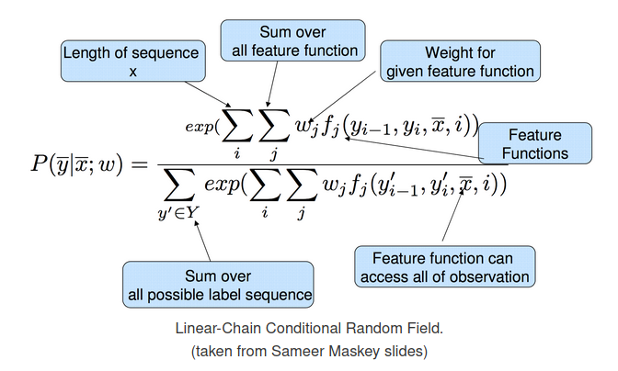

We want to try all possible \(\bar{y}\) sequences computing for each one the probability of “fitting” the observation \(\bar{x}\) with feature weights \(\bar{w}\).

The decoding problem is then to find an entire sequence of states such that the sum of the transition scores is maximized. We can again solve this problem using a variant of the Viterbi algorithm, in a very similar way to the decoding algorithm for HMMs or MEMMs.

We also need to find the \(\bar{w}\) parameters that best fit the training data, when given a set of labelled sentences:

The standard approach to finding \(\bar{w}^*\) is to compute the gradient of the objective function, and use the gradient in an optimization algorithm like L-BFGS.
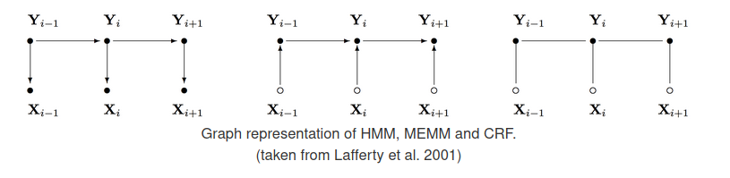

CRF Important Observations
- MEMMs are normalized locally over each observation, and hence suffer from the Label Bias problem, where the transitions going out from a state compete only against each other, as opposed to all the other transitions in the model.
- CRFs avoid the label bias problem a weakness exhibited by Maximum Entropy Markov Models (MEMM). The big difference between MEMM and CRF is that MEMM is locally renormalized and suffers from the label bias problem, while CRFs are globally re-normalized.
- The inference algorithm in CRF is again based on Viterbi algorithm.
- Output transition and observation probabilities are not modelled separately.
- Output transition dependent on the state and the observation as one conditional probability.

