**Abstract：**In this article, we proposed a new plasmonics-si coupler (PSC), which can provide relatively high transmission efficiency. We use four algorithms to optimize the PSC structure, which are binary search algorithm, genetic algorithm, particle swarm optimization algorithm and simulated annealing algorithm. The simulation results show that the structure designed by the binary search algorithm can obtain optimum optimization. The transmittance of light from the Si waveguide to the MDM waveguide is above 91.5%, and the input light whether in TE mode or TM mode has little effect on the coupling efficiency. What’s more, the bandwidth of transmitted light is 200 nm, ranging from 1450 to 1650 nm. The structure designed by particle swarm optimization and genetic algorithm can achieve a transmittance of more than 72%. The structure designed by simulated annealing algorithm can achieve a transmittance of more than 60%.

**Introduction**

Surface plasmon polaritons (SPPs) is the electromagnetic surface wave where light can be coupled into interface between metal and medium. Due to breaking the diffraction limit of traditional photonic devices， SPPs have attracted wide attention in nano-integration[1-3]. The main applications of SPPs are beam splitters [4,5], reflectors [6,7], filters, Mach-Zehnder interferometers [8,9,10], waveguide ring resonators [8], etc. In recent years, the research of optical couplers based on the characteristics and advantages of surface plasmon polaritons has been gradually carried out[10-18]. Argishti Melikyan[11] proposed a novel photonic-to-plasmonic mode converter for efficiently converting a silicon strip waveguide mode to a gap surface plasmon polariton (SPP) of a metallic slot structure, which can reach more than 85% for metallic slots with a slot size of 30–50 nm, and the optical 1 dB bandwidth of the converter is around 200 nm. A type of plasmonic coupler designed and demonstrated by Lin et al.[12], which enable polarization-controlled tunable directional coupling with polarization-invariant total conversion efficiency and preserve the incident polarization information. A mode converter between a conventional silicon strip waveguide and a metal-insulator-metal (MIM) waveguide was designed by Chin-Ta Chen[13], providing 93.3% conversion efficiency at 1550 nm. In addition, there is the paper in [14] present corrugated tapered waveguide for mode coupling enhancement at the 1550 nm optical communication wavelength between a 1.25μm silicon micro-slab and a plasmonic nano-gap waveguide, of which coupling efficiency can reach 86% ∼ 98%. Yi Song [15] et al. designed a silicon waveguide coupler based on SPPs, which achieves a coupling efficiency of 70% at the 1.55μm telecommunication wavelength. What’s more, Zhao et al[18]. adopt finite difference time domain (FDTD) method to simulate and analyze a novel optical directional coupler (ODC) based on surface plasmon polaritons (SPPs)，and the input is the TM mode light of a specific length with very narrow bandwidth. In summary, in the current work, a lot of work has been done to study the coupling between traditional silicon waveguide and plasma waveguide. Some of the work-designed couplers can cover a range of wavelengths, but their coupling efficiency is relatively low; another part of the work about designed coupler can achieve higher efficiency, but they can only have a specific wavelength. What’s more, there are few works have mentioned that the coupling efficiency of the designed coupler is independent of the polarization mode of the transmitted light.

Until now, optimization algorithms have been used in a plenty of works to design chip structures[1-7]. The first one is evolutionary algorithms[19-24],such as on-chip broadband polarization rotator designed by genetic algorithm[19], compact power splitters designed ab initio using binary particle swarm optimization in a 2D mesh for a standard foundry silicon photonic platform[20]. What's more, binary search algorithm has been used to design polarization beam splitter[21], polarizer coupler[22], polarization rotator[23], which can achieve relatively high conversion rate. By use of the simulated annealing algorithm, the work[24] designed fiber-to-waveguide coupling structure and optimize parameters to get to obtain maximum coupling efficiency. The second one is using topology optimization algorithm to design optical devices[25-27], such as polarization rotator based on multilevel shape optimization[25]. The third one is Modeling algorithm, for example using artificial neural networks (ANNs)[28] to achieve spectrum prediction, parameter fitting, inverse design and performance optimization for the plasmonic waveguide coupled with cavities structure (PWCCS).

Evolutionary and search algorithms

The discussion is organized as follows. Firstly, the geometry and simulation configuration of the mode converter are described. Secondly, we introduce how to use artificial intelligence algorithm to design the structure of PSC. DBS (direct-binary search) algorithm is introduced firstly. It is shown that the efficiency of transmission spectrum is very high whether the non-polarized light or the polarized light passes through the mode converter. The transmittance of non-polarized light is above 91.5%, and of polarized light is above 90%, what’s more, this structure can carry out broadband transmission from 1450nm to 1650nm, instead of aiming at a specific wavelength. Thirdly, the PSC is designed by using genetic algorithm, particle swarm optimization and simulated annealing algorithm, which can obtain relatively high transmission transmittance. Finally, we compare the PSC designed by the four algorithms in terms of bandwidth, transmission efficiency and complexity, we can draw the conclusion based on above parameters that: DBS algorithm is the best design algorithm among the four algorithms.

We designed a high-efficiency polarization-independent wideband PSC, and the bandwidth of the device ranges from 1450nm to 1650nm. As shown in Figure 1, the mode converter is a square two-dimensional code structure with a footprint of only 1*1um2(blue), which is composed of 40*40 pixels, each pixel representing one point with a total of 1600 points. The Si waveguide (blue) on the left side is an input waveguide having a length of 3μm, a width of 400nm, and a height of 250nm; the right MDM waveguide(yellow) is an output waveguide having a length of 3μm, a width of 3μm, and a height of 250 nm, what’s more, the width of the gap in the middle of the electrolyte medium is 500 nm.; the thickness silica substrate (grey) is 3um. The coupling efficiency of the dielectric-plasma slot waveguide mode converter is studied and optimized by the 2.5-dimensional finite-difference time-domain simulation MODE method. The coupling efficiency of the PSC is defined as the ratio of the power coupled to the plasma waveguide mode to the input power in the silicon waveguide. The transmission loss of the plasmonic waveguide is calculated by placing several monitors on the Si waveguide and the MDM waveguide and then fitting these transmissions.

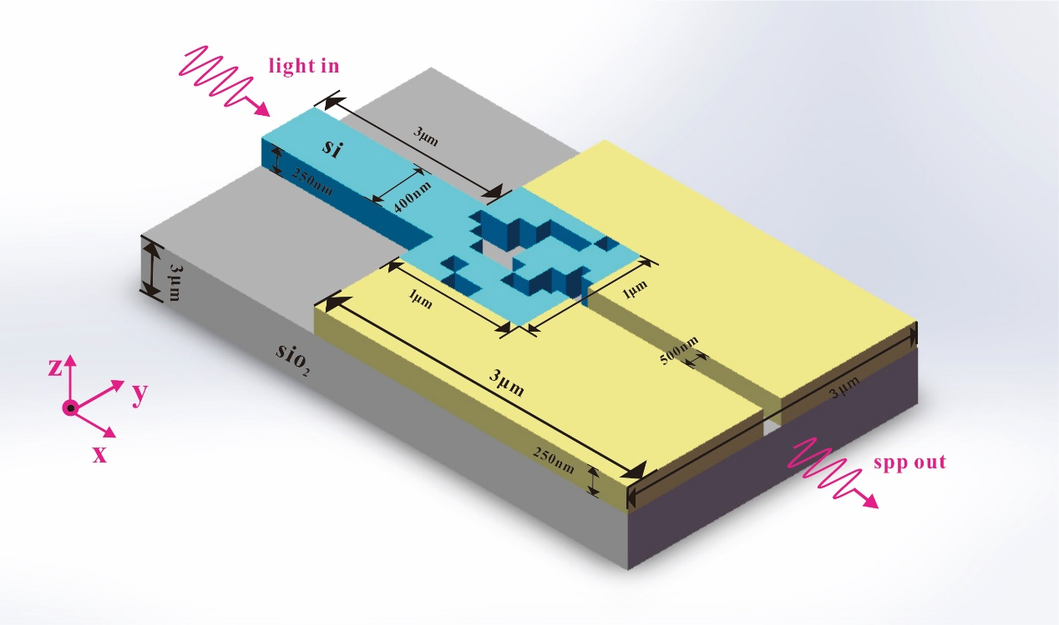

Figure.1. Schematic structure of the mode converter in three-dimensional.

A non-linear search algorithm is used to design the structure of PSC, which we call 'direct-binary search' (DBS) algorithm. For the plasmonics-si mode converter, it is a 40 *40 pixel square structure that is split into 1600 points, each point being '0' or '1'. Since the area of ​​the PSC structure is 1um*1um, the footprint of each pixel is 0.025um*0.025um. Firstly, the values of `0'and `1' are randomly assigned to 1600 points in the structure just like two-dimensional code, and as the initial value, the first iteration is performed to obtain the transmission transmittance. When the second iteration is performed, the value of the pixel position of the first row and the second column is changed first. The rule of change is: if the original value is '0', it will be changed to '1'; if the original value is '1' , then changed to '0', which is the exchange of '0' and '1'. The new structural parameters after the change are simulated to obtain a new value of the transmittance. The value of the old transmittance (ie, the value of the transmission spectrum obtained in the first iteration) is compared with the value of the new transmittance, and if the value of the new transmittance is higher than the value of the old transmittance, the changes in the values of `0' and `1' of the first row and the second column of pixels is saved; if the value of the new transmittance is lower than the value of the old transmittance, the value of the pixel of the first row and the second column is not changed, that is, the original value of the position is retained. According to this rule, the same algorithm iteration is performed on the position of the pixels in the first row and the third column. Since there are a total of 1600 pixels, 1600 iterations are required to complete one traversal.

In our work, we firstly consider the case of input as non-polarized light. We use the DBS algorithm to optimize PSC structure of 20*20, 30*30, 40*40 pixels respectively. And for each specification, the PSC structure is traversed five times, each traversal includes 1600 iterations, so for the structure of 20*20 pixels, there is a total of 5*400 = 2000 iterations; for the structure of 30*30 pixels, a total of 5 *900 = 4500 iterations; for the 40*40 pixel structure, it includes 5*1600, which is 8000 iterations.

We take 100 points at the waveguide structure, and the ideal value of each point is 1, that is, in the ideal case, the transmission spectrum has 100% transmittance. We calculate the difference between the transmittance of each point and the target value. And accumulating the difference of 100 points, the smaller the difference is, the higher transmittance of the PSC structure obtained.

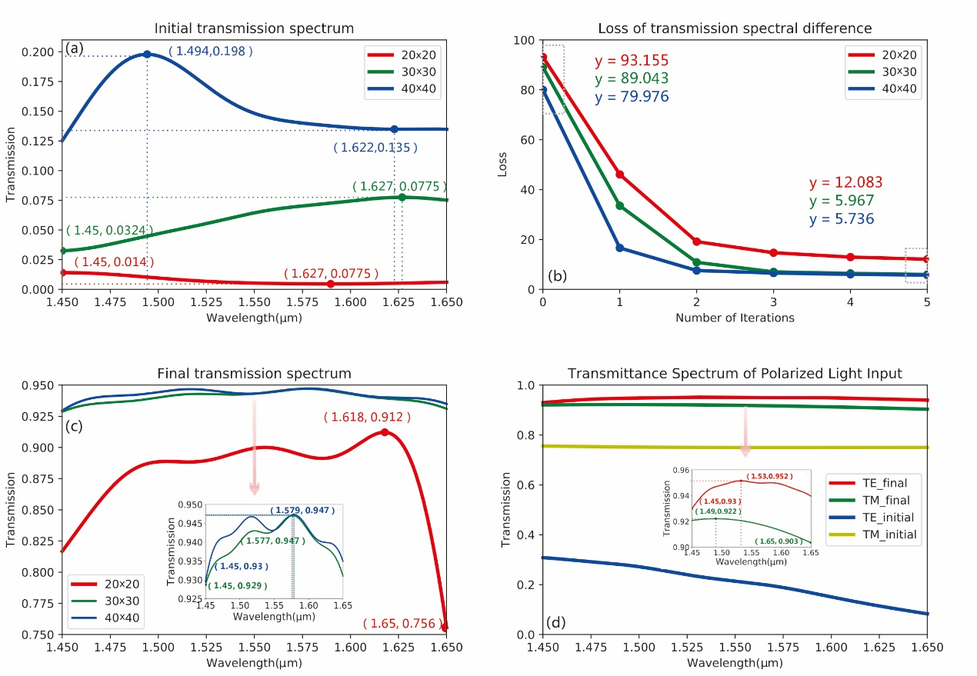

Figure.2. (a) The initial transmission spectrum curve. (b) The attenuation value of the transmission spectrum after each traversal. (c) The final transmission spectrum obtained after five traversals. (c-1) Final transmission spectrum values for 30x30 and 40x40 structures. (d) The curve of the initial transmission spectrum and the final transmission spectrum when the input is the TE mode and the TM mode, respectively. (d-1) The value of the final transmission spectrum after optimization by the DBS algorithm when the input light is in TE mode and TM mode.

When the DBS algorithm is not optimized, the structure of the PSC is randomly assigned, which can be regard as the initial value. The transmittance of the structure simulated in this situation is below 1.4%. As shown in Figure 2 (a), the initial values of the transmission spectrum of 20*20 (red), 30*30 (green) and 40*40 (blue) pixels are obtained before optimization by the DBS algorithm. We performed five iterations for each structure. After each traversal, the difference between the transmission spectrum and the target transmission spectrum, which we call the attenuation value, becomes smaller. As shown in Fig. 2(b), there is the transmission spectrum and the target difference of the three structures. The attenuation values ​​of the first two transmission spectrum are relatively high, and the latter three are relatively low. For the final target difference, the structures of 20*20, 30*30, and 40*40 pixels are 12.0828, 5.9672, and 5.7362, respectively. It can be seen that the DBS algorithm has a faster convergence rate and can quickly achieve the desired result. As shown in Fig. 2(c), the abscissa in the figure is the wavelength of light, which ranges from 1450 nm to 1650 nm, and the ordinate is the value of the transmittance of the two-dimensional code structure of three different densities after five traversals by the DBS algorithm. It can be seen that the structure effect of 40*40 pixels is the best. In the range of 20nm bandwidth, the transmittance can reach more than 93%, and the structure effect of 20*20 pixels is relatively poor, but the transmission spectrum can still reach above 75%.

Then we consider the case of which the input is polarized. We use MODE to simulate a 40*40 pixel mode converter. Firstly, the TE mode polarized light is input to the si waveguide, and the initial value is randomly assigned to PSC structure. Before the structure is optimized with the DBS algorithm, the initial transmittance is only 1.2%. We put 100 detection points, obtaining the transmission spectrum value, then get the sum of the differences from the target transmission spectrum,which is 77.061. It can be seen that the transmittance of this structure is very low, and light can hardly be transmitted through this structure. The DBS algorithm is used to optimize the PSC structure. After a total of four traversals, the sum of the difference between the transmission spectrum and the target transmission spectrum after each traversal is as follows: 77.061 (this is the value when the algorithm is not optimized, just for comparison ), 20.5834, 8.2586, 5.8343, 5.3309. The same as the input case of unpolarized, the convergence speed is faster in the first two optimizations, and slower in the last two optimizations. After 4 traversals, the transmittance of the PSC structure can reach 93% or more, and it can be seen that the transmittance is high. Secondly, the polarized light of the TM mode is input to the Si waveguide on the left side, and the same optimization method is used to perform the traversal five times. The initial value of the PSC structure is randomly assigned, and the initial transmittance is 74.9%. The sum of the difference between the transmission spectrum and the target transmission spectrum after each traversal is as follows: 21.1017 (this is the value not optimized by the algorithm, just for comparison), 10.2226, 8.836, 8.652, 8.4743, 8.3184, the transmittance of the structure optimized by the algorithm reaches more than 90%, which shows that the DBS algorithm has a good optimization effect. As shown in Fig. 2(d), the abscissa is the efficiency of the transmission spectrum in TE/TM mode after the algorithm is optimized. It can be seen that for polarized light, the PSC we designed can also ensure wide bandwidth and high efficiency transmission.

As shown in Fig. 3(a), there are the initial transmission curves of the transmission spectra for different wavelengths before the optimization of GA (red), PSO (green), and SA (blue) algorithms. Figure 3(b) shows the attenuation of the transmission spectrum obtained after each iteration of every algorithm. Fig. 3(c) is a plot of the transmission spectrum of the final structure obtained after five iterations, and Fig. 3(d) is the final transmission spectrum value obtained by five iterations by changing the different parameters using GA.

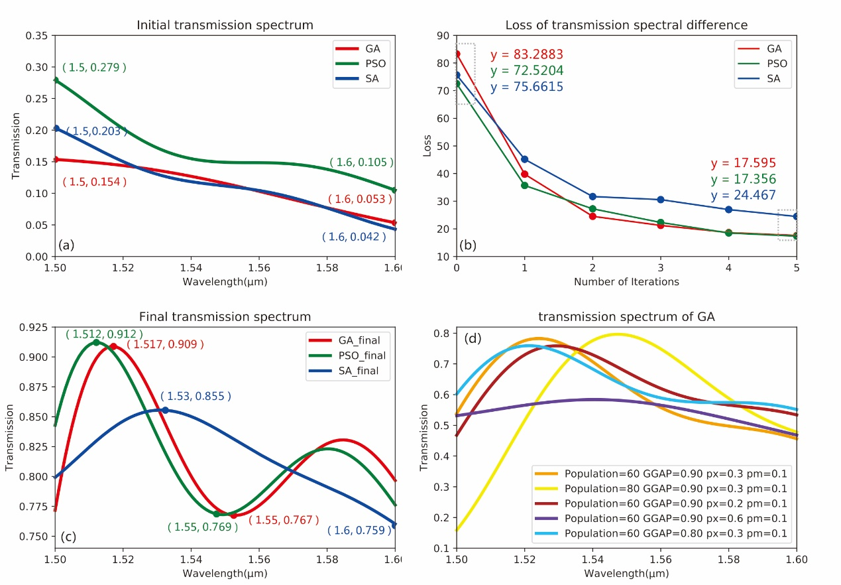

Figure.3. (a) Initial transmission spectral values that have not been optimized by the GA, PSO, and SA. (b) The attenuation values of the transmission spectra obtained by three algorithms respectively. (c) The final transmission spectrum curve obtained by three algorithms optimization (d) The transmission spectrum curve obtained by GA under different parameters

We also used particle swarm optimization (PSO), genetic algorithm (GA) and simulated annealing (SA) algorithm to design the 40*40 pixel code structure. We use particle swarm algorithm firstly. The population size we set is 50, and the maximum genetic algebra is 200 generations, which means that it takes 200 iterations in one traverse. Similar to the DBS algorithm, we set 100 detection points at the waveguide structure, and the ideal value of each point is 1. Calculate the absolute value of the difference between the transmission spectrum of each particle and the target transmission spectrum, set the individual with the smallest difference in transmission spectrum to the global optimum, set the maximum flight speed to 1, the minimum flight speed to -1, and the learning factor c1= c2 to 1.49445. Before particle swarm optimization, the transmittance of the PSC structure is only 10.5%. Then we use the algorithm to optimize the structure, the wavelength range is 1500nm-1600nm. After five traversal, the transmittance can reach more than 75%. The difference between the transmission spectrum obtained by each traversal and the target transmission spectrum is as follows: 72.5204 (the initial value which is not optimized by the algorithm, just for comparison), 35.691, 27.2439, 22.3112, 18.493, 17.3556. According to the simulation results. The effect of the particle swarm algorithm is worse than that of the DBS algorithm, both in terms of bandwidth and transmission efficiency.

Next, we use genetic algorithm (GA) to optimize the PSC structure of 40*40 pixels. In the simulation, we set the population size to 100, the maximum genetic algebra to 50, the generation gap selection ratio GGAP=0.8, the probability of crossover occurrence PX=0.3, and the probability of mutation occurrence PM=0.001. We connect MODE to MATLAB and use the Sheffield Toolbox to implement genetic algorithms for selection, crossover and mutation. Being same with the two algorithms mentioned above, we select 100 detection points in the waveguide structure, the ideal transmittance is 100%, and the transmittance of each individual in the population is subtracted from the target transmittance to obtain the difference, then we get the absolute value, which is used as the basis for the objective function.

We used the genetic algorithm to traverse the structure five times. The difference between the transmission spectrum and the target transmission spectrum obtained after each traversal is as follows: 83.2883 (the initial value without optimization of the algorithm, just for comparison), 39.7735, 24.5314, 21.2399, 18.65604, 17.59502. The PSC structure optimized by the GA has a transmittance of more than 75% in the wavelength range from 1500 nm to 1600 nm. It means that using GA implemented by the above parameters, a relatively good transmittance effect can be achieved.

It is worth noting that when we choose the genetic algorithm for optimization, we do not get the transmission spectrum as high as 75% from the beginning. We first set the parameters as follows: population size to 60, maximum genetic algebra to 50, generation gap selection ratio GGAP=0.9, probability of crossover occurrence PX=0.3, probability of mutation occurrence PM=0.01, and after five traversals, the obtained transmission spectrum can only reach about 50%. We modify population to 80, other parameters remain unchanged, and the variance of obtained transmission spectrum is very large, which ranges from 10% to 80%. Then we change the crossover probability to px=0.2, other parameters remain unchanged, after five traversal, the value of the transmission spectrum is above 45%. We change the crossover probability to px=0.6 again, and the other parameters remain unchanged. After five traversals, the value of the transmission spectrum is above 47%. Finally, we change the value of the GGAP to 0.8, and other parameters are unchanged, then the transmittance we get is above 55%. It can be seen that it is difficult to increase the transmittance of the structure by changing the parameters in the genetic algorithm. The parameters we set at the beginning can achieve maximum transmission efficiency among all.

Finally, we use the simulated annealing algorithm to design the structure of the 40*40 pixel mode converter. We set the maximum temperature to 2000 and the lowest temperature to 1e-18. The new individual structure matrix is generated based on the previous individual structure matrix and has a certain random probability to change. It is worth noting that this probability is related to temperature changes. It isn’t difficult to understand, because as the temperature decreases, it tends to be stable, and the probability of change should also become smaller. We select 100 detection points in the waveguide structure, calculate the difference between the transmission spectrum of the structure obtained and the target transmission spectrum after each iteration. According to the SA algorithm, there is a certain probability accept a value that is worse than the previous result. We set the acceptance tolerance to rand(0.5,1). After five times of traversal, the difference between the target and the transmission spectrum after each traversal is: 75.6615 (initial value for comparison), 45.1666, 31.6836, 30.5698, 26.967, 24.467, the spectrum transmission of the finally optimized structure is above 65%.

**Conclusion**

We used the four algorithms to design the structure of a new plasmonics-si coupler (PSC), which are direct-binary search(DBS), particle swarm optimization (PSO), genetic algorithm (GA) and simulated annealing (SA). We use polarized and unpolarized light as input sources respectively, and optimize the structure of 20x20, 30x30, 40x40 pixels by DBS, then optimize the PSC structure of 40x40 pixels by using other three algorithms. It can be obtained through simulation that the PSC structure obtained by DBS design can achieve the maximum coupling efficiency. Firstly, such high coupling efficiency is polarization-independent; secondly, the PSC designed by the DBS algorithm has a very wide conversion bandwidth ranging from 1450 nm to 1650 nm.

[1] WilliamL.Barnes, Alain Dereux ThomasW.Ebbesen, “Surface plasmon subwavelength optics,” Nature (London) 824, 424 (2003).

[2] Ozbay, E. Plasmonics: Merging Photonics and Electronics at Nanoscale Dimensions[J]. Science, 2006, 311(5758):189-193.

[3] Min B , Ostby E , Sorger V , et al. High-Q surface-plasmon-polariton whispering-gallery microcavity[J]. NATURE, 2009, 457(7228):455-458.

[4] Sanshui Xiao and Niels Asger Mortensen, "Resonant-tunnelling-assisted crossing for subwavelength plasmonic slot waveguides," Opt. Express 16, 14997-15005 (2008)

[5] Han Z , Elezzabi A Y , Van V . Wideband Y-splitter and aperture-assisted coupler based on sub-diffraction confined plasmonic slot waveguides[J]. Applied Physics Letters, 2010, 96(13):131106 (3 pp.)---131106 (3 pp.)131106 (3 pp.).

[6] Liu J Q , Wang L L , He MD, et al. A wide bandgap plasmonic Bragg reflector.[J]. Optics Express, 2008, 16(7):4888-94.

[7] Gong Y , Wang L , Hu X , et al. Broad-bandgap and low-sidelobe surface plasmon polariton reflector with Bragg-grating-based MIM waveguide[J]. Optics Express, 2009, 17(16):13727-36.

[8] Tobias Holmgaard, Zhuo Chen, Sergey I. Bozhevolnyi, Laurent Markey, Alain Dereux, Alexey V. Krasavin, and Anatoly V. Zayats, "Bend- and splitting loss of dielectric-loaded surface plasmon-polariton waveguides," Opt. Express 16, 13585-13592 (2008)

[9] Veronis G , Fan S . Bends and splitters in metal-dielectric-metal subwavelength plasmonic waveguides[J]. Applied Physics Letters, 2005, 87(13):131102.

[10] Tian J , Ma Z , Li Q , et al. Nanowaveguides and couplers based on hybrid plasmonic modes[J]. Applied Physics Letters, 2010, 97(23):231121.

[11]Melikyan A , Kohl M , Sommer M , et al. Photonic-to-plasmonic mode converter[J]. Optics Letters, 2014, 39(12):3488.

[12] Lin J , Mueller J P B , Wang Q , et al. Polarization-Controlled Tunable Directional Coupling of Surface Plasmon Polaritons[J]. Science, 2013, 340(6130):331-334.

[13] C.-T. Chen, X. Xu, A. Hosseini, Z. Pan, H. Subbaraman, X. Zhang, and R. T. Chen, “Design of Highly Efficient Hybrid Si-Au Taper for Dielectric Strip Waveguide to Plasmonic Slot Waveguide Mode Converter,” J.Lightwave Technol. 33(2), 535–540 (2015)

[14]Liu Y , Lai Y , Chang K . Plasmonic Coupler for Silicon-Based Micro-Slabs to Plasominc Nano-Gap Waveguide Mode Coversion Enhancement[J]. Journal of Lightwave Technology, 2013, 31(11):1708-1712.

[15] Song Y , Wang J , Li Q , et al. Broadband coupler between silicon waveguide and hybrid plasmonic waveguide[J]. oe/18/12/oe-18-12-13173.pdf, 2010, 18(12):13173-0.

[16] Zhu B , Tsang H K . High coupling efficiency silicon waveguide to metal-insulator-metal waveguide mode converter[J]. Journal of Lightwave Technology, 2016:1-1.

[17] Yang R , Wahsheh R A , Lu Z , et al. Efficient light coupling between dielectric slot waveguide and plasmonic slot waveguide[J]. Optics Letters, 2010, 35(5):649-651.

[18] Zhao H , Guang X G , Huang J . Novel optical directional coupler based on surface plasmon polaritons[J]. Physica E, 2008, 40(10):3025-3029.

[19] Yu Z , Cui H , Sun X . Genetic-algorithm-optimized wideband on-chip polarization rotator with an ultrasmall footprint[J]. Optics Letters, 2017, 42(16):3093.

[20] Mak J C C , Sideris C , Jeong J , et al. Binary particle swarm optimized 2×2 power splitters in a standard foundry silicon photonic platform[J]. Optics Letters, 2016, 41(16):3868.

[21] Shen B , Wang P , Polson R , et al. An integrated-nanophotonics polarization beamsplitter with 2.4×2.4μm2 footprint[J]. Nature Photonics, 2015, 9(6):378-382.

[22] Shen B , Wang P , Polson R , et al. Ultra-high-efficiency metamaterial polarizer[J]. Optica, 2014, 1(5):356.

[23] Apratim M , Bing S , Randy P , et al. Ultra-compact polarization rotation in integrated silicon photonics using digital metamaterials[J]. Optics Express, 2017, 25(17):19721-.

[24] T. Dillon, J. Murakowski, S. Shi, and D. Prather, “Fiber-to-waveguide coupler based on the parabolic reflector,” Opt. Lett., vol. 33, no. 9,pp. 896–898, May 2008.

[25] Nicolas Lebbe, Alain Glière, and Karim Hassan, "High-efficiency and broadband photonic polarization rotator based on multilevel shape optimization," Opt. Lett. 44, 1960-1963 (2019)

[26] L. H. Frandsen, Y. Elesin, L. F. Frellsen, M. Mitrovic, Y. Ding, O. Sigmund, and K. Yvind, “Topology optimized mode conversion in a photonic crystal waveguide fabricated in silicon-on-insulator material,” Opt. Express 22, 8525–8532 (2014)

[27] Sigmund O , Søndergaard Jensen, Jakob. Systematic design of phononic band-gap materials and structures by topology optimization[J]. Philos.trans.r.soc.lond.a Math.phys, 2003, 361(1806):1001-1019.

[28] Zhang T , Wang J , Liu Q , et al. Efficient spectrum prediction and inverse design for plasmonic waveguide systems based on artificial neural networks[J]. 2018.