Project Report: -
Lakshay 24csu107
Manjeet Yadav 24csu121
Nikhil Yadav 24csu144
Repository Link- https://github.com/YdvManjeet/Bank-Management-System
-------------------------------------------------------------------------
Bank Management System
The bank management system is used for maintaining the balance, deposits, withdrawals and fixed deposit details of users.
Definition Of Done:
I. The system should ask the user to enter a username and password. On successful login, System opens the account information (current balance and Fixed Deposit balance) of the user.
II. The system should ask the user to enter an option from the selected list of operations on Notice (View Balance, Withdraw Money, Deposit Money, Transfer money to FD)
III. While displaying balance compute interest and add the interest balance amount.
IV. The system should store all records in files.
-------------------------------------------------------------------------
1. Introduction
Our project is a desktop-based Java application designed to simulate core banking functionalities such as account creation, balance management, fixed deposits, card management, and transaction history.
The project uses Java Swing for GUI, Object-Oriented Programming, and text files for data storage, making it a lightweight yet powerful banking simulation tool.
This system allows two types of users:
- Admin – Can manage users (add, edit, delete, view).
- Customer/User – Can perform banking operations like deposit, withdraw, FD, debit/credit card use, and check transaction history.
2. Objectives of the Project
- To provide a simple and user-friendly interface for banking operations.
- To implement secure login for admin and users.
- To manage customer accounts using OOP principles.
- To simulate real banking operations such as:
  - Deposits & Withdrawals
  - Fixed Deposits (FD)
  - Card Management (Debit & Credit)
  - Transaction History
- To understand Java Swing components and event handling.
- To store and retrieve user data using text files.
3. Technologies Used
Technology | Purpose
Java (Core Java) | Logic + OOP + data processing
Java Swing | Graphical User Interface
Java AWT | Basic UI components and icons
File Handling (I/O) | Storing user data and transaction records
OOP Concepts | Classes, objects, inheritance, encapsulation

4. System Architecture
The application follows a modular OOP structure:
Main Components
- Login Module
  - Accepts username & password
  - Detects whether login is admin or user
- Admin Dashboard
  - Add new user or Edit existing user
  - Delete user and View all user details
- User Dashboard
  - View balance
  - Deposit & withdraw
  - Transfer to FD and Withdraw from FD
  - Debit & credit card details
  - Pay using credit card
  - View complete transaction history
- File Management
  - User data stored in: users.txt
  - Transactions stored per user: username_transactions.txt
5. User Interface Layout
5.1 Login Screen
- Application opens with a professional bank-themed login interface.
- Inputs: Username and Password
- Displays logo and “Bank of Modi – Trusted Banking Since 1947”.
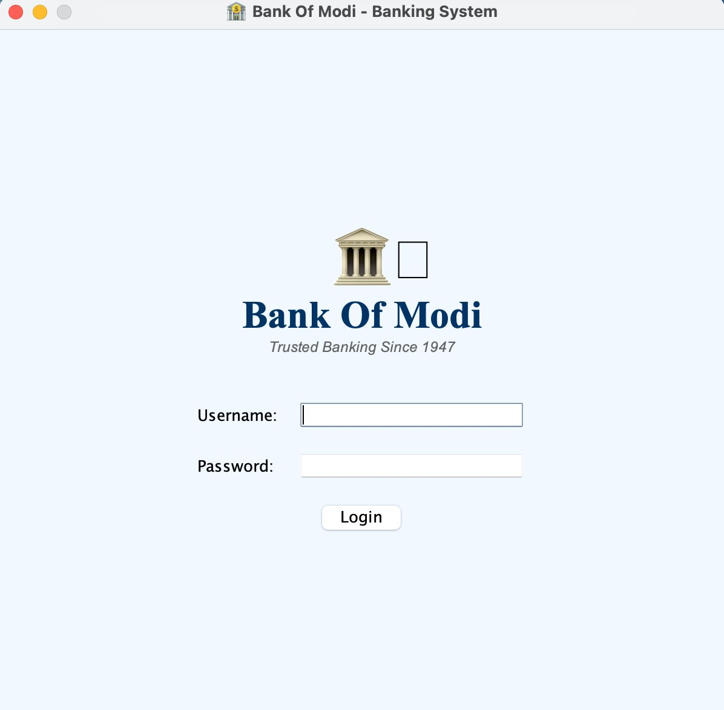
5.2 Admin Dashboard
Buttons available:
- Add New User and Edit User
- Delete User
- View All Users
- Logout and Exit
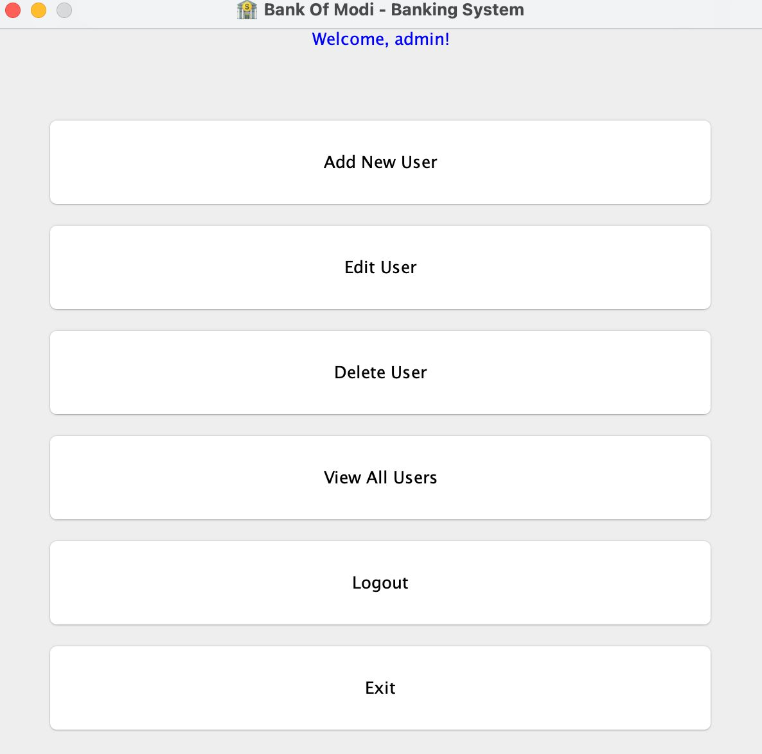

5.3 Add New User Dialog
Fields:
- Username and Password
- Initial Balance and Initial FD Balance
Includes Java logo icon for UI aesthetics.
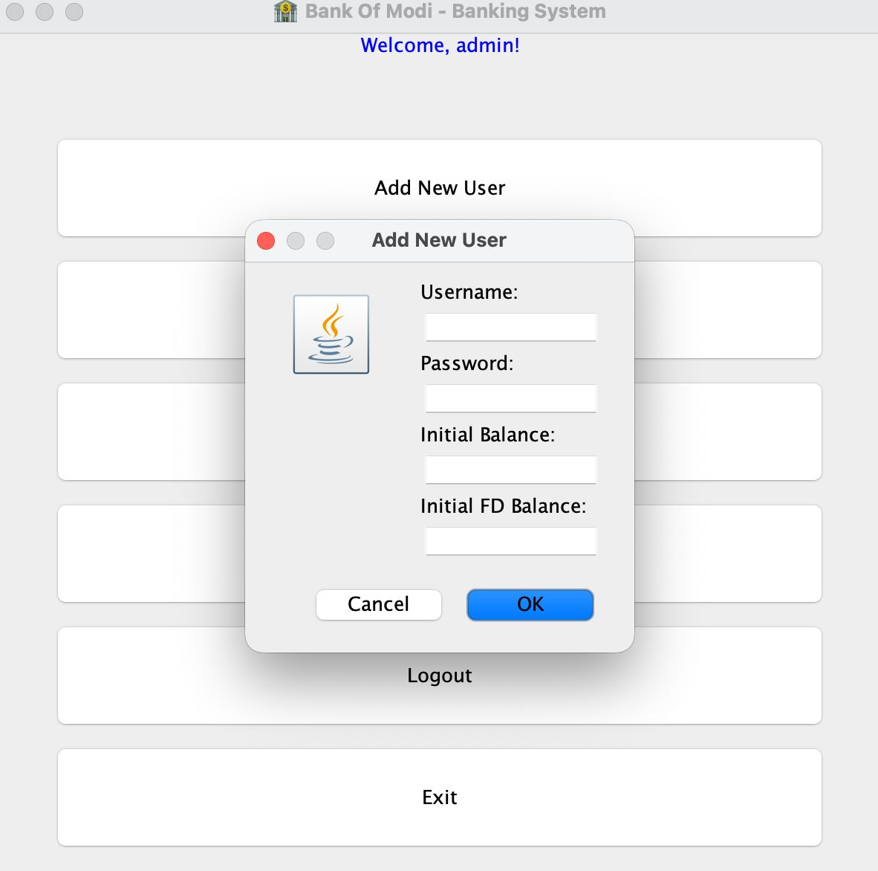
5.4 User Dashboard
Displays:
- Main balance
- FD balance
- Welcome message
- Operations grid:
  - View Balance
  - Deposit and Withdraw
  - Transfer to FD and Withdraw from FD
  - Debit Card and Credit Card Details
  - Pay from Card
  - Transaction History
  - Logout and Exit
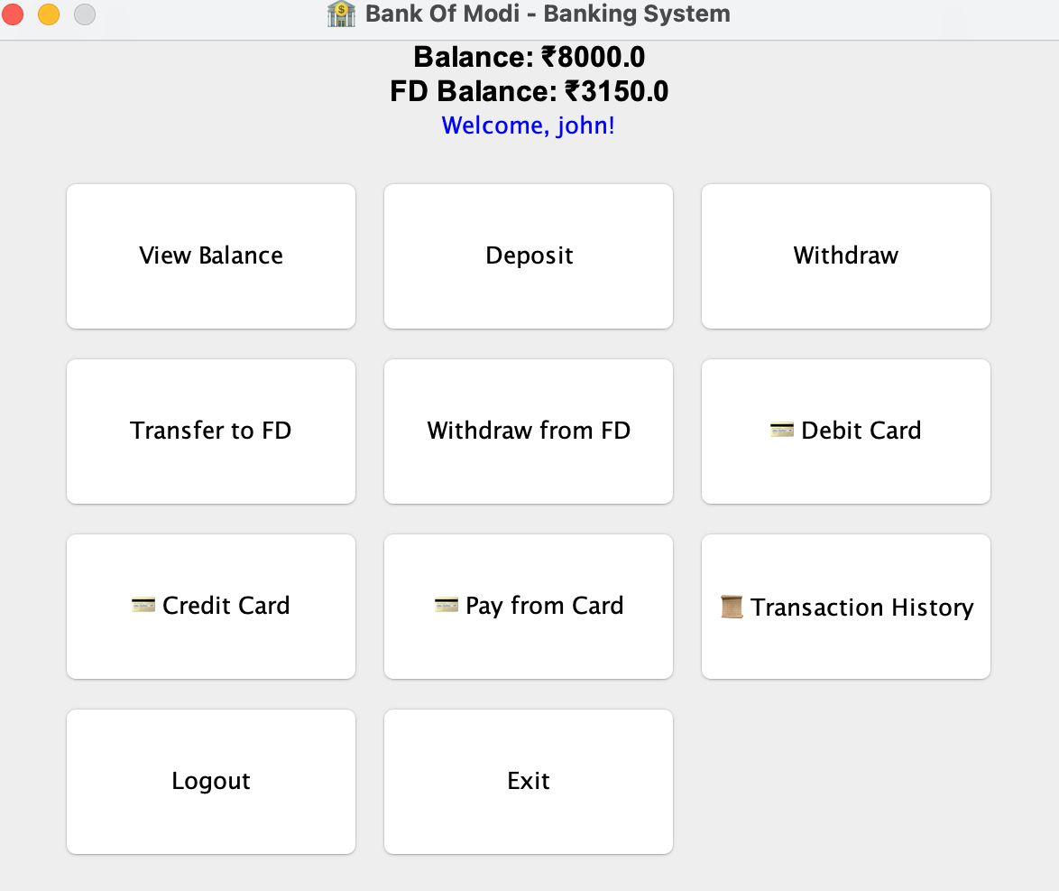
5.5 All Users Window (Admin)
Shows table listing:
- Username
- Balance
- FD Balance
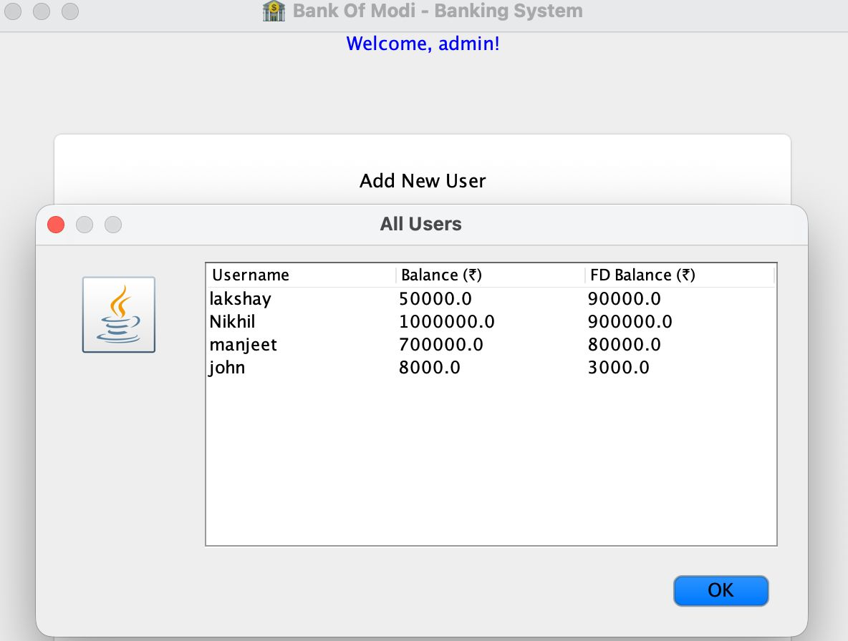

6. Features Implemented
6.1 Admin Features
Add new users
Edit existing user data
Delete users
View all users in table format
Secure login
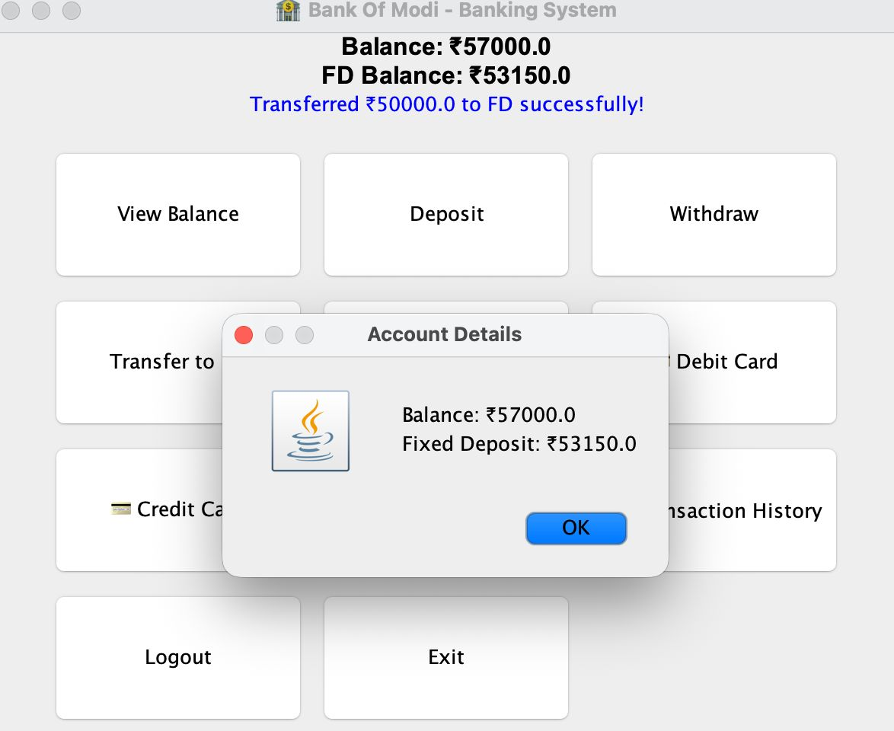

6.2 User Features
1. Deposit Money
- Adds money to main balance and Records transaction
2. Withdraw Money
- Deducts from balance if sufficient or Shows error message if low balance
3. Fixed Deposits (FD)
- Transfer amount to FD and Withdraw from FD
4. Debit Card
- Auto-generated:
  - 16-digit card number, 3-digit CVV, Expiry date
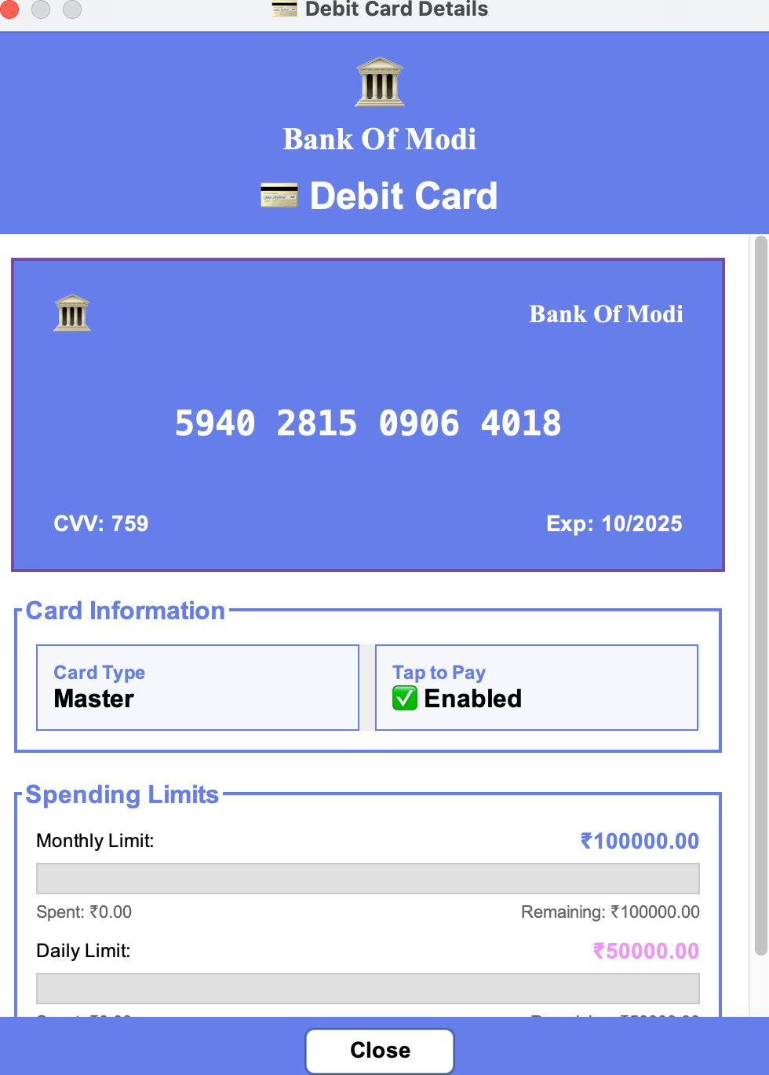
5. Credit Card
- Similar auto-generated card system
- Simulated payment method using credit card

6. Transaction History
- Complete list of all transactions
- Stored permanently in files
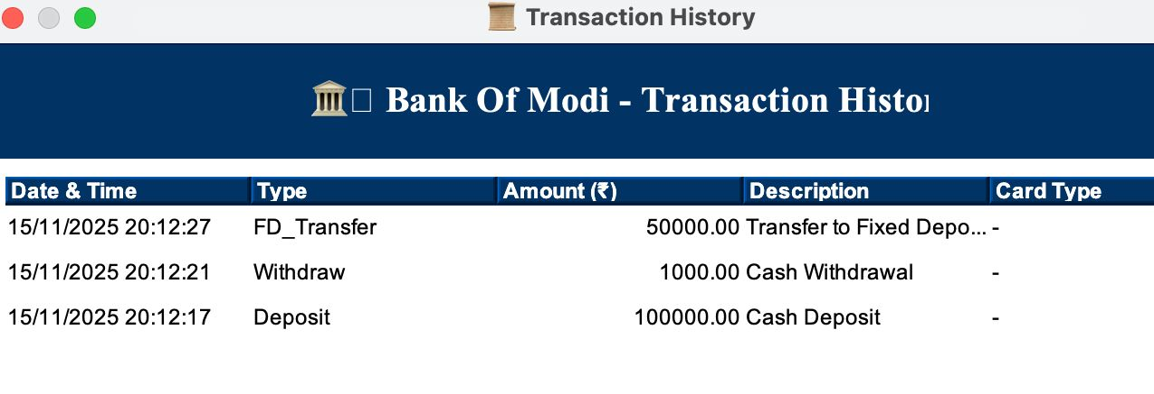

7. Future Enhancements
- Integrate MySQL database
- Add multi-admin support
- Add interest calculation for FD
- Improve UI using JavaFX
- Add ATM pin management
- Add loan management module

8. Conclusion
This Java-based Bank Management System successfully demonstrates the use of Java Swing, OOP, and file handling to build a fully functional banking application.

