Preserve-Enhance-Select: A Task-Oriented Detection Framework for Weak-Anomaly Defects in Guided-Wave Spectra
Dan Gan¹, Peng Lin¹*, Zexiang Li¹, Yaojun Zhang²
1. College of Civil Engineering and Geomatics, Southwest Petroleum University, Chengdu 610500, China;
2. School of Civil Engineering, Chongqing University, Chongqing 400045, China;
gandan@swpu.edu.cn, linpeng802319@163.com*, lzx2024@swpu.edu.cn, zhangyaojun0321@163.com
*Corresponding Author. E-mail address: linpeng802319@163.com (Peng Lin).

Abstract
Surface defect detection in polyethylene pipelines is important for operational safety, yet weak anomalies in guided-wave spectrograms are difficult to identify because they appear as small deviations embedded in highly structured backgrounds. Conventional inspection also relies heavily on expert interpretation and does not provide explicit, reproducible detection results. We propose a Preserve-Enhance-Select (PES) framework built on YOLOv8m for this task. The framework addresses three modality-specific limitations: loss of shallow cues during downsampling, insufficient local discriminability, and interference from irrelevant frequency channels. A P2 prediction branch preserves high-resolution features, RepConv enhances local feature interactions, and Efficient Channel Attention (ECA) recalibrates channel responses. DIoU is used for bounding-box regression. On a guided-wave spectral dataset containing 581 images, the proposed model achieves 90.32% mAP50 and 59.82% mAP50-95 at 21.96 FPS on an RTX 4060 GPU. These results indicate that task-oriented architectural adaptation can improve weak-anomaly detection under small-sample industrial conditions, while the observed generalization remains limited to the tested pipeline and excitation configuration.
Keywords: Polyethylene pipeline; Guided-wave spectrum; Surface defect detection; YOLOv8; Small object detection

1 Introduction
Timely and reliable surface defect detection is a prerequisite for ensuring the long-term service safety of polyethylene pipelines, as minor surface anomalies can readily evolve into stress-concentration sites, leading to leakage or even explosion. The difficulty lies in the fact that these defects often appear as small, weakly textured [1], and irregularly shaped targets embedded in highly repetitive structured backgrounds [2][3]. This detection task demands both high sensitivity and stringent false-alarm control [4][5].
These inherent difficulties are further amplified when the input images shift from natural RGB photographs to frequency-domain spectrograms derived from guided-wave signals—a transformation that arises in the use of piezoelectric ultrasonic guided waves for long-range nondestructive testing of polyethylene (PE) pipelines [6][7][8]. Specifically, original time-domain signals are transformed via fast Fourier transform (FFT) into frequency-domain amplitude spectra. These spectral images then serve as the input images for the detector. Although deep learning models can capture useful patterns from these spectrograms, the detection task here differs fundamentally from standard object detection. Rather than recognizing well-defined objects, the model must detect subtle signals at specific frequency positions—signals that are often hidden by the structured background. This is what makes the detection task difficult.
Guided-wave spectral images exhibit three key properties that fundamentally reshape the detection task: (1) a structured background that is highly regular, (2) weak defect signals that appear as slight deviations from this background pattern, often occupying only a few pixels, and (3) sparse frequency channels where discriminative information is concentrated in only a limited number of bands.
These properties make guided-wave spectrograms fundamentally different from natural images, so standard detectors may perform poorly when applied without adaptation. For example, the standard YOLOv8m prediction head relies predominantly on P3 (stride=8), P4 (stride=16), and P5 (stride=32) feature maps. For weak defects with extremely small spatial extents, repeated downsampling strategy can irreversibly discard the shallow response information that is essential for reliable prediction. Furthermore, ambiguous boundaries and variable contrast make small-box localization unstable. While physical attributes call for tailored architecture modifications, most existing improvements—including sample assignment strategies [9][10], regression losses [11][12][13][14], and lightweight attention mechanisms [15][16][17][18], they have been validated mainly on natural-image datasets, and their effectiveness for guided-wave spectral defects remains unclear.
To address this issue, a task-oriented structural reconstruction of YOLOv8m is proposed under an interpretable Preserve-Enhance-Select (PES) framework. Each component is explicitly designed to address a specific physical challenge: the P2 branch preserves shallow spatial cues; Re-parameterized Convolution (RepConv) strengthens local feature interactions during training while maintaining inference efficiency via structural re-parameterization [19]; and Efficient Channel Attention (ECA) performs sparse channel recalibration matched to the spectral image sparsity of the modality [20]. To improve localization precision under ambiguous boundary conditions, DIoU is adopted as the regression objective [21]. The main contributions are summarized as follows:
(1) Guided-wave spectral defect detection is formalized as a weak-anomaly problem, explaining why standard RGB-oriented detectors fail on this modality.
(2) The PES framework is proposed, where each component is tailored to a specific physical challenge, revealing a synergy among preservation, enhancement, and selection.
(3) Through systematic experiments across detector families, YOLOv8 scales, loss functions, and component combinations, the PES framework consistently outperforms standard YOLOv8m and several mainstream detectors, achieving 90.32% mAP50 at 21.96 FPS. Ablation analyses further reveal that the sequential synergy among P2, RepConv, and ECA—rather than any individual component—is the key to performance gains, and that this synergy depends critically on the prior preservation of shallow cues by the P2 branch.

2 Related Work

2.1 Surface Defect Detection on Industrial Surfaces
Pipeline surface-defect detection has evolved from hand-crafted feature engineering [1] to deep feature learning [2][3] and end-to-end frameworks [4][5]. Despite these advances, the fundamental challenge remains unchanged: defects are small, weak, and embedded in repetitive backgrounds. This challenge is shared by guided-wave spectral detection, where detectors must distinguish subtle defect responses from structured background patterns. Recent studies have also emphasized robustness, small-object sensitivity, and deployment-oriented evaluation in industrial vision [21][22][23]. However, most existing methods are optimized for natural images and do not explicitly address the physical characteristics of signal-derived spectrograms.

2.2 Guided-Wave Spectrograms in Object Detection
Guided-wave techniques are well established for long-range pipeline inspection [6][7][8], but most existing studies focus on physical signal interpretation rather than visual detection. This leaves a clear research gap: although guided-wave testing generates rich spectral data, these data have rarely been treated as input images for deep-learning object detectors. Guided-wave spectrogram analysis is therefore formulated as a weak-anomaly detection problem and evaluated using a reproducible visual-detection pipeline.

2.3 Small Object Detection and Real-Time Detectors
Small object detection has long been challenging because discriminative information is lost during downsampling, and limited context degrades classification and localization stability [24]. Feature Pyramid Networks [25] and Path Aggregation Networks [26] became standard solutions by strengthening the fusion of shallow high-resolution and deep semantic features. Subsequent works, including Fully Convolutional One-Stage Object Detection [9], Adaptive Training Sample Selection [10], Generalized Focal Loss [11], Task-Aligned One-Stage Object Detection [27], and EfficientDet [18], further improved dense prediction via better sample assignment and network scaling. The YOLO family has become a widely used architecture for real-time detection due to its balance of accuracy and efficiency [28][29]; later variants such as YOLOv4 [30], YOLOX [31], YOLOv7[32], RTMDet [33], YOLOv6 [34], and YOLOv9 [35] have progressively advanced the state of the art. However, improvements effective for natural images are not necessarily transferable to weak guided-wave anomaly detection. To improve feature quality under limited computational cost, structural re-parameterization (RepVGG [19], RepConv [34]) and lightweight channel attention (SENet [15], CBAM [16], ECA [20]) have been proposed. Their practical value depends on whether they match the target modality's detection pipeline. Guided by this, these modules are selectively combined and evaluated for the guided-wave spectral task.

3 Dataset and Task Characteristics

3.1 Guided-Wave Spectral Dataset
The guided-wave signals were acquired from polyethylene pipes using piezoelectric transducers. The pipe had an outer diameter of 110 mm and a wall thickness of 6.3 mm. The transducers were made of PZT-4 ceramic and were operated with a 20 kHz tone-burst excitation. The relevant material and geometrical parameters are summarised in Table 1.
The received time-domain signals were digitised at a sampling rate of 120 kHz. Each spectrogram was computed using a 512-point FFT, corresponding to a frequency resolution of approximately 234 Hz. After FFT, the resulting amplitude spectra were rendered as spectrogram images using the Jet colormap. Each spectrogram image represents a pipe segment of 2 m in length.
Two types of artificial defects were introduced into the pipe sections: surface scoring (scratches) and small-diameter drilled holes. These defect types were selected to represent typical surface anomalies encountered in field conditions, including mechanical damage and localised material loss. The dataset comprises 581 images. Fig. 1 presents representative samples at three defect-visibility levels. The dataset was divided into training, validation, and test sets at a ratio of 7:2:1.
Table 1. Key parameters of the guided-wave inspection setup.
Group | Parameter | Value
PE pipe | Outer diameter (mm) | 110
PE pipe | Wall thickness (mm) | 6.3
PE pipe | Poisson's ratio | 0.45
PE pipe | Young's modulus (GPa) | 0.8
PE pipe | Density (kg/m³) | 950
PZT-4 transducer | Poisson's ratio | 0.33
PZT-4 transducer | Young's modulus (GPa) | 140
PZT-4 transducer | Density (kg/m³) | 7500
PZT-4 transducer | Excitation frequency (kHz) | 20
Acquisition | Sampling rate (kHz) | 120
Acquisition | FFT points | 512
Acquisition | Frequency resolution (Hz) | ≈ 234
Acquisition | Pipe segment per spectrogram (m) | 2
Acquisition | Defect types | Surface scoring, drilled holes

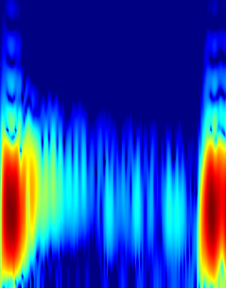 | 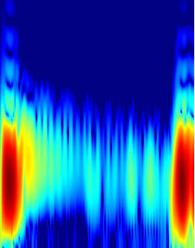 | 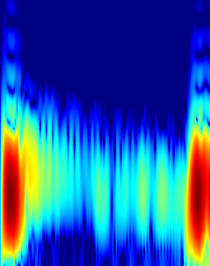
(a) Low-visibility defects
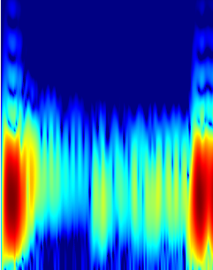 | 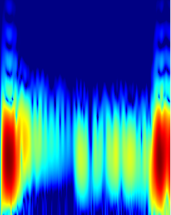 | 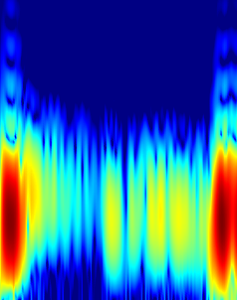
(b) Moderate defects
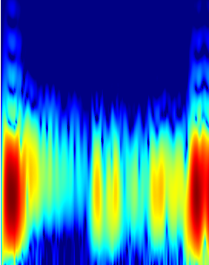 | 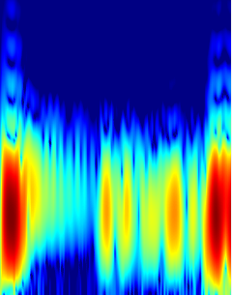 | 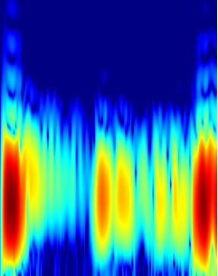
(c) High-visibility defects
Fig. 1. Representative guided-wave spectra at different defect-visibility levels.

3.2 Visibility-Oriented Task Interpretation
Under this pseudo-color scheme, defect-related spectral perturbations often manifest as warm-colored (yellow-to-red) regions. To quantify defect visibility, a warm fraction (WF) is defined for each annotated defect region as the proportion of pixels satisfying the HSV-based warm-color criteria listed in Table 2:
where A_{warm} denotes the area (in pixels) covered by warm-color pixels and and A_{total} is the total area of the defect region. Both are measured in pixels within each annotated bounding box. The HSV thresholds in Table 2 are selected to isolate yellow-to-red tones under the Jet colormap—Hue defines the color range, while Saturation and Value exclude pixels with low chroma or low luminance.
Based on the WF distribution over an independent validation subset, defects are grouped into three visibility levels (Table 3). The two thresholds—0.018 and 0.20—are chosen empirically to separate visually distinct groups while preserving sufficient samples in each category for subsequent visibility-wise analysis. Notably, the lower threshold (0.018) corresponds to perturbations barely distinguishable from background fluctuations, while the upper threshold (0.20) captures salient peaks. This grouping, while not a direct physical SNR measurement, provides a practical proxy for defect saliency under the fixed Jet colormap configuration.
It should be noted that WF is an engineering proxy for visual saliency rather than a physical measurement of defect severity or SNR. Its reliability depends on the Jet colormap and the assumption that defect responses consistently manifest as warm-colored regions. This limitation is acceptable for the present study, as WF is used solely for grouping defects into three visibility levels for subsequent fine-grained performance evaluation, rather than as a core component of the detection framework.
Table 2. HSV criteria for identifying warm-highlight pixels in defect regions.
Hue | Saturation | Value
$\text{H} \text{≤} \text{35}$ or $\text{H} \text{≥} \text{170}$ | $$\text{S} \text{>} \text{60}$$ | $$\text{V} \text{>} \text{100}$$

Table 3. Visibility-level partition based on warm fraction.
Low-Visibility | Medium-Visibility | High-Visibility
< 0.018 | 0.018 $\text{≤}$ WF < 0.20 | $\text{≥}$0.20

3.3 Conservative Data Augmentation
Considering the physical meaning of the spectrograms and the precision of the annotations, we adopt a conservative data-augmentation strategy. Specifically, we employ random horizontal flipping (probability 0.5), mild affine transformations (rotation and scaling), and moderate brightness/contrast adjustments. This strategy enlarges the training distribution while largely preserving the physical fidelity of local spectral morphology. Fig. 2 compares original and augmented samples.
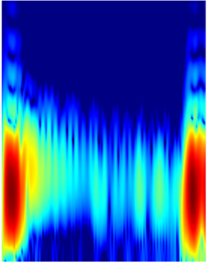 | 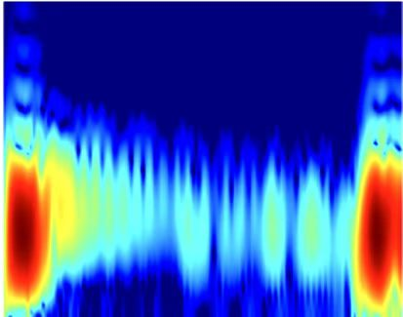
(a) Original image | (b) brightness
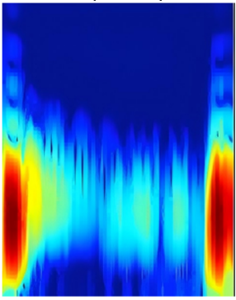 | 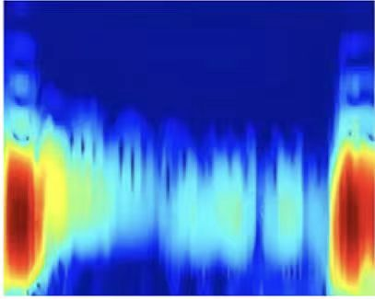
(c) Original image | (d) contrast
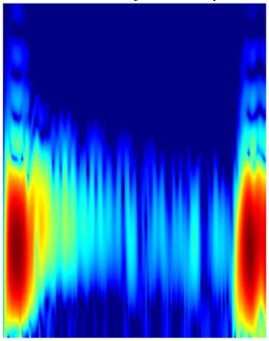 | 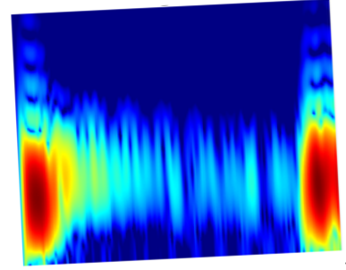
(e) Original image | (f) rotation
Fig. 2. Comparison between original and augmented guided-wave spectra.

4 Method

4.1 Design Rationale and Overall Architecture
The proposed detector is built around a Preserve-Enhance-Select design principle to address three interrelated physical challenges in spectrogram analysis: (1) loss of weak defect cues during early downsampling; (2) insufficient discriminability of local features against structured spectral backgrounds; (3) channel-level interference caused by non-informative frequency channels. These three components are cascaded to form a coordinated response: the P2 branch serves as the Preserve component to retain shallow anomalous information; RepConv acts as the Enhance component to strengthen local feature representation while maintaining inference efficiency via re-parameterization; and ECA functions as the Select component to suppress channels weakly associated with subtle defects.
The detector is reconstructed based on YOLOv8m for the guided-wave spectral defect-detection task. The backbone extracts hierarchical features, and the neck retains the standard top-down and bottom-up feature-fusion logic. The detection head is redesigned to allow high-resolution shallow features to participate directly in the final predictions. The detailed network structure is shown in Fig. 3.
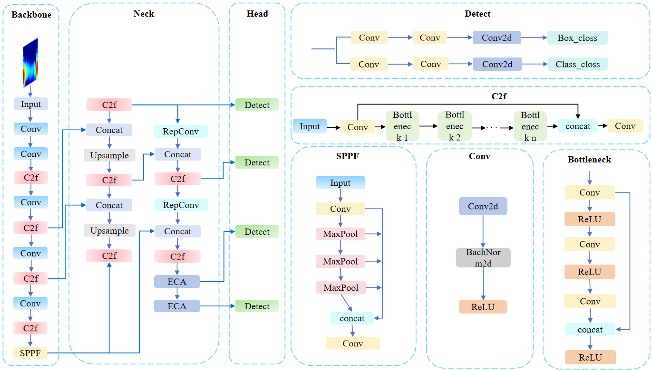
Fig. 3. Overall structure of the reconstructed YOLOv8m with P2, RepConv, and ECA.

4.2 P2 Prediction Branch: Preserving Shallow Anomalous Cues
Targeting the loss of shallow anomalous cues during early downsampling, we introduce a P2 prediction branch. In our dataset, many low-visibility defect boxes are smaller than 32×32 pixels at the input resolution of 1280×1280. If the standard YOLOv8 P3 layer (stride=8) is used as the highest-resolution prediction layer, a 20×20 defect is compressed to approximately 3×3 pixels before entering the detection head—an irreversible loss. The P2 branch (stride=4) increases the retained spatial information by a factor of four within the effective receptive field, as the spatial resolution doubles along each dimension.
In implementation, this branch is taken from the output of the second stage of the backbone (the second C2f block), corresponding to a downsampling factor of 4. Under 1280×1280 input, the four prediction scales are P2: 320×320, P3: 160×160, P4: 80×80, and P5: 40×40. The P2 feature map contains 256 channels. To integrate it into the PANet structure, we fuse this feature map with the upsampled P3 feature map after 1×1 convolutional channel alignment, and then send the fused result to a dedicated P2 detection head. The final detector performs prediction simultaneously at the P2, P3, P4, and P5 scales (Fig. 3).

4.3 Feature Enhancement Based on RepConv
Given the insufficient local discriminability of features against structured backgrounds, RepConv is incorporated into the neck network to address this specific challenge. After shallow details are preserved by the P2 branch, these features still contain both defect-related local structures and structured background noise. Their local discriminability therefore needs to be enhanced during feature fusion. RepConv [19][34] is introduced for this purpose. Its main advantage lies in structural re-parameterization: during training, a multi-branch structure composed of 3×3 convolution, 1×1 convolution, and identity-mapping branches provides richer optimization paths for learning local spectral patterns; during inference, the module is folded into an equivalent single-path 3×3 convolution. RepConv is particularly suitable for this task for two reasons:
(1) Multi-scale receptive-field fusion. A standard 3×3 convolution has a fixed local receptive field. For weak defects superimposed on structured backgrounds, the defect’s spatial support may be smaller than the convolution kernel, causing inseparable mixing of defect signal and background noise. During training, RepConv combines 3×3, 1×1 convolution, and identity branches in parallel, aggregating responses from multiple receptive-field scales. The 3×3 convolution branch captures local patterns, the 1×1 convolution branch performs pointwise channel recombination, and the identity branch preserves original details. This multi-path structure enables the network to learn differentiated response strategies for perturbations at different scales.
(2) Unlike the baseline where shallow gradients rely solely on a single convolutional path, RepConv’s multi-branch structure provides multiple shortcut paths, facilitating earlier error propagation to shallow layers and mitigating gradient attenuation in weak-signal scenarios.
However, RepConv's strong representational capacity is a double-edged sword under small-sample conditions. The multi-branch structure—with an effective parameter scale roughly two to three times that of a single-path convolution—may overfit structured backgrou
nd spectral patterns spuriously correlated with defect labels in the training set. Crucially, this overfitting risk can be effectively counteracted by the subsequent channel-selection mechanism (ECA), which suppresses the spuriously activated background channels. This synergistic phenomenon is examined in the ablation study (Section 5.4).
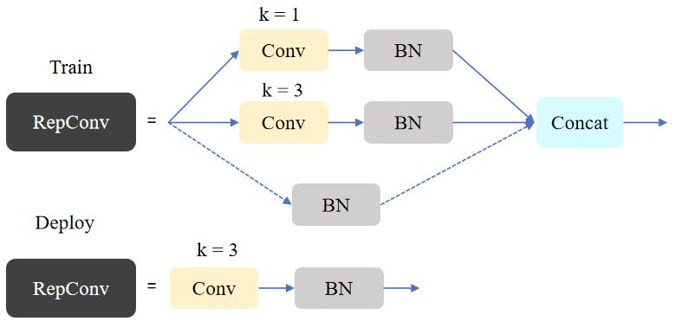
Fig. 4. Structural re-parameterization of the RepConv module.

4.4 Efficient Channel Attention
A third source of interference arises from non-informative frequency channels. To suppress their impact, the ECA module is embedded. Guided-wave propagation in PE pipelines exhibits pronounced dispersion: different frequency components propagate at different velocities, and defect-reflection signal energy is not uniformly distributed but concentrated in specific frequency intervals. These information-rich bands depend on both pipeline parameters and defect characteristics. Therefore, an effective channel-attention mechanism should be able to focus sparsely on such bands.
SENet [15] realizes attention via fully connected layers, but its dimensionality-reduction operation disrupts the original dependency structure among channels. In guided-wave spectra, defect-related channels are sparse and localized. SENet’s dimensionality reduction mixes and compresses this sparse activation pattern together with a large number of irrelevant channels, thereby diluting attention weights. ECA [20] avoids dimensionality reduction and instead implements local cross-channel interaction directly via one-dimensional convolution. Its adaptively determined kernel size ensures that the interaction range matches the total number of channels while preserving sparsity in channel dependency.
After preservation by P2 and enhancement by RepConv, ECA acts as the final feature-gating mechanism. Its selection effect essentially amounts to automatically focusing on physically informative frequency bands rather than indiscriminately suppressing all channels. The results in Section 5.6 show that, for defective samples, channels with high ECA weights are indeed concentrated near the frequency locations where defect signals occur, whereas for defect-free samples, the weight distribution becomes more dispersed and lower in amplitude.
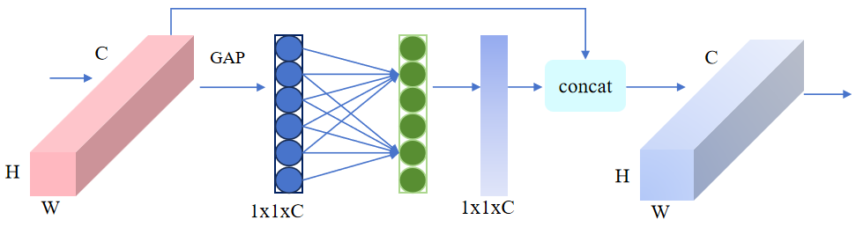
Fig. 5. Schematic illustration of the efficient channel attention (ECA) module.

4.5 Bounding-Box Regression Based on DIoU
Accurate bounding-box regression is crucial for localizing weak defects with ambiguous boundaries. To this end, the DIoU loss is adopted, which augments IoU by adding a penalty term for the distance between the centers of the predicted box and the ground-truth box. Given a predicted box and a ground-truth box, the DIoU loss is defined as Eq. (2).
where denotes the Euclidean distance, b and b_{gt} denote the centroids of the predicted and ground-truth boxes, respectively, and c is the diagonal length of the smallest enclosing rectangle that covers both boxes.
The first term, , measures the overlap between the two boxes, while the second term penalizes the normalized center-point offset. By jointly considering overlap and center distance, DIoU provides clearer geometric constraints when spectral contrast is low and boundaries are blurred. A geometric illustration of DIoU is shown in Fig 6.
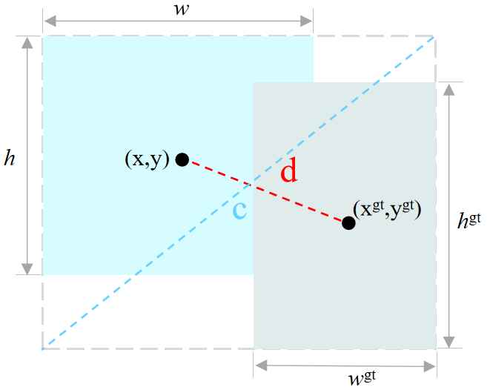
Fig. 6. Illustration of the DIoU regression loss.

5 Experiments

5.1 Experimental Settings
All experiments were conducted on a unified hardware and software platform (Table 4) with the hyperparameters summarized in Table 5. A two-stage optimization strategy was employed: Stage 1 froze the first ten backbone layers to train the newly added P2 head and RepConv modules with a learning rate of 2×10⁻⁴ and weight decay of 5×10⁻⁴; Stage 2 fine-tuned all layers with a lower learning rate (3×10⁻⁵) and higher weight decay (8×10⁻⁴) to prevent optimization drift.
Due to the 8 GB memory constraint, the batch size was set to 4. In this task, shallow spatial details are highly important, and reducing input resolution solely to allow a larger batch size could destroy the fragile cues that the P2 branch is intended to preserve.
Table 4. Computing environment used for training and testing.
Device | Configuration
CPU | Intel(R) Core(TM) i5-14600K
GPU | NVIDIA GeForce RTX 4060
CUDA | CUDA 11.8
Framework | PyTorch 2.7.1
IDE | PyCharm
System | Windows 11 Pro

Table 5. Training configuration and hyperparameter settings.
Hyperparameter | Value
Input image size | 1280×1280
Epochs | 200
Batch size | 4
Optimizer | AdamW
Initial learning rate | Stage 1: 2 × 10⁻⁴
Initial learning rate | Stage 2: 3 × 10⁻⁵
Weight decay | Stage 1: 5 ×10⁻⁴
Weight decay | Stage 2: 8 ×10⁻⁴
Momentum | 0.937
Warmup epochs | Stage 1: 4
Warmup epochs | Stage 2: 3
Box loss gain | 10.0
Classification loss gain | 1.05
Distribution Focal Loss loss gain | 2.0
IoU loss | DIoU

5.2 Evaluation Metrics
Precision, Recall, F1-score, Average Precision (AP), mAP50, and mAP50-95 are adopted as evaluation metrics in accordance with standard object-detection protocols [36][37]. Precision reflects the ability to control false alarms, whereas Recall reflects the ability to control missed detections. mAP50 evaluates detection performance at IoU = 0.50, while mAP50-95 is more sensitive to high-quality localization. These metrics should be reported jointly, because a higher Recall may come at the expense of more false positives, whereas a higher Precision alone may conceal missed detections of weak defects. The definitions of Precision, Recall, and F1-score are given in Eqs. (3)–(5):
where TP, FP, and FN denote true positives, false positives, and false negatives, respectively.
For a given defect category c, the Average Precision (AP) is computed as the area under the precision-recall curve:
where is the precision at recall level r for category c.
For n defect categories (n = 3 in this study: Low-Visibility, Medium-Visibility, and High-Visibility), the mean average precision (mAP) is obtained by averaging AP over all classes:
Specifically, mAP50 is calculated at IoU = 0.50, whereas mAP50-95 averages AP over IoU thresholds from 0.50 to 0.95 with a step of 0.05:
The metrics should be interpreted together with ablation results and scale-wise analyses rather than as definitive population estimates, especially when comparing close mAP values.

5.3 Comparison with Mainstream Detectors
To examine whether YOLOv8m is an appropriate baseline and to compare different detection paradigms on this task, we evaluated several mainstream detectors under a unified protocol (Table 6). This comparison serves two purposes: it supports our choice of baseline architecture, and it helps reveal which inductive biases are more suitable for weak spectral anomalies.
Among the evaluated models, YOLOv8m achieved the best overall balance between accuracy and efficiency, with 86.44% mAP50 and 58.33% mAP50-95. Its Precision and Recall reached 78.04% and 86.03%, respectively. Faster R-CNN showed different behaviour. Although its Recall was much higher at 94.58%, its Precision dropped to 63.05%, indicating a substantial false-positive burden.
One possible explanation is that proposal-based detectors are less well matched to this modality. In guided-wave spectra, defects are not clear semantic entities with stable boundaries, but weak perturbations superimposed on structured backgrounds. Under these conditions, the proposal stage may generate many candidates around strong background responses that resemble defect patterns, making false positives harder to suppress. In contrast, one-stage dense prediction may be better suited to this setting because classification and localisation are learned directly on shared feature maps.
Interestingly, YOLOv9m and YOLO12m[38] did not outperform YOLOv8m on this dataset, despite their more recent designs. This result suggests that architectural advances developed for natural-image benchmarks do not necessarily transfer to guided-wave spectra. A reasonable interpretation is that this task still depends heavily on local inductive bias and stable shallow-detail preservation, whereas more globally oriented mechanisms may be less effective when weak defect cues are easily masked by dominant spectral backgrounds.
Table 6. Comparison with mainstream object detectors.
Method | Precision | Recall | mAP50 | mAP50-95 | Params (M) | FLOPs (G)
YOLOv3 | 72.34 | 82.84 | 85.63 | 57.15 | 103.75 | 1133.3
YOLOv5m | 71.74 | 76.32 | 81.52 | 52.03 | 25.11 | 258.4
YOLOv8m | 78.04 | 86.03 | 86.44 | 58.33 | 25.90 | 317.3
YOLOv9m | 73.72 | 80.49 | 78.24 | 49.13 | 20.22 | 311.5
YOLO12m | 81.50 | 75.88 | 84.56 | 55.79 | 20.20 | 272.3
Faster R-CNN | 63.05 | 94.58 | 88.16 | 56.89 | 41.36 | 123.1
SSD | 50.90 | 84.94 | 74.49 | 46.25 | 24.01 | 30.5

5.4 Component-Level Ablation Experiments
Systematic component-level ablation experiments were conducted to verify the effectiveness of the PES framework and the independent contribution of each component (Table 7). Rather than a simple linear accumulation of performance gains, the results reveal nonlinear synergy among the components when addressing specific physical challenges. The foundational role of the P2 branch is evident: shallow preservation is the primary source of performance improvement.
Comparing ID 1 with ID 2, introducing the P2 branch raises mAP50 from 86.44% to 87.22% and mAP50-95 from 58.33% to 59.72%. This result is consistent with the analysis in Section 4.2. For low-visibility defects with very small spatial support, the stride-8 downsampling of the baseline can remove shallow information before prediction. The P2 branch (stride = 4) injects higher-resolution features into the detection head and provides the foundation for the subsequent component analysis. The observed gain should not be interpreted as a direct empirical test of the data-processing inequality.
The contrasting behaviors of ID 3 and ID 4 reveal the importance of sequential order in the PES pipeline. For ID 3, adding RepConv solely on top of the P2 branch leads to a notable performance degradation, with mAP50 dropping to 85.23%. We attribute this drop to overfitting: RepConv's multi-branch structure effectively enlarges the hypothesis space (roughly 2–3 times the effective parameters of a plain convolution). Under the limited sample size (2,143 instances), this strong capacity encourages the model to fit spurious background patterns that are accidentally correlated with defect labels in the training set, especially for low-visibility cases where the signal is buried in noise.
In contrast, adding ECA alone on top of P2 (ID 4) yields a stable yet modest improvement (87.84% mAP50), which is consistent with channel selection providing a relatively stable inductive bias. However, without feature enhancement, ECA operates on ambiguous representations and may not fully resolve the local discriminability issue.
The full model (ID 5) achieves 90.32% mAP50. Its improvement over the partial configurations is consistent with an interaction among shallow-cue preservation, local feature enhancement, and channel recalibration. One plausible interpretation is that P2 provides higher-resolution features, RepConv improves local feature interactions, and ECA attenuates less informative responses. Because the present ablation is based on a limited dataset and single reported runs, this interaction should be described as evidence consistent with synergy rather than as a definitive causal decomposition. Precision increases from 79.61% (ID 2) to 88.36% (ID 5), but the stability of this gain should be assessed across repeated runs.
Table 7. Component-level ablation experiments for the proposed framework.
ID | P2 | RepConv | ECA | Precision (%) | Recall (%) | mAP50 (%) | mAP50-95 (%)
1 | N | N | N | 78.04 | 86.03 | 86.44 | 58.33
2 | Y | N | N | 79.61 | 81.27 | 87.22 | 59.72
3 | Y | Y | N | 84.12 | 76.68 | 85.23 | 58.30
4 | Y | N | Y | 83.99 | 83.76 | 87.84 | 58.81
5 | Y | Y | Y | 88.36 | 81.65 | 90.32 | 59.82
Note: Y : Yes, N : No.

5.5 Deployment-Oriented Evaluation
Deployment constraints such as latency, throughput, and memory consumption are important in industrial detection workflows. Table 8 reports deployment cost on an RTX 4060 under a unified FP16 protocol with 1280 x 1280 input. Because RepConv is re-parameterised before inference, the reported cost reflects deployment-time rather than training-time overhead.
Standard YOLOv8m runs at 28.04 FPS with a memory footprint of 153 MB. The full model achieves 21.96 FPS with 216 MB of memory, while latency increases from 35.67 ms to 45.54 ms per image. These results show the practical cost of four-scale fusion and additional modules. Even so, the redesigned detector remains above 20 FPS, which makes it suitable for offline batch detection and preliminary industrial screening. For stricter real-time scenarios requiring over 30 FPS, further engineering optimizations—such as TensorRT acceleration or model pruning—could be applied without altering the core architectural design.
Compared with manual interpretation of guided-wave spectrograms, which typically requires an experienced analyst to visually inspect each image and can take several seconds to minutes per spectrum, the proposed model processes a 1280×1280 spectrogram in approximately 45 ms on a mid-range GPU. This speed enables rapid screening of large inspection datasets. In addition, the model provides consistent and reproducible detections, whereas manual interpretation may vary between operators. However, the current model should be regarded as a screening aid rather than a replacement for expert judgement, especially for borderline indications.
Table 8. Deployment-oriented evaluation under the unified FP16 test protocol.
Method | Input Size | Precision Mode | Latency (ms/image) | FPS | Memory (MB)
YOLOv8n | 1280x1280 | FP16 | 31.50 | 31.75 | 38
YOLOv8s | 1280x1280 | FP16 | 32.34 | 30.92 | 94
YOLOv8m | 1280x1280 | FP16 | 35.67 | 28.04 | 153
YOLOv8l | 1280x1280 | FP16 | 48.77 | 20.50 | 288
P2 + RepConv + ECA (Ours) | 1280x1280 | FP16 | 45.54 | 21.96 | 216

5.6 Convergence and Visualization Analysis
Fig. 7 illustrates the training dynamics by depicting the trajectories of the loss and evaluation metrics throughout the two-stage training procedure. As seen in Fig. 7(a) (Stage 1), when the backbone is frozen, the validation box loss and classification loss stabilize quickly, indicating that allowing the newly added modules to adapt independently is beneficial under small-sample conditions. As shown in Fig. 7(b) (Stage 2), after the backbone is unfrozen, the validation metrics (specifically mAP50 and mAP50-95) continue to improve without obvious oscillation, suggesting that a cautious learning-rate annealing strategy helps preserve the feature-extraction capability of the pretrained backbone while fine-tuning the entire architecture.
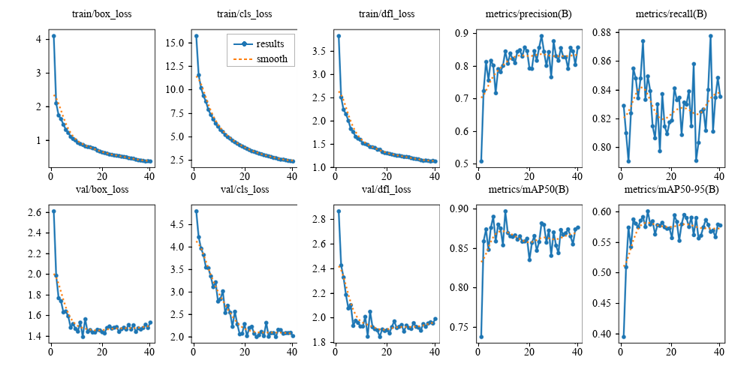
(a) Stage-1 training dynamics
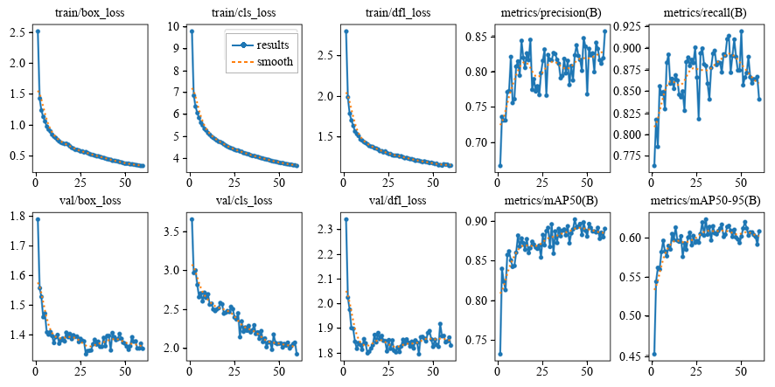
(b) Stage-2 fine-tuning performance evolution
Fig. 7. Two-stage training loss and performance trajectories.

The threshold-dependent characteristics are further examined through F1-confidence and precision-recall curves. The F1-confidence curve (Fig. 8(a)) and precision-recall curve (Fig. 8(b)) guide the selection of deployment thresholds. The F1 curve peaks at a confidence threshold of approximately 0.45, which can be used as a default operating point balancing false alarms and missed detections. The PR curve shows that Precision remains relatively stable even in the high-recall region (Recall > 0.75), meaning that when the threshold is lowered to improve recall for industrial screening, the model does not rapidly lose control by generating excessive false positives.
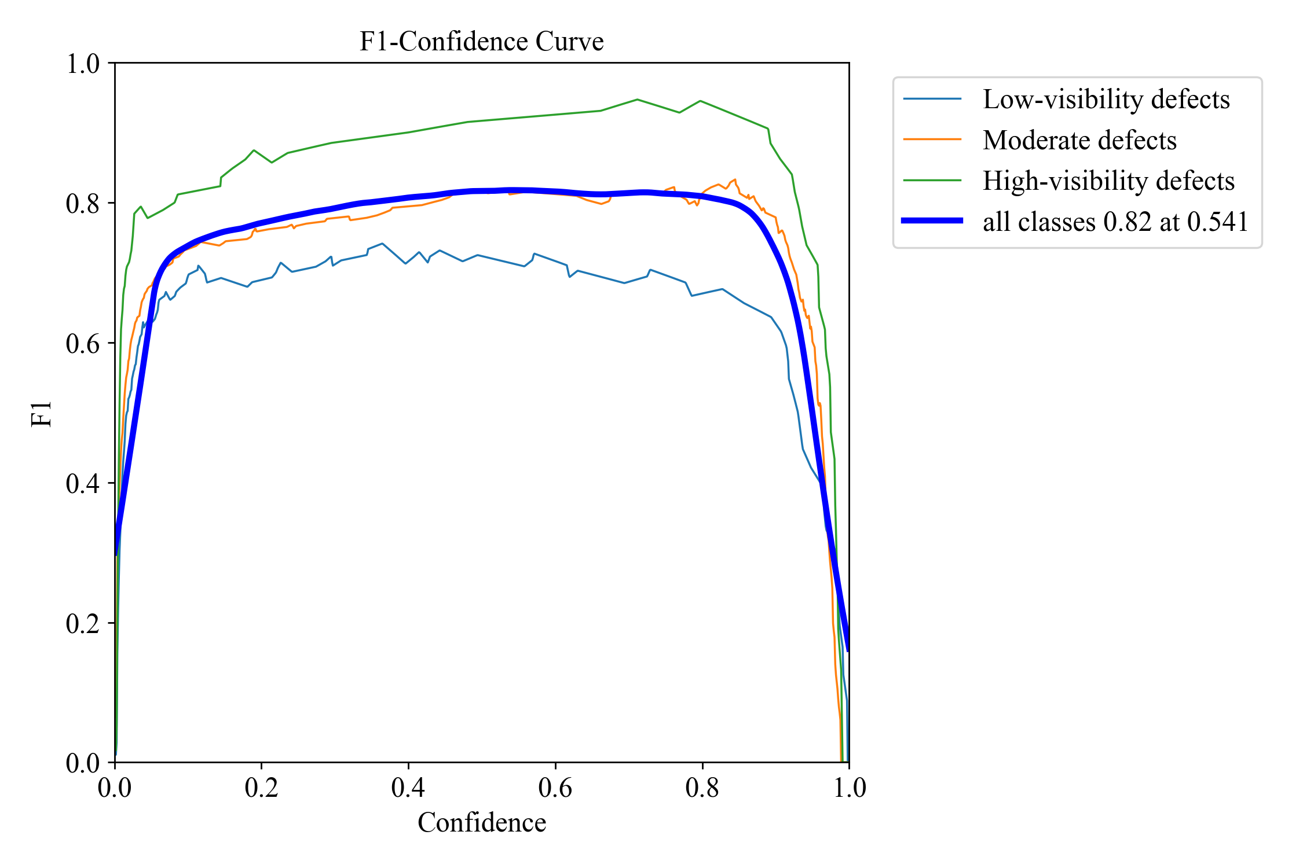
(a) F1-score versus confidence threshold
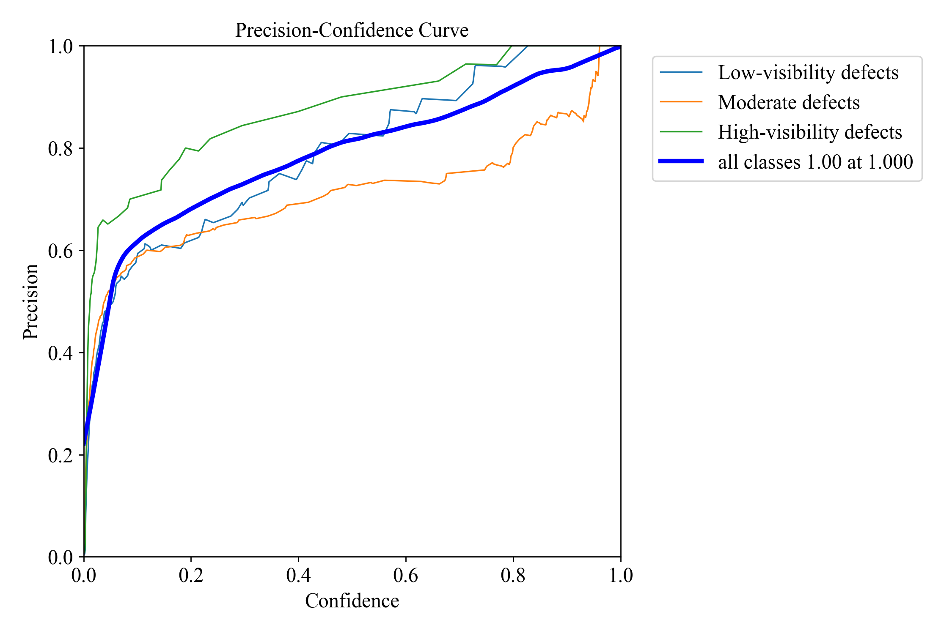
(b) Precision-Recall curve
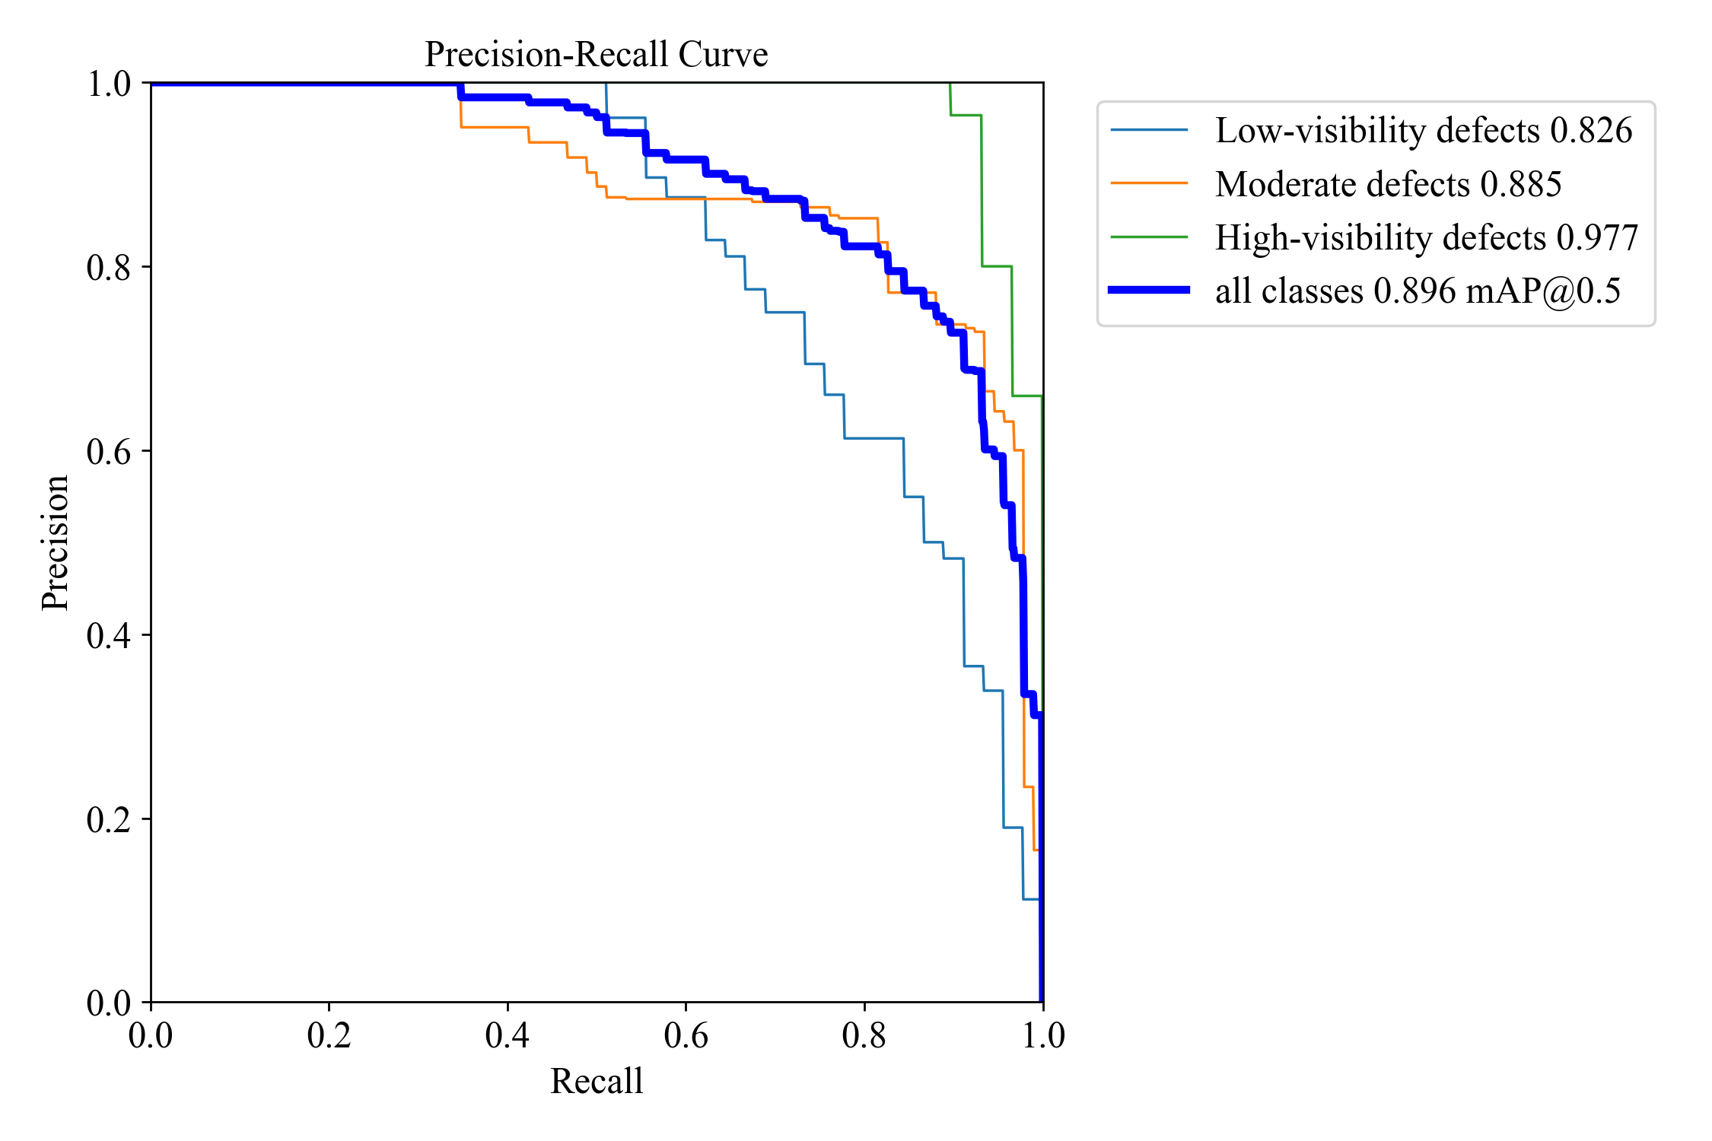
(c) Precision versus confidence threshold
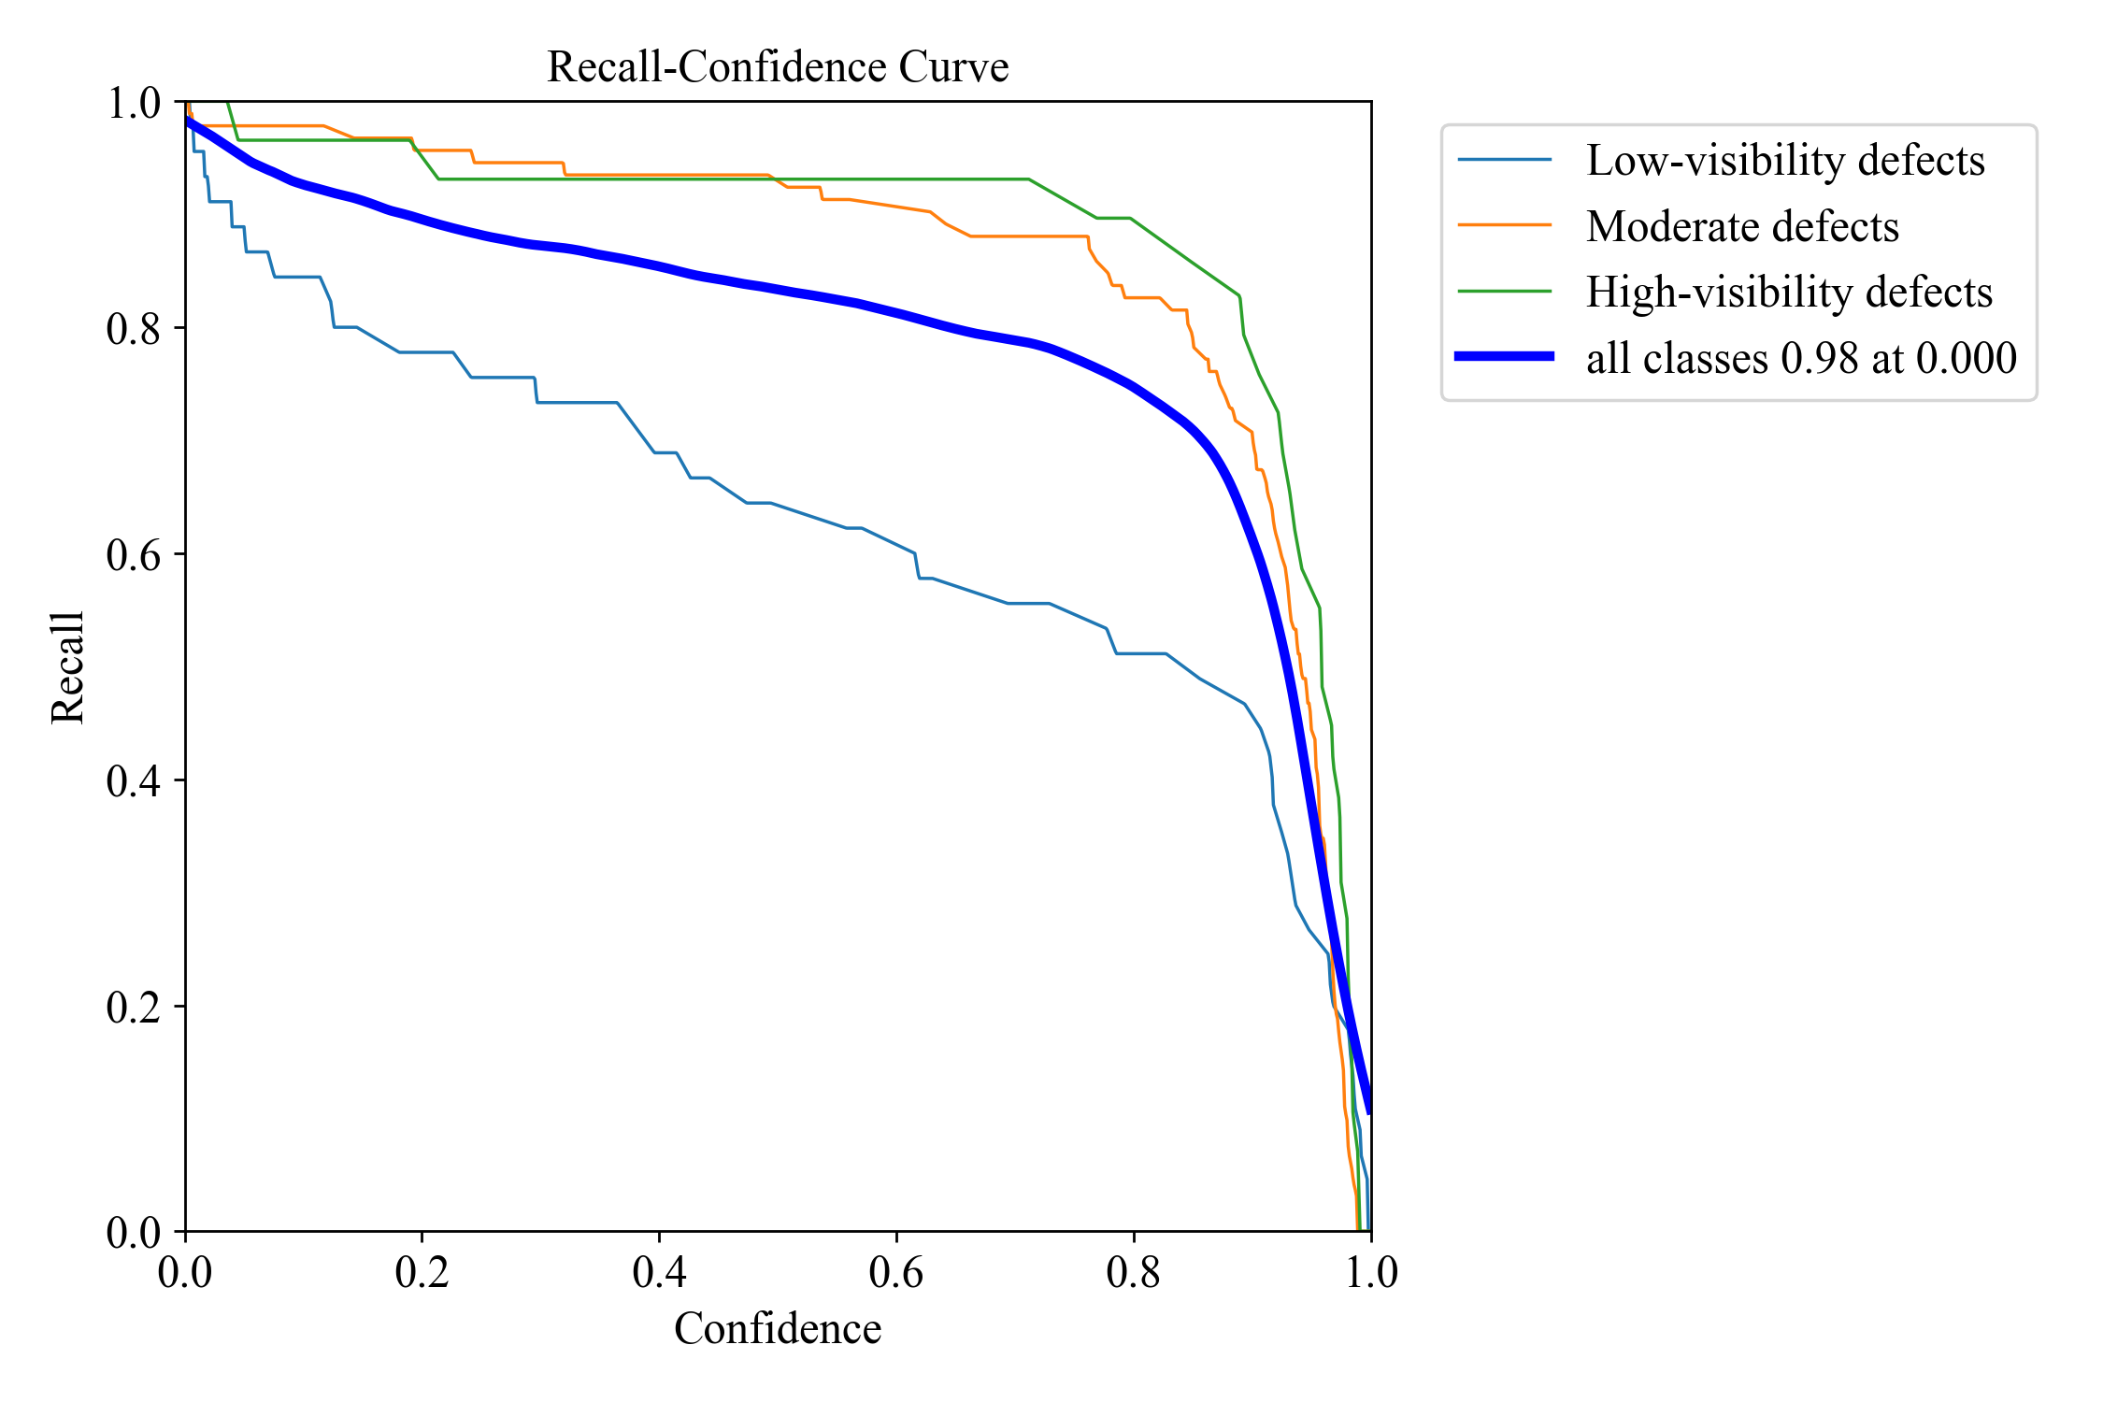
(d) Recall versus confidence threshold
Fig. 8. Threshold-dependent F1, PR, precision, and recall curves.

Confusion matrices for Stages 1 and 2 (Fig. 9) reveal that misclassifications predominantly occur between adjacent visibility levels rather than extreme ones. This is consistent with the physical nature of guided-wave spectra, because defect saliency varies continuously rather than being inherently discrete. The visibly stronger diagonal elements in Stage 2 further indicate that the two-stage fine-tuning process helps refine the decision boundaries among visually similar classes.
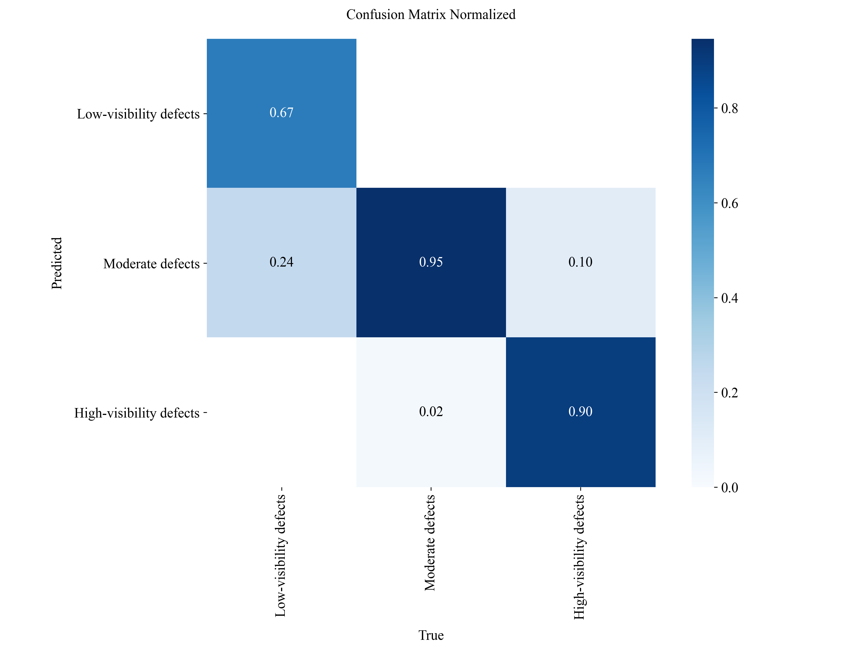
(a) Confusion matrix after Stage 1
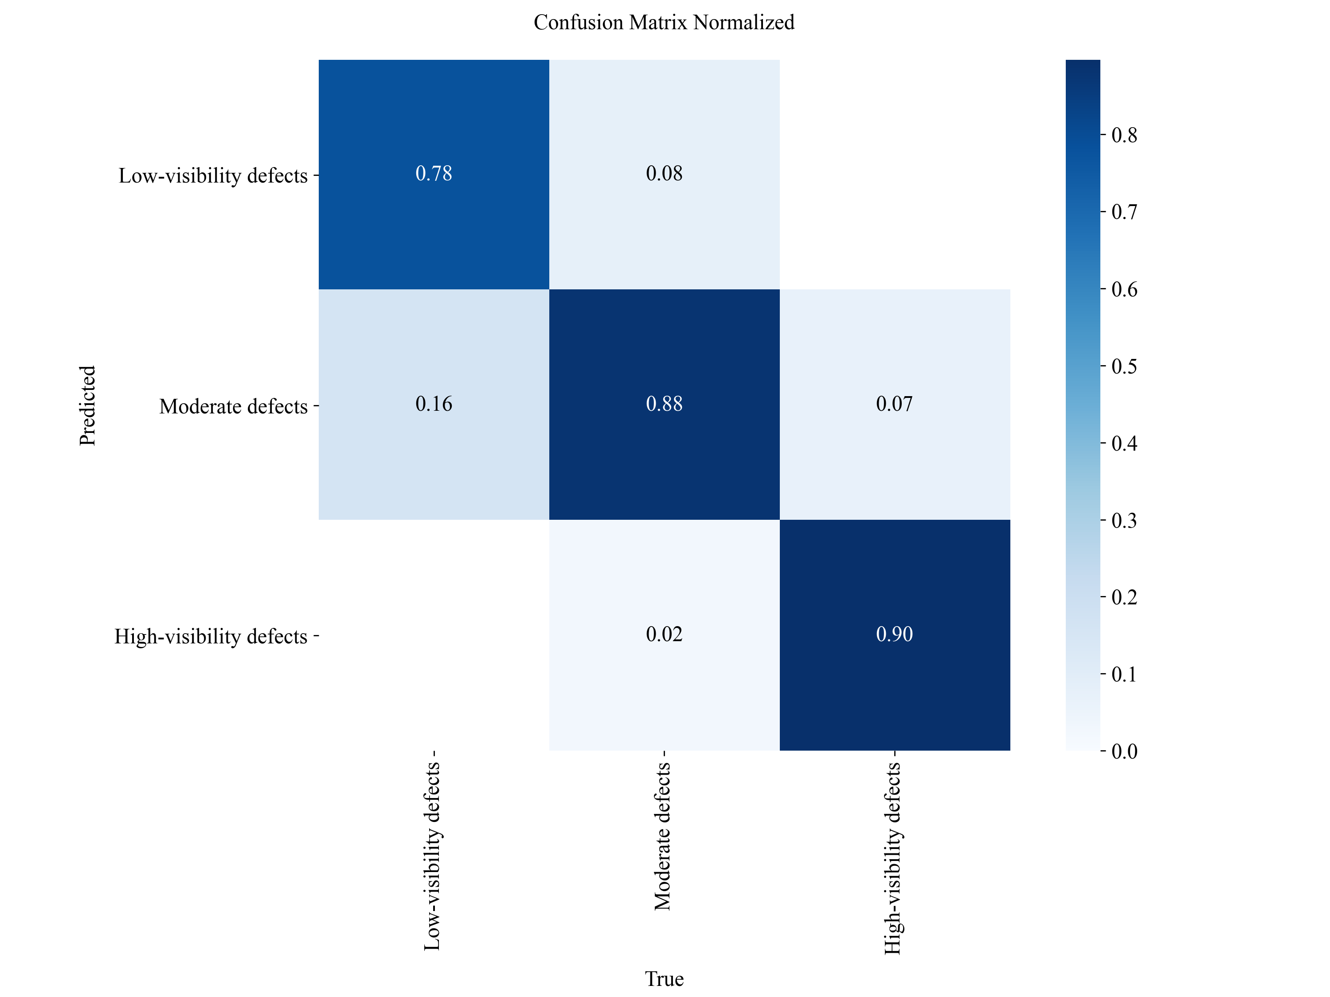
(b) Confusion matrix after Stage 2
Fig. 9. Validation-set confusion matrices by visibility level.

Qualitative detection results are shown in Fig. 10. Overall, the proposed model demonstrates relatively robust localization across different defect severities. For weak defects, the predicted boxes tightly enclose the warm-highlight regions, which phenomenologically supports the design motivation of the P2 branch in preserving shallow details. Overall, these visual results align with the quantitative ablation findings, confirming that the PES pipeline yields robust localization across varying defect saliency levels.
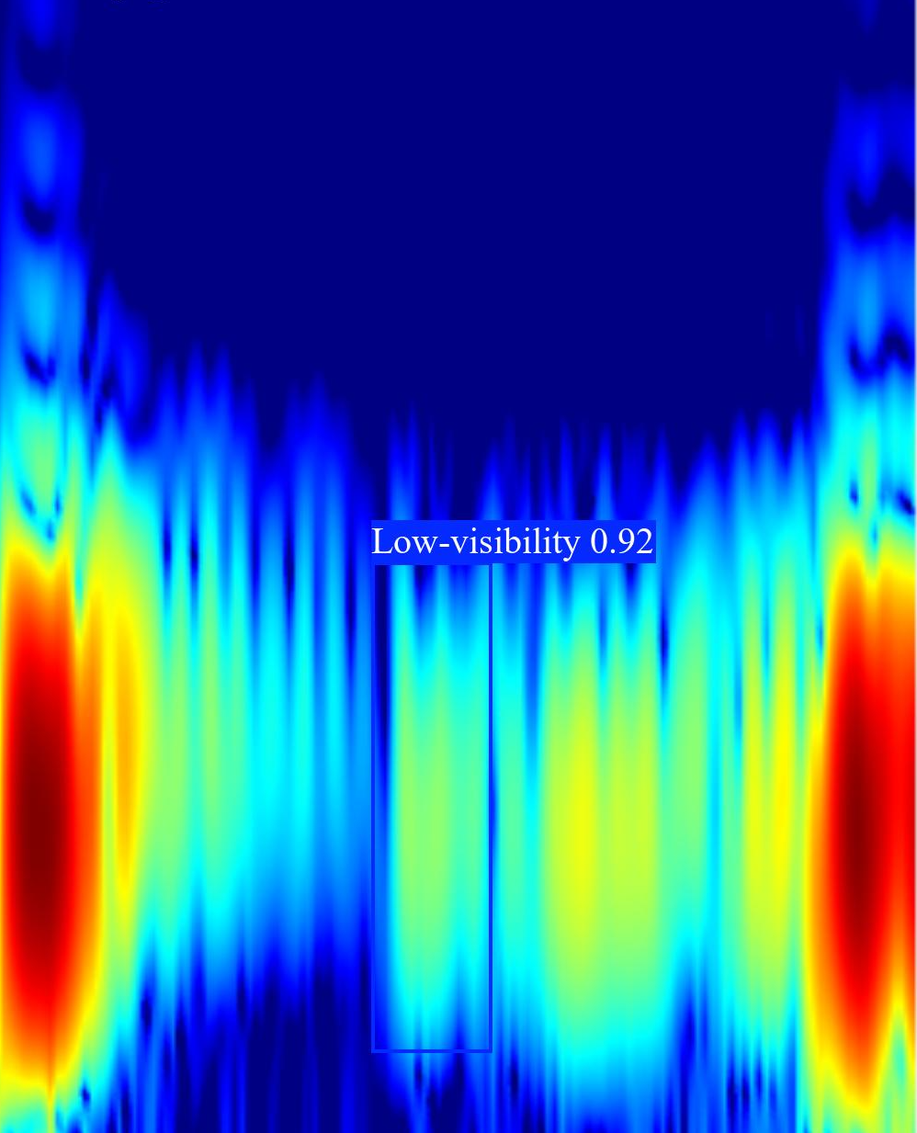 | 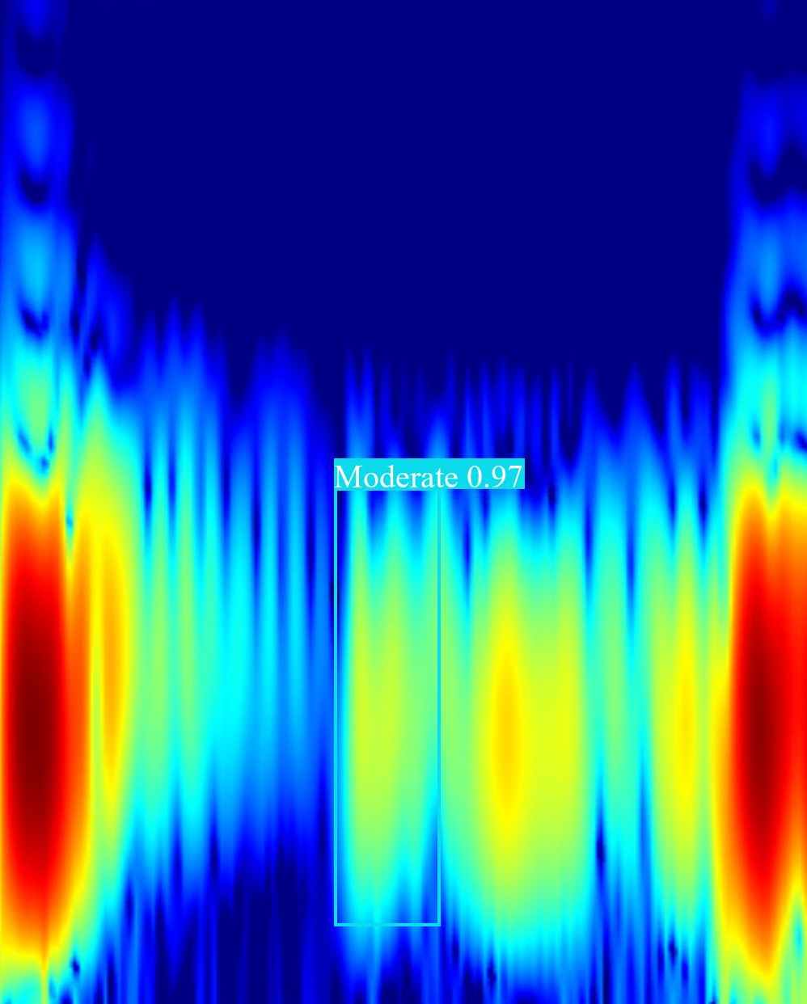 | 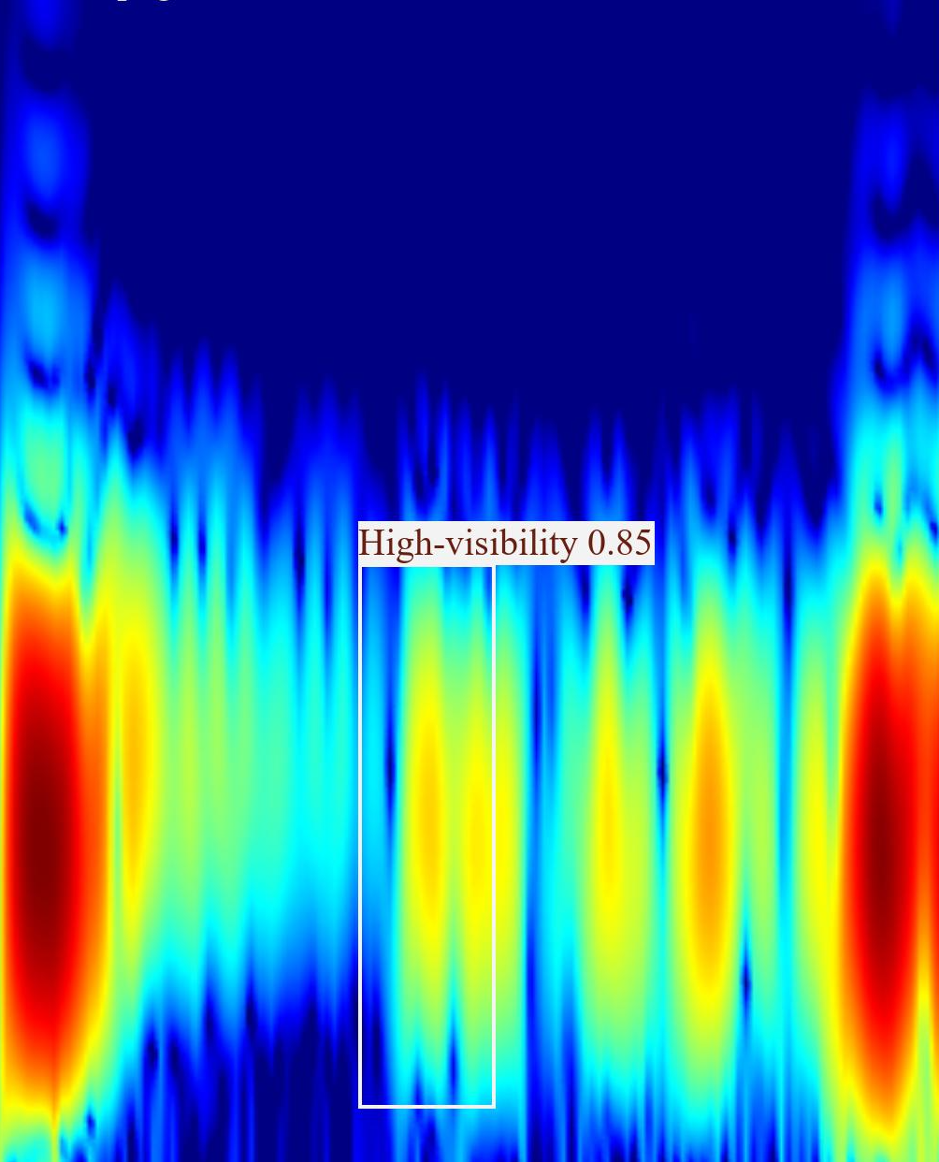
(a) Low-visibility defect | (b) Moderate-visibility defect | (c) High-visibility defect
Fig. 10. Exemplar detections for defect samples of varying saliency.

6 Conclusion and Future Work
This work investigated weak-anomaly detection in guided-wave spectra of polyethylene pipelines, where defect signals are scarce and difficult to annotate. A Preserve-Enhance-Select framework built on YOLOv8m was proposed, which combined a P2 prediction branch, RepConv modules, and Efficient Channel Attention (ECA). The framework was trained on a guided-wave spectral dataset, with detection performed simultaneously at P2–P5 scales using DIoU as the regression objective. Experiments showed that the proposed framework achieves 90.32% mAP50 and 59.82% mAP50-95 at 21.96 FPS on an RTX 4060 GPU, outperforming both the standard YOLOv8m baseline and several mainstream detectors.
The main contribution is a spectrogram-tailored redesign of YOLOv8m, in which each component targets a distinct task characteristic: the P2 branch preserves shallow spatial cues, RepConv enhances local feature interactions through re-parameterization, and ECA recalibrates channel responses. The ablation results show that RepConv alone is less stable, ECA alone provides a modest gain, and the complete configuration gives the strongest reported performance. These findings motivate further work on physically interpreting channel weights and on evaluating whether such information can guide frequency-specific augmentation or weighting strategies.
Several limitations should be acknowledged. The method was validated on a single configuration (fixed pipeline diameter, material, and excitation parameters) with a moderate sample size of 581 images; its generalizability to other pipeline specifications remains to be established. The reliance on a fixed Jet colormap mapping also limits its applicability to grayscale spectral inputs, and the conservative augmentation policy and small batch size may restrict robustness.

Acknowledgements
The authors greatly appreciate the financial support provided by Sichuan Science and Technology Program (No. 2026NSFSCZY0089) and National Natural Science Foundation of China (No. 52378133). However, the opinions expressed in this article are solely the authors’ own.

References
- Cumbajin, Rodrigues, Costa, et al.: A systematic review on deep learning with CNNs applied to surface defect detection. J. Imaging 9(10), 193 (2023). https://doi.org/10.3390/jimaging9100193
- Gao, Y.P., Li Y, et al.: A review on recent advances in vision-based defect recognition towards industrial intelligence. J. Manuf. Syst. 62, 753–766 (2022). https://doi.org/10.1016/j.jmsy.2021.05.008
- Ameri, R., Hsu, et al.: A systematic review of deep learning approaches for surface defect detection in industrial applications. Eng. Appl. Artif. Intell. 130, 107717 (2024). https://doi.org/10.1016/j.engappai.2023.107717
- Ma, Y.C., Yin JX, et al.: Surface defect inspection of industrial products with object detection deep networks: a systematic review. Artif. Intell. Rev. 57(12), 1–48 (2024). https://doi.org/10.1007/s10462-024-10956-3
- Wang Q, Wang M, Sun JD, et al.: Review of surface-defect detection methods for industrial products based on machine vision. IEEE Access 13, 90668–90697 (2025). https://doi.org/10.1109/ACCESS.2025.3571297
- Rose, J.L.: Ultrasonic Guided Waves in Solid Media. Cambridge University Press, Cambridge (2014).
- Yu, S.Q., Fan, et al.: Guided waves-based structural health monitoring techniques for spacecraft: a review. J. Astronaut. 45(4), 487–495 (2024). https://doi.org/10.1088/0964-1726/25/5/053001
- Wu, J., Yang, et al.: Defect detection in pipes using Van der Pol systems based on ultrasonic guided wave. Int. J. Press. Vessel. Pip. 195, 104595 (2022). https://doi.org/10.1016/j.ijpvp.2021.104577
- Zhang, X.W., Guo, et al.: AugFCOS: augmented fully convolutional one-stage object detection network. Pattern Recognit. 134, 109098 (2023). https://doi.org/10.1016/j.patcog.2022.109098
- Zhang SF, Chi C, Yao YQ, et al.: Bridging the gap between anchor-based and anchor-free detection via adaptive training sample selection. In: Proceedings of the IEEE/CVF Conference on Computer Vision and Pattern Recognition (CVPR), pp. 9759–9768 (2020). https://doi.org/10.1109/CVPR42600.2020.00978
- Li X., Wang WH, Wu LJ, et al.: Generalized focal loss: learning qualified and distributed bounding boxes for dense object detection. In: Proceedings of the IEEE/CVF Conference on Computer Vision and Pattern Recognition (CVPR), pp. 2103–2112 (2020). https://doi.org/10.48550/arXiv.2006.04388
- Zheng ZH, Wang P, Liu W, et al.: Distance-IoU loss: faster and better learning for bounding box regression. In: Proceedings of the AAAI Conference on Artificial Intelligence, pp. 12993–13000 (2020). https://doi.org/10.1609/aaai.v34i07.6999
- Zhang YF, Ren WQ, Zhang Z, et al.: Focal and efficient IoU loss for accurate bounding box regression. Neurocomputing 506, 146–157 (2022). https://doi.org/10.1016/j.neucom.2022.07.042
- Tong ZJ, Chen YH, Xu ZW, et al.: Wise-IoU: bounding box regression loss with dynamic focusing mechanism. arXiv preprint arXiv:2301.10051 (2023). https://doi.org/10.48550/arXiv.2301.10051
- Hu J, Shen L, Albanie, et al.: Squeeze-and-excitation networks. IEEE Trans. Pattern Anal. Mach. Intell. 42(8), 2011–2023 (2020). https://doi.org/10.1109/CVPR.2018.00745
- Wu, S.Q., Yamauchi, et al.: A lightweight binarized convolutional block attention module: B-CBAM. J. Adv. Inf. Technol. 16(5), 751–759 (2025). https://doi.org/10.12720/jait.16.5.751-759
- Hou QB, Zhou DQ, Feng JS.: Coordinate attention for efficient mobile network design. In: Proceedings of the IEEE/CVF Conference on Computer Vision and Pattern Recognition (CVPR), pp. 13713–13722 (2021). https://doi.org/10.1109/CVPR46437.2021.01350
- Tan MG, Pang RM, Le QV: EfficientDet: scalable and efficient object detection. In: Proceedings of the IEEE/CVF Conference on Computer Vision and Pattern Recognition (CVPR), pp. 10781–10790 (2020). https://doi.org/10.1109/CVPR42600.2020.01079
- Ding XH, Zhang XY, Ma NN, et al.: RepVGG: making VGG-style ConvNets great again. In: Proceedings of the IEEE/CVF Conference on Computer Vision and Pattern Recognition (CVPR), pp. 13733–13742 (2021). https://doi.org/10.1109/CVPR46437.2021.01352
- Wang QL, Wu BG, Zhu PF, et al.: ECA-Net: efficient channel attention for deep convolutional neural networks. In: Proceedings of the IEEE/CVF Conference on Computer Vision and Pattern Recognition (CVPR), pp. 11531–11539 (2020).
- Liu, Y., Sun, et al.: A survey and performance evaluation of deep learning methods for small object detection. Expert Syst. Appl. 172, 114602 (2021). https://doi.org/10.1016/j.eswa.2021.114602
- Mei SH, Lian JW, Wang XF, et al.: A comprehensive study on the robustness of deep learning-based image classification and object detection in remote sensing: surveying and benchmarking. J. Remote Sens. 4, 0045 (2024). https://doi.org/10.34133/remotesensing.0219
- Feng, Q.H., Xu, et al.: Deep learning-based small object detection: a survey. Math. Biosci. Eng. 20(4), 6551–6590 (2023). https://doi.org/10.3934/mbe.2023282
- Cheng G, Yuan X, Yao XF, et al.: Towards large-scale small object detection: survey and benchmarks. IEEE Trans. Pattern Anal. Mach. Intell. 45(11), 1–20 (2023). https://doi.org/10.1109/TPAMI.2023.3290594
- Zhang L, Xu C, Zhang KB, et al.: Enhanced object detection via complementary feature pyramid networks. Signal Image Video Process. 20(5), 1–8 (2026). https://doi.org/10.1007/s11760-026-05372-9
- Liu, S., Qi, et al.: Path aggregation network for instance segmentation. In: Proceedings of the IEEE Computer Society Conference on Computer Vision and Pattern Recognition (CVPR), pp. 8759–8768 (2018). https://doi.org/10.1109/CVPR.2018.00913
- Feng, C.J., Zhong, et al.: TOOD: task-aligned one-stage object detection. In: Proceedings of the IEEE/CVF International Conference on Computer Vision (ICCV), pp. 3490–3499 (2021). https://doi.org/10.48550/arXiv.2108.07755
- Redmon, Divvala, Girshick, et al.: You only look once: unified, real-time object detection. In: Proceedings of the IEEE Conference on Computer Vision and Pattern Recognition (CVPR), pp. 779–788 (2016). https://doi.org/10.48550/arXiv.1506.02640
- Redmon, J., Farhadi, et al.: YOLOv3: an incremental improvement. arXiv preprint arXiv:1804.02767 (2018). https://doi.org/10.48550/arXiv.1804.02767
- Bochkovskiy A, Wang CY, Liao H Y M.: YOLOv4: optimal speed and accuracy of object detection. arXiv preprint arXiv:2004.10934 (2020). https://doi.org/10.48550/arXiv.2004.10934
- Ge Z., Liu ST, Wang F, et al.: YOLOX: exceeding YOLO series in 2021. arXiv preprint arXiv:2107.08430 (2021). https://doi.org/10.48550/arXiv.2107.08430
- Wang CY, Bochkovskiy A, Liao HYM.: YOLOv7: trainable bag-of-freebies sets new state-of-the-art for real-time object detectors. In: Proceedings of the IEEE/CVF Conference on Computer Vision and Pattern Recognition (CVPR), pp. 7464–7475 (2023). https://doi.org/10.1109/CVPR52729.2023.00721
- Lyu CQ, Zhang WW, Huang HA, et al.: RTMDet: an empirical study of designing real-time object detectors. arXiv preprint arXiv:2212.07784 (2022).
- Li CY, Li LL, Jiang HL, et al.: YOLOv6: a single-stage object detection framework for industrial applications. arXiv preprint arXiv:2209.02976 (2022). https://doi.org/10.48550/arXiv.2209.02976
- Wang, C.Y., Yeh, et al.: YOLOv9: learning what you want to learn using programmable gradient information. arXiv preprint arXiv:2402.13616 (2024)
- Liu, W., Anguelov, et al.: SSD: single shot MultiBox detector. In: Computer Vision – ECCV 2016, pp. 21–37. Springer, Cham (2016)
- Howard, Sandler, Chu, et al.: Searching for MobileNetV3. In: Proceedings of the IEEE/CVF International Conference on Computer Vision (ICCV), pp. 1314–1324 (2019). https://doi.org/10.1109/ICCV.2019.00140
- Alif MAR, Hussain M.: YOLOv12: a breakdown of the key architectural features. arXiv preprint arXiv:2502.14740 (2025). https://doi.org/10.48550/arXiv.2502.14740

