**ENNOVATE’19**

***Team member’s names:***

*1) Marvin Tellis*

*2) Chaitravi More*

*3) Sneh Chitalia*

*4) Vicky Daiya*

***Problem Statement:***

*In the restaurant industry, the menu and the service are central motivations which attract consumers to your establishments and brand. Attracting consumers requires a strong reputation, an enticing menu and a good level of service.The main shortcoming of traditional flyer menus or online ordering apps is the lack of sufficient visual information. Customers often have trouble visualizing the food, which impairs ordering ethnic dishes and confuses portion size. Our objective is to help a customer visualize and customize the food in order to give him/her a rich experience.*

***Solution:***

*We have developed a revolutionary tool which allows you to radically change the way you present your menu and engage with your consumers. The technology used by* ***FoodArt*** *allows you to* ***visualize your menu in 3D*** *through a process of digital rendering and photography. Using smart device technology, you can present your menu to your consumers in 3D, enabling them to make informed food choices and ensuring their expectations are met or even exceeded. By using innovative technologies in online food ordering,* ***FoodArt*** *enables you to extend* ***visual information*** *without limits. Customers can see the food in correct dimensions before they order and can combine different side toppings with main courses simultaneously, keeping them wholly informed about what they are going to eat. Because of all of this, the* ***FoodARt*** *app minimizes customer frustration and buyer remorse. With this next generation of online food ordering, customers can always be satisfied with their orders.*

***Business model (Abstract):***

(Mention the business model here in a nutshell)

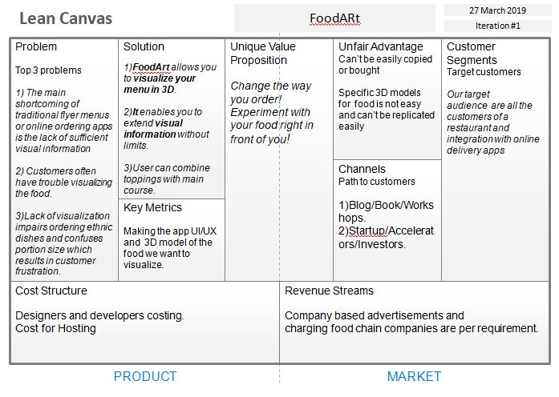

**Link:** [**https://github.com/chaitravimore/FoodARt**](https://github.com/chaitravimore/FoodARt)