Process
Each Process is isolated from other processes,
Each Process has (in image 1) its own
- Memory Address Space
  - memory_limits
- CPU State (Context that is switched between process) :
  - Program_counter (where the program currently is
  - General_purpose_registers (Registers Values Held)
  - Flags (Processor flags)
  - Index_registers (More Registers )
  - Etc ..
Struct OCB (Process Control Block) which is the task / process from the perspective of OS
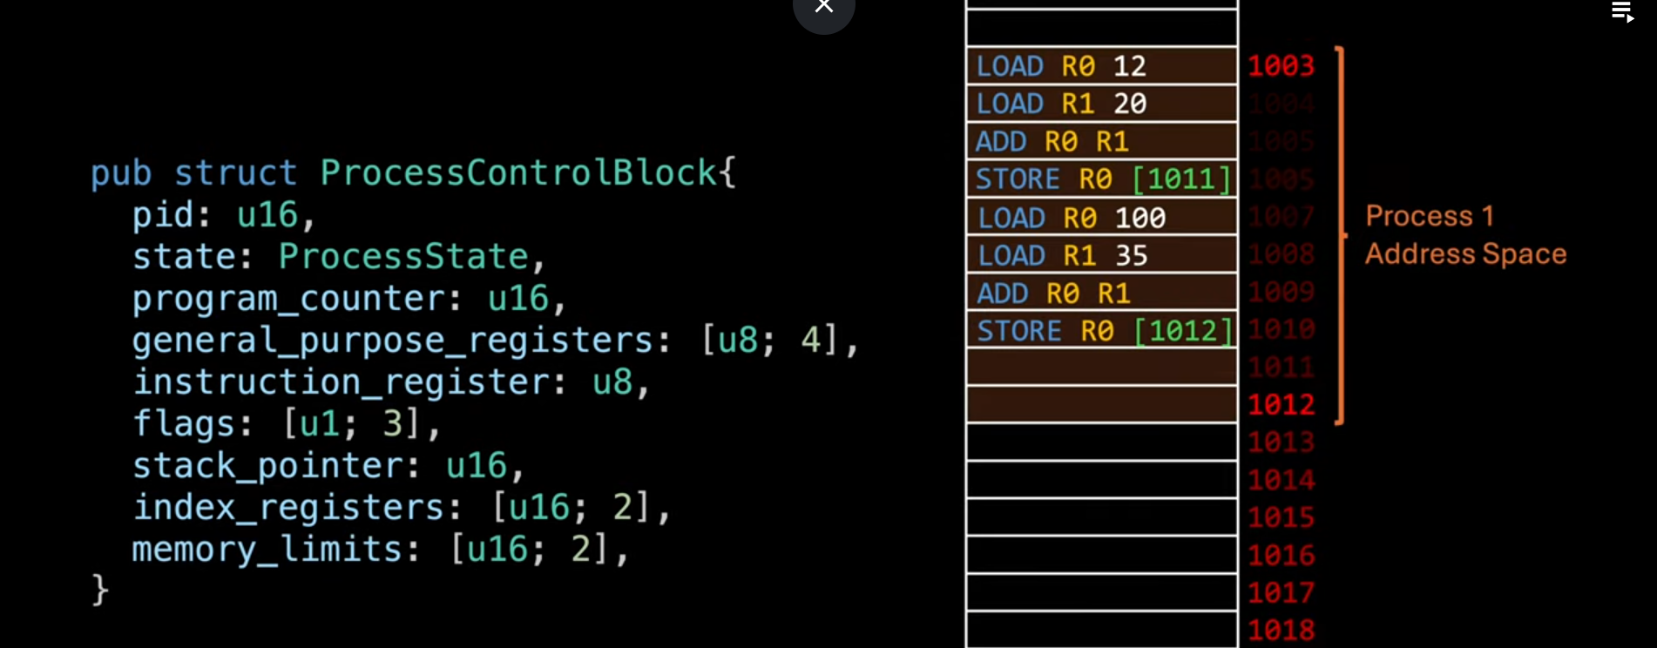

Concurrency vs Parallelism
In Single core CPU (single cpu systems) , The process can only handle one task at a time , processing multiple tasks at very high speed achieving the illusion of parallelism.

Unlike Multi core processors which achieves true parallelism
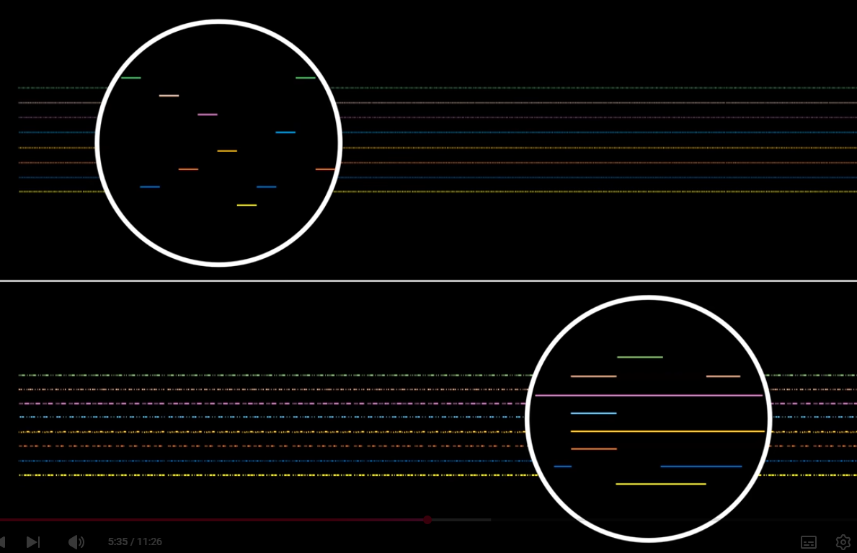

Race Condition

A race condition is a bug that happens due to the unpredictable order in which multiple threads access and modify memory

i.e. multiple threads access a variable (memory block) editing and reading from it in the same time will lead to incorrect information

