Diagnostic Agent
Current Implementation Design
  - Runtime control, health diagnosis, evidence boundaries, and two-tier model collaboration for EBO
Implementation reviewed September 22, 2026
This document describes capabilities that exist in the current workspace. It does not present roadmap items as implemented behavior. It explains how the business runtime is selected, where diagnostic data originates, which decisions are deterministic, what the models contribute, and which conclusions still require human or live-environment verification.
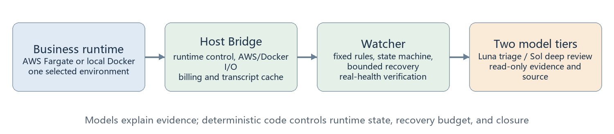
Figure 1 Overview from runtime state through diagnosis and verification
The key point is that the Diagnostic Agent is not an autonomous model with administrator access. It is a deterministic monitoring and bounded-remediation system with two read-only diagnostic stages. A model assessment of identified means that the evidence supports a root-cause judgment; it does not mean the service has recovered. Recovery is established only by subsequent real health samples.

Current implementation at a glance
Item | Current implementation
Business runtime | AWS Fargate, local Docker, or stopped; the Host Bridge persists the choice and enforces mutual exclusion
Models | Tier 1: gpt-5.6-luna / low; Tier 2: gpt-5.6-sol / high
Operator UI | Bilingual dashboard on 127.0.0.1:8179 with cloud, local, and stop-everywhere controls
Automatic action | Fixed, bounded, and budget-reserved; models cannot restart, deploy, edit configuration, or call AWS
Verification | ops/diagnostics tests rerun on 2026-09-22: 109 passed, 0 failed, 0 skipped

1 System components
The business runtime handles the robot, realtime voice, and Home Assistant. The diagnostic plane observes it from the side. The business may run on AWS Fargate or local Docker, while the Host Bridge enforces an exclusive choice. Watcher, diagnostic-service, codex-triage, and codex-worker are four local diagnostic containers. [S01 S02 S03]
diagnostic-service persists jobs and dispatches two model tiers. Tier 1 performs fast triage. Tier 2, when needed, reviews the same evidence, the triage result, and a source snapshot. Neither model tier has a business-recovery interface.
Figure 2 Relationship among the business runtime, host control, deterministic diagnosis, and two model tiers
Component | Primary responsibility | Direct business control
Host Bridge | Runtime switching, Docker/AWS I/O, caches, constrained control APIs | Only through fixed code
Watcher | Sampling, confirmation, bounded recovery, diagnosis submission, real-health verification | Requests a constrained bridge action
diagnostic-service | Persists jobs and selects Tier 1/Tier 2 | No
Model workers | Explain evidence and read-only source; return structured reports | No

2 Runtime selection and durable intent
Runtime selection supports aws, local, and stopped. Before side effects, the Host Bridge writes the desired state to local/host/runtime.json, so the last operator choice survives restart. config.local.json supplies startup configuration and must not be confused with the durable runtime choice. [S03 S04]
A switch is serialized. AWS mode stops the three local business containers, disables their automatic restart, sets the ECS Service desired count to one, and waits for task, container, audio, and video capability. Local mode first sets the cloud desired count to zero and waits for every running, pending, and live task to disappear, then starts and verifies local Engine, Assistant, and HA. stopped makes a best effort to shut down both sides.
Every 60 seconds, the controller compares intent with reality. If the active environment unexpectedly stops, and maintenance, observe mode, and budget do not block it, one automatic restoration may be attempted. A stop request received during another operation is queued; an interrupted switch becomes failed and requires an explicit retry.
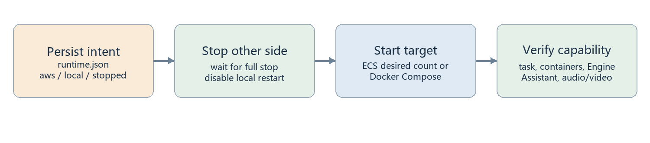
Figure 3 A runtime switch persists intent before mutually exclusive stop/start and capability verification
Mode | Completion condition | Failure meaning
aws | Local business is off; cloud task and capabilities are healthy | Step and error are recorded; retry is possible
local | Cloud tasks are fully gone; three local services are healthy | Cloud and local business are not intentionally left running together
stopped | Both sides are stopped or each shutdown was attempted | Failure on one side does not prevent trying the other

3 Dashboard and control path
The dashboard listens only on 127.0.0.1:8179. English is the default; Chinese can be selected and remembered. It exposes Run cloud, Run local, and Stop everywhere, and shows desired versus actual state, switch steps, health issues, recent incidents, model stages, runtime history, and the full health report. [S05]
Writes require a loopback Host header, same-origin request, and CSRF token; JSON bodies are limited to 1,024 bytes. Bridge tokens, AWS profiles, and administrative credentials are never sent to the page. The browser can only request fixed actions from the local Host Bridge.
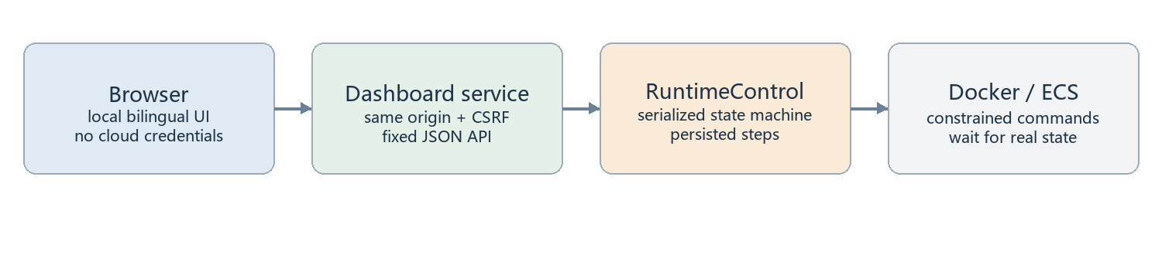
Figure 4 Browser actions cross a local security boundary into the fixed runtime controller
Panel | Source | How to read it
Runtime card | runtime.json and live checks | desired and actual may temporarily differ
Health/incidents | Watcher report files | model completion does not prove recovery
Billing | local cache | page refresh does not query providers again
Conversations | local/CloudWatch allowlisted text | no WAV or internal identifiers are exposed

4 Cloud health data lineage
A wrapper inside the cloud task calls Engine /api/robots and Assistant /health about every 15 seconds, then writes only allowlisted health.snapshot JSON to CloudWatch. The host AWS adapter lists current service tasks and container state, reads matching log streams, validates timestamps, and selects the newest usable event. [S06 S07]
Control-plane and business evidence are merged. A RUNNING task does not prove robot, audio, or video capability. If identity, account, pagination, time, or cache state cannot be trusted, the system returns monitoring_failed or unknown instead of treating missing evidence as healthy.
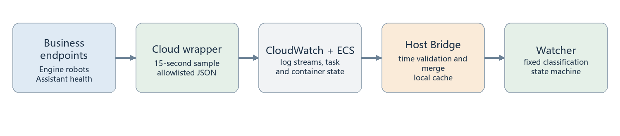
Figure 5 Cloud business capability and ECS control-plane evidence are merged on the host
Evidence | What it proves | What it does not prove
ECS task RUNNING | The scheduling unit is running | Audio/video capability is usable
Engine state | Robot and incoming-media state | Assistant consumes it correctly
Assistant state | Source, media, and session state | Robot speaker end to end succeeds
Sample time | Evidence freshness | No short failure occurred between samples

5 Audio health and RTC rejoin recovery
Audio health uses evidence that the robot upstream received real packets, Engine decoded real PCM, and Assistant saw the expected source and media state. Diagnostics receive booleans, counts, and ages—not household recordings. [S08 S09]
After an unplanned robot RTC rejoin, the bridge re-sends OP_AUDIO_LISTEN and re-subscribes to audio after 2.5, 5, 10, 20, and 30 seconds. It stops when real PCM arrives and cancels for a stale generation, shutdown, disconnect, or mute. This is bounded recovery, not an endless loop.
unplanned_realtime_reconnects is included in health evidence. Authenticated runtime intent from the Host Bridge suppresses false incidents during a switch or while stopped.
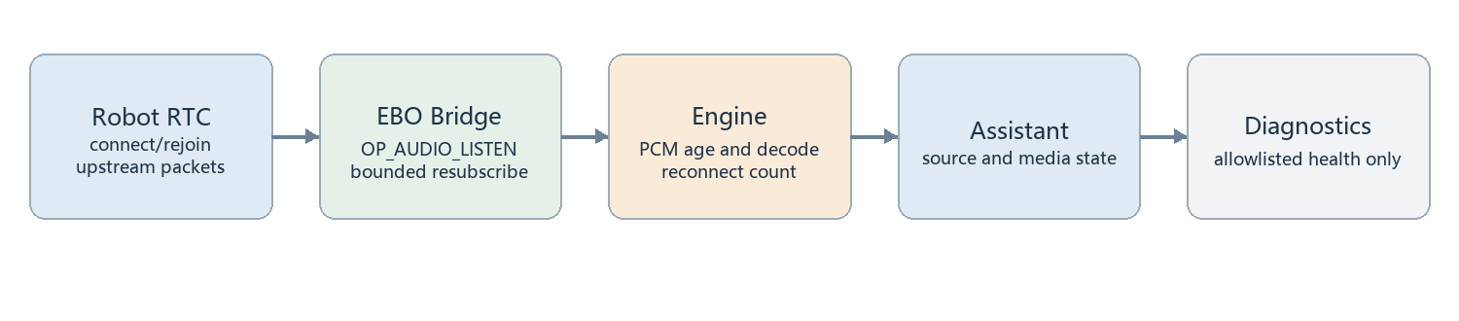
Figure 6 Audio path and bounded source recovery after an RTC rejoin
Condition | Recovery behavior | Stop condition
Unplanned RTC rejoin | At most five delayed listen/resubscribe attempts | Real PCM arrives
Connection generation changes | Old recovery task cannot operate on the new connection | Generation mismatch
Mute or shutdown | The microphone is not forced open | Mute, disconnect, or shutdown

6 Sampling, confirmation, and classification
Cloud health events are produced about every 15 seconds, host AWS sampling targets a 60-second cycle, and Watcher waits 10 seconds after a cycle. The 600-second value is a log lookback and 180 seconds is evidence validity; neither is a poll interval. A fault needs at least 60 seconds plus a newer sample; recovery needs 30 seconds of sustained health. [S01 S10]
Classification first asks whether observation is reliable, then whether resources are ready, and finally whether business capabilities work. Maintenance, explicit stop, and runtime transition are suppressed or grace states. They are not healthy and must not be recorded as verified recovery.
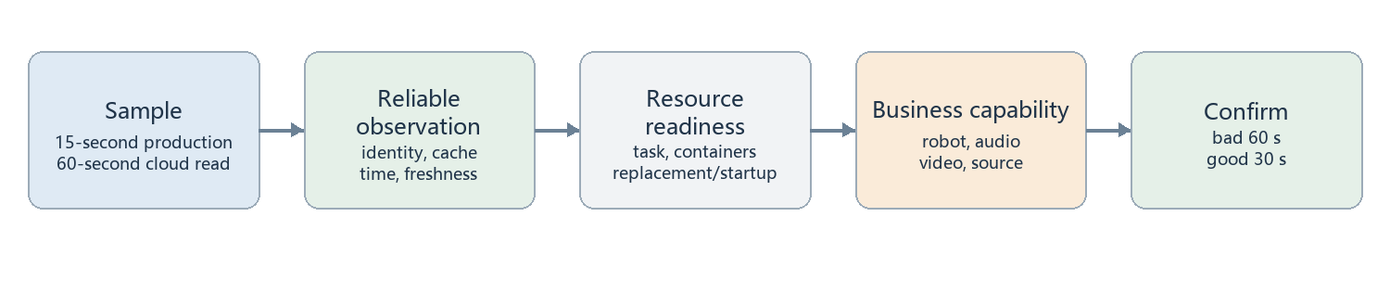
Figure 7 Fixed decision order from evidence freshness to business capability
State | Meaning | Next step
healthy | Allowlisted capability stays good | May close an existing incident
grace | Startup or platform self-healing is within its window | Wait for a newer sample
suppressed | Maintenance, stop, or transition | Do not call it recovered
fault | Reliable new evidence remains abnormal | Enter the incident state machine
monitoring_failed | Evidence cannot be acquired or interpreted reliably | Diagnose the monitoring path

7 Watcher state machine and incident walkthrough
Each target has an independent incident, confirmation clock, recovery budget, diagnostic job, and notification state. The first bad sample enters pending. After confirmation, applicable fixed recovery is reserved once; otherwise the incident goes directly to diagnosis_pending. Diagnosis is submitted only after the recovery window still shows failure. [S11]
diagnosing means only that a model job is running. A finished job with unhealthy business becomes unresolved. At any stage, only sustained real-health samples close the incident. Maintenance, stop, or environment change closes as unverified rather than recovered.
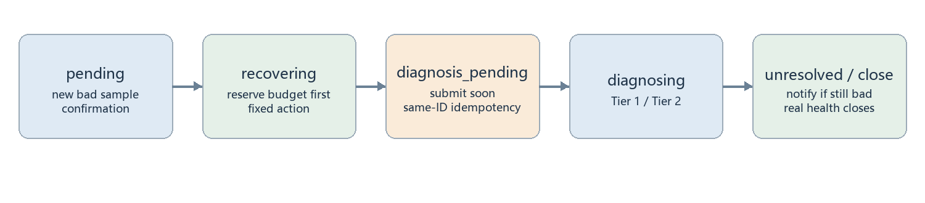
Figure 8 The fixed state machine separates diagnostic completion from business recovery
Example stage | What happens during a video stall
t=0 | First new bad sample starts confirmation only
about t=60s | A newer bad sample creates the incident and evidence
Diagnosis | With cloud task replacement disabled, read-only analysis starts
Recovery | Only 30 seconds of sustained healthy samples closes the incident
Still broken | A terminal job or notification deadline tells the user to inspect the report

8 What fixed recovery can do
Recovery is encoded in the program and guarded by observationOnly, maintenance, autoRecovery, target switches, cooldowns, counts, and idempotent action IDs. Watcher and Host Bridge both persist reserved before issuing a command, prioritizing duplicate prevention. [S12 S13]
Local services may be restarted by fixed target. Normal cloud runtime switching uses ECS update-service desired-count and never StopTask. Incident-time restartOnStall remains a separate option and is currently off. HTTP 202 means accepted, not successful; real health is still the final check.
Action | Required condition | Model can trigger it
Local service restart | Allowed target, budget, and cooldown | No
Cloud runtime start/stop | Control identity, account, and service constraints pass | No
Incident-time cloud task replacement | restartOnStall explicitly enabled and budgeted | No
Deploy/edit code or configuration | No automatic path exists | No

9 Evidence package and model tiers
An incident evidence package contains health endpoints, filtered logs, ECS state, event history, pre/post-action samples, and fixed metadata. It excludes recordings, full conversations, credentials, and arbitrary host files. Models also receive a read-only source snapshot to map symptoms to implementation. [S14 S15]
Tier 1 is gpt-5.6-luna / low with up to 90 seconds. Tier 2 is gpt-5.6-sol / high. The default on-inconclusive policy returns a Tier 1 identified result directly; inconclusive, failed, or timed-out triage is escalated with both the original evidence and triage result. The overall diagnostic job defaults to 300 seconds.
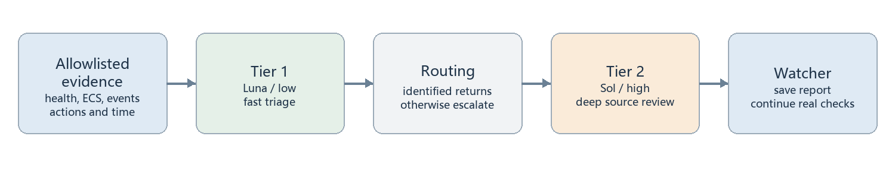
Figure 9 Two-tier diagnosis explains evidence without changing business state
Stage | Input | Purpose of output
Tier 1 | Incident evidence + read-only source | Quick localization or an honest uncertainty
Tier 2 | Original evidence + Tier 1 + read-only source | Deeper verification and actionable human recommendations
Watcher | Model result + later health samples | Records diagnosis and recovery separately

10 Agent loop, tools, and permissions
The workers use the Codex SDK tool loop. A model decides whether it has enough information, optionally selects read-only commands to list, search, or read allowed source, and then either continues or returns structured JSON. The project does not implement its own step planner or a mandatory tool sequence. [S15]
sandboxMode=read-only, approvalPolicy=never, networkAccessEnabled=false, and webSearchMode=disabled. Workers have no Docker socket, AWS profile, or bridge/diagnostic/worker tokens and cannot edit code or configuration. Model inference still needs the model service; that is separate from the command tool's network ban.
Capability | Allowed | Boundary
Read request evidence | Yes | Only filtered incident data
Search/read source | Yes | Read-only snapshot and sandbox
Run read-only comparisons | Subject to image tools | No network or escalation
Modify/deploy/restart/AWS | No | No credentials or interface
Request recordings/transcripts/credentials | No | Explicitly prohibited by shared instructions

11 Job API, queue, timeout, and cancellation
POST /jobs enqueues idempotently by job ID; GET /jobs/{id} returns status and result; cancel marks queued work cancelled or uses AbortController for running work. GET /health proves only basic service liveness, not that the latest model request can succeed. [S16]
Each Jobs instance runs one job at a time. queued + running reaching eight rejects new work, so the limit is eight unfinished jobs—not one running plus eight queued. Queue wait does not count against that instance's execution timer, but it consumes the parent diagnosis deadline.
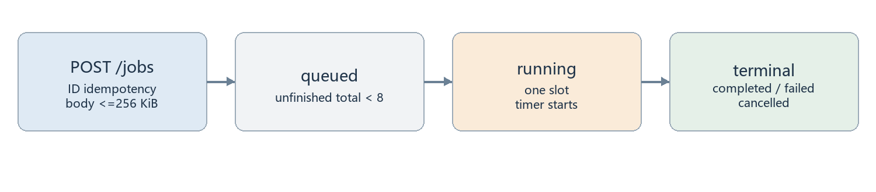
Figure 10 Jobs are persisted before entering the single execution slot
API/state | Correct interpretation
GET /jobs | Returns recent summaries without the original request
cancel | Parent tries to cancel child; child timeout remains a fallback
completed | Model job completed; business may still be broken
429 | The eight-unfinished-job capacity is full

12 Persistence, idempotency, and restart semantics
Watcher state, each job store, host actions, AWS cache, runtime intent, and switch history are persisted in their owning volume or local/host file. Store writes a temporary file, fsyncs, and renames it to reduce partial JSON. Corruption fails loudly rather than silently resetting budgets. [S17]
Actions persist reserved before commands. This favors duplicate prevention but does not guarantee exactly once: a crash after persistence may consume budget before a command actually runs. On process restart, running jobs become worker_restarted; queued work may continue, and paid model work already started is not replayed automatically.
Record | Contents | Purpose
state.json | incidents, history, recovery budgets | continuous Watcher decisions
jobs.json | request, status, result, usage | job idempotency and restart handling
actions.json | reserved/completed/uncertain | host action deduplication
runtime.json | desired, phase, steps, history | traceable runtime selection
AWS cache | snapshot, tasks, scheduling anomalies | bounded cloud reads and freshness

13 Reports, notifications, and the health report
Model output is assessment, summary, evidence, and recommendations. assessment is identified or inconclusive. Validation constrains types, counts, and lengths but does not independently prove every citation. Results also record stage, model, reasoning effort, threadId, usage, and tool success/failure counts. [S18]
Notifications contain incident ID, target, symptom code, stage, and action status, plus a pointer to the local report. They do not forward model free text, raw logs, or household conversations. A separate task writes local/health-report every 60 seconds; the page reloads every 30 seconds and marks data older than 180 seconds unknown/attention. It triggers no model, recovery, or notification. [S19 S20]
Output | Meaning | Do not read it as
identified | Evidence supports a model diagnosis | Service recovered
inconclusive | Evidence is insufficient or ambiguous | No fault exists
Notification accepted | At least one channel returned success | The user definitely saw it
Report stale | Report generation or host may be stalled | The business is definitely unhealthy

14 Billing scope and refresh cadence
OpenAI month-to-date organization cost is read from /v1/organization/costs using an OPENAI_ADMIN_KEY separate from model credentials, no more than every 15 minutes. AWS Cost Explorer supplies month-to-date UnblendedCost, called in us-east-1, no more than every six hours. [S21]
The dashboard reads local cache; a page refresh does not query providers again. Credentials are never persisted. Errors are sanitized, and the last successful value may remain visible as stale. These are organization/account totals, not precise attribution to one incident or Diagnostic Agent job.
Source | Measure | Refresh ceiling | Key limitation
OpenAI | Organization month-to-date cost | 15 minutes | Admin key required; not per-job
AWS | Account month-to-date UnblendedCost | 6 hours | Cost Explorer is delayed and not service-specific
Dashboard | Last successful local cache | From cache | Read stale values with their timestamp

15 Conversations, privacy, and grouping semantics
The conversation view merges local assistant-data/transcripts.jsonl and assistant_outputs.jsonl with CloudWatch conversation.user.transcript and conversation.assistant.output events. It never reads WAV files. The UI receives role, time, and text—not raw event IDs, paths, task IDs, or audio metadata. [S22]
Local files are checked every 30 seconds. Cloud is polled every five minutes when active and every 30 minutes when inactive. The daily cloud request budget is 600, with two pages per poll and 200 rows per page. Bootstrap covers seven days, overlap is ten minutes, retention is 30 days, storage is capped at 20,000 messages, and the UI shows at most 500 groups.
The implementation deduplicates, joins chunks, tolerates partial or malformed lines, paginates, and backs off. Grouping is for reading, not strict causal pairing. Conversation text is not automatically added to model evidence.
Boundary | Current behavior
Collected | User transcript and assistant output text
Explicitly excluded | WAV, raw event IDs, internal paths, task IDs, audio metadata
Diagnostic models | Conversation list is not automatically placed in incident evidence
Grouping | Reading convenience, not strict request-response causality

16 Deployment and credential separation
The four diagnostic containers use non-root users, read-only root filesystems, cap_drop ALL, no-new-privileges, resource limits, and dedicated writable volumes. Read-only root does not mean zero writes; jobs and Watcher state persist in their own volumes. [S02]
Diagnostic read identity, runtime-control identity, and incident-recovery identity are separate. allowRuntimeControl must be explicit. The runtime controller validates AWS account/root identity, Fargate launch type, complete service information, and suspended Application Auto Scaling. aws-cli allows only constrained operations and removes OPENAI_ADMIN_KEY from child environments. [S04 S23]
Cloud shutdown uses update-service desired-count 0, never StopTask as a substitute for a durable stop. Control is refused while autoscaling can override desired count.
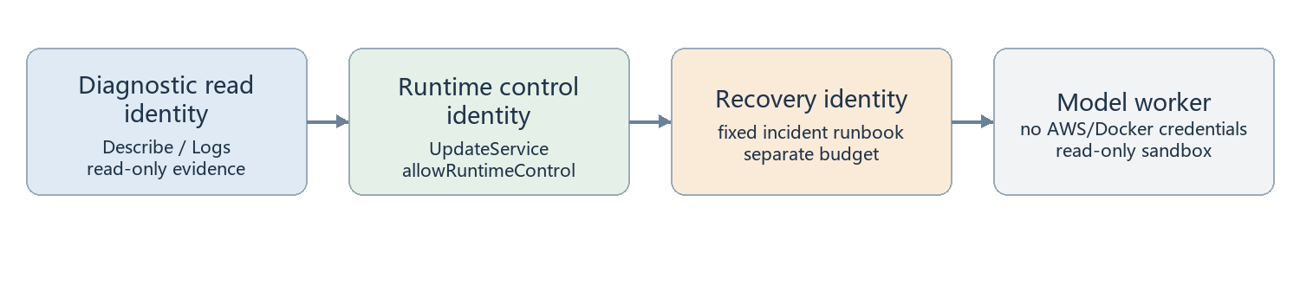
Figure 11 Read, runtime switching, incident recovery, and model analysis have separate privilege boundaries
Boundary | Protection
Browser | loopback, Host validation, same origin, CSRF
Host Bridge | fixed parameters and target allowlist; no arbitrary shell
AWS CLI | operation/argument allowlist plus identity and service constraints
Model | no operation tokens, AWS profile, Docker socket, or tool network

17 Verified scope
The current npm test run completed 109 tests: 109 passed, 0 failed, 0 skipped. Coverage includes AWS evidence and command constraints, billing, conversation merging, environment selection, health reporting, diagnostic pipeline, runtime control, and system state. Tests rely mainly on fixtures and doubles; they do not prove current live cloud health.
Historical repository validation also records real Docker fixture recovery, synthetic two-tier Codex calls, sandbox read/write/network boundaries, and AWS read-only collection. A synthetic diagnosis is not a production incident, and an unexecuted live cloud replacement cannot be described as verified. [S24]
Validation | Result | Boundary
Current automated tests | 109/109 passed | Mostly offline and test-double based
Runtime state machine | Success, failure, queued stop, and automatic restore paths | Not a live switch performed for this document
Billing/conversations | Cache, sanitization, budget, and deduplication paths | Provider data remains externally delayed
Models/permissions | Historical synthetic calls and sandbox checks | Does not guarantee every external model request succeeds

18 Current limitations and how to read results
The business may run in AWS, but diagnostics, dashboard, and local notifications still depend on this Windows host. Health coverage is not a complete robot end-to-end acceptance test: local Engine is mostly process-level, HA mostly HTTP-level, and speaker, motion, and every control action are not uniformly verified.
The source snapshot may lag deployment. Models cannot acquire new online evidence. Forensics are bounded by time windows, pagination, and an event vocabulary. Tool audit primarily counts successes and failures and does not verify every source citation. Billing is account/organization scope, while transcript text is sensitive local data.
Guardian behavior must be read with current code and configuration; observe mode is not an unlimited cross-process guarantee of zero local prompts. The safest approach is to treat runtime state, real health, incident state, model assessment, and notification status as five independent dimensions.
Dimension | Question
Runtime | Where should the business run, and where is it actually running?
Health | Do fresh allowlisted capabilities remain healthy?
Incident | pending, recovering, diagnosing, unresolved, or closed?
Model assessment | identified/inconclusive, and based on what evidence?
Notification | Did a channel accept the message, not whether it was read?

19 Routine operation
The recommended entry point is the local dashboard. PowerShell commands remain for status, reports, pause/resume, reload, and sampling changes. A runtime switch really starts and stops cloud or local business, so it should be used with that impact in mind. [S25]
This documentation update did not switch runtime environment, restart business services, create a paid model diagnosis, or query live provider billing. It read code/configuration and ran the offline test suite.
Entry point | Purpose
http://127.0.0.1:8179 | Runtime switching, health, incidents, billing, conversations, full report
diagnostics.ps1 status | Current environment, active targets, containers, and incidents
diagnostics.ps1 reports | Recent diagnostic jobs
diagnostics.ps1 report -Id <id> | One model report
diagnostics.ps1 pause / resume | Observe or return to active mode
diagnostics.ps1 reload | Reload operations services after configuration changes

20 Glossary and final reading checklist
One page may show desired=aws, actual=starting, incident=diagnosing, assessment=identified, and notification=sent at the same time. These are not contradictions; they are different layers of state. First confirm runtime transition stability, then evidence freshness, then read the incident and model report.
Term | Plain meaning
desired / actual | Requested runtime location / observed runtime location
Probe / Sample / Evidence | How state is read / one reading / the diagnostic package
Incident / Job | A sustained service fault / one bounded model task
Grace / Suppressed | Waiting for startup or self-healing / maintenance, stop, or transition
Identified / Recovered | Model believes cause is identified / Watcher verified real health
Stale | Cached value is displayable but older than its trust window

Implementation source index (1/2)
[Sxx] references in the body map to the files below. Paths are relative to ebo-ai-home and line numbers come from this workspace. After source changes, search for the named symbol rather than relying only on the line number.
ID | File and line | Purpose
S01 | ops/diagnostics/src/watcher.mjs:18 | Watcher entry point and main loop
S02 | ops/diagnostics/compose.yaml:16 | containers, networks, volumes, and model defaults
S03 | ops/diagnostics/src/runtime.mjs:28 | runtime intent, serialization, history, and automatic restoration
S04 | ops/diagnostics/src/runtime-io.mjs:8 | local/cloud stop, start, and capability verification
S05 | ops/diagnostics/src/dashboard.mjs:8 | bilingual dashboard data and loopback control endpoints
S06 | ops/diagnostics/src/aws-ecs.mjs:24 | ECS and CloudWatch evidence acquisition
S07 | ops/diagnostics/src/aws-health.mjs:10 | cloud reliability, readiness, and capability classification
S08 | ha-enabot/ebo/audio_health.py:6 | audio packet and PCM health fields
S09 | ha-enabot/ebo/ebo_bridge.py:419 | bounded source recovery after RTC rejoin
S10 | ops/diagnostics/src/probes.mjs:9 | allowlisted health evidence and local classification
S11 | ops/diagnostics/src/controller.mjs:12 | per-target incident state machine
S12 | ops/diagnostics/src/bridge.mjs:4 | bounded, idempotent recovery and guardian
S13 | ops/diagnostics/src/aws-cli.mjs:18 | AWS operation and argument allowlist

Implementation source index (2/2)
[Sxx] references in the body map to the files below. Paths are relative to ebo-ai-home and line numbers come from this workspace. After source changes, search for the named symbol rather than relying only on the line number.
ID | File and line | Purpose
S14 | ops/diagnostics/src/pipeline.mjs:14 | Tier 1 budget and Tier 2 escalation
S15 | ops/diagnostics/src/codex-worker.mjs:24 | Codex SDK options, tool loop, and sandbox
S16 | ops/diagnostics/src/jobs.mjs:3 | queue, capacity, timeout, cancellation, and restart handling
S17 | ops/diagnostics/src/common.mjs:39 | atomic persistence and HTTP limits
S18 | ops/diagnostics/src/providers.mjs:3 | diagnostic schema and shared model instructions
S19 | ops/diagnostics/src/notifications.mjs:3 | notification content and delivery semantics
S20 | ops/diagnostics/src/health-report.mjs:4 | durable health report generation
S21 | ops/diagnostics/src/billing.mjs:94 | OpenAI and AWS billing cache
S22 | ops/diagnostics/src/conversations.mjs:68 | local/cloud transcript merge and privacy fields
S23 | ops/diagnostics/src/aws-policy.mjs:24 | separate diagnostic and runtime-control permissions
S24 | ops/diagnostics/VALIDATION.zh-CN.md:42 | historical live-fixture and sandbox validation
S25 | ops/diagnostics/scripts/diagnostics.ps1:2 | PowerShell operations entry point

