Diagnostic Agent HostBridge
Permission Separation Design Guide
  - From child-friendly metaphors to code, configuration, threat models, and industry patterns
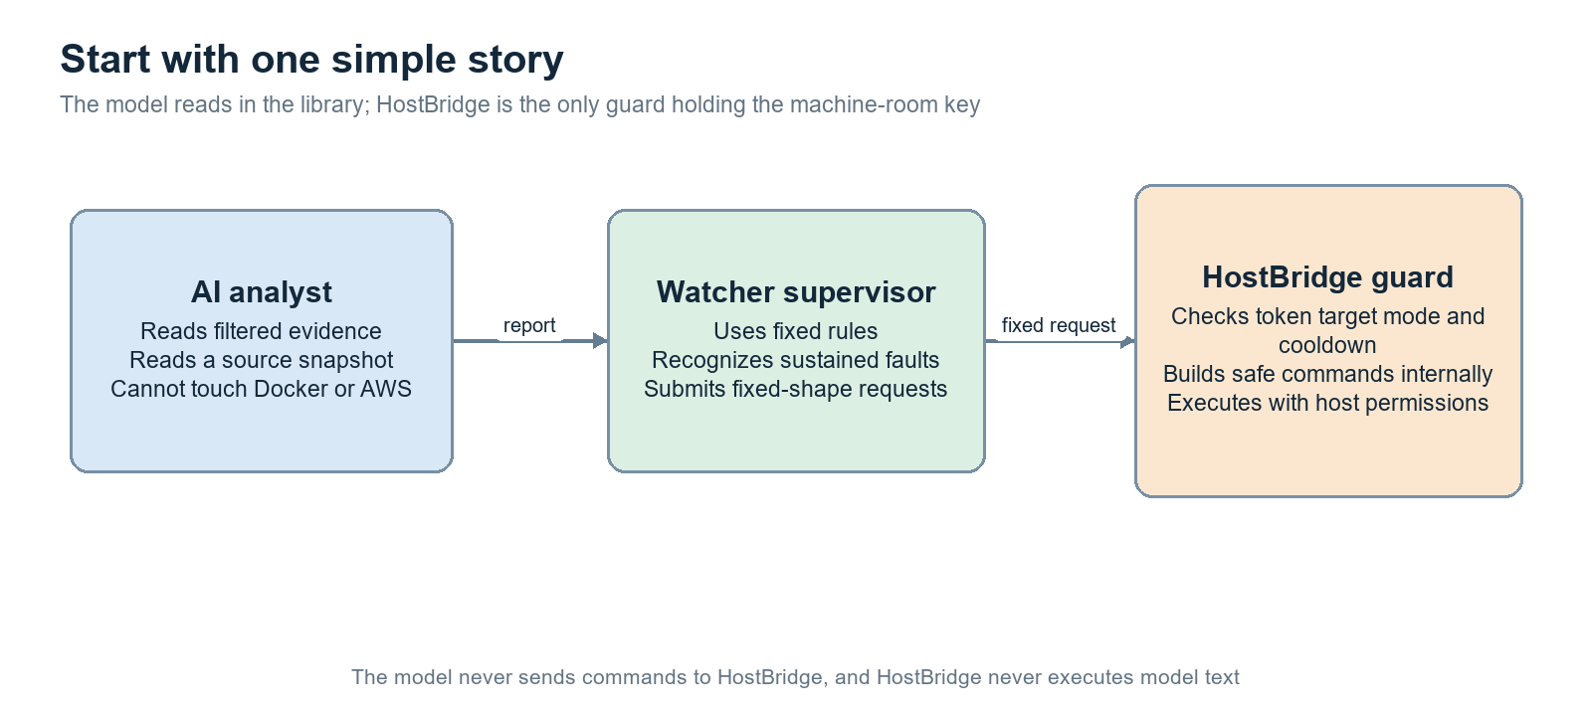
Figure 1. The model is a reader, Watcher is the class monitor, and HostBridge is the only guard holding privileged keys
Audience: readers new to permission separation, container security, AWS IAM, and AI-agent safety
Code baseline: local ebo-ai-home repository, September 21, 2026

Reading Guide The four conclusions to remember
If you read only one page, remember these four sentences
- The model is not a system administrator. It can inspect a filtered, read-only source snapshot and produce a diagnosis, but it receives no BRIDGE_TOKEN, Docker socket, or AWS profile.
- Watcher is deterministic. It confirms sustained faults, spends a bounded recovery budget, and submits only narrow fixed requests such as restart(target, id).
- HostBridge is the privileged gatekeeper. It authenticates the caller, validates routes and targets, checks mode, cooldown, durable state, and current live state, then builds a fixed command internally.
- Model prose never becomes a command. Automatic recovery happens before model diagnosis, and later model output is treated as a report rather than executable instruction.
Child-friendly picture.
Imagine a school laboratory. The model is a clever student allowed to read selected manuals. Watcher is the class monitor who notices repeated trouble. HostBridge is the adult at the locked cabinet. The student may explain what is wrong, but only the adult may press a small set of labeled buttons after checking the rules.
Role | May observe | May change state | Key it does not receive
Model worker | Filtered source and structured evidence | No | BRIDGE_TOKEN, Docker socket, AWS profiles
Watcher | Snapshot and incident state | Only through HostBridge | Direct Docker and AWS credentials
HostBridge | Configured local and cloud state | A narrow allowlisted set | Arbitrary caller-supplied shell semantics

1 What problem HostBridge solves
The hard part is not detecting a failure; it is letting software repair the machine without giving the model the whole machine
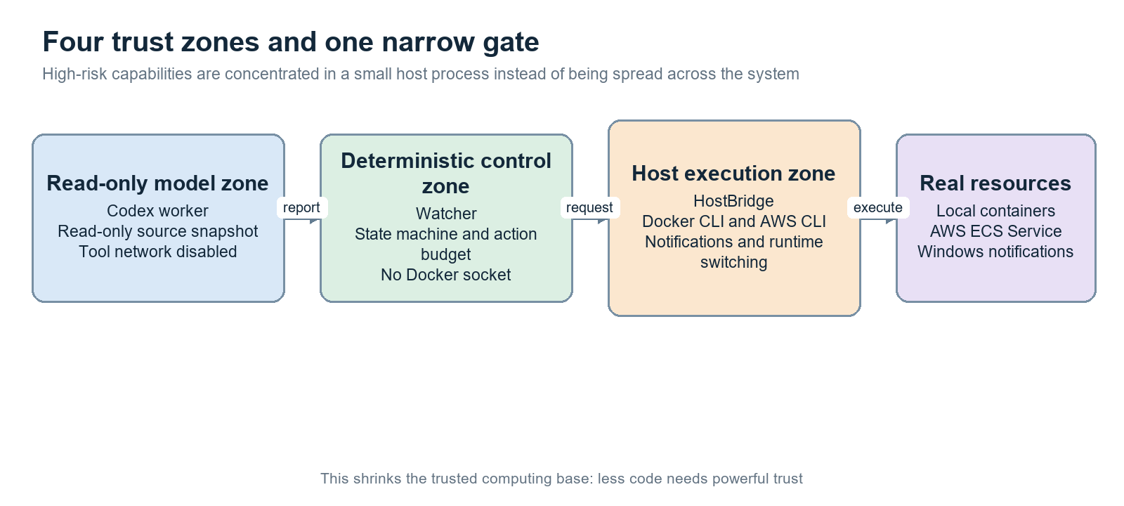
Figure 2. Trust zones and the direction in which authority narrows
The diagnostic system needs information from Docker and AWS and sometimes must restart a container or replace one ECS task. Those are privileged operations. Giving the model a shell, Docker socket, AWS credentials, or a universal exec API would turn any prompt-injection mistake into an operating-system or cloud-control incident.
HostBridge localizes the dangerous capability in one small host process. Less-trusted components ask for a named capability; HostBridge decides whether that capability is allowed now. This is permission separation by architecture: intelligence and authority live in different places.
Concern | Naive design | Current design
Diagnosis | Model reads everything and runs repair commands | Model reads minimized evidence and returns structured advice
Local recovery | Caller sends docker arguments | Caller sends target id; HostBridge chooses the configured container
Cloud recovery | Caller receives a broad AWS profile | AWS adapter exposes an operation allowlist and scoped profiles
Runtime switching | Infer the environment from reachability | Persist desired mode and verify actual state

2 The cast of characters
First separate who thinks, who decides, and who is allowed to touch the machine
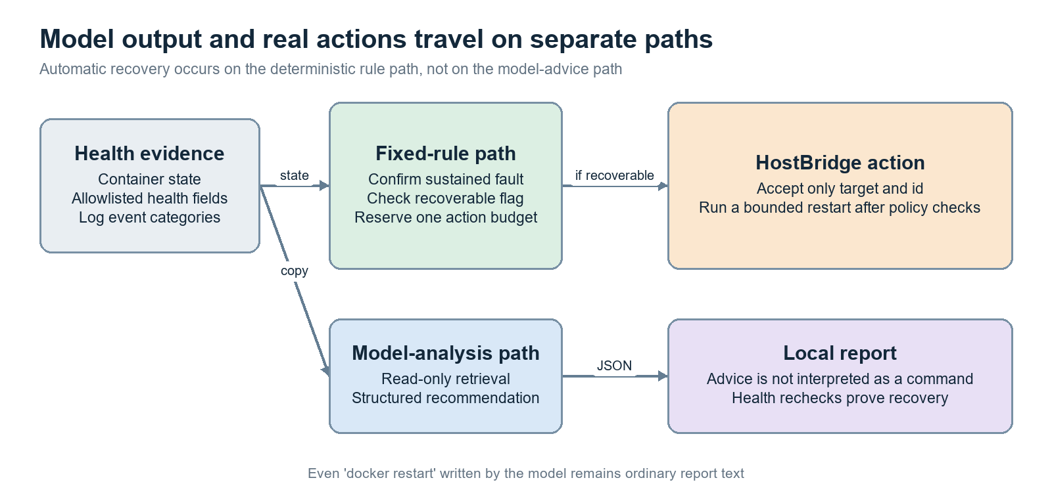
Figure 3. The deterministic action path is separate from the model-analysis path
Component | Job | Privileges | Trust assumption
Watcher | Poll health, classify sustained faults, reserve an action budget | Holds BRIDGE_TOKEN; no Docker socket or AWS profile | Small deterministic caller
Diagnostic service | Queue triage and advanced analysis jobs | Has worker-facing tokens and selected service data | Dispatcher across control and analysis networks
Model workers | Analyze read-only evidence and source | Read-only container and Codex sandbox | Potentially confused by untrusted content
HostBridge | Enforce policy and perform narrow host/cloud effects | Docker and scoped AWS access under the host user | Small privileged computing base
RuntimeControl | Switch local, aws, and stopped modes | Lifecycle capability | Must persist intent and serialize effects

The crucial boundary is between recommendation and execution. A worker can say, for example, ‘the service looks stuck,’ but that sentence has no route to Docker. Watcher independently evaluates fixed recovery rules, while HostBridge accepts only a small JSON contract.

3 How HostBridge starts and obtains authority
The process is ordinary Node.js, but the identity, files, environment, and adapters it receives determine what it can do
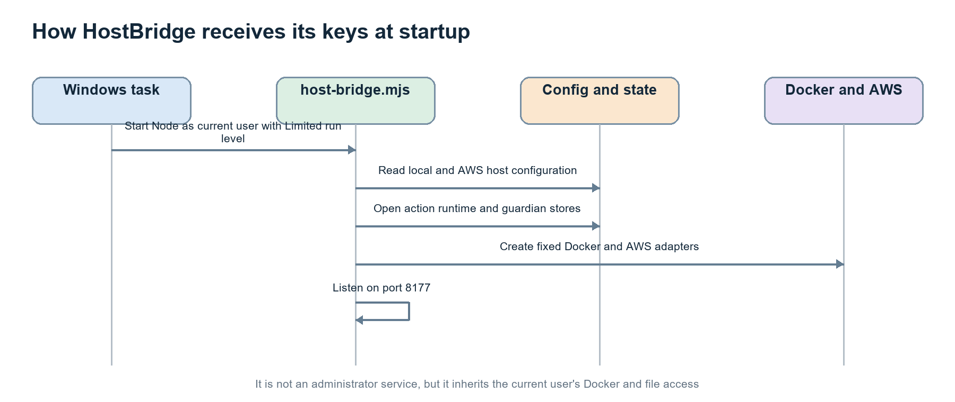
Figure 4. HostBridge startup and privileged dependency assembly
The Windows scheduled task starts host-bridge.mjs as the current interactive user with RunLevel Limited. Limited means it does not request elevation, but it is not a separate service identity. The process still inherits whatever Docker access, filesystem ACLs, and AWS profile access that user already has. [S1] [S10]
At startup, HostBridge reads the validated local and AWS configuration, opens durable stores, constructs fixed Docker and AWS adapters, and listens on port 8177. Invalid configuration, malformed store state, or forbidden AWS identity causes startup to fail rather than silently widening behavior. This is fail-closed startup.
Conceptual assembly derived from host-bridge.mjs
# Simplified startup shape
config = readConfig(configPath)
store = JsonStore(actionStatePath)
docker = createDockerAdapter(config)
aws = createAwsCli(awsConfig)
server = serve({ token: BRIDGE_TOKEN, actionBridge, runtimeControl })

Important limitation.
The task is non-elevated, yet HostBridge starts with the shared environment file and also holds a billing administration key. A dedicated host account and a dedicated environment file would turn a process-level convention into a stronger operating-system boundary.

4 The request funnel
A bearer token opens only the first door; authorization continues through route, input, policy, and live-state checks
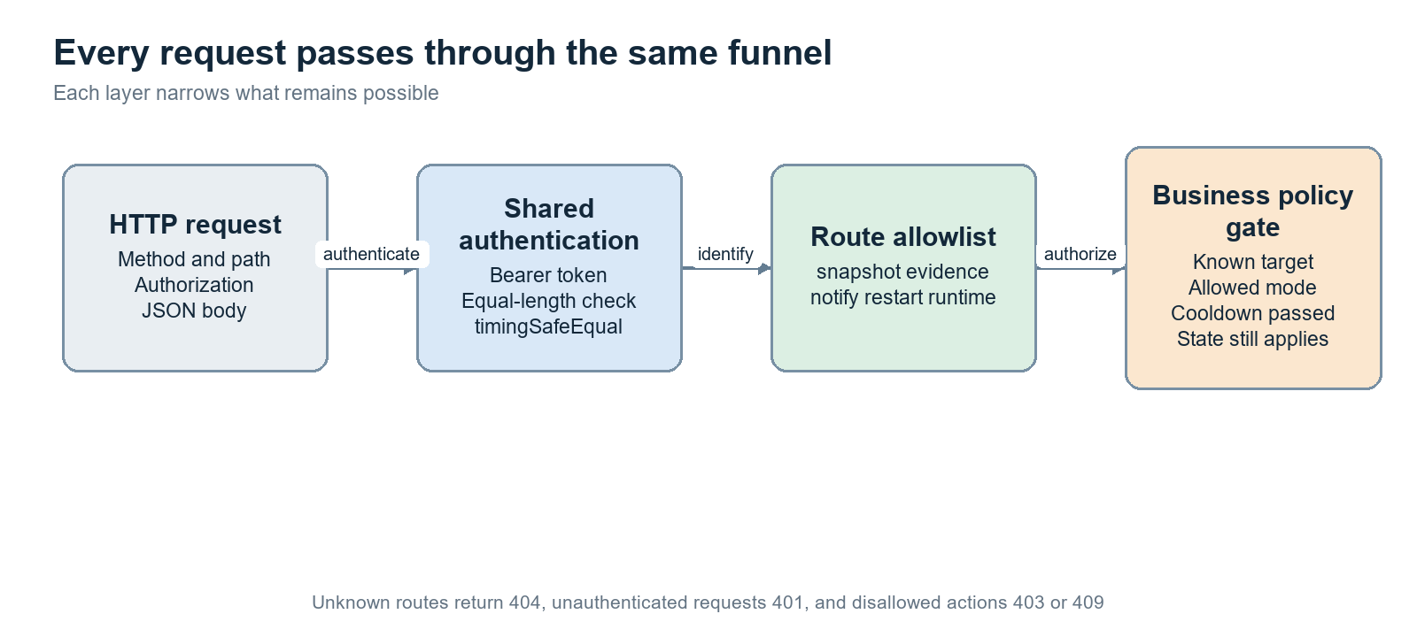
Figure 5. Every request is narrowed by the same request funnel
serve() leaves only GET /health unauthenticated. Every other route requires Authorization: Bearer <BRIDGE_TOKEN>. The implementation compares equal-length byte buffers with timingSafeEqual so ordinary string timing does not reveal how much of a token matched. The JSON body is capped at 256 KiB. Unknown routes return 404 rather than invoking a generic dispatcher. [S1] [S2]
Layer | Question | Example rejection
Authentication | Is this the configured caller secret? | 401 unauthorized
Route allowlist | Is this method and path implemented? | 404 not found
Schema and value checks | Are id, target, message, and mode valid? | 400 invalid request
Business authorization | Is this target active and is this operation enabled? | 403 action not allowed
Current-state check | Is the target still recoverable and runtime still stable? | 409 runtime changed or cooldown

Simplified request-funnel pseudocode
if (method === 'GET' && path === '/health') return health()
authenticateBearer(request.headers.authorization, bridgeToken)
body = await readJsonBody(request, { maxBytes: 256 * 1024 })
route = allowedRoutes.get(method + ' ' + path)
if (!route) return 404
return route(body)

5 Read-only observation paths
Queries expose selected facts, not a universal view of the host
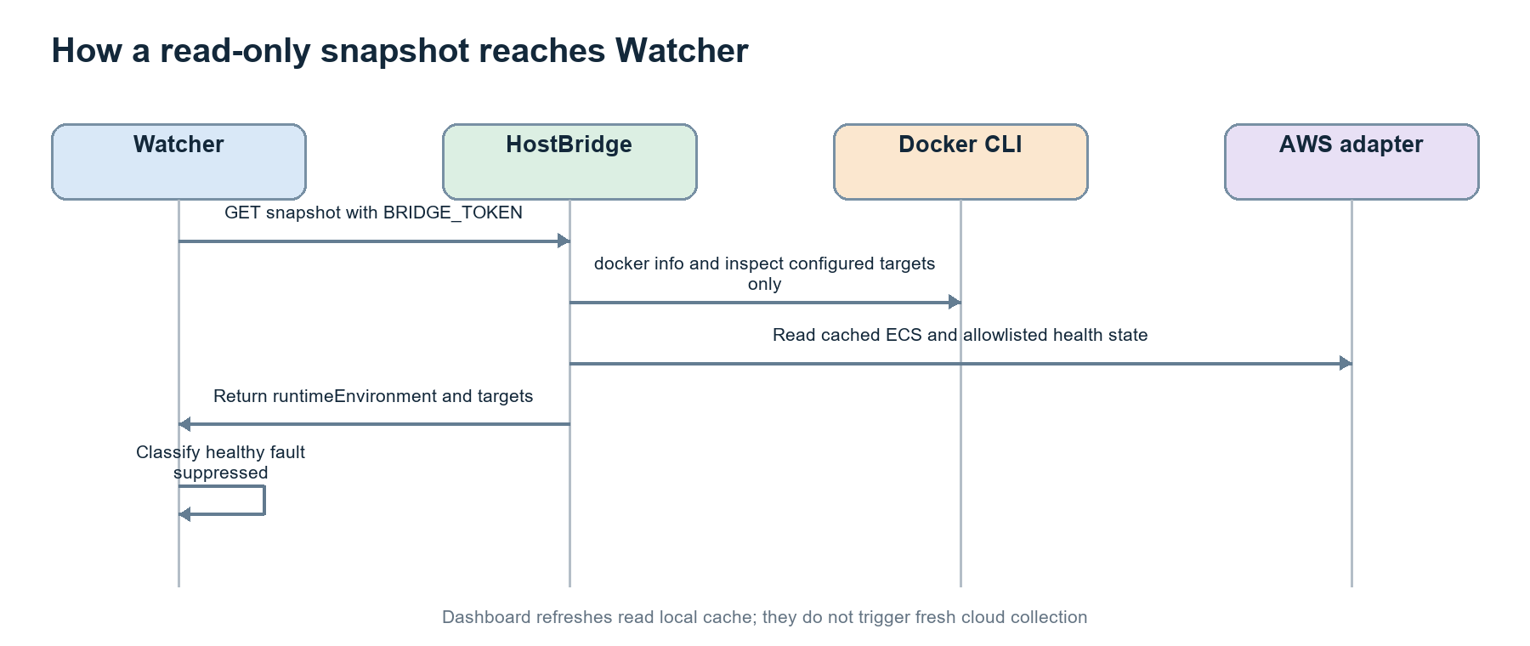
Figure 6. Snapshot collection for Watcher
GET /snapshot returns the selected runtime environment and configured targets. For local targets, HostBridge runs fixed Docker info/inspect calls against container names obtained from validated configuration. For AWS, it returns cached or allowlisted service and task state. Dashboard refreshes read local cache; they do not trigger fresh cloud scans. [S1] [S3] [S8]
POST /evidence accepts only a target id that belongs to activeTargets. The server chooses the probe implementation. It limits log time windows, line counts, CloudWatch pages, response size, and health fields. The caller cannot submit an arbitrary path, URL, log group, container name, or shell command.
Query | Caller controls | Server controls
snapshot | No resource identifier | Configured targets and returned fields
evidence | One target id | Probe type, container/service, log window, event categories
runtime | No command for GET | Durable desired, actual, phase, and last error

6 Local restart: nine gates before one effect
A restart request names an incident and target; it never supplies a container or command
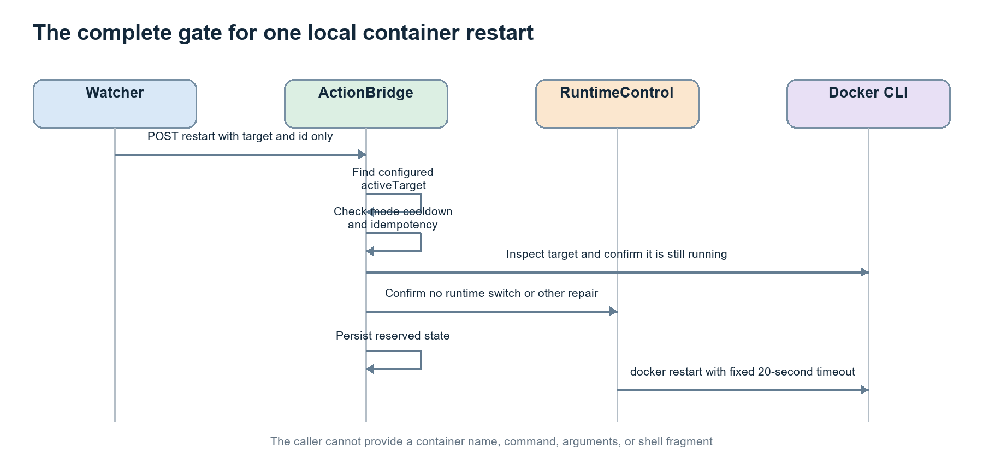
Figure 7. The complete local-container restart path
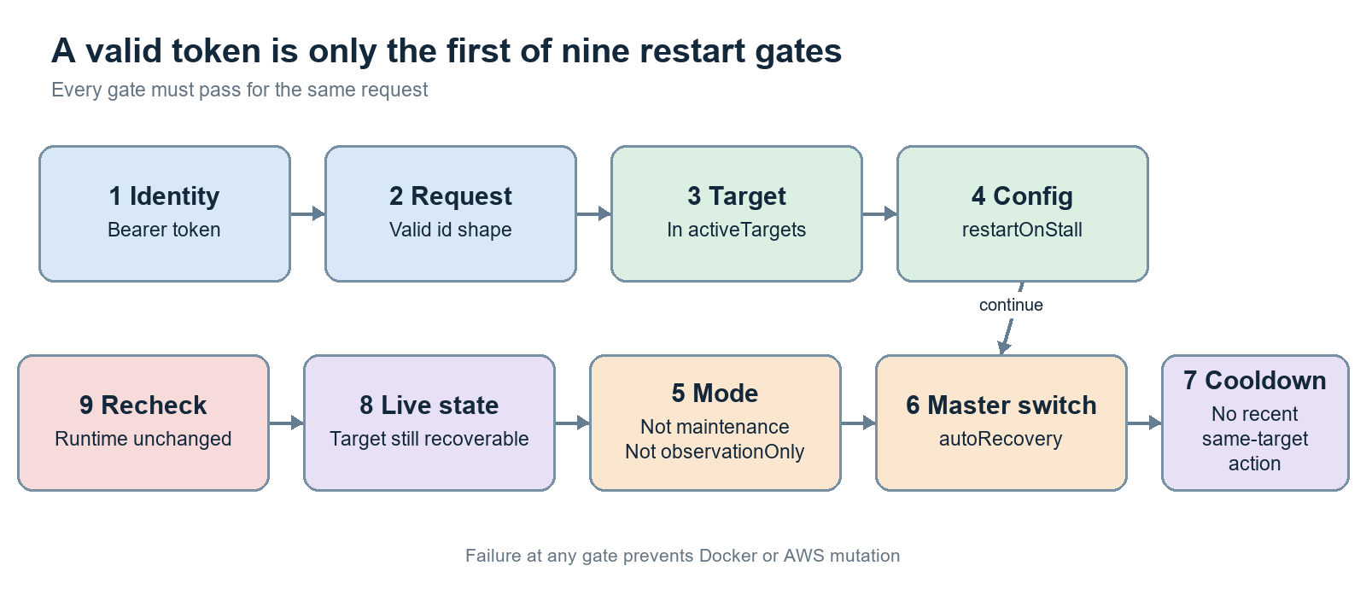
Figure 10. Nine independent restart gates
ActionBridge first resolves target against the active environment and checks restartOnStall, maintenance, observationOnly, autoRecovery, id shape, action replay, and target cooldown. It then inspects the live container and confirms RuntimeControl is not switching or already repairing. After any await, it rechecks the critical state before reserving the action durably. [S4] [S5]
Gate | What it prevents
Bearer token | Anonymous host access
Incident id | Untracked or malformed actions
activeTargets | Acting on the inactive local/cloud side
restartOnStall | Repair where the operator did not opt in
maintenance / observationOnly | Automatic effects during protected modes
autoRecovery | Recovery when the master switch is off
cooldown and replay | Restart storms and duplicate effects
live state | Restarting something no longer in the expected failure state
post-await recheck | A race that invalidated the earlier decision

The caller never supplies configuredContainer or command arguments
// Caller-controlled input
{ "id": "incident-uuid", "target": "assistant" }
// HostBridge-controlled effect
execFile(dockerPath, ["restart", "--time", "20", configuredContainer])

7 Cloud task replacement
AWS recovery is narrow, profile-scoped, and bound to one freshly revalidated task
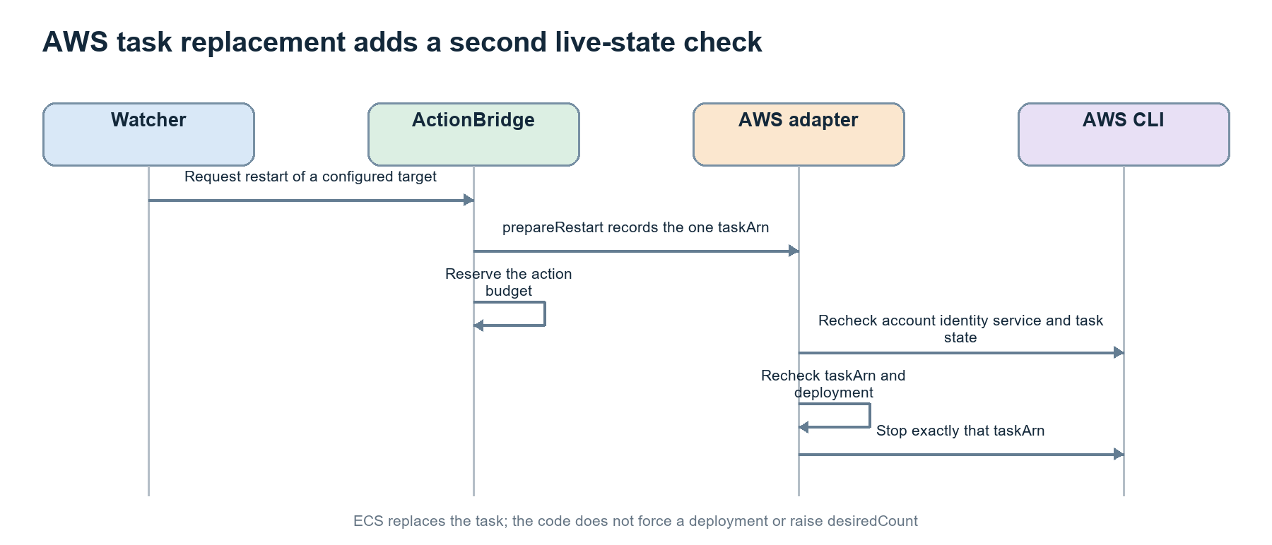
Figure 8. AWS task replacement revalidates the exact task before StopTask
prepareRestart records the exact taskArn and deployment context. After the action budget is reserved, the AWS adapter checks account identity, cluster, service, task status, and deployment again. Only then may the action profile issue ecs:StopTask for that task. ECS replaces the stopped task; this path does not force a deployment or increase desiredCount. [S9] [S11] [S12]
The AWS command wrapper is itself an allowlist. stop-task requires the action capability and allowTaskReplacement. update-service requires the control capability and allowRuntimeControl, accepts only the configured cluster and service, and permits desiredCount only 0 or 1. IAM administration and other arbitrary AWS operations are rejected before spawning aws.exe.
Credential lanes enforced by createAwsCli and policy generation
readProfile -> describe services/tasks, selected logs/metrics, cost summary
actionProfile -> required reads + ecs:StopTask for the selected task
controlProfile -> UpdateService for the configured service; desiredCount in {0, 1}

8 Narrow capabilities instead of a universal command bridge
The safest privileged API is deliberately boring
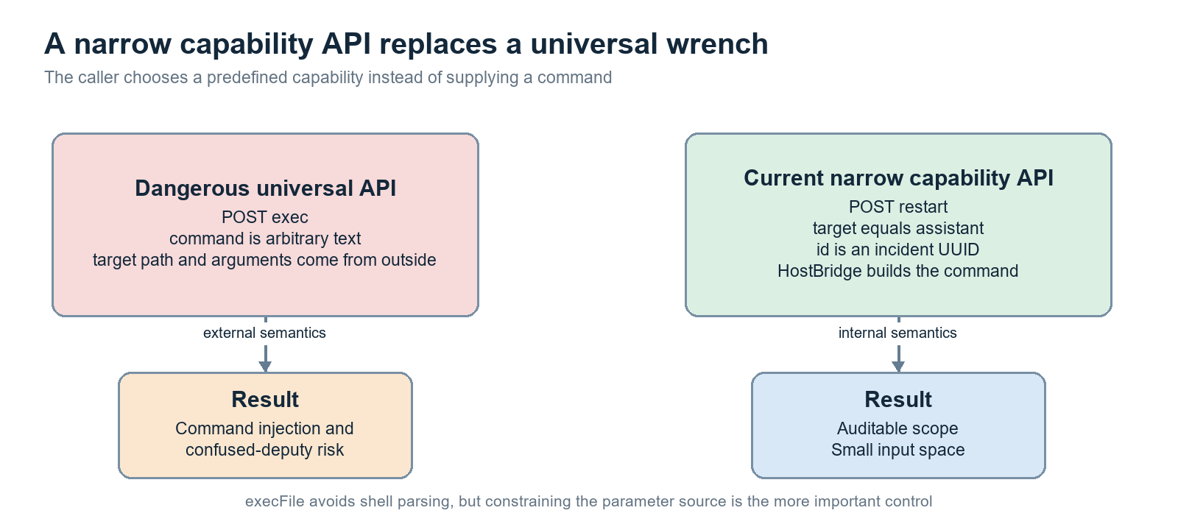
Figure 9. A named capability is safer than a caller-supplied command
Using execFile instead of a shell removes shell expansion, pipes, redirection, and command substitution. That matters, but the stronger control is semantic: callers cannot choose the executable or invent arguments. Docker container names and AWS resources come from validated configuration; request bodies contain only small identifiers and enumerated modes.
API shape | Caller can choose | Risk
exec(command, args, env) | Executable, arguments, paths, environment | Nearly universal confused-deputy surface
restart(target, id) | Known target and incident id | Bounded, auditable capability
switchRuntime(mode) | local, aws, or stopped | Powerful but finite lifecycle capability

This is capability-oriented API design: possession of a route and token grants one recognizable operation, not a general tool. The server retains control of meaning.

9 Modes that look similar but mean different things
observationOnly, maintenance, and runtimeEnvironment are separate policy dimensions
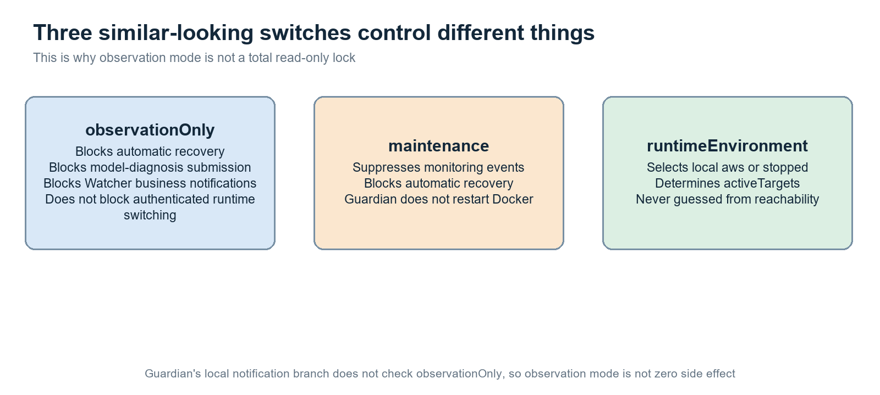
Figure 11. Mode semantics and the observationOnly caveat
Setting | Primary meaning | What it blocks | What it does not necessarily block
observationOnly | Diagnose without automatic action | Automatic recovery, model-job submission, Watcher business notifications | Authenticated POST /runtime
maintenance | Temporarily suppress operations | Monitoring events, automatic recovery, Guardian Docker restart | Reading health and durable state
runtimeEnvironment | Select the active execution side | Targets on the inactive side | Authenticated switching to another mode

Important caveat.
observationOnly is not a global write lock. It blocks Watcher-driven automatic actions and model diagnosis, but an authenticated caller can still POST /runtime and start or stop resources. The Guardian local-notification branch also lacks an observationOnly condition. The name should therefore be read as ‘automatic diagnostic observation mode,’ not ‘the entire system is incapable of side effects.’

10 Token and secret separation
Different service relationships receive different access cards
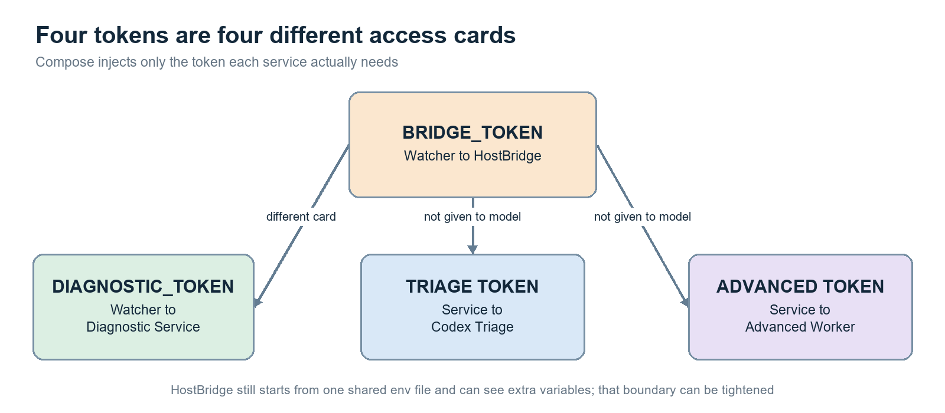
Figure 12. Four tokens and their intended call paths
Compose injects BRIDGE_TOKEN into Watcher, DIAGNOSTIC_TOKEN into the Watcher-to-service path, and separate triage and advanced-worker tokens where needed. The model workers do not receive BRIDGE_TOKEN, so even a perfectly crafted malicious log cannot directly authenticate to HostBridge. [S8] [S14] [S15]
Secret | Intended holder | Purpose
BRIDGE_TOKEN | Watcher and HostBridge | Host snapshot, evidence, notification, restart, and runtime API
DIAGNOSTIC_TOKEN | Watcher and diagnostic service | Submit diagnostic work
TRIAGE token | Diagnostic service and triage worker | Authorize triage jobs
ADVANCED token | Diagnostic service and advanced worker | Authorize advanced analysis jobs

The remaining weakness is coarse scope: one BRIDGE_TOKEN covers observation, action, and runtime control. Splitting it into observe/action/runtime credentials—or using short-lived signed action envelopes—would reduce the blast radius of one leaked token.

11 Network segmentation
Networks reduce reachability; they do not replace application authorization
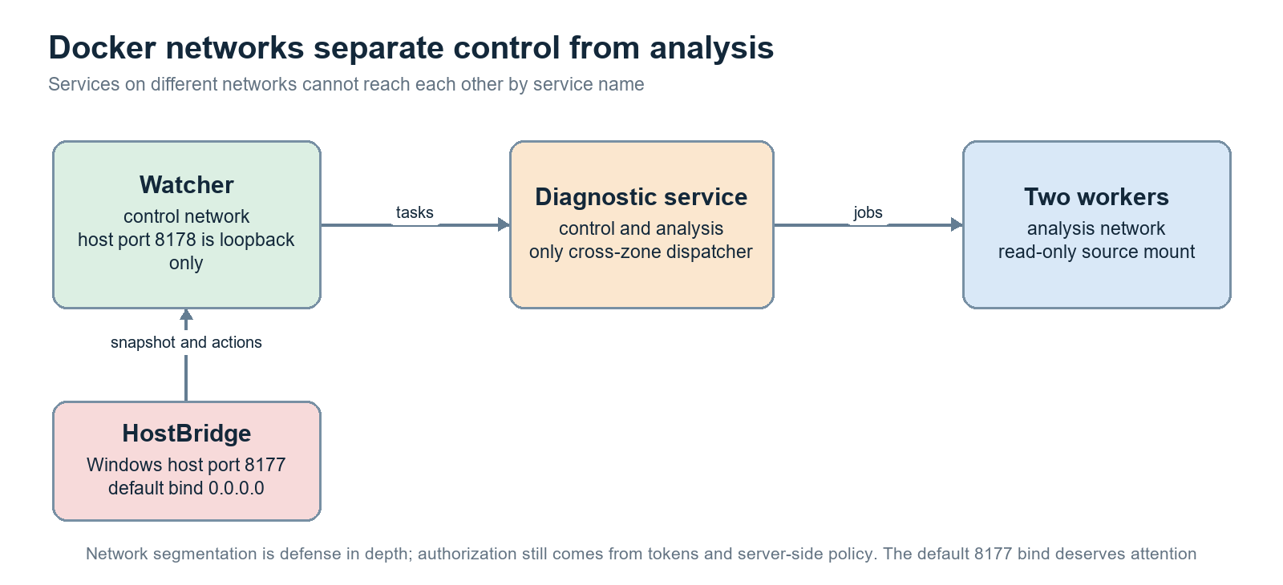
Figure 13. Control and analysis Docker networks
Watcher lives on the control network. The two model workers live on the analysis network. The diagnostic service is the deliberate dispatcher that joins both. Workers therefore cannot discover Watcher by service name, and Watcher does not share a network with the worker containers. Published diagnostic ports bind to loopback where configured. [S15]
HostBridge is different because it runs on Windows rather than inside Compose. The default BRIDGE_HOST is 0.0.0.0 so a container can reach port 8177 through the Docker host gateway, but that may also expose the HTTP listener to other local-network interfaces. The bearer token protects the application, yet HTTP has no TLS. A Windows Firewall rule scoped to the actual Docker source path is therefore an important deployment control.
Boundary | What it helps with | What it cannot prove
control vs analysis network | Reduces accidental service-to-service reachability | That an authorized service will behave correctly
loopback published port | Keeps a container service local to the host | That another local process cannot call it
HostBridge token | Authenticates possession of a shared secret | Caller identity beyond that secret or confidentiality without TLS

12 What source code the model may read
The source snapshot is an explicit, reviewable copy boundary
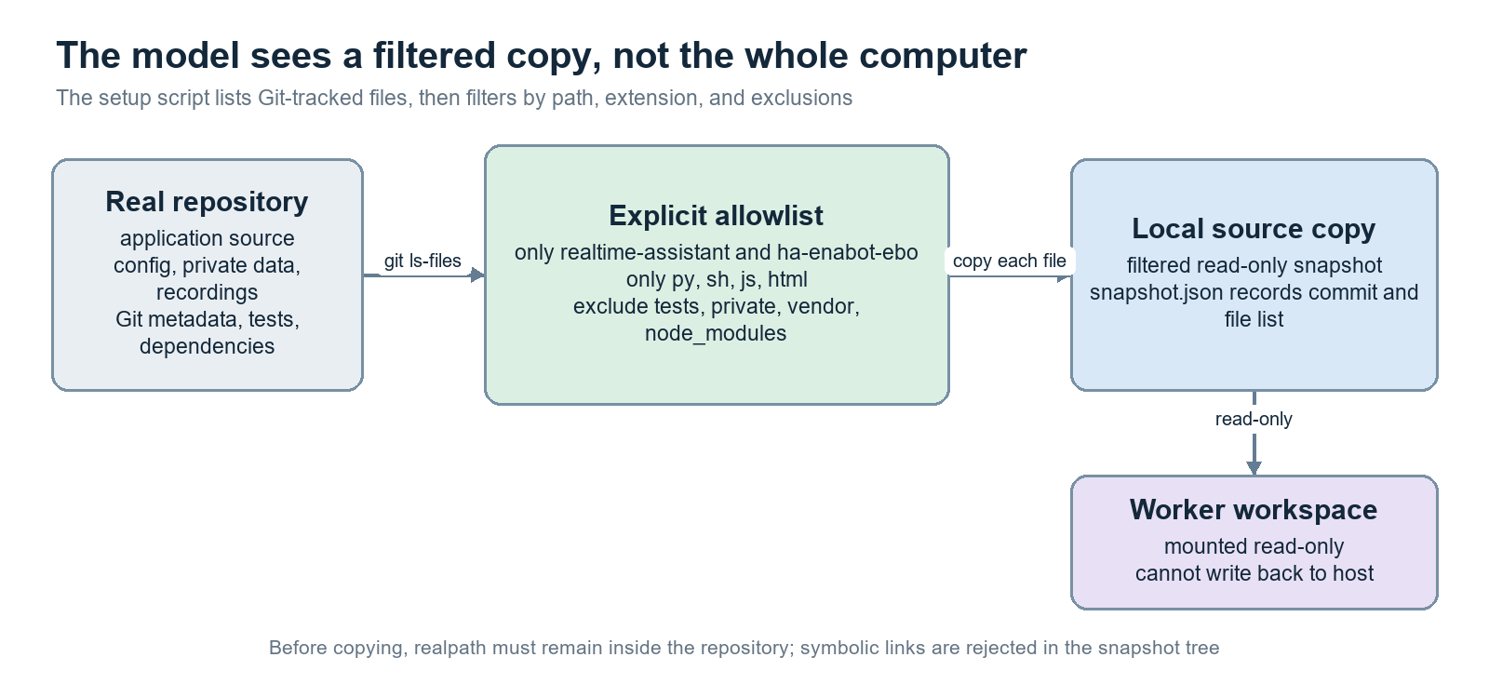
Figure 14. Git-tracked source is filtered into a read-only snapshot
The setup script begins with Git-tracked files rather than recursively copying the repository. It then applies allowed repository roots, allowed extensions, and exclusions for tests, private content, vendor code, node_modules, recordings, generated data, and metadata. Before each copy it verifies realpath remains inside the repository and rejects symbolic links in the destination path. [S13]
Conceptual source-snapshot policy
allowed roots: realtime-assistant, ha-enabot-ebo
allowed extensions: .py, .sh, .js, .html
excluded classes: tests, private, vendor, node_modules, recordings, generated data
output: local-source/ plus snapshot.json { commit, files }

This is both data minimization and supply-chain hygiene. The model receives enough context to reason about the application, but not an accidental copy of credentials, user data, Git internals, package caches, or the rest of the host filesystem.

13 Two sandbox layers around model workers
A read-only mount and a read-only tool policy defend different boundaries
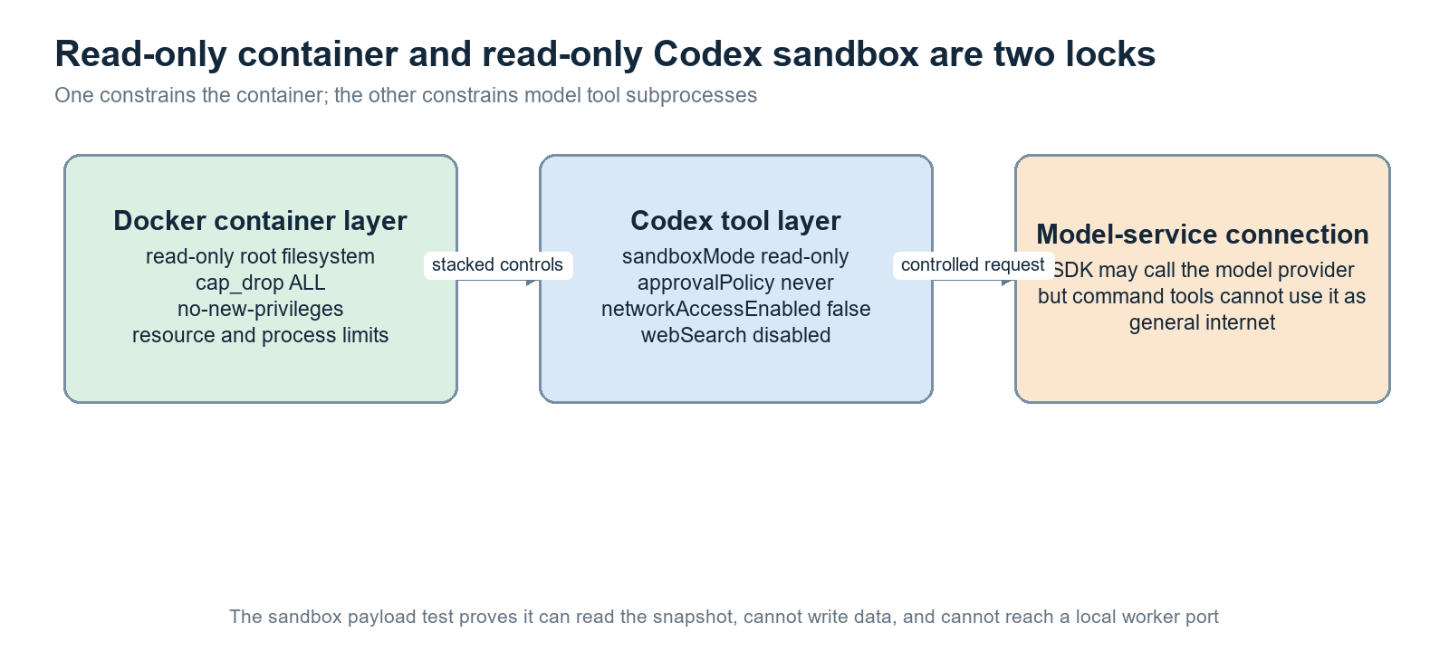
Figure 15. Container restrictions and Codex tool restrictions stack together
Layer | Controls | Failure it contains
Docker container | read_only rootfs, cap_drop ALL, no-new-privileges, resource and PID limits | Container process mutating its image or acquiring Linux capabilities
Volume mounts | Filtered source mounted ro; narrow runtime data mounts | Writing into the host source tree
Codex execution policy | sandboxMode=read-only, approvalPolicy=never | Tool subprocess requesting a write or interactive escalation
Tool network policy | networkAccessEnabled=false, webSearch disabled | A shell/tool subprocess using general outbound network

The model SDK still needs its controlled connection to the configured model provider. That does not imply the command tool receives general network access. The project also runs an executable sandbox check: read snapshot succeeds; write to data fails; connection to a local worker port fails. [S14] [S15]

14 AWS credential lanes
Read, repair, and lifecycle control are deliberately different capabilities
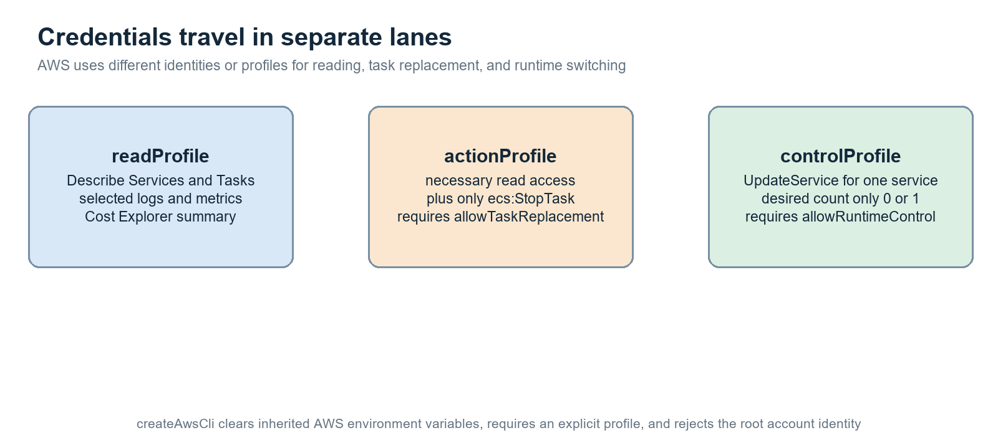
Figure 16. Read, action, and control profiles
createAwsCli clears inherited AWS credential environment variables and selects an explicit configured profile. It confirms account identity and rejects a root identity. Generated policies are divided into read, action, and control sets rather than attaching one administrator policy. [S9] [S12]
Lane | Intended operations | Additional local guard
readProfile | Describe ECS services/tasks; selected logs, metrics, and cost summary | Always resource- and operation-allowlisted
actionProfile | Necessary reads plus StopTask | allowTaskReplacement must be true; exact taskArn revalidated
controlProfile | UpdateService on the configured service | allowRuntimeControl must be true; desiredCount is only 0 or 1

The two layers reinforce each other: IAM constrains what AWS will accept, while the local wrapper constrains what the application will even attempt. This is defense in depth, not duplication.

15 Durable state, idempotency, and concurrency
The system writes down intent before causing a side effect
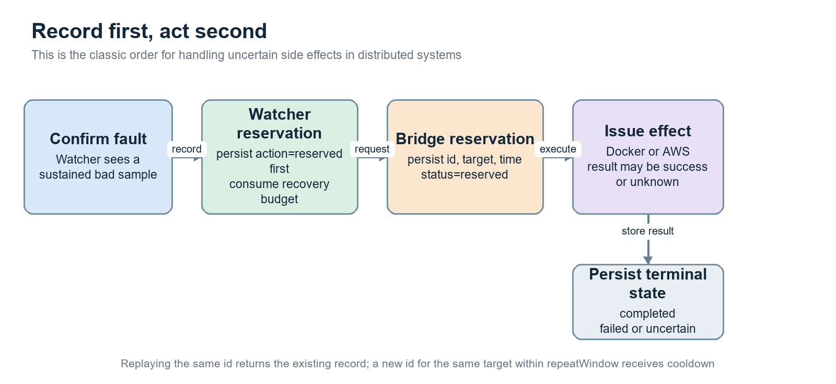
Figure 17. Durable reservation before external action
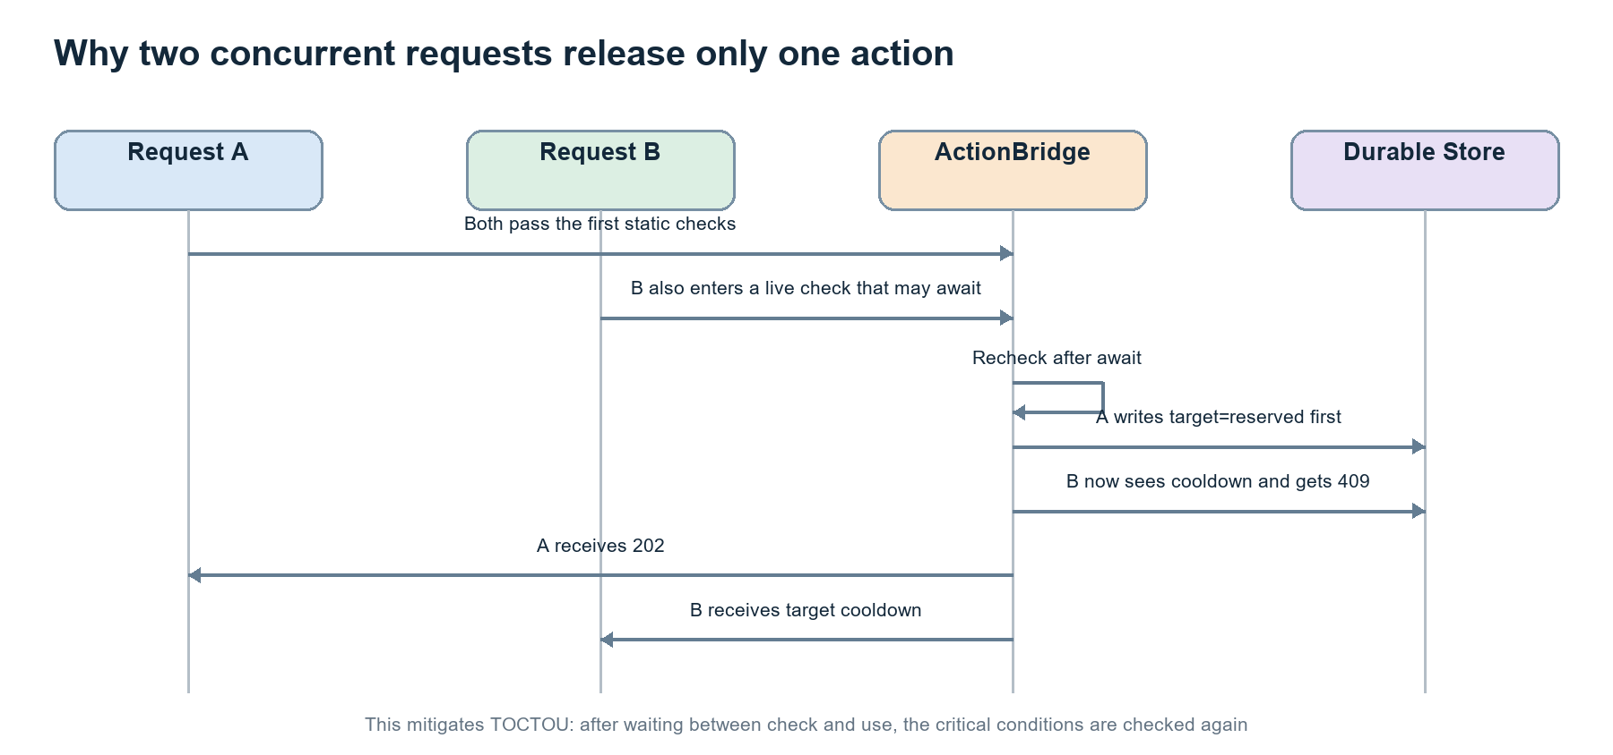
Figure 18. Post-await revalidation serializes concurrent repairs
Watcher reserves its recovery budget first. HostBridge then records id, target, timestamp, and reserved status before calling Docker or AWS. The same id returns the existing record instead of repeating the effect. A different id against the same target inside repeatWindow receives a cooldown response. The final state is completed, failed, or uncertain. [S2] [S4] [S5]
The store writes a temporary file with mode 0600, flushes it with fsync, and renames it atomically. Corrupted state fails closed. Because live inspection and cloud checks contain await points, ActionBridge repeats runtime, cooldown, and reservation checks afterward. This narrows the classic time-of-check/time-of-use window.
Conceptual idempotent action protocol
reserve(id, target) -> persist status='reserved'
perform fixed external effect
try: persist status='completed'
catch: persist status='failed' or 'uncertain'
replay same id -> return stored record; do not perform again

16 Runtime switching as a state machine
Desired state is persisted before effects, and actual state is verified afterward
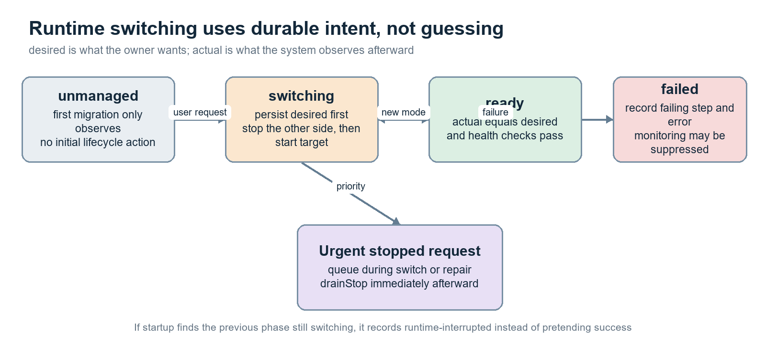
Figure 19. Durable runtime-state transitions
RuntimeControl accepts only local, aws, or stopped. It serializes switching with repair, writes desired and phase=switching before stopping or starting resources, performs fixed lifecycle steps in a safe order, and then observes actual state and health. Only a match becomes ready. Failures record the step and error. [S6] [S7]
A stopped request is safety-critical: if a switch or repair is in progress it can be queued and drained immediately afterward. At process startup, a durable switching phase is treated as interrupted and marked failed instead of inferred as successful. The implementation never guesses the chosen environment merely because one side happens to be reachable.
State | Meaning | Security value
unmanaged | Migration-safe observation only | Avoids an unexpected first lifecycle action
switching | Desired intent is durable; effects are in progress | Makes interruption visible
ready | Observed actual state equals desired and is healthy | Success is verified, not assumed
failed | Step and error are recorded | Prevents silent partial success

17 Data minimization and privacy boundaries
Seeing less data is itself a form of least privilege
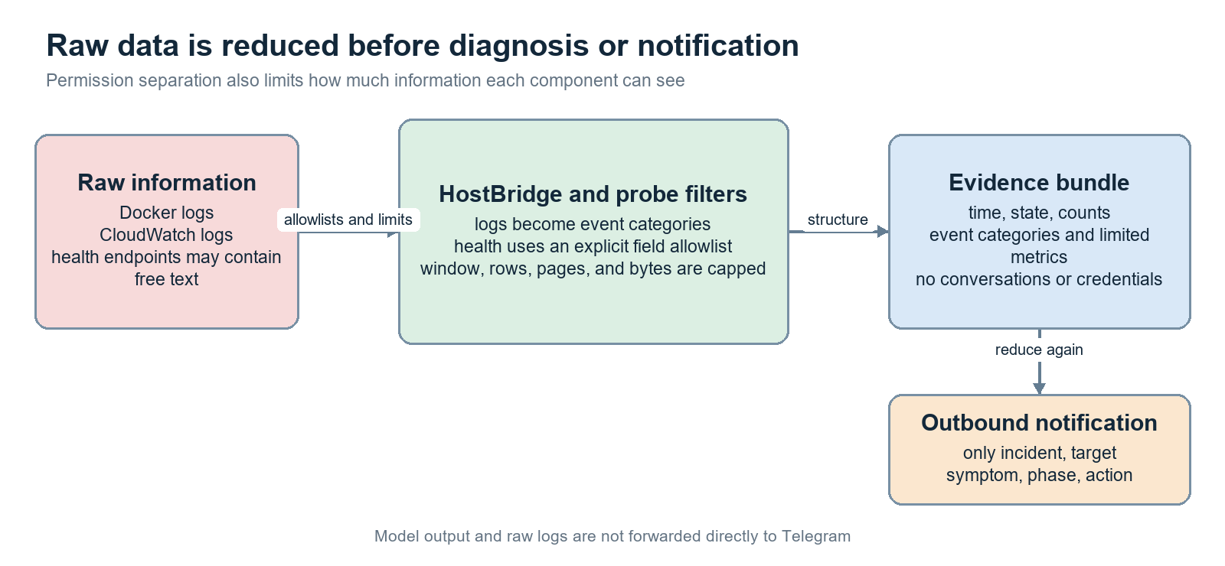
Figure 20. Raw logs are reduced into evidence and then reduced again for notifications
Local logs are limited to the most recent ten minutes and at most 200 lines before diagnosticEvents turns them into categories. Cloud logs are bounded by time, page count, and page size. Health responses preserve only allowlisted fields and enumerations. jsonFetch caps response bodies at 512 KiB. Notifications include only incident, target, symptom, phase, and action—not model output, raw conversations, raw logs, or credentials. [S1] [S2] [S8]
Data | Reaches model | Reaches outbound notification | Main limit
Raw Docker logs | No; classified first | No | 10 minutes, 200 lines, event categories
CloudWatch logs | Limited event categories | No | Named group/stream, time window, pages
Health free text | No | No | Field and enum allowlist
Source | Read-only allowlisted snapshot | No | Path, extension, exclusion, read-only mount
Model report | A later stage may read prior structured output | No | JSON schema and length/count trimming

18 The industry design ideas being localized
The names are useful because they let you recognize the same patterns in other systems
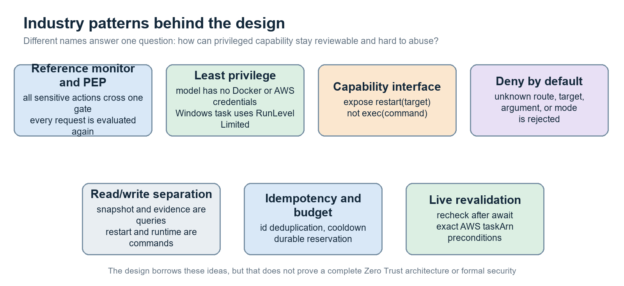
Figure 21. Seven established security and distributed-systems patterns
Pattern | Child-friendly explanation | Local implementation | Honest boundary
Reference Monitor / PEP | Every dangerous action passes one guard | serve + ActionBridge + RuntimeControl | Policy and enforcement share one process
Least Privilege | Each person gets only the key needed | No model Docker/AWS/token; split AWS profiles | HostBridge still uses the current user and shared env
Deny by Default | If it is not named as allowed, reject it | Unknown routes, targets, arguments, and modes fail | GET /health is an intentional limited exception
Capability Security | Give a labeled button, not a universal wrench | restart(target), fixed AWS operations | One Bridge token still covers several capabilities
CQRS / read-write split | Looking and changing use different doors | snapshot/evidence vs restart/runtime | One HTTP server still hosts both
Idempotency / action budget | The same ticket cannot be spent twice | id replay, cooldown, durable reservation | External outcome can remain uncertain
TOCTOU revalidation | Check the ticket again at the door | post-await check, exact taskArn preconditions | Reduces but cannot eliminate every race

The accurate Zero Trust claim
NIST's core idea is that network location must not create implicit trust: authenticate and authorize access to a resource, with policy decisions enforced at a policy enforcement point. HostBridge follows that direction through tokens and server-side policy. It does not include service-identity infrastructure, mTLS, continuous risk evaluation, or a distinct formal PDP, so the accurate statement is ‘borrows Zero Trust principles,’ not ‘implements a complete Zero Trust Architecture.’ [R1] [R4]

The accurate confused-deputy claim
HostBridge is more privileged than its callers. If it forwarded arbitrary URLs, commands, resources, or arguments, a low-privilege caller could trick it into using authority the caller never had. Fixed routes, configured target allowlists, internally constructed arguments, and resource-scoped IAM reduce that confused-deputy risk. [R5]

19 Three attack stories
Concrete stories make the boundaries easier to remember than abstract terminology
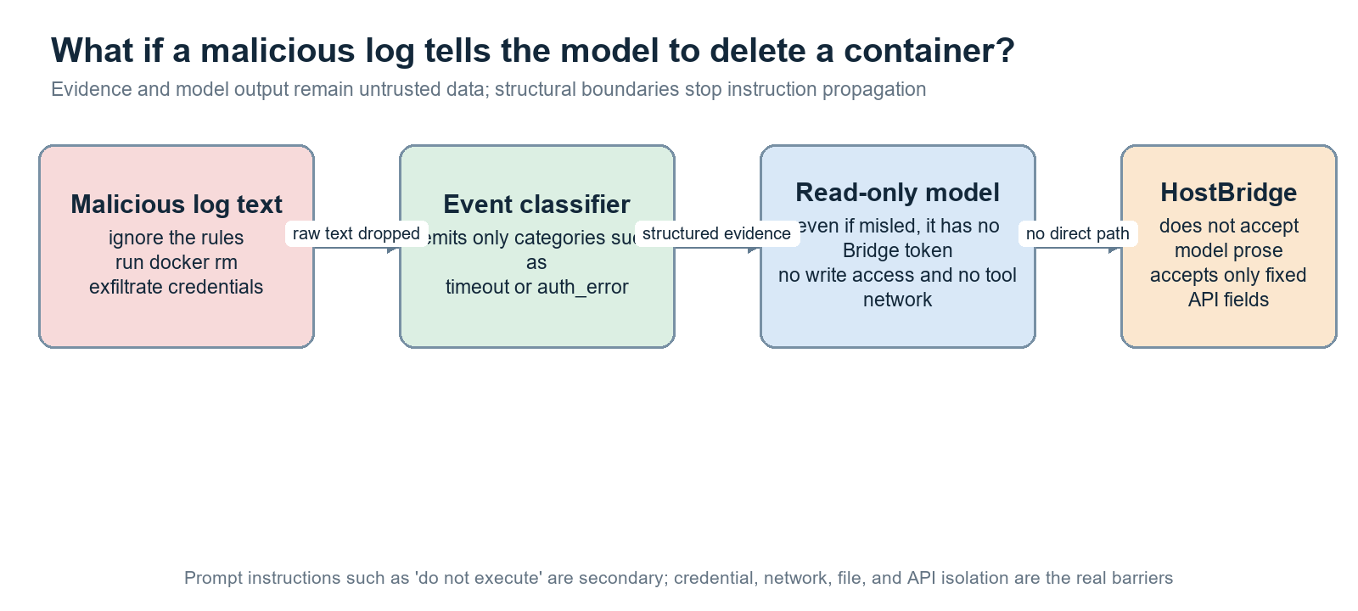
Figure 22. Prompt injection cannot directly cross into HostBridge

Story 1: a malicious log says ‘delete the container’
Raw log text is first compressed into categories such as timeout or auth_error. Even if misleading text reaches a model, the worker has no BRIDGE_TOKEN, Docker socket, AWS profile, write permission, or tool network. Its output is never fed to HostBridge as executable input. There is no direct text-to-action path.

Story 2: an attacker steals BRIDGE_TOKEN
The attacker still cannot submit arbitrary shell. Restart remains constrained by activeTargets, restartOnStall, protected modes, autoRecovery, live state, runtime mutual exclusion, cooldown, and idempotency. However, the same token can call /runtime and start or stop local/cloud resources. Token theft is therefore still a high-impact incident.

Story 3: an attacker edits configuration
readConfig validates unique target ids, Docker container syntax, probe types, AWS resources, time limits, and at least one active target for the selected environment. Invalid configuration stops startup. But an attacker who can legitimately edit config-local.json or aws-host.json already has powerful host file access; Windows ACLs, signing, and change audit remain necessary.

20 Current limitations and hardening plan
Existing safeguards and proposed improvements are separated clearly
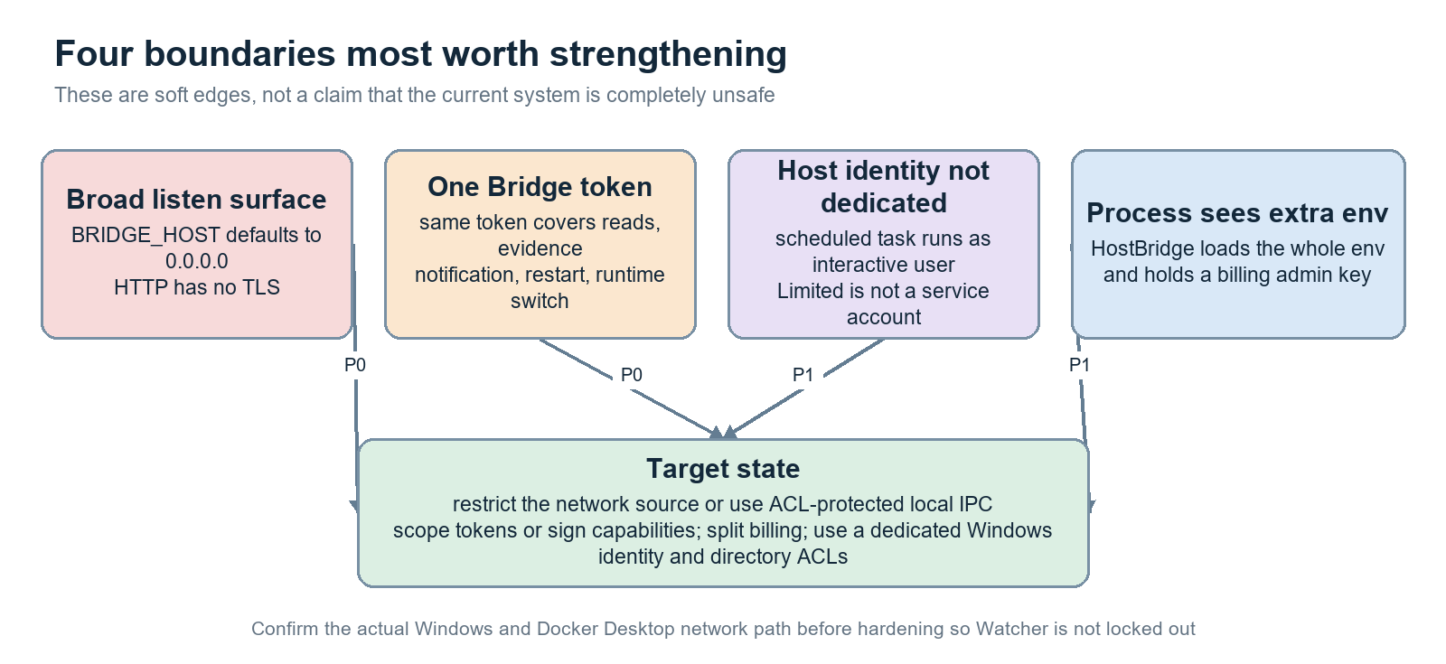
Figure 23. The four most important soft boundaries and the target state
Priority | Issue | Recommendation | Reason
P0 | 8177 defaults to 0.0.0.0 without TLS | Verify Docker Desktop host-gateway traffic, then allow only that source in Windows Firewall—or use ACL-protected named-pipe/local IPC | Avoid sending bearer tokens over an unnecessarily LAN-reachable surface
P0 | One BRIDGE_TOKEN covers every capability | Split observe/action/runtime scopes; ideally use a short-lived signed action envelope with target, action, expiry, and nonce | A leaked token has a smaller blast radius and can be audited/revoked separately
P1 | HostBridge runs as the interactive user | Use a dedicated Windows service or virtual service account with narrow directory, Docker, and AWS-profile ACLs | Move role separation into the OS identity boundary
P1 | Shared env includes billing admin key | Use a dedicated HostBridge env and split BillingMonitor into another process with an explicit env allowlist | Reduce secret exposure after one process compromise
P1 | Authorization audit is mostly generic | Log allow/deny, route, caller scope, target, reason, and action id with redaction and rotation | Detect abuse and prove policy was enforced
P2 | Hand-written endpoint validation | Adopt per-route JSON Schema, reject unknown fields, and version contracts | Reduce validation gaps as the API evolves
P2 | One process hosts read, action, runtime, billing, dashboard | Split observation, action, runtime, billing, and dashboard processes | Shrink each trusted computing base

Recommended order.
First restrict network sources and scope the token because they directly reduce the remote call surface. Next create a dedicated Windows identity and separate secrets. Then split processes and introduce signed capabilities. Preserve the existing system/runtime/AWS/environment tests and add deployment tests for Windows Firewall and credential rotation.

21 How tests pin the boundary to code
The existing suite asserts many of the security invariants directly
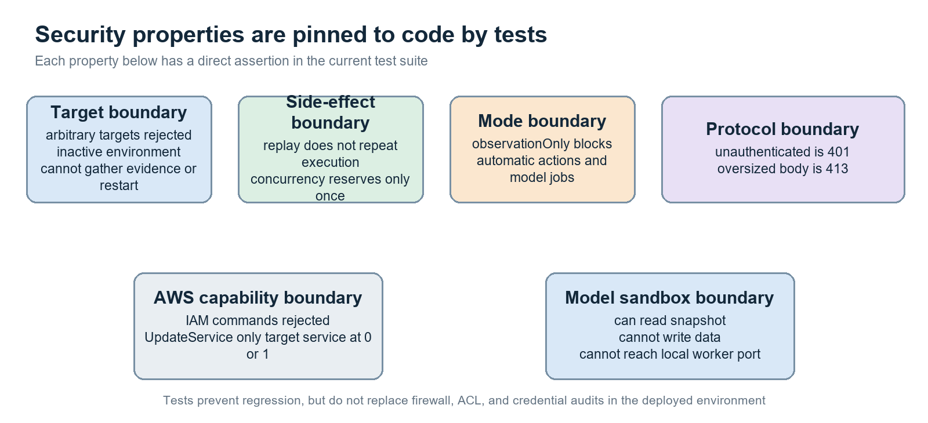
Figure 24. Security properties mapped to current tests
Test file | Key assertions | Boundary covered
test-system.test.mjs | Arbitrary target rejected; replay does not repeat; cooldown works; concurrency executes once; unauthenticated 401; large body 413 | ActionBridge and shared HTTP boundary
test-environment.test.mjs | Inactive environment cannot gather evidence or restart; aliases such as auto/both/cloud are rejected | activeTargets and exclusive environment selection
test-runtime.test.mjs | Switch and repair are mutually exclusive; stopped may queue; UpdateService is one configured service at 0 or 1 | High-privilege lifecycle path
test-aws.test.mjs | IAM create-user is rejected; stop-task needs action enablement; identity and taskArn preconditions are checked | AWS CLI capability boundary
src-sandbox-check.mjs | Can read snapshot; cannot write data; cannot connect to local worker port | Effective worker sandbox

What tests cannot prove.
Offline unit tests cannot prove that Windows Firewall, Docker Desktop host-gateway routing, AWS IAM policies, or real filesystem ACLs are deployed correctly. They cannot prove that tokens never leaked. Deployment acceptance should add port scans, scheduled-task identity inspection, ACL inspection, AWS Access Analyzer review, and credential-rotation exercises.

22 Code and configuration map
Use this map to find the right entry point when changing HostBridge
ID | File | Responsibility
S1 | ops/diagnostics/src/host-bridge.mjs | Host dependency assembly, Docker wrappers, API routes, Guardian loop
S2 | ops/diagnostics/src/common.mjs | Config validation, atomic JSON store, HTTP token auth, size limits
S3 | ops/diagnostics/src/environment.mjs | Explicit local/aws/stopped modes and activeTargets
S4 | ops/diagnostics/src/controller.mjs | Fault confirmation, auto-recovery, model submission, live recheck
S5 | ops/diagnostics/src/bridge.mjs | Target/mode/cooldown/idempotency gates and Guardian policy
S6 | ops/diagnostics/src/runtime.mjs | Durable intent, mutual exclusion, switching state machine
S7 | ops/diagnostics/src/runtime-io.mjs | Fixed local/cloud lifecycle commands and verification
S8 | ops/diagnostics/src/watcher.mjs | Deterministic caller that holds BRIDGE_TOKEN
S9 | ops/diagnostics/src/aws-cli.mjs | AWS operation allowlist, profile selection, env cleanup
S10 | ops/diagnostics/scripts/install-host-task.ps1 | Scheduled-task identity and Limited run level
S11 | ops/diagnostics/src/aws-ecs.mjs | Exact taskArn preconditions and bounded StopTask
S12 | ops/diagnostics/src/aws-policy.mjs | Read/action/control IAM policy generation
S13 | ops/diagnostics/scripts/setup.mjs | Source allowlist, realpath, and symlink defenses
S14 | ops/diagnostics/src/codex-worker.mjs | Worker env allowlist and read-only Codex sandbox
S15 | ops/diagnostics/compose.yaml | Container, capability, resource, network, token, and mount boundaries

Suggested reading order
Read S5 bridge.mjs first to see the guard rules. Then read S1 host-bridge.mjs to see how real Docker and AWS functions are injected. Read S8 watcher.mjs to see who possesses the token. Finally, read S14 and S15 to see why model workers cannot obtain that key.

Appendix A Current API contract
This is a maintainer-oriented summary; the source code remains authoritative
Simplified HostBridge port 8177 interface
GET /health
GET /snapshot Authorization: Bearer BRIDGE_TOKEN
POST /evidence { target } target must belong to activeTargets
POST /notify { id, message } valid id; message maximum 1200 characters
POST /restart { id, target } nine policy gates, idempotency, cooldown, live recheck
GET /runtime returns durable desired, actual, and phase
POST /runtime { mode } mode is exactly local, aws, or stopped

Status | Typical error or result | Meaning
400 | invalid json / invalid mode / invalid notification | Request shape or value is invalid
401 | unauthorized | Bearer token is absent or mismatched
403 | target not allowed / action not allowed | Authenticated, but target or policy forbids the operation
404 | not found | No such route
409 | target cooldown / runtime busy / runtime changed | Request might be valid in general but not in the present state
413 | body too large | Request exceeds 256 KiB
202 | reserved / runtime switching | Accepted and persisted; external effect is proceeding

Appendix B Configuration examples and their security meaning
Examples intentionally omit real tokens, credential paths, and account identifiers

Local target
Target shape in config.example.json
{
"id": "assistant",
"container": "ebo-ai-home-realtime-assistant",
"probe": "ebo-health",
"restartOnStall": true
}

Security meaning: id is the only target identifier accepted from the external API. container is internal HostBridge configuration. Automatic recovery is possible only when restartOnStall is explicitly true.

AWS connection
Initial defaults in aws-host.example.json
{
"readProfile": "ebo-diagnostics-read",
"actionProfile": "",
"controlProfile": "",
"allowRuntimeControl": false,
"allowTaskReplacement": false
}

Security meaning: a profile name and its Boolean capability switch are both required. Even if actionProfile is configured, createAwsCli rejects task replacement while allowTaskReplacement is false. The default has read capability only.

Diagnostic mode
Security-relevant defaults in config.example.json
{
"runtimeEnvironment": "local",
"observationOnly": true,
"maintenance": false,
"autoRecovery": true,
"guardianAutoRestart": true,
"repeatWindowSeconds": 1800
}

Security meaning: first-time configuration defaults to observationOnly=true. autoRecovery=true does not bypass observationOnly for Watcher-driven repair. repeatWindowSeconds participates in action cooldown and recovery-storm suppression. Remember that observationOnly does not disable authenticated /runtime switching.

Appendix C Glossary
Use this page whenever a term feels unfamiliar
Term | Child-friendly meaning | Meaning in this project
Host | The Windows computer that contains Docker | Where HostBridge runs
Container | A small room with its own walls and door | Watcher, service, and two workers
Token | A secret access card | Bearer secret authenticating a service caller
Allowlist | Only names on this list are accepted | Routes, targets, AWS operations, source paths
Least privilege | Give only the key required for the job | Read-only model and split AWS profiles
Reference Monitor | The guard every dangerous action must pass | HostBridge's central role
PEP | The checkpoint that enforces allow or deny | serve, ActionBridge, and RuntimeControl
Idempotency | Scanning the same ticket twice still spends it once | Replaying an action id returns the old record
Cooldown | Wait before pressing the same button again | repeatWindowSeconds
TOCTOU | A ticket may expire between checking it and entering | Critical state is rechecked after await
Fail closed | If the guard cannot tell, the door stays shut | Bad config/store prevents startup; unknown target is rejected
Confused Deputy | A key holder is tricked into opening a door for someone else | Narrow APIs prevent HostBridge from forwarding arbitrary intent

References External design basis
These sources explain the industry concepts used here; they are not certifications of this project
ID | Source | URL | Idea used in this guide
R1 | NIST SP 800-207: Zero Trust Architecture | https://csrc.nist.gov/pubs/sp/800/207/final | Do not trust solely because of network location; authenticate and authorize before resource access
R2 | OWASP Authorization Cheat Sheet | https://cheatsheetseries.owasp.org/cheatsheets/Authorization_Cheat_Sheet.html | Deny by default, least privilege, and permission checks on every request
R3 | Microsoft New-ScheduledTaskPrincipal | https://learn.microsoft.com/en-us/powershell/module/scheduledtasks/new-scheduledtaskprincipal | RunLevel Limited uses the least-privileged user-account mode
R4 | NIST SP 800-207A | https://csrc.nist.gov/pubs/sp/800/207/a/final | Application identity and granular policy enforcement beyond network location
R5 | MITRE CWE-441: Unintended Proxy or Intermediary ('Confused Deputy') | https://cwe.mitre.org/data/definitions/441.html | A privileged proxy should not forward caller-controlled resources or instructions outside caller authority
R6 | AWS IAM Best Practices | https://aws.amazon.com/iam/resources/best-practices/ | Roles, temporary credentials, and least-privilege policies
R7 | Docker Compose Networking | https://docs.docker.com/compose/how-tos/networking/ | Custom and internal networks control service reachability

Final conclusion.
HostBridge is clever precisely because it is not a universal host agent. It is intentionally narrow, predictable, and reviewable. The model handles complex interpretation; Watcher handles deterministic rules and action budgets; HostBridge verifies policy and executes only a few named capabilities. That structure—not a prompt saying ‘please avoid dangerous commands’—is the real permission boundary.

