1) Preprocessing using FSL (tool: FSL)

eddy_correct (to correct for eddy current distortion and motion distortion),

Command: eddy_correct 1157.nii.gz 1157_EC 0

bet (to make brain mask)

Command: bet 1157.nii.gz 1157_brain -m -n -f 0.2

2) correct gradient table and erode mask (pure matlab code)

adjust_bvecs('1157_EC.ecclog','dti.bvecs','1157.bvecs');

myerode('1157_brain_mask.nii','1157_mask.nii')

the difference between with myerode and without myerode can be seen from the comparison between dti_FA.nii and dti_FA_mask_modi.nii

Note: In dti_FA.nii, the brain edge has lots of high value points, which should be removed before running whole brain tractography.

3) whole brain tractography---tool: diffusion toolkit (<http://trackvis.org/dtk/>)

Using diffusion toolkit, FACT option (there are windows version, Mac version, unix version)

Run bash script run_dtk.sh to get whole brain tractography (named as : dti_fact_tracts.trk)

This step can be run in script mode or GUI mode, so please read run_dtk.sh and let me know if any problem.

4) Label generation

Use Freesurfer + FSL

Run bash script: reg_FSROI_Jan2014.sh (Please note you can adjust the dilation_factor based on what you expect)

Output is: label.nii

5) Compute the network (need label.nii and dti_fact_tracts.trk, pure matlab code)

First to overlay label.nii on dti_fact_tracts.trk to make sure no orientation mismatch.

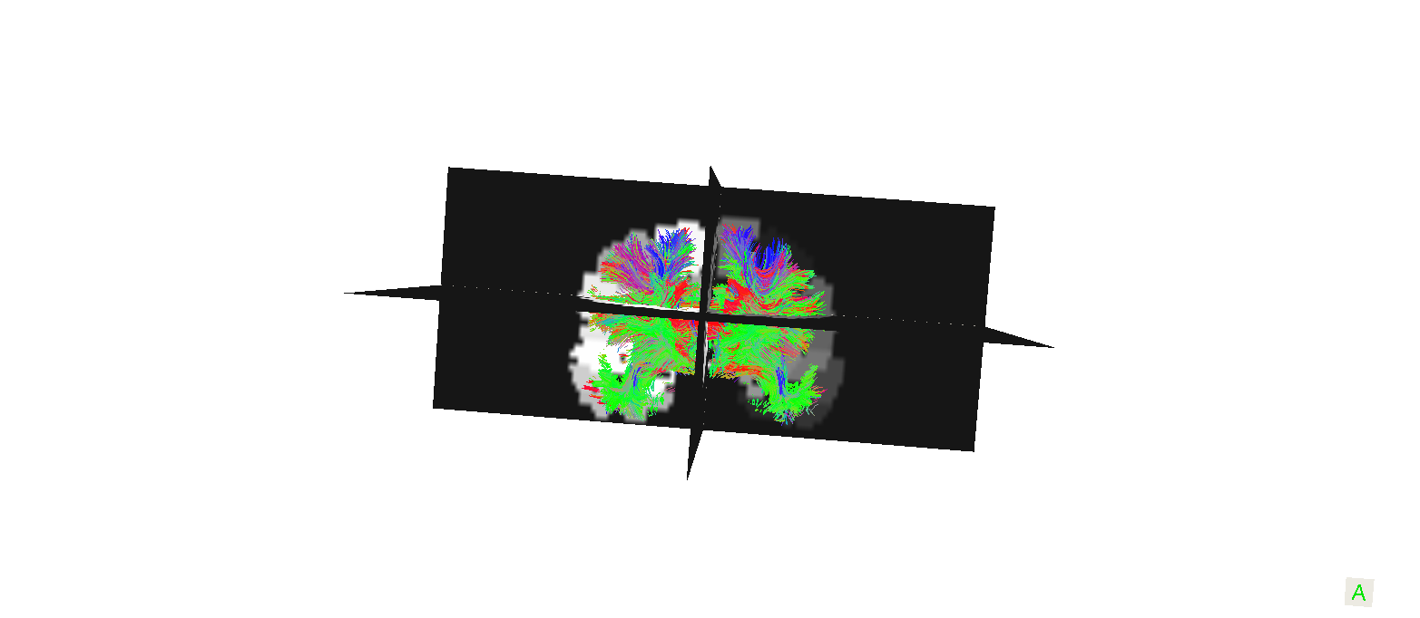

Then run matlab code:

compute_matrix_May_23_2014_fastversion('dti_fact_tracts.trk','label.nii','1157.mat',5)

** dti_fat_tracts.trk is computed in step 3

Label.nii is computed in step 4

1157.mat is brain connectivity matrix output

5 is the threshold, to remove those short fibers.