Assessable Exercise 3

**Figure 1：Count of Types for Movies During 2000 ~ 2010**

Based on the findings, it appears that the category labeled "Other" has the highest value, coming in at nearly 2100. However, this finding is not particularly meaningful given that "Other" is a broad category encompassing unspecified cases and thus has no bearing on the decision of what types of movies to produce. The second highest category is Drama, with a value of nearly 1300, while Comedy comes in third with a value of nearly 1050. The five least popular categories are "Western", "Musical", "History", "War", and "Biography", all of which have less than 100. It can be inferred that genres with higher frequencies of occurrence, such as Drama, are more likely to be successful, as there would not be such a significant quantity of them produced if they were not in demand.

The figure below shows the frequency of movies in different categories under different levels of competition:

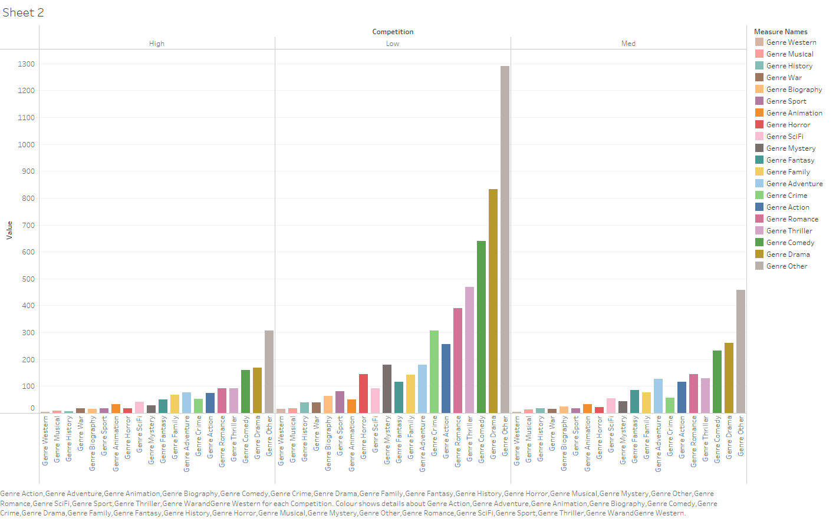

**Figure 2：Count of Types for Movies Under Different Competition Levels**

It is noteworthy that, regardless of the level of competition, the top movie genres with the highest count values remain consistent. This discovery suggests that selecting a frequently occurring but low-competition movie genre may not significantly increase the likelihood of success.

**Figure 3：Treemap for Gross Box Office in Different Years**

The above picture shows the distribution of profits in different years. It can be found that no matter what year, most movies have no profits or only a few theories.