The University of South Australia

**Visual Analysis of COVID-19 and Vaccines**

**Student Name: wangjun shen**

**Student ID Number: 110248810**



The University of South Australia

# Table

Table 2

Dashboard 3

Introduction 4

Visualisation Results 4

Epidemic trends 4

Vaccine Usage 7

Conclusion 12

References 13

# Dashboard

# Introduction

The global COVID-19 outbreak has had a significant impact on the world. As of May 2021, there are over 164 million confirmed cases and 3 million deaths (World Health Organization, 2021). This pandemic has disrupted not only healthcare, but also social and economic activities, as well as international travel.

The development of vaccines for COVID-19 has been a major milestone in the fight against the pandemic. Clinical trials have established the efficacy of COVID-19 vaccines, resulting in a significant reduction in cases and deaths (Voysey et al., 2021). The global vaccine rollout has been successful, with over 1.5 billion doses administered as of May 2021 (Our World in Data, 2021). However, despite the progress made in vaccine administration, there is still a long way to go before the world can fully recover from the pandemic.

Therefore, it is important to analyze and understand the data related to COVID-19 and COVID-19 vaccines, as well as to continue researching and developing new treatments and vaccines to combat the virus. This visualization project provides an in-depth overview of the COVID-19 pandemic and vaccination progress worldwide, using publicly available data sources such as the GitHub repository by Our World in Data (2021) and the Kaggle dataset by Preda (2021). The project is intended for healthcare professionals, policymakers, and the general public who can benefit from the insights and information provided by the visualization. By gaining a deeper understanding of the data, we can continue to make informed decisions to help stop the spread of the virus and ultimately save lives.

# Visualisation Results

## Epidemic trends

**Figure 1 New Cases by Year and Continent**

Figure 1 illustrates the fluctuations in new cases across various continents. As depicted in the figure, Asia experienced a remarkably high number of new cases in January 2023. Moreover, Asia encountered several spikes between May 2021 and May 2022, as well as in March and October 2022. Similarly, North America and Oceania had a relatively high peak around January 2022. In contrast, South America had a relatively stable rate of new cases.

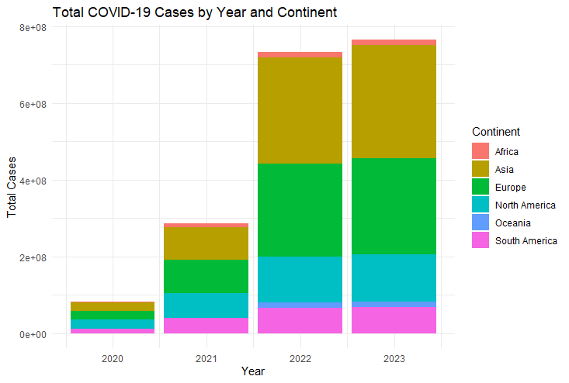

**Figure 2 Total Cases by Year and Continent**

The figure 2 displays the total number of cases per continent and year. Upon inspection of the total cases by year, it is clear that there was an overall increase from 2020 to 2023. Specifically, the total number of cases rose from around 65,000,000 in 2020 to around 810,000,000 in 2023, indicating a sharp increase in the number of cases globally. When comparing the total cases by continent for the same year, we observe that Asia had the highest number of cases in all four years, followed by Europe, North America, South America, and Oceania. In 2023, Asia had a total of around 297,000,000 cases, while Oceania had the lowest number of cases at around 14,000,000. Finally, upon examining the total cases by continent and year, we can see that all continents experienced an increase in the number of cases over the four-year period. For example, in Africa, total cases increased from around 2,750,000 in 2020 to around 13,100,000 in 2023, which represents a significant increase. Similarly, Europe saw a rise in total cases from around 23,700,000 in 2020 to around 249,000,000 in 2023.

**Figure 3 Total Deaths by Year and Continent**

The figure 3 displays the total number of deaths per continent and year. Upon analyzing the data by year, it is evident that there was an overall increase in deaths from 2020 to 2023. Specifically, the total number of deaths rose from approximately 1.7 million in 2020 to roughly 3.9 million in 2023, indicating a sharp global increase in mortality. When comparing the total deaths by continent for the same year, it is noticeable that Asia saw the highest number of deaths in all four years, followed by Europe, South America, North America, and Oceania, respectively. In 2023, Asia recorded a total of approximately 1.6 million deaths, while Oceania had the lowest number of deaths with approximately 26,000. Finally, after examining the total deaths by continent and year, it is evident that all continents experienced an increase in the number of deaths over the four-year period. For example, in Africa, total deaths increased from approximately 65,000 in 2020 to roughly 259,000 in 2023, indicating a significant increase. Similarly, Europe saw a rise in total deaths from around 587,000 in 2020 to approximately 2.1 million in 2023.

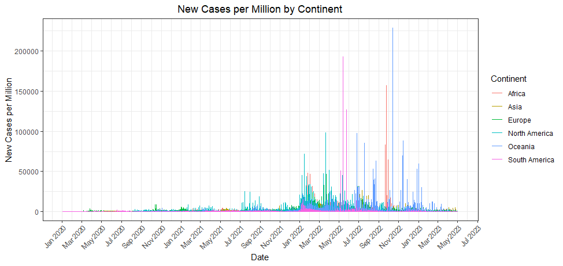

**Figure 4 New Cases per Million by Year and Continent**

On the other hand, the "new case count" can not be used alone to accurately compare the epidemic situation in different regions, as it does not account for differences in population size. For instance, Asia has a much larger population than other regions, so even if the number of new cases per million population is relatively low, there may still be a significant number of new cases. By using "the number of new cases per million population," we can better compare the epidemic situation across regions, as this metric adjusts for population size and density and provides a more accurate comparison ability.

Using "new cases per million people" as a measure can provide valuable information. By comparing the previous data with the figure 4, it can be observed that although Asia had the highest number of new cases around January 2023, the number of new cases per million people remained very low from 2020 to 2023. Africa, which was previously considered insignificant, experienced a significant growth peak between September and November 2022. Oceania had the highest number of new cases per million people in the world in October 2022, while North America experienced several small peaks in 2022. South America had the second-highest number of new cases per million people in the world in June 2022, but this number remained low at other times.

## Vaccine Usage

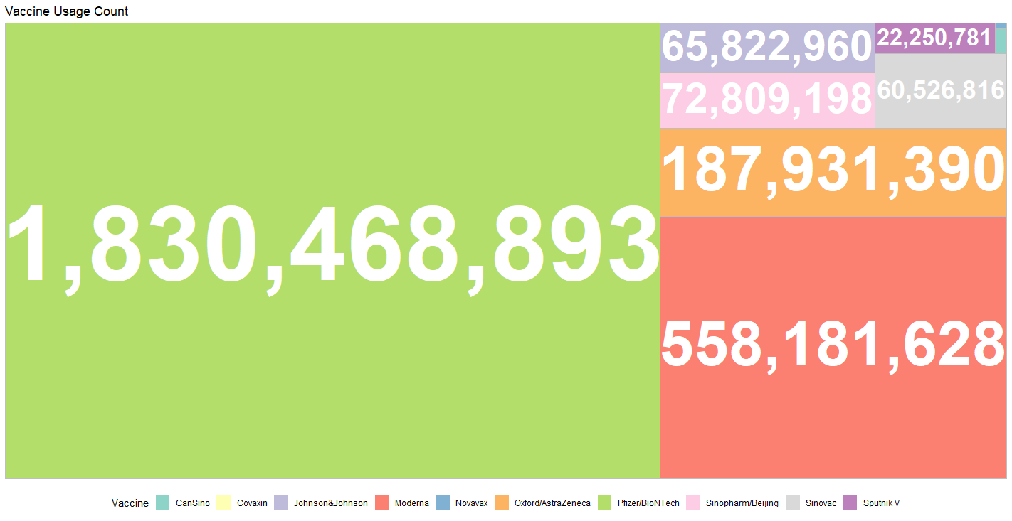

**Figure 5 Use of Different Classes of Vaccines**

The Pfizer/BioNTech vaccine is the most commonly used, accounting for 65.37% of the total doses administered. The Moderna vaccine is also widely used, accounting for 19.93% of the total doses administered. The Oxford/AstraZeneca vaccine is relatively less used, accounting for only 6.71% of the total doses administered. The use of vaccines such as CanSino, Johnson&Johnson, Sinopharm/Beijing, Sinovac, and Novavax is relatively low, with each vaccine accounting for no more than 7% of the total doses administered. The use of Covaxin and Sputnik V vaccines is the lowest, with each vaccine accounting for no more than 1% of the total doses administered. In summary, the Pfizer/BioNTech and Moderna vaccines are the most commonly used, while the use of other vaccines is relatively low.

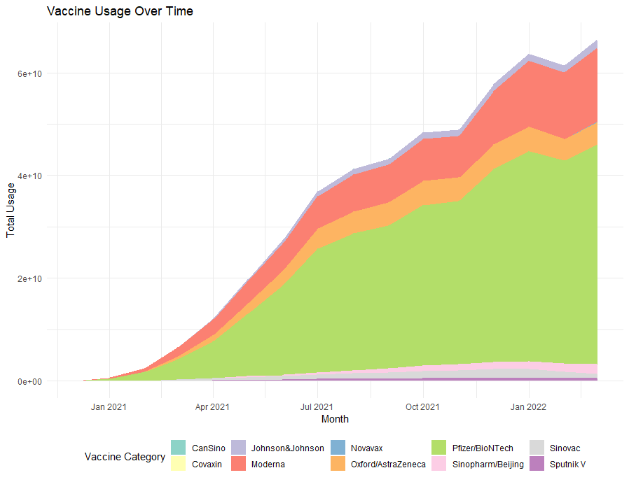

**Figure 6 Vaccine Usage Over Time**

As shown in the figure 6, the usage of Pfizer/BioNTech vaccine has consistently increased over time, occupying a significant proportion within the same time interval. Moderna vaccine ranks second, with a noticeable but comparatively smaller increase in usage since July 2021. Oxford/AstraZeneca vaccine comes in third with a relatively minor increase in usage from April to July 2021, and no significant change thereafter. Other types of vaccines have a very small proportion during this period and show no significant change in the long run.

**Figure 7 Vaccine Usage Proportion Over Time**

According to the chart above, the Pfizer/BioNTech vaccine had the highest usage percentage initially but began to decline and reached 0.75 in January 2021. The decline then slowed down and reached around 60% in March 2021. The percentage had some fluctuations afterwards, but with no significant changes. The Sputnik V vaccine ranked second in usage percentage initially, but its usage percentage dropped quickly and hit the lowest point in January 2021. The percentage had some fluctuations afterwards, but with no significant changes. The Moderna vaccine had a rapid increase in usage percentage from the beginning, reached the maximum in January 2021, and then showed a downward trend overall. The Oxford/AstraZeneca vaccine started to be used in January 2021 and its usage percentage began to increase, reaching the highest point in April 2021 and then remaining stable.

**Figure 8 Global Use of Different Types of Vaccines**

The figure presented above depicts the usage of various types of vaccines across different countries worldwide. It is evident that a majority of countries have employed a mix of vaccine combinations in order to combat COVID-19. Among the different vaccine combinations, "Pfizer/BioNTech" and "Moderna, Oxford/AstraZeneca" vaccines have been used extensively, with higher adoption rates compared to other vaccine combinations. In countries where only one vaccine type has been used, "Pfizer/BioNTech" has been the most widely used vaccine.

**The impact of other factors on the epidemic**

**Figure 9 The relationship between total cases per million and population density**

From the figure above, there is no relationship between population density and total cases per million. Countries on the same continent with similar population densities have a relatively wide distribution in total cases density, and there is no obvious pattern.

**Figure 10 The relationship between total vaccinations per Hundred and total cases per million**

It can be seen from Figure 10 that, in general, with the increase of total cases per million, people will be more inclined to get vaccinated to protect themselves, resulting in an increase of total vaccinations per hundred. Although Africa seems to be contrary to the general trend, only two data are not enough to form a sufficient basis.

**Figure 11 The relationship between GDP per capita and total deaths per million**

In Figure 11, a bubble chart presents interesting information. In general, there is a slight increase in total deaths per million as GDP per capita increases, but the correlation is low. However, a closer look at different continents reveals distinct trends. European countries show a decreasing trend in total deaths per million as GDP per capita increases, despite some countries experiencing an increase in total cases. South American countries maintain a GDP per capita of around 15000, with one country having an exceptionally high total deaths per million and others having a total death per million around 3000, regardless of the size of total cases, with no clear trend. Despite Asian countries generally having a lower GDP than Europe, their death rate is also lower, which may be due to other factors like culture or policies. African countries have remarkably low GDP per capita, total deaths per million, and total cases, which is perplexing. It is speculated that this may be due to the difficulty of collecting medical data in African countries.

# Conclusion

The COVID-19 pandemic has had a significant impact on healthcare systems, economies, and societies globally. Vaccines are essential in the fight against the virus, but we need to do more to overcome the pandemic.

This project presents visualizations that offer insights into COVID-19 and vaccination trends across continents and countries. The data shows that Asia has the highest number of cases and deaths, with Europe and North America also experiencing severe impacts. Africa faces unique challenges in data collection and healthcare infrastructure. Vaccine usage varies across countries, with the Pfizer/BioNTech and Moderna vaccines being the most common. However, vaccine access and distribution are not equal worldwide. GDP per capita and total deaths per million have varying relationships across continents. European countries have decreasing death rates as GDP per capita increases. South American countries exhibit inconsistent patterns, while Asian countries have lower death rates despite lower GDP per capita. Africa's low GDP per capita and overall cases and deaths raise concerns about data collection and healthcare infrastructure.

In conclusion, a comprehensive understanding of COVID-19 and vaccination data is critical to informed decision-making and response strategies. These visualizations highlight the need for continued efforts to control the virus, ensure equitable vaccine access, and strengthen healthcare systems worldwide. By staying informed and working together, we can overcome the pandemic's challenges and create a healthier future.

# References

Our World in Data. (2021, May 23). Coronavirus (COVID-19) Vaccinations. <https://ourworldindata.org/covid-vaccinations>

Preda, G. (2021). Covid-19 World Vaccination Progress. <https://www.kaggle.com/gpreda/covid-world-vaccination-progress>

Voysey, M. and Pollard, A.J. (2020). ChAdOx1 nCoV-19 vaccine for SARS-CoV-2 – Authors’ reply. The Lancet, 396(10261), pp.1486–1487. doi:https://doi.org/10.1016/s0140-6736(20)32267-4.

World Health Organization. (2021, May 24). WHO Coronavirus Disease (COVID-19) Dashboard. <https://covid19.who.int/>