Unit Test for Ticket Object Creation

This test check newly created ticket has “archived value” which is default by “false”.
It becomes “true” when user click this ticket via “Archive” button under “Done” column.

Test Failure Case
Here, the original constructor with “archived value” and the value “this.archived = archived;” are disabled to test whether Unit Testing is correct or not.

For this test, TicketService.test.js is created and used. It is located under services/__test__

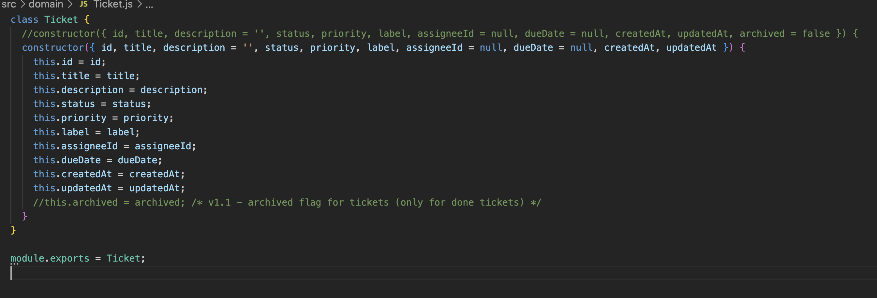

To test this unit testing,
- Run npm test under kanban-ai-board-json-app

Result
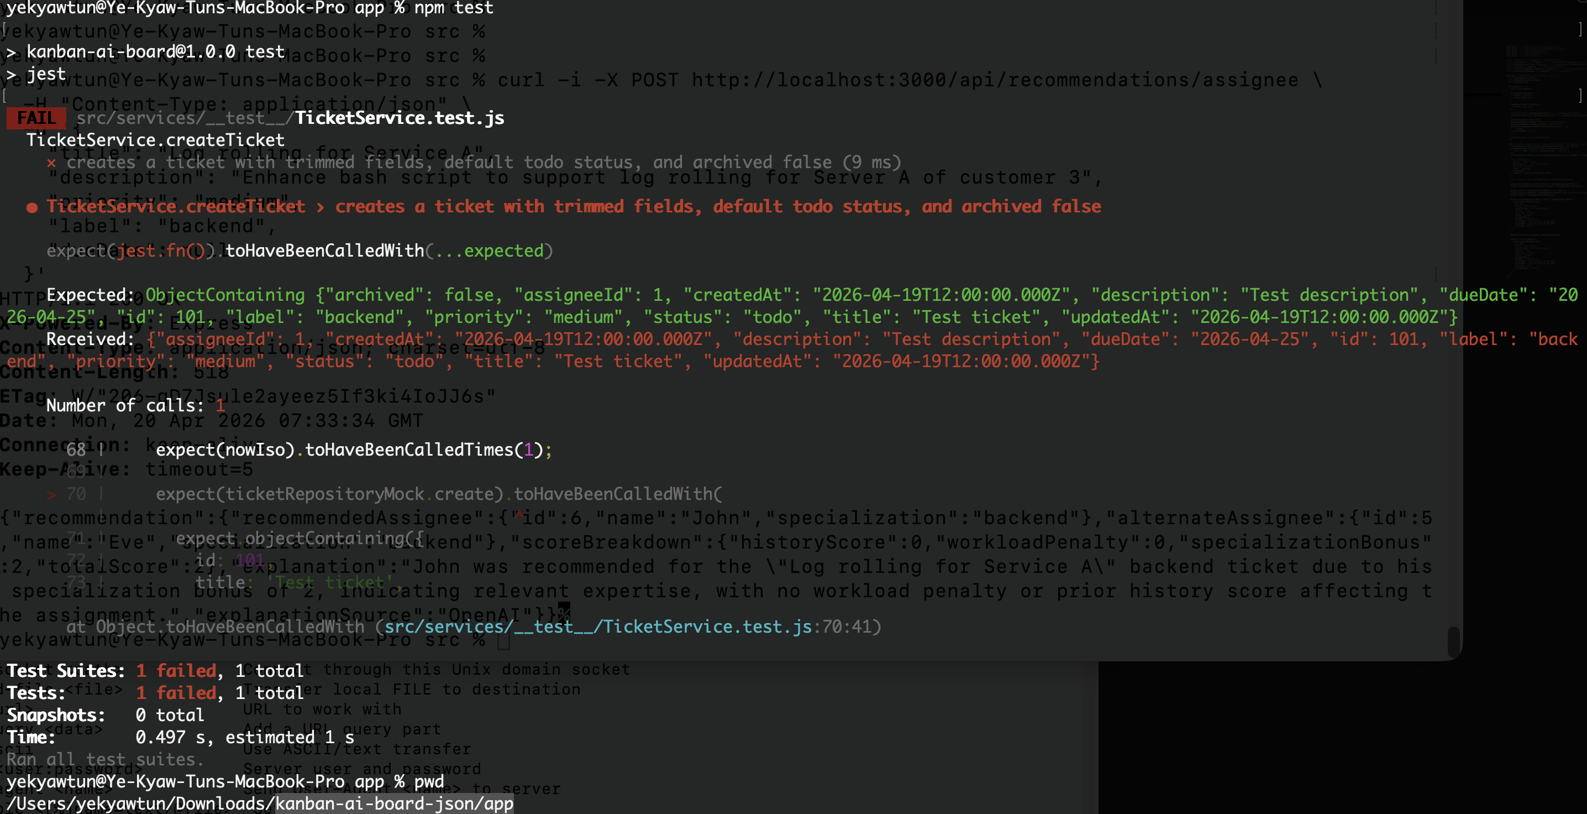

Test Successful Case
Here, the original constructor with “archived value” and the value “this.archived = archived;” are enabled back to test whether Unit Testing is correct or not.

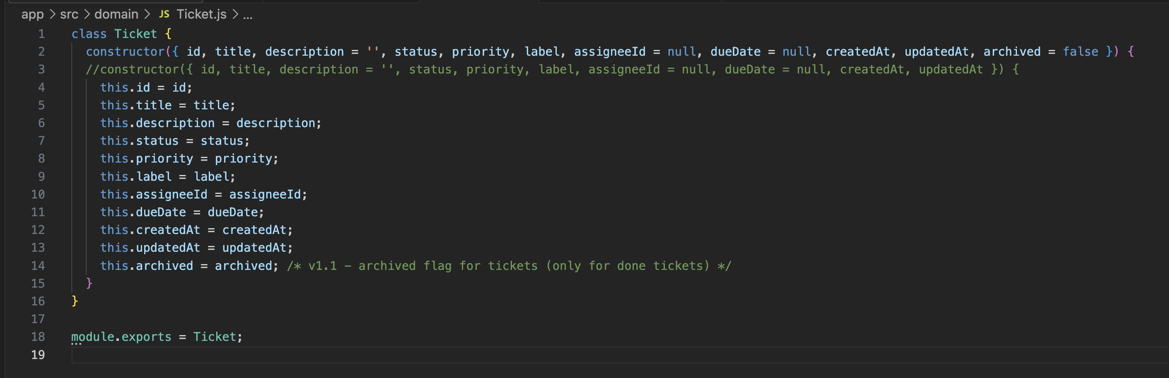

To test this unit testing,
- Run npm test under kanban-ai-board-json-app

