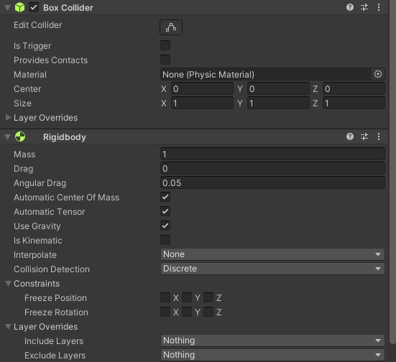

Box collider->sphere collider

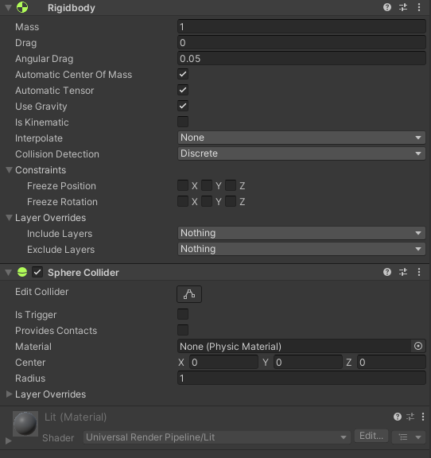

Pig:

https://sketchfab.com/3d-models/hiberworld-minion-pig-605c9e53897c4c1f9563beaad716b9d1

Bomb bird:

https://sketchfab.com/3d-models/hiberworld-bomb-9ce8a924efc64b2d878032e94cd6c645