# AC Switch

For switching AC circuits, there are 2 typical use cases:

* Electromechanical Relay
* Solid State Relay (SSR)

## Electromechanical Relay

## Solid State Relay

### General approach

Proper name : `Zero-cross optoisolators with triac driver output`

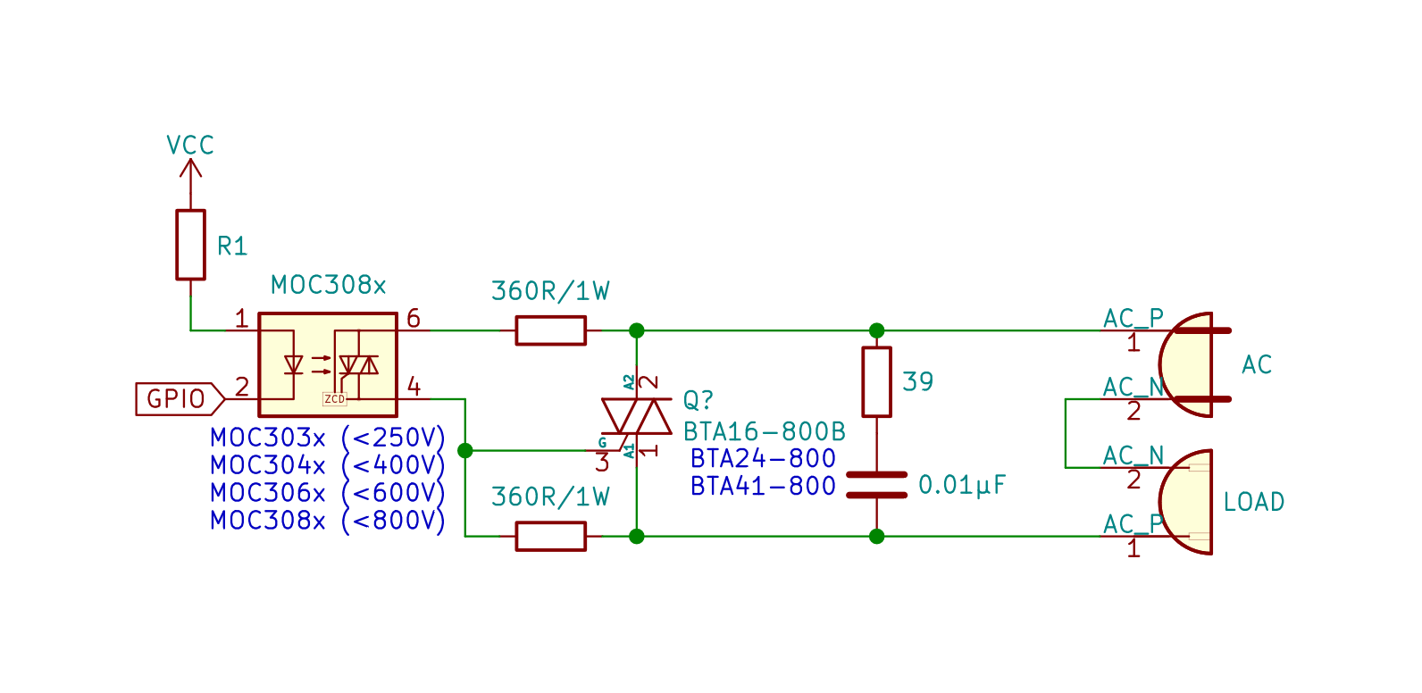

Depending on exact model of thyristor, the LED trigger current is different, and resistor `R1` might need selection:

|  |  |  |  |
| --- | --- | --- | --- |
| Model | Trigger current, mA | Logic Voltage, V | `R1` value, Ω |
| MOC30x1 | 5 | 5.0 | 1K |
| MOC30x2 | 10 | 5.0 | 510 |
| MOC30x3 | 15 | 5.0 | 330 |
| MOC30x1 | 5 | 3.3 | 680 |
| MOC30x2 | 10 | 3.3 | 330 |
| MOC30x3 | 15 | 3.3 | 220 |

Thyristors are dissipating a lot of heat, consider heatsinks for those!

If needed extra indication of state level, check if there is no exceeding of current limits per pin of microcontroller.

If there is such one, consider this circuit:

![](images/switch_indication_upgrade.svg)

Or, use the schematic from market-ready solution:

Left side functions as stabilized current source, Where the load current (current through the LED of MOC30xx IC) is determined as:

$$I_{load}=\frac{V_{Zener}-0.6}{R}$$

Where: R – is the value of resistor between transistor and GND, Vzener – value of voltage Zener diode is rated for, 0.6 … 0.7 V is a typical value of voltage dropout across the base of transistor (marked in datasheets as Vbe). Such circuitry consumes more power but can be rated for a wide range of power-supply voltage 3…24 VDC. Note, that Resistors from the side of AC must be at least 1W power rated (for SMD applications, typically in 2512 or 3520 size).

### If load is inductive / high and needs periodical on/off

To extend the lifetime of SSR, consider use of relay in parallel with following control idea:

* the turning the final device "ON" is done by SSR  
  Since the MOC30xx are opto-isolators with zero-detection, they will turn the device at the moment of zero-crossing, when it is the safest.
* after some delay (when the maximum power consumption is achieved) close the electro-mechanical relay (EMR)
* since the circuit is already closed via SSR, there will be no sparkling within the mechanical relay
* the EMR has lower resistance, thus, it dissipates less heat than SSR and causes the current to be distributed between the SSR and EMR, decreasing the load through the SSR
* turn off the SSR
* turn off the device in following order:
* turn on the SSR
* than, turn-off the EMR
* now all current will go to the SSR
* after, turn-off the SSR
* it will automatically wait until the zero-cross moment to do it safely.

Presumably, a similar type of control is implemented in control circuit of water pump Grundfos MQ 3-35. However, such schematic can be also described as "soft start of asynchronous motor". Also a good blog post on the topic with suggested schematic:

Replace R5 with 510R

This concept should be used in:

- water pumps for greenhouses (not only)

- drills motors, etc.