Using USB type C in devices

According to the latest USB specification connectors of mini-, micro-USB are outdated and not recommended for new designs. So far, the only standardized connectors remain full-size USB and USB type C.

# As 5.0V power supply only

Wiring:

|  |
| --- |
|  |
| Schematic for power only supply |

|  |  |
| --- | --- |
| 10pcs USB Type C 3.1 Vrouwelijke 6Pin SMT Socket Connector Micro 6 Pin  Plaatsing SMD DIP Voor PCB ontwerp DIY hoge stroom opladen 6 P - AliExpress  Consumentenelektronica  10pcs USB Type C 3.1 Vrouwelijke 6Pin SMT Socket Connector Micro 6 Pin  Plaatsing SMD DIP Voor PCB ontwerp DIY hoge stroom opladen 6 P - AliExpress  Consumentenelektronica |  |
| 6-pin connector for power only connection | 6-pin connector for power only connection in waterproof option |

Don't omit 5.1KΩ resistors! It is important for plugging to various USB type C adapter / splitters or Type C - Type C cables. Those types of power sources try to check if connected device is suitable for Power Delivery and expect response via communication with `CC` pins.

The 5.1K resistors are needed to clearly declare target device as power consumer. Additionally, there is discussion if it is needed the connectivity nearby the shield pin, or if it should left floating.

# As Full Speed USB 2.0

Wiring:

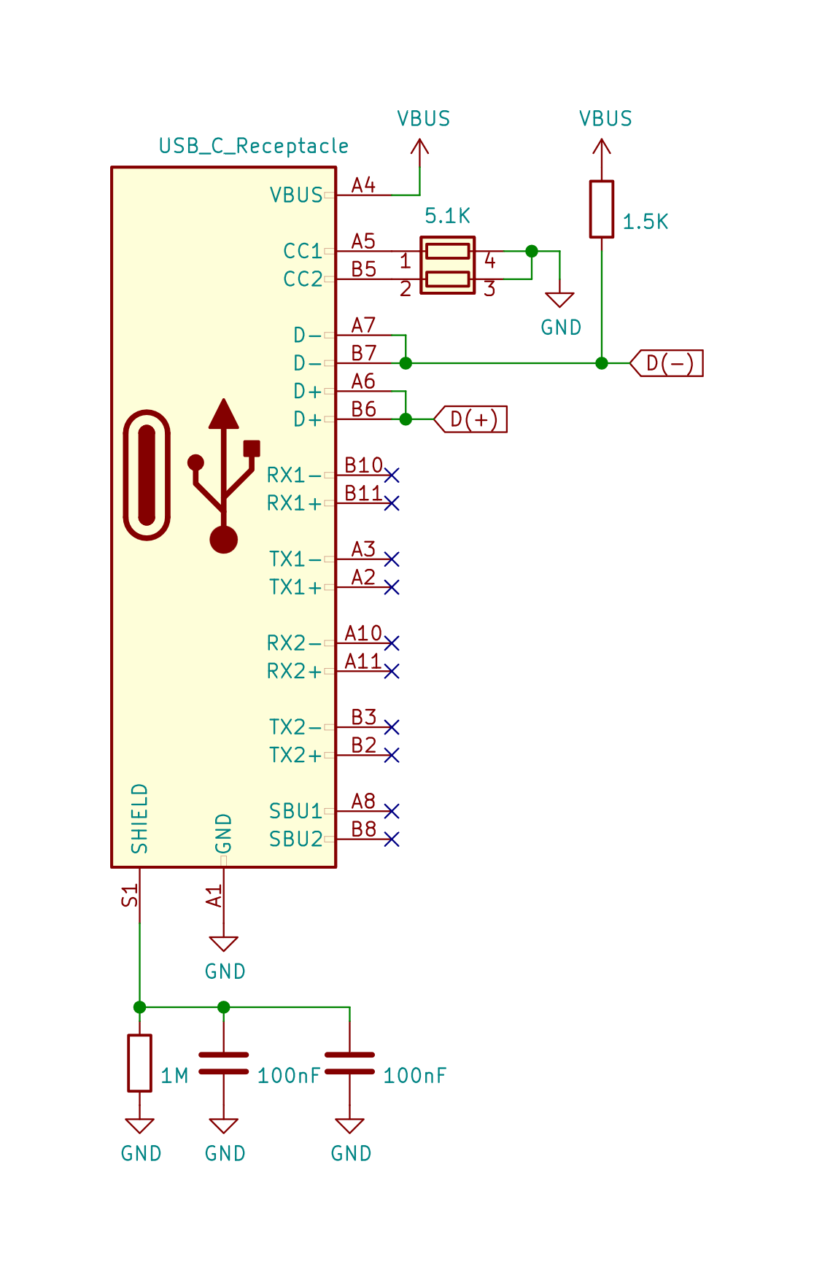

Specifications:

* differential impedance between D+ and D- : 90 Ohm ± 10 %;
* Max. length difference of data tracks: 1.1 mm
* Max. track length: 200 mm

The 1.5K resistor can be omitted if the accepting IC (specialized converter or MCU) has own built-in resistor.

References:

* USB Type-C® Cable and Connector Specification  
  <https://www.usb.org/document-library/usb-type-cr-cable-and-connector-specification-revision-20>
* SuperSpeed USB Specification  
  <https://www.usb.org/superspeed-usb>
* USB4 Specification  
  <https://www.usb.org/document-library/usb4tm-specification>