Connecting buzzer

Also known as piezo-speaker, piezo-beeper. It is inductive load.

# Active buzzers

According to [this](https://projects.raspberrypi.org/en/projects/rpi-connect-buzzer), active buzzer (such as HCM12) can be connected directly to the output pin of Raspberry Pi and plugged to the ground. However, since this speaker consumes:

* approx. 16 mA at 3.3V
* approx. 24.75 mA at 5V

Which is above current limitations for majority of microcontrollers, thus "driving" circuit is required.

Such buzzers are used on modules like [KY-012](https://cdn.shopify.com/s/files/1/1509/1638/files/Buzzer_Modul_aktiv_Datenblatt.pdf).

# Buzzer to ESP8266 (3.3 V logic)

This schematic was borrowed from [this](https://www.instructables.com/DIY-Geiger-Counter-With-an-ESP8266-and-a-Touchscre) project[1]:

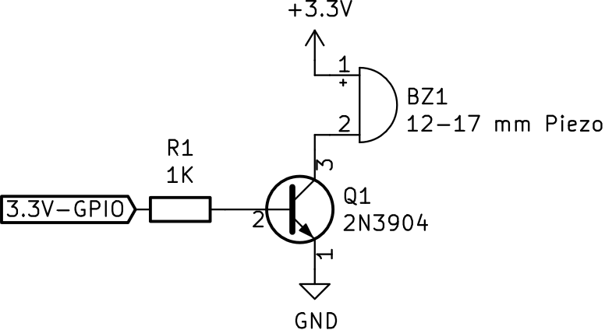

For Raspberry Pi consider use 2.2 KΩ resistor and 2N2222A transistor (in order to be within current per pin limitations). However, it seems to require extra anti-parallel diode (also referred as flyback diode), as stated [here](https://media.digikey.com/pdf/Application%20Notes/CUI%20Application%20Notes/Buzzer_Basics.pdf)[2]. This one can also drive 5.0 V buzzer with 3.3 V logic.

# Buzzer to ESP32 (3.3 V logic)

This schematic was borrowed from [this](https://diyi0t.com/active-passive-buzzer-arduino-esp8266-esp32/) project[3]:

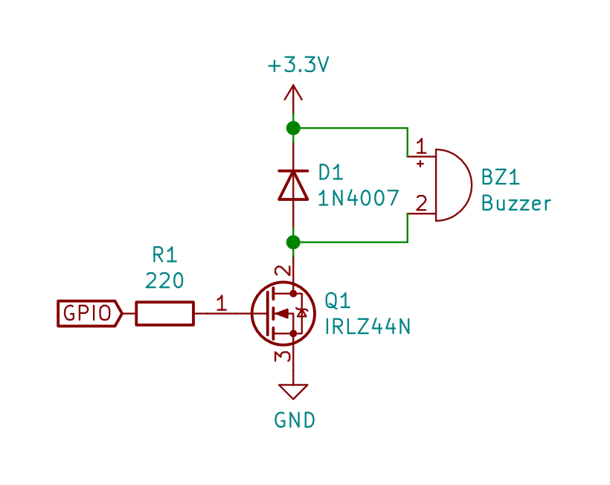

Other MSOFETS to consider:

* AO3400A - MOSFET N TRENCH 30V 5.7A 1.5V
* FS8205A - MOSFET 2 N CHANNEL(DUAL) 20V 6A 1V
* FS8205 - MOSFET 2 N CHANNEL(DUAL) 20V 6A 1.2V

# Universal 5.0 and 3.3 V module schematics

This[4] circuit is available as buzzer[5] module from DFRobot:

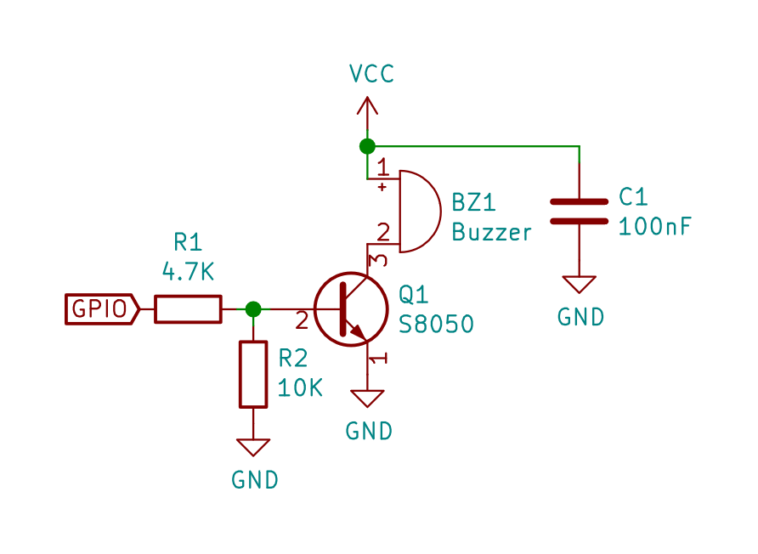

However, it also seems to miss the anti-parallel diode.

# Inverted logic circuit

If need to drive the buzzer with inverted logic, this circuit can be used

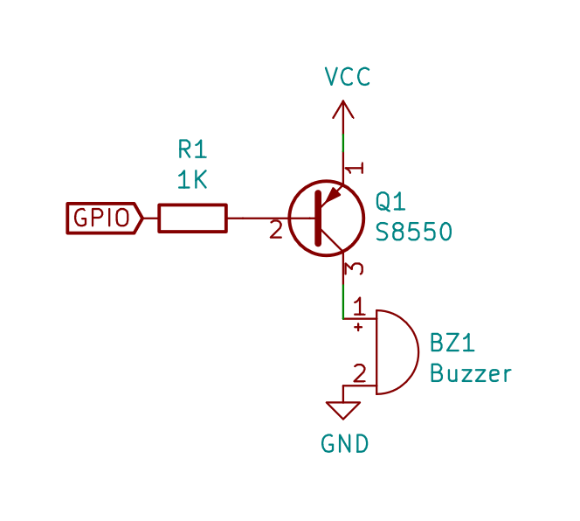

1. https://www.instructables.com/DIY-Geiger-Counter-With-an-ESP8266-and-a-Touchscre/
2. https://media.digikey.com/pdf/Application%20Notes/CUI%20Application%20Notes/Buzzer_Basics.pdf
3. https://diyi0t.com/active-passive-buzzer-arduino-esp8266-esp32/
4. https://www.dfrobot.com.cn/images/upload/File/DFR0032/20170719173339yekhk0.pdf
5. https://www.dfrobot.com/product-84.html