ာ
Simulation of a Reaction Wheel Pendulum System with PID Control Using Simscape Multibody
Maung Ye Thura Oo

VI. B.E. McE-4
Mahar Aung Mway, Mandalay

megamoris525@gmail.com

Abstract - This paper presents the simulation and control of a reaction wheel pendulum system using Simscape Multibody in MATLAB/Simulink. The objective is to demonstrate the application of control engineering principles, particularly the design and implementation of a Proportional-Integral-Derivative (PID) controller, to stabilize the pendulum in an upright position. The reaction wheel pendulum, a classic example of an underactuated system, is modeled and simulated within the Simscape Multibody environment to accurately capture the dynamics and interactions of its mechanical components. The PID controller is designed to regulate the reaction wheel's angular velocity, thereby providing the necessary control torque to maintain the pendulum's balance. Simulation results are presented to validate the effectiveness of the control strategy, making the study a useful demonstration for control engineering students and professionals exploring the practical application of PID control in dynamic multibody systems.

Keywords - Simscape Multibody, Reaction Wheel Pendulum, PID Controller, MATLAB, Simulink, Dynamic Systems, Modeling and Simulation, Stability, Control Engineering, Motor Saturation, Disturbance Response, 3D Printed Model, File Solid Block, Rigid Transform Block, Revolute Joint Block, Subsystems, System Design, Mathematical Modeling.

INTRODUCTION
This paper provides a detailed simulation approach for a reaction wheel pendulum system using the Simscape Multibody environment in MATLAB/Simulink. Designed as a template for control engineering applications, it serves as a guide for users to replicate the modeling and simulation of dynamic systems like the reaction wheel pendulum, which is known for its instability and underactuated dynamics.
The reaction wheel pendulum is commonly used in control theory as a challenging system that requires feedback control to achieve stabilization. In this paper, a Proportional-Integral-Derivative (PID) controller is used to maintain the pendulum in its upright position.
The goal of this document is to provide an adaptable template that users can apply to other dynamic systems by replacing the system parameters or modifying the control approach. The rest of the paper walks through the simulation setup and results, offering a practical resource for students and professionals in control engineering.

Simscape
Simscape is a powerful tool within the MATLAB/Simulink environment that enables the simulation and modeling of physical systems across multiple domains, such as mechanical, electrical, hydraulic, and thermal. By using Simscape, engineers and researchers can create accurate, high-fidelity simulations of complex systems without the need for extensive coding or manual equation solving. This allows for the integration of real-world components and behaviors directly into the simulation, making it easier to analyze system dynamics, test control strategies, and validate designs before physical implementation.
Simscape is highly effective for projects involving complex interactions between physical components, offering a robust platform for modeling, simulation, and analysis. In the case of the Reaction Wheel Inverted Pendulum, Simscape enables accurate modeling of the pendulum's dynamics and the interaction between the reaction wheel and pendulum arm. This simulation provides critical insights into stability and control, allowing engineers to refine design and control strategies in a virtual environment, leading to more efficient and effective implementation.

model setup
The Simscape model for the Reaction Wheel Pendulum system is meticulously constructed to simulate the physical interactions and dynamics of the system. It includes three distinct frames that represent different parts of the system:
- Base: This is the stationary part of the system, providing a reference point for the rest of the model. It represents the foundation to which the rest of the system is anchored.
- Body: The Body is the moving frame connected to the reaction wheel. It allows for relative motion and is crucial in simulating the pendulum's dynamic behavior as it reacts to the forces generated by the flywheel.
- Flywheel: The Flywheel is the rotating component of the system, responsible for generating torque to control the pendulum's balance. This frame is key to the control mechanism of the reaction wheel system.
Each of these frames is modeled using “File Solid” blocks within Simscape, ensuring that their physical properties and interactions are accurately represented.
- File Solid Block
The File Solid block is a powerful tool in Simscape that models a solid component based on its geometry, inertia, color, and reference frame, all of which can be derived from a CAD file. This block is particularly useful for importing real-world mechanical parts into the simulation environment. Key specifications of this block include:
- Geometry and Inertia: In this model, the inertia values and physical dimensions of each component are specified to closely match the actual physical parts.
- CAD Format: The model uses the stereolithography (STL) file format to import the physical characteristics of the components. This ensures that the geometrical and inertial properties of the base, body, and flywheel are accurately reflected in the simulation.
- Rigid Transform Block
The rigid transform block is used to connect the solid components, maintaining a fixed spatial relationship between two frames during the simulation. The following are key features of this block:
- Spatial Relationship: This relationship includes both translation and rotation, ensuring that the movement and positioning of the components relative to each other are accurately simulated.
- Positioning: The block allows for precise specification of how the follower frame (e.g. Flywheel) is positioned and oriented relative to the base frame (e.g. Body), which is crucial for accurate dynamic simulation.
- Revolute Joint Block
The Revolute Joint block models a joint with one rotational degree of freedom, which is essential for simulating the rotational movement in the Reaction Wheel Pendulum system. The two specific joints used in this simulation are as follows:
Joint-1 (Body and Base): This joint, as illustrated in Figure 1, connects the Body and Base, allowing the Body to rotate relative to the Base. It functions as a bearing and includes an output sensor to read the tilt position of the pendulum, which is critical for feedback in the control system.
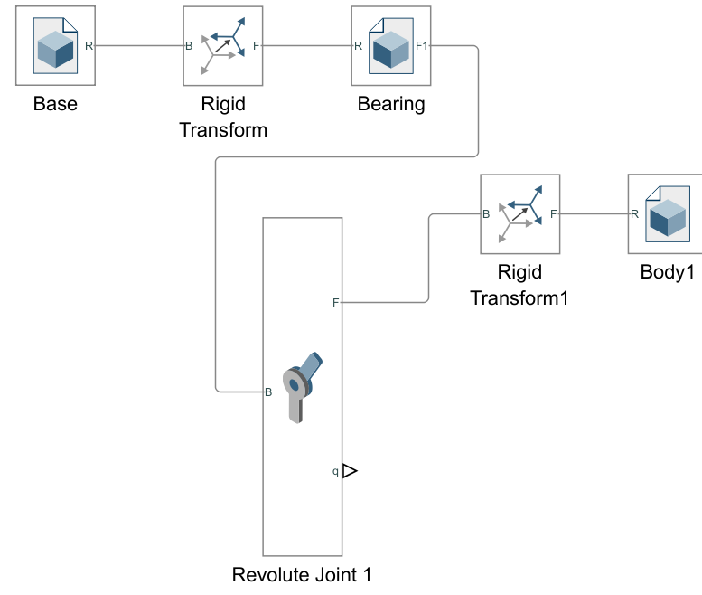
FIGURE 1. Joint 1 Configuration, Connection Between Body and Base
Joint-2 (Flywheel and Motor Shaft): This joint, depicted in Figure 2, connects the Flywheel to the motor shaft, allowing it to rotate and generate the necessary torque to balance the pendulum. The joint includes an input to control the torque applied by the motor, making it the primary actuator in the system.
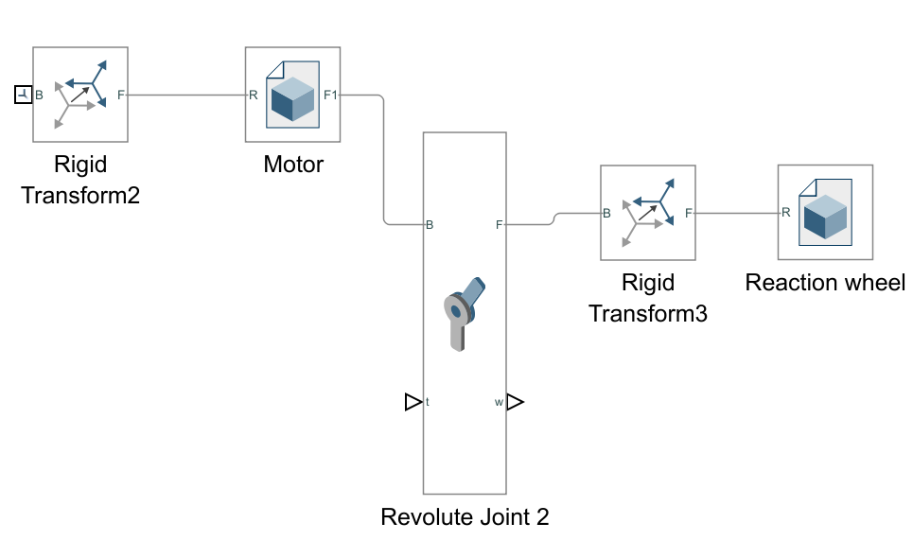
FIGURE 2. Joint 2 Configuration, Connection Between Flywheel and Motor Shaft
Additionally, the internal mechanics of these joints include parameters for simulating damping and energy dissipation, using the damping coefficient parameter. This feature adds realism to the simulation by accounting for frictional forces that would be present in the actual system.
- Subsystem
To enhance the clarity and manageability of the Simscape model, subsystems are used to group related components and streamline the overall design. For the reaction wheel model, two key subsystems are created: the body subsystem and the reaction wheel subsystem.
Body Subsystem: This subsystem, as shown in Figure 3, encapsulates all components related to the Body frame. It includes Revolute Joint 1, which connects the body to the base frame, and the output of the joint to sense the tilt. Additionally, it contains other 3D model components like the bearing. By grouping these elements into a single subsystem, the model is simplified and makes it easier to understand how the body frame interacts within the system. The parameters for each block in the body subsystem are summarized in Table 1. This includes the File Solid blocks for the body and bearing, detailing their geometry and mass. The Rigid Transform blocks specify the spatial relationships and orientations, while the Revolute Joint 1 block covers position targets, damping, and sensing for accurate simulation of the body frame’s dynamics.
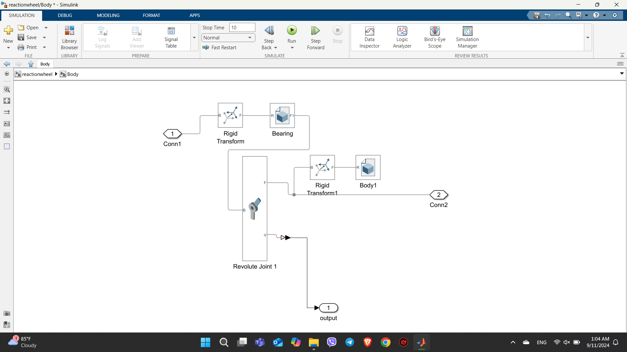
FIGURE 3. Simscape Model for Body Subsystem
Reaction Wheel Subsystem: This subsystem focuses on the flywheel and its operation, including Revolute Joint 2, which connects the flywheel to the motor shaft and facilitates its rotational movement. It also requires external input to drive the motor. Isolating these components into a dedicated subsystem clarifies their operation and control, improving understanding of how the flywheel generates torque and maintains balance. The Simscape model for the Reaction Wheel subsystem, shown in Figure 4, and its parameters are detailed in Table 2. This includes File Solid blocks for the Reaction Wheel and Motor, Rigid Transform blocks for spatial relationships, and Revolute Joint 2 for damping, torque, and velocity sensing.
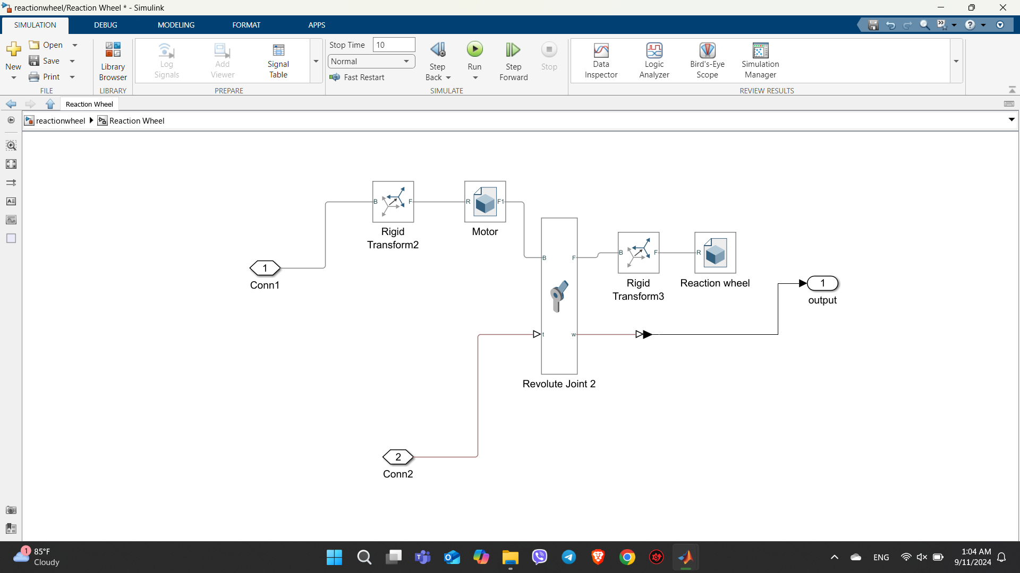
FIGURE 4. Simscape Model for Reaction Wheel Subsystem
Using these subsystems not only improves the visual clarity of the model but also helps in managing complex interactions between components. Each subsystem can be viewed and edited independently, making the overall model easier to understand and troubleshoot.
- PID Controller Model
The PID control model designed to achieve the balancing of the reaction wheel is illustrated in Figure 5. The model utilizes the PID Controller block from the library for calculation and tuning. It requires input data, specifically the angle position of the body obtained from Revolute Joint 1, and a setpoint to compute the necessary output to control the torque applied to Revolute Joint 2. The setpoint is configured at 180 degrees, representing the upright position. Additionally, a pulse generator is used to introduce a disturbance pulse to the PID controller, simulating the system's response under disturbance conditions. The PID gain parameters can be adjusted in the PID block to tune, test, and simulate the system's performance effectively.
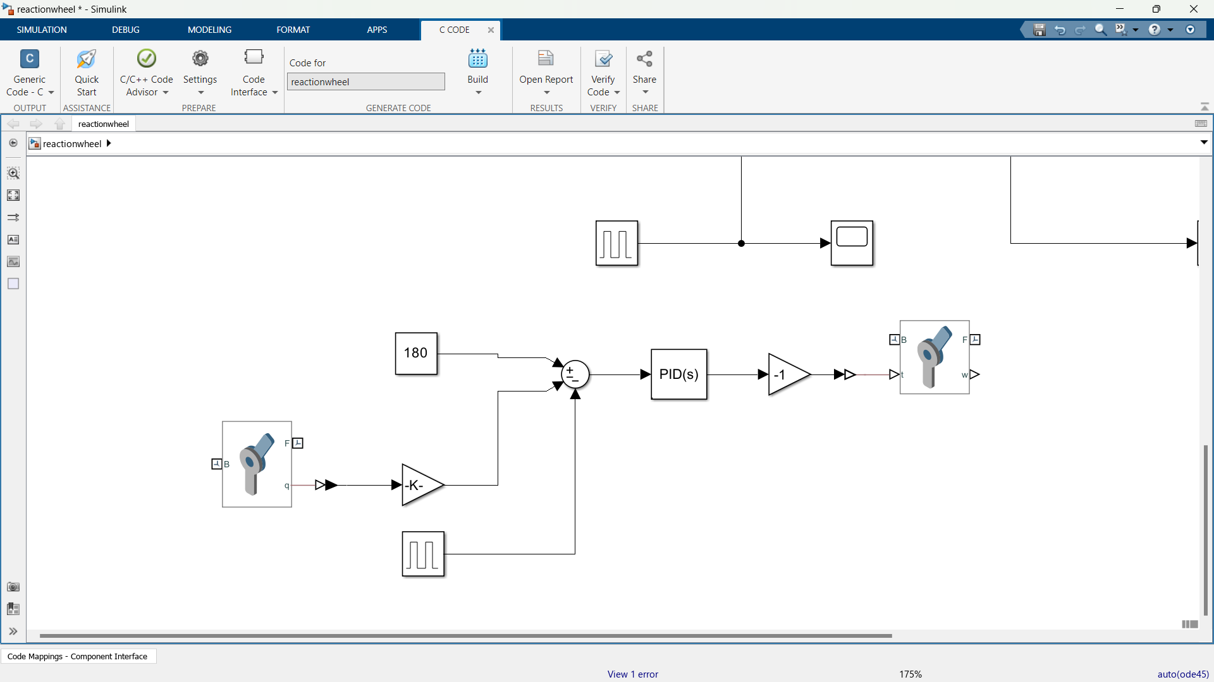
FIGURE 5. Simscape Model for PID Controller

Simulation Result
After setting up the Simscape model for the Reaction Wheel Pendulum system, the complete simulation setup is illustrated in Figure 6. This model integrates all components and subsystems, allowing for a comprehensive simulation of the system’s dynamics.
Figure 7 displays the 3D model obtained using the STL format, which provides a detailed visual representation of the system setup.
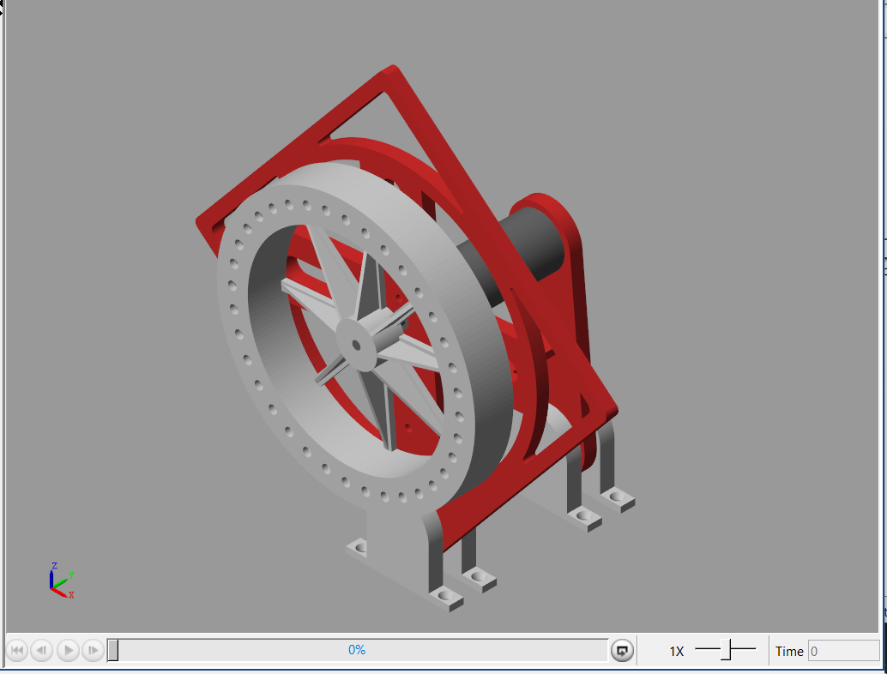
FIGURE 7. 3D Model Obtained after Model Setup in Simscape
The subsequent simulations involve testing the system's response under different conditions. Specifically, the results include graphs depicting the tilt angle of the pendulum over time, comparing scenarios with and without the PID control implemented. These response graphs are crucial for evaluating the effectiveness of the PID controller in stabilizing the pendulum and assessing the overall performance of the system. The analysis will highlight how well the PID control strategy manages the pendulum’s balance and its impact on system stability and response to disturbances.
- Response Without PID Control
After setting up the reaction wheel model, it was initially observed that without the PID controller, the system could not maintain balance and was adversely affected by gravitational forces. In this scenario, the reaction wheel failed to balance, causing the body to drop, swing, and eventually settle at 360 degrees, the downward position. This behavior is evident from the corresponding data plot, as shown in Figure 8.
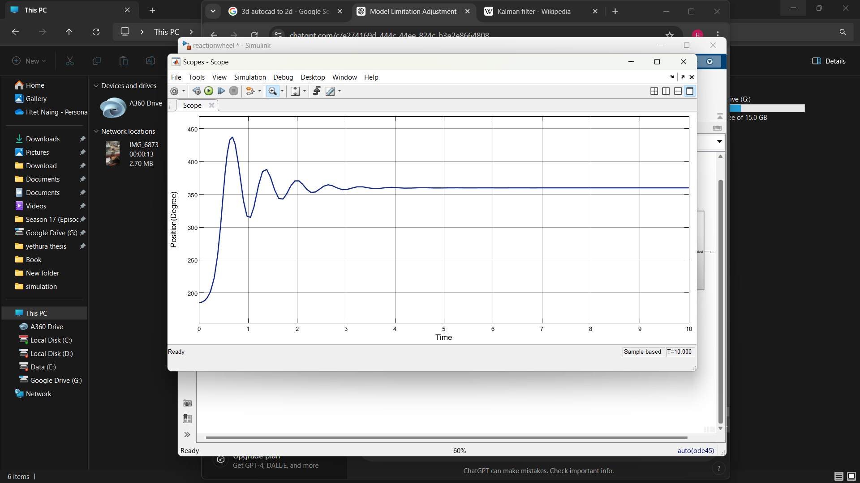
FIGURE 8. Tilt Angel of The Body over Time Without PID Control
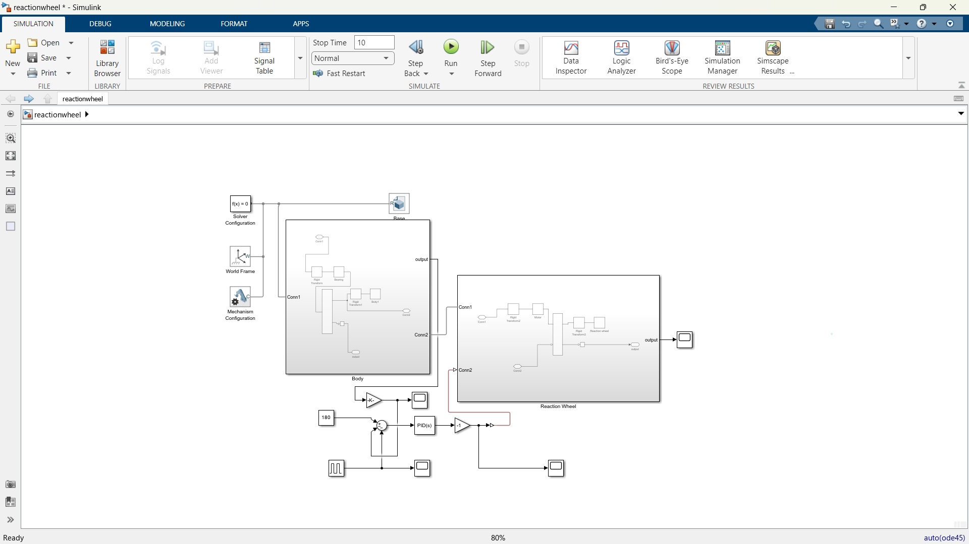
FIGURE 6. Complete Simscape Model of Reaction Wheel Pendulum System

- Response With PID Control
The integration of the PID controller significantly improved the system's performance. For the PID control, the gains were set as follows: proportional gain (Kp​) = 0.1, integral gain (Ki) = 0.6, and derivative gain (Kd)= 0. With these parameters, the system was able to maintain balance. The plot from Figure 9 shows that, upon starting the simulation with the body 5 degrees away from the setpoint of 180 degrees, the body initially swayed but gradually moved towards and stabilized at the setpoint.
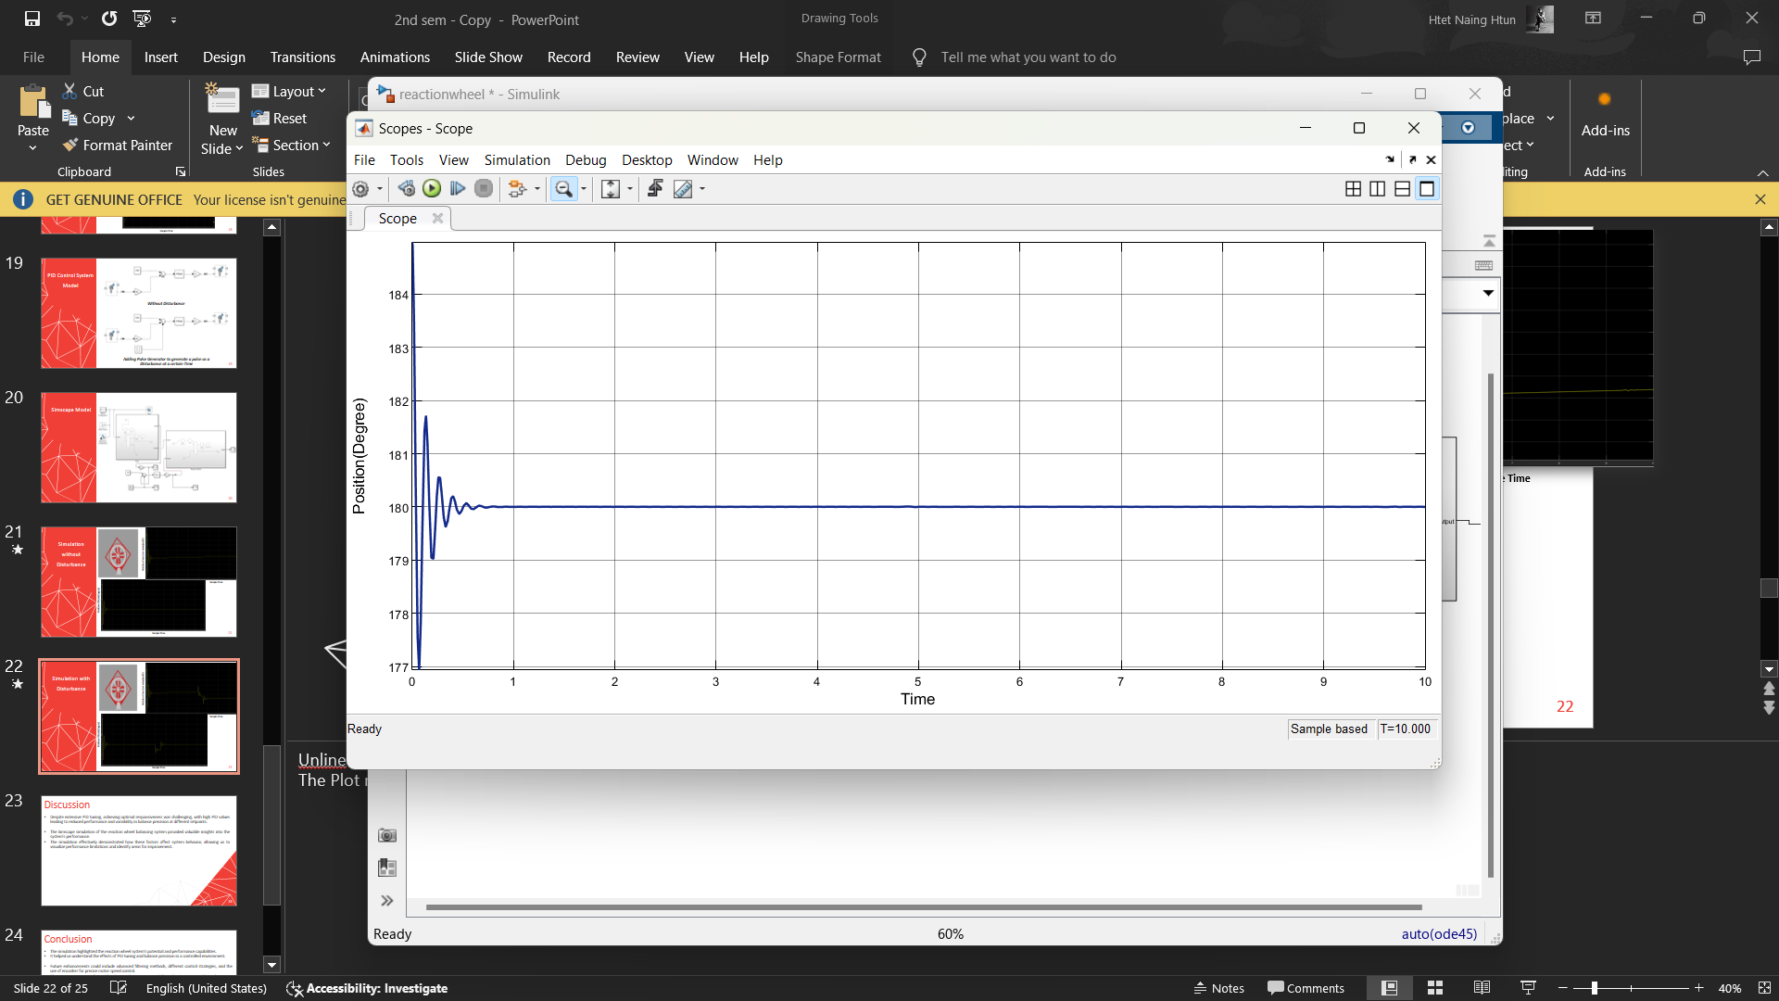
FIGURE 9. Tilt Angel of The Body over Time With PID Control under No-Disturbance Condition
Figure 10 illustrates the reaction wheel velocity over time with PID control applied. The graph shows a gradual increase in velocity, indicating that the motor is approaching its saturation point. The motor begins to rotate in one direction, gradually increasing its speed, and it is known as motor saturation. As the motor's speed continues to increase, it eventually approaches its maximum RPM limit. Once the motor reaches this limit, it can no longer provide sufficient force to maintain balance, causing the pendulum to tilt.
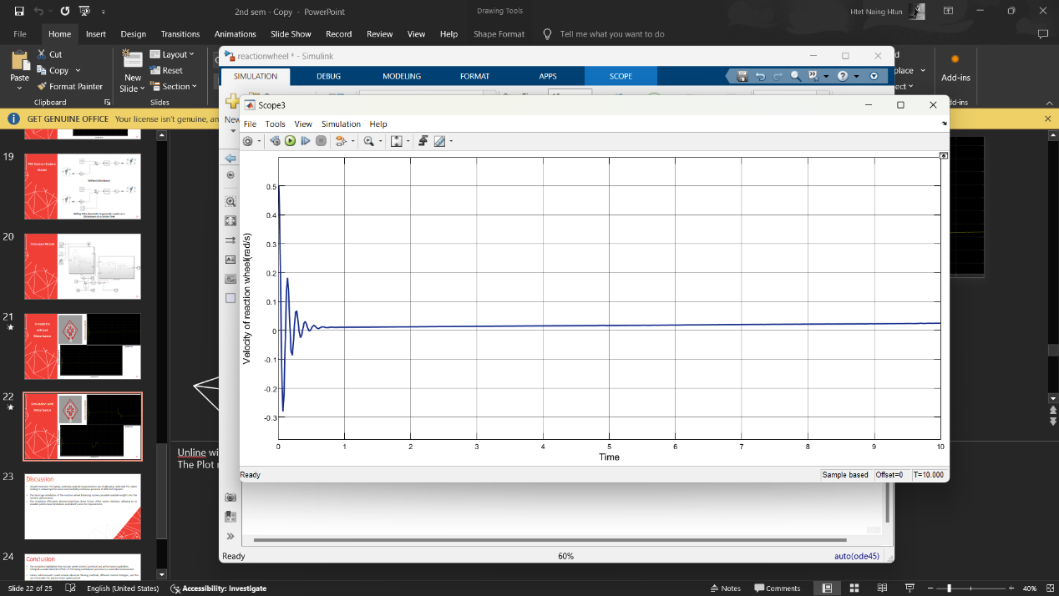
FIGURE 10. Reaction Wheel Velocity over Time With PID Control under No-Disturbance Condition
For testing purposes, a disturbance was introduced using a pulse generator set to trigger a disturbance at the 5-second mark. This pulse generator simulates an external perturbation. Figure 11 illustrates that, upon disturbance, the body exhibits some vibrations but ultimately returns to the setpoint position. The plot effectively shows how the PID controller helps in stabilizing the system despite external disturbances and varying conditions.
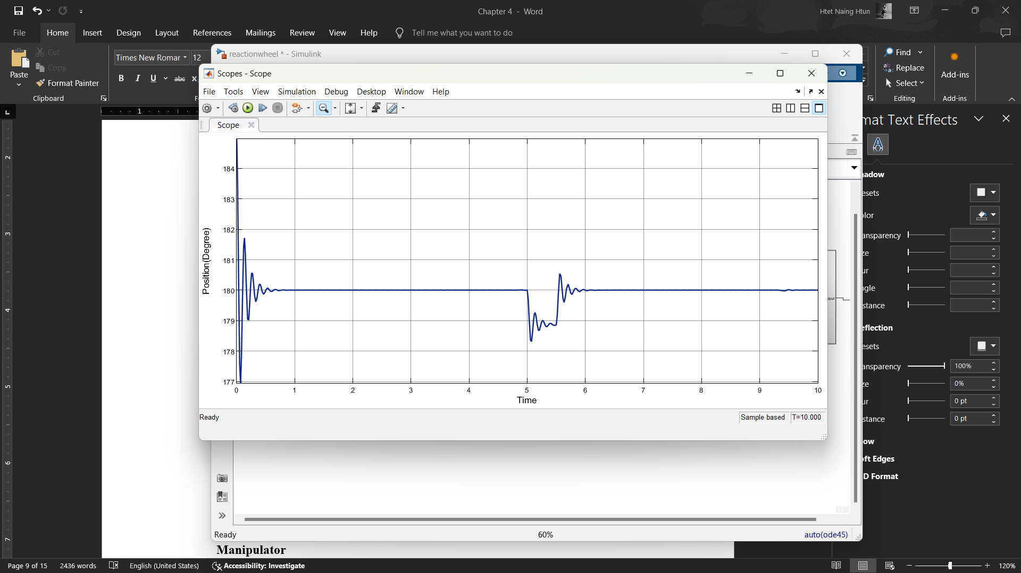 FIGURE 11. Effect of Disturbance on Body Angel with PID Control
TABLE I
Parameters for Each Block of the Body Subsystem

Block Name | Parameter | Value | Unit | Description
Body1 (File Solid) | Geometry | Imported from STL | mm | 3D shape and size of the Body
Body1 (File Solid) | Mass | 0.105 | kg | Mass of the Body
Bearing (File Solid) | Geometry | Imported from STL | mm | 3D shape and size of the Body
Bearing (File Solid) | Mass | 0.06 | kg | Mass of the Body
Rigid Transform | Translation | Cartesian  [13.95 8.5 11.95] | mm | Position of Bearing relative to Base
Rigid Transform 1 | Rotation | Rotation Sequence  Y-X-Z [90 -90 180] | deg | Rotation of Body relative to Bearing
Rigid Transform 1 | Translation | Cartesian  [179.8029 -99.8029 36.5] | mm | Position of Body relative to Bearing
Revolute Joint 1 | Position Target | High (desired)  185 | deg | Start Position of the Body frame
Revolute Joint 1 | Damping Coefficient | 0.0001 | N*m/(deg/s) | Energy dissipation to simulate gravitational effect
Revolute Joint 1 | Sensing | Position | radians | Measures the tilt position of the Body
TABLE
Parameters for Each Block of the Reaction Wheel Subsystem
Block Name | Parameter | Value | Unit | Description
Reaction Wheel (File Solid) | Geometry | Imported from STL | mm | 3D shape and size of the Reaction Wheel
Reaction Wheel (File Solid) | Mass | 0.13 | kg | Mass of the Reaction Wheel
Motor (File Solid) | Geometry | Imported from STL | mm | 3D shape and size of the Motor
Motor (File Solid) | Mass | 0.11 | kg | Mass of the Motor
Rigid Transform 3 | Rotation | Rotation Sequence  Y-X-Z [90 -90 180] | deg | Rotation of Reaction Wheel relative to Motor
Rigid Transform 3 | Translation | Cartesian  [62.5 -62.5043 62.16] | mm | Position of Reaction Wheel relative to Motor
Rigid Transform 2 | Rotation | Rotation Sequence  Y-X-Z [90 -90 180] | deg | Rotation of Motor relative to Body
Rigid Transform 2 | Translation | Cartesian  [92.55 -12.55 58] | mm | Position of Motor relative to Body
Revolute Joint 2 | Damping Coefficient | 0.0001 | N*m/(deg/s) | Energy dissipation to simulate gravitational effect
Revolute Joint 2 | Actuation Torque | Provided By Input | N*m | Applied torque to control Flywheel rotation
Revolute Joint 2 | Sensing | Velocity | rad/s | Measures the rotational velocity of Reaction Wheel

Conclusion
The Simscape simulation has been crucial for understanding the reaction wheel pendulum system's dynamics and the impact of disturbances on the system. By integrating the 3D printed model into a Simscape model in MATLAB, the simulations provided a platform to visualize how the reaction wheel operates and how disturbances influence system behavior. They effectively demonstrated the role of PID tuning on system performance, showing how different gain parameters affect stability and balance.
Although the simulated PID gains were not directly transferable to the physical model due to unmodeled factors such as friction and mechanical resistance, the simulations offered valuable insights into system behavior and control strategy testing. While Simscape simulations illustrated the dynamic interactions between the reaction wheel, pendulum, and control inputs, they were not the primary tool for achieving final control

performance. Incorporating detailed measurements of the system’s center of mass and weight distribution into future simulations will enhance accuracy by including precise mathematical modeling to account for these factors, improving the system's real-world design before implementation.
References
- Mouad Boumediene - Hobby Coding, “Enhanced Self Balancing Robot Simulation in Simulink [PID],” YouTube, 2022. https://youtu.be/fdy86fPQiXY
- S. Miller, T. Soares, Y. Van Weddingen, and J. Wendlandt, "Modeling Flexible Bodies with Simscape Multibody Software," MathWorks Technical Paper, MathWorks, Inc.
- Simscape Multibody Documentation, MathWorks. Available: https://www.mathworks.com/help/sm/index.html
- Miller, S., "Flexible Body Models in Simscape Multibody," MathWorks. https://www.mathworks.com/matlabcentral/fileexchange/47051-flexible-body-models-in-simscape-multibody

