Ye Yint Zin

Stat Calc 3.0

Data Structures and Object-Oriented Programming

Table of Contents

1. Project Description, Challenges and Learning Process

2 – 5. Program Features

Project Description:

Stat Calc 3.0 is a statistics/probability calculator that can compute factorial, permutations, combinations, the binomial probability density function and the normal probability density function. Although possible and more efficient with the use of simple static methods, each calculation is an object, containing a result, process, explanation, and all calculations used to get this result.

Challenges:

The more I coded, the newer code relied heavily on the old one. For example, factorial was relatively simple, but it would be called many, many times in Combinations (At least 3). This made fixing the program a nightmare, especially when it affected every single piece of code made. I went insane. I remade this project many times, not to mention this wasn’t even the original idea.

Learning Outcomes:

This project has been in the making for a couple weeks, but the amount of time I’ve dedicated into this has made me insane. I realized the potential of coding, and realized I hate doing this! If you’re reading this sir, thank you for all the advice you gave me. I really appreciate it, and wish I said this in person.

Program Features:

Two hierarchies of classes: Table and Calculation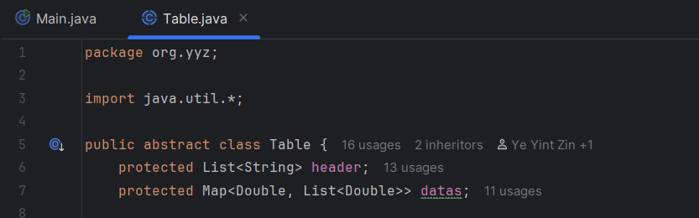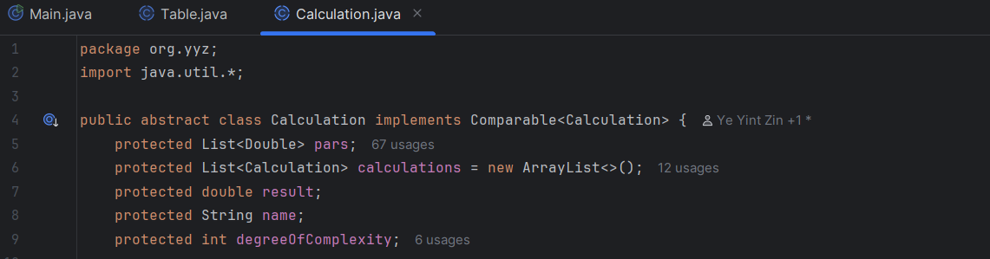

Interface: TableCalc

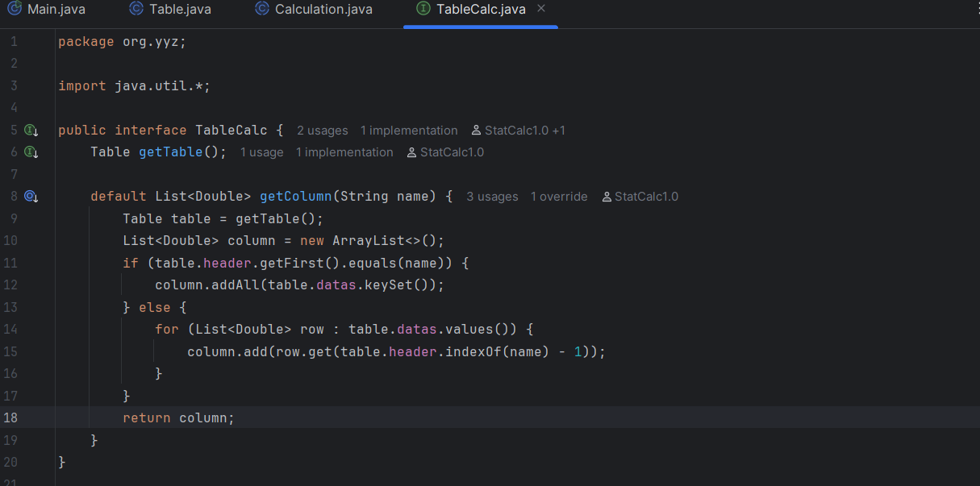

Runtime Polymorphism:

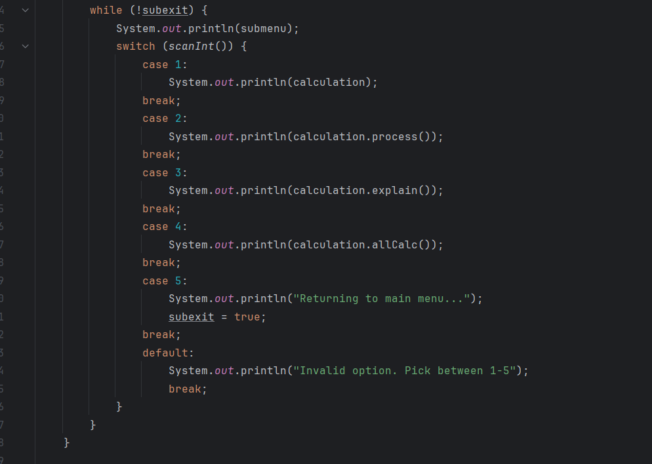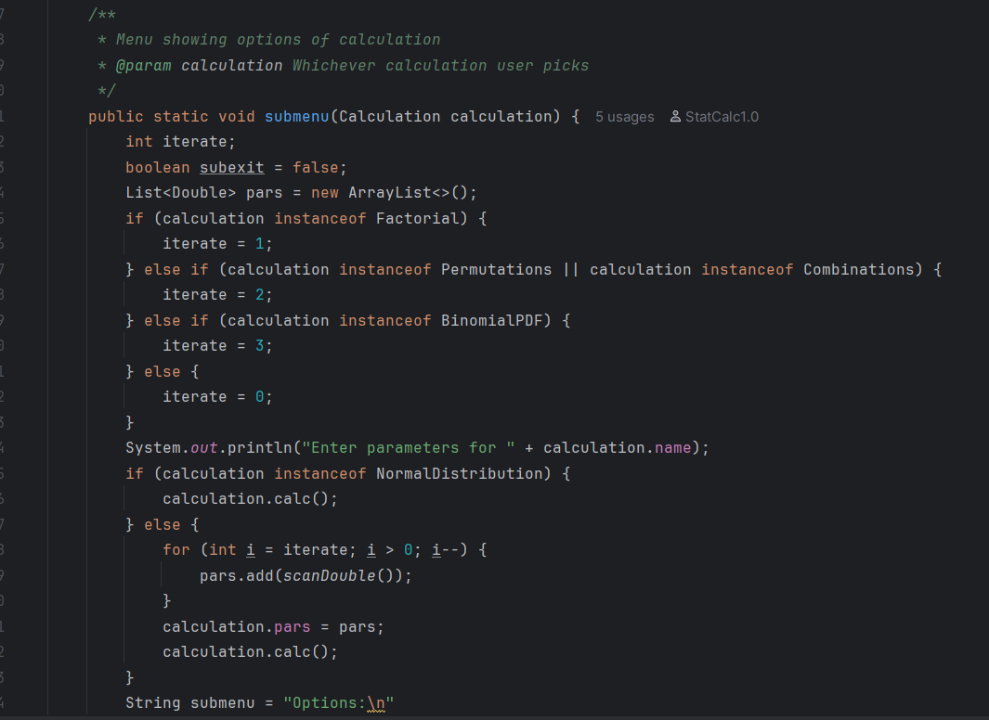

TextIO:

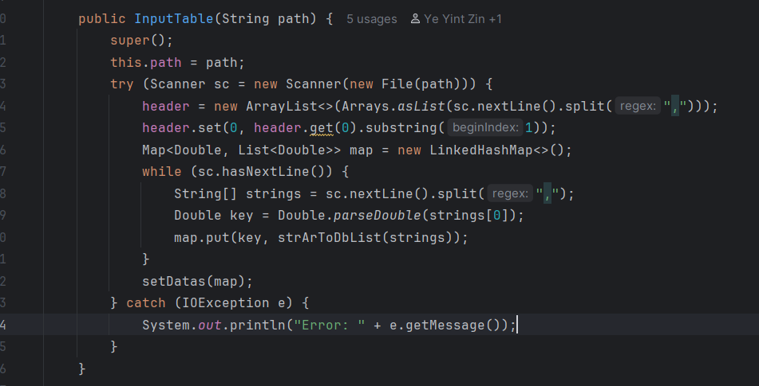

Comparable, sorts calculation based on complexity:

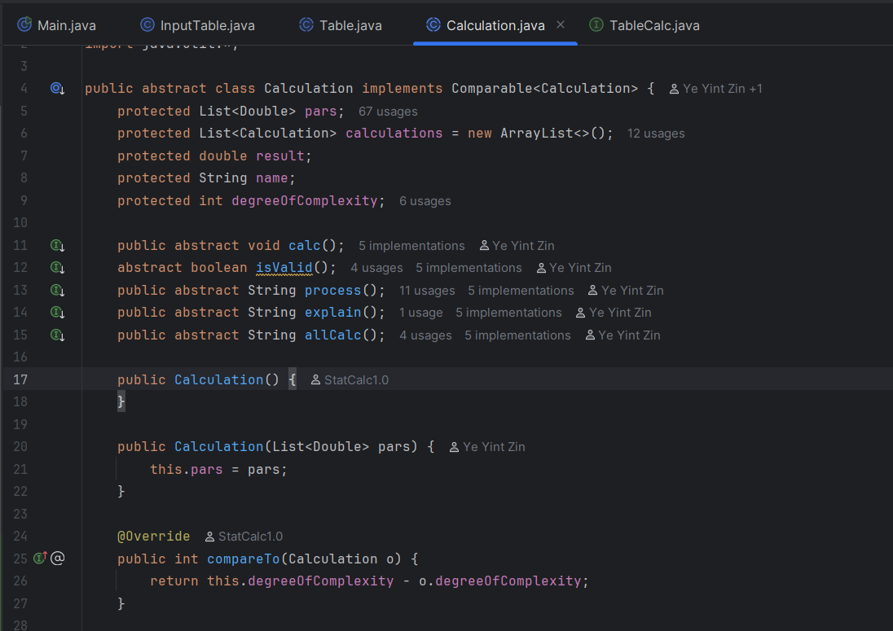

A lot of unit testing.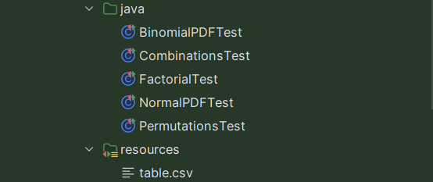

GitHub links (Original and Final, in that order):

<https://github.com/YeYintZin/StatCalc3.0>

<https://github.com/YeYintZin/actualfinalrah>