

**ADDIS ABABA INSTITUTE OF TECHNOLOGY**

**CENTER OF INFORMATION TECHNOLOGY AND SCIENTIFIC COMPUTING**

DEPARTMENT OF **Information Technology**

**The Internet**

Prepared By: Yeabsira Mezgebu

ID: ATR/4243/11

Submitted To: Mr. Fitsum Alemu

February 2020

**Table of content**

1. History of the internet 2

2. Top five websites 4

3. Types of websites 9

4. Guidelines to evaluate website 21

References 23

# History of the internet

**Before the internet**

Before the internet or before 1960s life was different from these days. If one has any relatives or friends which live abroad or even in a different city, he/she have to be there to talk to them or write a letter which may take months to reach to its destination. Also, letters do not give the feeling of actual conversation with the person additionally it may be needed to wait a long time to get a replay from the person. And talking face to face might even be impossible, the person may live in the opposite side of the country or in another country.

Information was so precious, people who can read may benefit from newspapers which are good option else radios and television was also available there were few news stations since owning news station requires a good investment unlike now which all you need is YouTube channel. On the other hand, social life was really good and communication was not based on need, its was mandatory. Also, books did have readers, and libraries was not empty.

**Who Created Internet**

Some inventions are pulled of by a single person and make a difference in the world. And others need a lot of minds to work together. Internet is one of them some brought the idea others bring it to reality others put it to something useful. It can be said Internet is one of the greatest innovations the world has ever seen. To understand the internet more, it is mandatory to go to the start.

Even though there were the idea of the internet for so long the idea for the internet was credited to Leonard Kleinrock after he published his first paper called "Information Flow in Large Communication Nets" on May 31, 1961. But there were a lot of scientists like Nikola Tesla who have the idea of World Wireless System and others like Paul otlet and Vannevar Bush have the idea to create searchable storage system of books. Even though Kleinrock brought the idea the first practical schematics for the internet arrive in the 1960s by J.C.R Licklider which brought the idea of “Intergalactic Network” of computers. Shortly thereafter, the development of internet was rapid. computer scientists developed the concept of “packet switching,” a method for effectively transmitting electronic data that would later become one of the major building blocks of the internet. In the late 1960s ARPANET (Advanced Research Projects Agency Network) was established which led to the first workable prototype of the internet. ARPANET was funded by the U.S. Department of Defense, and used packet switching to allow multiple computers to communicate on a single network. In December 1968, Elmer Shapiro with SRI released a report "A Study of Computer Network Design Parameters." Based on this and earlier work by Paul Baran, Thomas Marill and others, Lawrence Roberts and Barry Wessler created the IMP (Interface Message Processor) specifications.

On Friday, October 29 1969 at 10:30 p.m. ARPAnet delivered its first message: a “node-to-node” communication from one computer to another. The first computer was located in research lab at UCLA and the second computer was in Stanford and have a size of a small house. The message to be sent was “LOGIN”. But unfortunately, the computer at UCLA crashed and was not able to send the full message. The computer at Stanford only received the first two letters “LO” only. But after that they were abled to fix the situation and was successful.

Then in the following years major inventions starts to arrive in the 1970s after scientists Robert Kahn and Vinton Cerf developed Transmission Control Protocol and Internet Protocol, or TCP/IP, a communications model that set standards for how data could be transmitted between multiple networks. In 1971 Ray Tomlinson sends the first network e-mail. A few years later in 1974 ARPANET introduced commercial version of it self-called Telenet which is considered to be the first ISP (Internet service provider). In 1977 home users was able to connect to the internet thanks to the innovation was the 80-103A modem by Dennis Hayes and dale Heatherington.

Also, the ARPANET adopted TCP/IP on January 1, 1983, and from there researchers began to assemble the “network of networks” that became the modern Internet. The online world then took on a more recognizable form in 1990, when computer scientist Tim Berners-Lee invented the World Wide Web.

**After the internet**

There was a time when the internet was considered as magic and was not back bone of existence now it is almost impossible to imagine life with out the internet. There is no any part of the world without the influence of the internet. Internet is in everything, it almost feels like internet was created with air and water. Internet have brought human beings to a new era. New innovation which make life easier are always coming out, people with bright ideas share their ideas to the world easily, information flows like water, where ever you are in the world have the information about the world with continues updates. May TV programs satisfy you but there will be at least one person who understands you. You can be alone at the same time you are with billions of people around the world. Internet can be what ever you want it to be it is up to you.

But every thing comes with price, in this case it may be even the cause of human destruction. Human existence depends on each other which seems like the internet it taking away. The internet Is like an ocean you can drown easily, or get eaten by a predator or if you are wise enough you can get out of the ocean with fish.

# Top five websites

1. **YouTube:** URL: <https://www.youtube.com/>

YouTube was founded by [Chad Hurley](https://en.wikipedia.org/wiki/Chad_Hurley), [Steve Chen](https://en.wikipedia.org/wiki/Steve_Chen), and [Jawed Karim](https://en.wikipedia.org/wiki/Jawed_Karim) in 2005. Later in 2006 it was purchased by google for US$1.65 billion. It is now one of the biggest video sharing platform. It has reached 2 billion users over the world.

It has clean and good-looking home page. The home page contains search bar and other navigation menus. And most of the part is filled with videos which may suit your personal need or other videos which are trending at the time. It contains tons of information, knowledge which can be enough to stat any career.

To share videos in this platform it is needed to have a YouTube account or channel through there the owner of the channel can post any videos as long as they do not violet the rules and regulation. If a video violet the rules it will be brought down from the platform and based on which rules are violated the cannel may get shut down for ever.

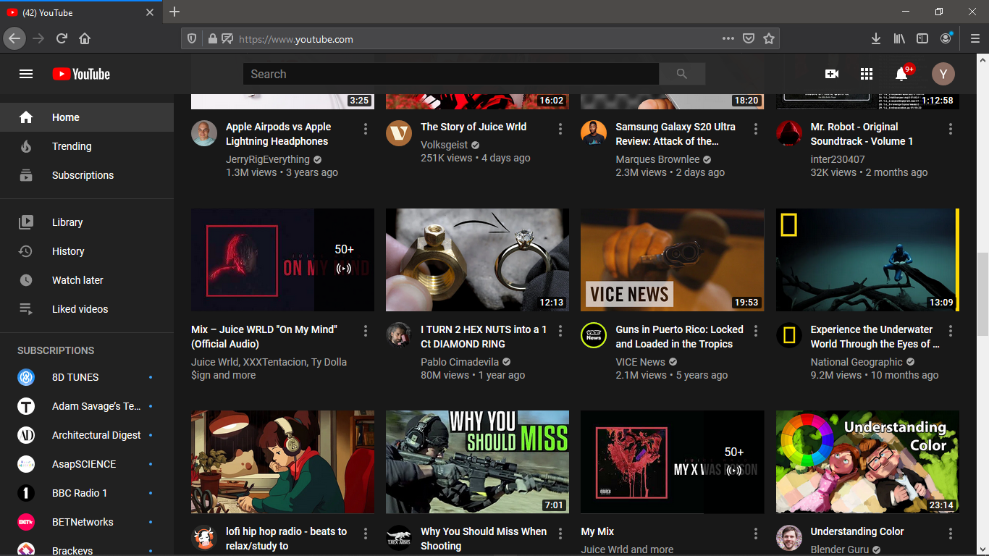

And to watch any video in the platform all needed is to go to the YouTube website. Also, there is another option which one can sign in to using their google account. This will allow you to subscribe the channels you like and to get more accurate video recommendations.

On the other hand, YouTube can be frustrating since every one is allowed to participate in the platform some videos may be offensive or even turns out to be a lie. People can give inappropriate comments to a video which can be sad since it takes a lot of work and commitment to do decent YouTube video. And also, videos can be done carelessly and may violet people’s privacy just to get views. But over all this is a great platform and one the biggest platform which transformed the world.

1. **Quora: URL:** <https://www.quora.com/>

Quora is an American [question-and-answer website](https://en.wikipedia.org/wiki/List_of_question-and-answer_websites) where questions are asked, answered, and edited by [Internet](https://en.wikipedia.org/wiki/Internet) [users](https://en.wikipedia.org/wiki/User_(computing)), either factually or in the form of opinions. Its owner, Quora Inc., is based in [Mountain View, California](https://en.wikipedia.org/wiki/Mountain_View,_California), [United States](https://en.wikipedia.org/wiki/United_States).

The company was founded in June 2009, and the website was made available to the public for the first time on June 21, 2010. Users can collaborate by editing questions and suggesting edits to answers that have been submitted by other users.

Any one can ask any kind of question and that question will be viewed by other user and hopefully will get answered. Any person can create Quora account and choose the type question he wants to answer so only questions on those categories will be recommend for the user to answer.

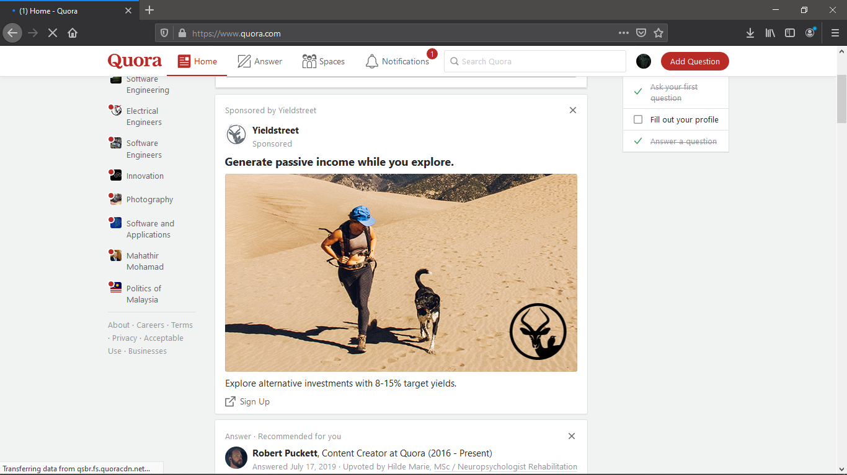

1. **Stack overflow: URL:** <https://stackoverflow.com/>

Stack Overflow is a question and answer site for professional and enthusiast programmers. It is a privately held website, the flagship site of the [Stack Exchange Network](https://en.wikipedia.org/wiki/Stack_Exchange), created in 2008 by [Jeff Atwood](https://en.wikipedia.org/wiki/Jeff_Atwood) and [Joel Sapolsky](https://en.wikipedia.org/wiki/Joel_Spolsky). It features questions and answers on a wide range of topics in [computer programming](https://en.wikipedia.org/wiki/Computer_programming). It was created to be a more open alternative to earlier [question and answer sites](https://en.wikipedia.org/wiki/Question-and-answer_site) such as [Experts-Exchange](https://en.wikipedia.org/wiki/Experts-Exchange). The name for the website was chosen by voting in April 2008 by readers of Coding Horror, Atwood's popular programming blog.

There will be no question with out an answer in stack over flow. At least someone has experienced the same type of problem you have is kind enough to share the solution. There are a lot of valuable knowledge and intelligent people in this website.

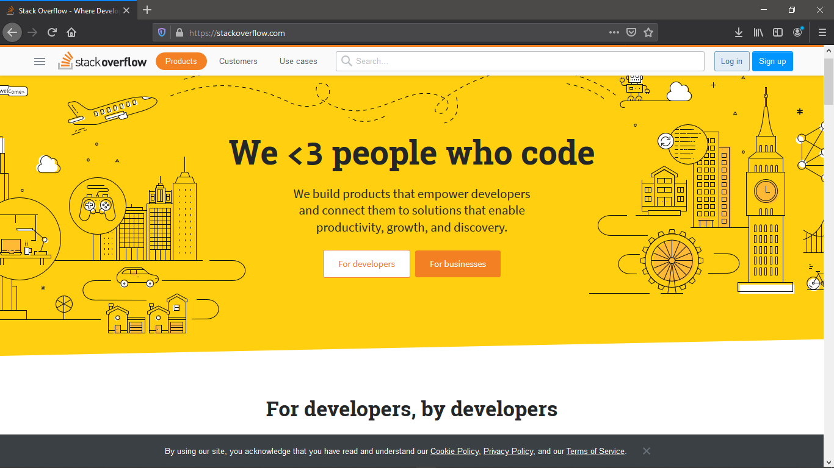

1. **Instructables: URL:** <https://instructables.com/>

After graduating from the [Media Lab](https://en.wikipedia.org/wiki/MIT_Media_Lab) at [MIT](https://en.wikipedia.org/wiki/Massachusetts_Institute_of_Technology), Wilhelm and Griffith founded [Squid Labs](https://en.wikipedia.org/wiki/Squid_Labs), an engineering and technology company specializing in design and consulting. Instructables started as an internal Squid Labs project, which later spun out as an independent company with Wilhelm as its [CEO](https://en.wikipedia.org/wiki/Chief_Executive_Officer). Wilhelm still regularly contributes to the site.

A prototype version of the site, complete with the initial content of electronics, cooking, kiting, and bicycle projects, was released in August 2005 at the [O'Reilly Foo Camp conference](https://en.wikipedia.org/wiki/Foo_Camp).

The original content focused mostly on such projects as building electronic or mechanical devices to solve common problems around the home. The scope of the project has expanded to include a larger array of categories, including Food, Living, Outside, Tech, Play and Workshop. Sponsored categories are sometimes added for companies to advertise a specific topic on the site.

The site allows uploading of photos, diagrams, video and animation to help explain complex terminology and mechanisms in clear and understandable terms.

They also have annual competitions in different categories like art, wood work, 3D printing etc. If you search how to make anything its mostly likely you will get your answer in instructables.

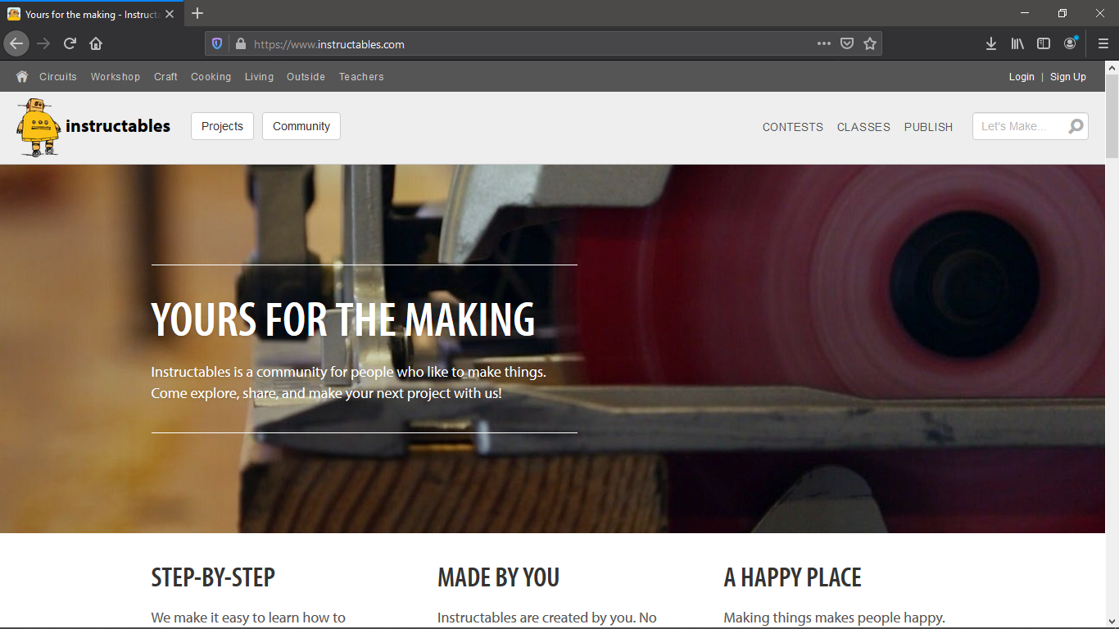

1. **Ocean of games: URL:** <https://oceanof-games.com/>

Let say you love playing games all day, but all the cool games are payed and you can not afford them or you do not have a way to pay. Well do not be worried. This site has millions of games in the library and each and every one of them are free. You can simply download and play them. And the library is always updated, though you may have to wait a while until some one figures it out hoe to crack the new released video game.

But this site has a major issue which is computer viruses, it seems like they guy how cracked the games need something in return some so some of the games contains different types of viruses specially cryptocurrency miner viruses which can reduced your pc performance in a significant way.

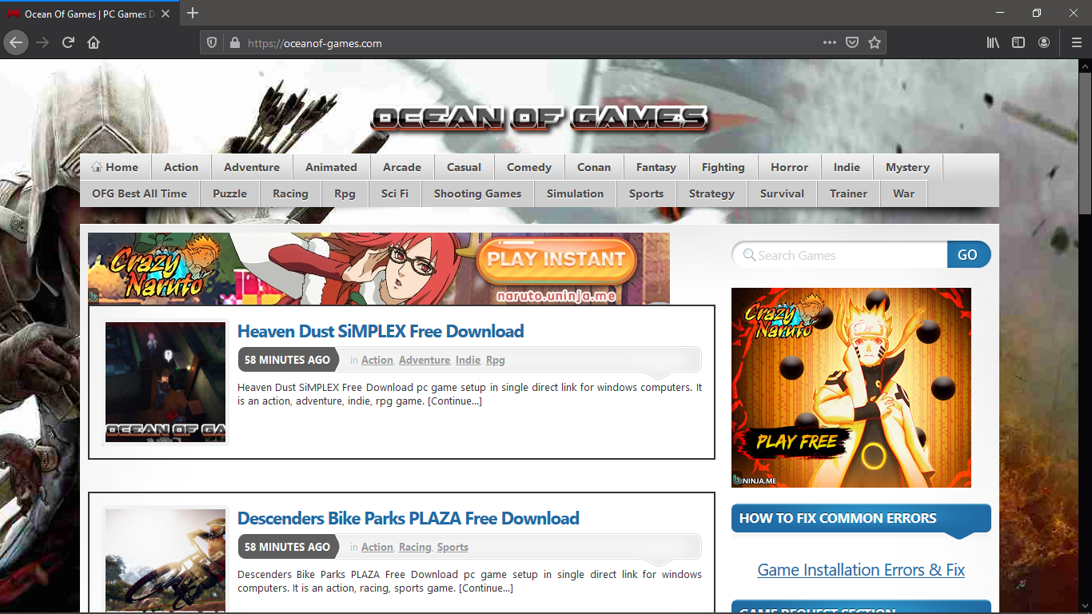

# Types of websites

1. **Portal:** Here are some examples of portal websites

* **Live oak Bank**

**Website**:<https://www.liveoakbank.com/>

This site takes very minimalistic approach focusing on providing valuable information. It also provides other bank functionalities like Loan rates, saving interest rate, contact information.

* **TCF Bank**

**Website**: <https://www.tcfbank.com/>

This site illustrates the effectiveness of simplicity. It has very easy to use navigation. And the transition between the desktop site to the mobile site is smooth the navigation menus and content is displayed neatly.

* **LMH Health**

**Website:** <https://www.lmh.org/>

**This site takes simple and effective approach. Patients can have information, view their record, and lot of other information. This lead this to take** three impressive awards.

* **Stamford Health**

**Website:** <https://www.stamfordhealth.org/>

The site delivers a modern feel with patient-centered photography and the home page took home platinum for [Best Internet Home Page from the eHealthcare Leadership Awards](https://ehealthcareawards.com/2018-winners/best-internet-home-page/).

* **EDX**

**Website:** https://www.edx.org/

This site provides one of the world’s leading massive open online courses that are offered for free to anyone wishing to learn.

1. **News:** Here are some examples of portal websites

* **Yahoo! News**

**Website:** <https://news.yahoo.com>

This site has over 175 million unique visitors every month. The website offers news related to almost every section, such as sports, finance, politics, and entertainment.

* **Huffington Post**

**Website:** https://www.huffingtonpost.in/

**This site has over 110 million unique visitors every month. It also provides news related to almost every section such as politics, entertainment, technology and much more. The website also offers a very clean and unique layout which is loved by its visitors a lot.**

* **New York Times**

**Website:** <https://www.nytimes.com/>

**This site has over 70 million unique visitors every month. The layout of the website is similar to a traditional newspaper which makes it attractive to see for its visitors.**

* **Washington Post**

**Website:** <https://www.washingtonpost.com/?noredirect=on>

**This site has over 47 million unique visitors every month. This sites also adapts traditional newspaper layout.**

* **WSJ (The Wall Street Journal)**

**Website:** https://www.wsj.com/india

**This site has 40 million unique visitors every month. The layout of the website is amazingly similar to modern newspapers.**

1. **Informational**

* **TechRadar**

**Website:** [www.techradar.com](http://www.techradar.com)

**This site provides helpful guides related to tablets, laptops and mobiles etc. Also, it rates the different kind of Smartphone devices, mobiles as well as tablets also.**

* **Droid-Life**

**Website:** [www.droid-life.com](http://www.droid-life.com)

**This site has the greatest Android community in the world. The community talk general news, feature apps, review phones, and even teach you how to hack a little.**

* **Gigaom**

**Website:** [www.gigamo.com](http://www.gigamo.com)

**This site gives brief analysis on new emerging technologies and their impact on the media, business and society.**

* **Business Insider**

**Website:** www.businessinsider.com

**This site gives deep financial, media, tech, and other industry verticals.**

* **Digital Trends**

**Website:** <https://www.digitaltrends.com>

**This site is the largest hub of technology, computer gaming devices and interesting lifestyle guides. It also covers guides related to music, cars and photography.**

1. **Business/ Marketing**

* **Minimums**

**Website:** <http://minimums.com/>

**This is a website with absolutely interesting content and communicates with simplicity and confidence. The website design is grid-based and uses bid typography and full-width, high-quality images.**

* **ETQ**

**Website:** <http://www.etq-amsterdam.com/>

**This is a great website with minimalistic approach and it is also beautiful, simple, flat, color-background and big cool visual images.**

* **Exposure**

**Website:** <https://exposure.co/>

**This site is a platform for your photography and a home for your adventure and stories. The website design is simple and focusses mainly on photos.**

* **Sierra Designs**

**Website:** <https://sierradesigns.com/>

**This site has clean aesthetic, lifestyle drive photography and is responsive.**

* **Hotel Tonight**

**Website:** <https://www.hoteltonight.com/>

**The home page of this site creates a very somber feeling with a dark background with great photos.**

1. **Educational**

* **Academic Earth**

**Website:** https://academicearth.org/

**The website gives huge array of academic options to student from traditional to contemporary studies. They provide online degree courses from accounting and economics to engineering and also carries material on niche subjects like behavioral psychology.**

* **Big Think**

**Website:** https://bigthink.com/

**This site provides students articles written by experts and record tutorials for the students.**

* **Brightstorm**

**Website:** https://www.brightstorm.com/

**This website is making the textbooks easier for students. They provide help in all subjects from mathematics to science, history and other subjects.**

* **Khan Academy**

**Website:** https://www.khanacademy.org/

**This is an online coaching website. Students who cannot afford a coaching can refer to this website.**

* **CosmoLearning**

**Website:** https://cosmolearning.org/

**Unlike other websites, this portal provides academic as well as skill-based learning to the students.**

1. **Entertainment**

* [**TMZ**](http://www.tmz.com/)

**Website:** www.tmz.com

**This site is a celebrity news blog that covers what the stars are talking about in and around Hollywood. Their scandal coverage includes the high focus professions of fashion and sports too.**

* [**Gawker**](http://gawker.com/)

**Website:** https://gawker.com/

**This is a popular site that’s based on celebrity news, fashion fads, health, and popular media.**

* [**HitFix**](http://www.hitfix.com/)

**Website:** https://uproxx.com/entertainment/

**This site gives salacious gossip and gives entertainment fans what they want, the inside scoop on the movies, music, and television.**

* [**E! Online**](http://www.eonline.com/)

**Website:** www.eonline.com

**This site gives news flashes, insider scoops, and live event coverage.**

* [**Hollywood**](http://www.hollywood.com/)

**Website:** www.hollywood.com

**This site provides news headlines to offbeat scoops, star interviews and photo galleries, the site covers a lot of ground. You can also catch what’s coming to the theatres near you along with a lot of showtime information.**

1. **Advocacy**

* **Royal Conservancy**

**Website:** <https://www.rcmusic.com/>

**This site is Beautifully simplistic! The home page with its strong compelling imagery and clear font and call actions, make this website very nice to use.**

* **Dogs on deployment**

**Website:** https://www.dogsondeployment.org/

**As soon as you land on the page it is clear what they do – they have a search right forefront that is paramount to their offerings. They clearly note how funds are allocated, how much they have helped and profile dogs that are currently being helped.**

* **That’s not cool**

**Website:** <https://thatsnotcool.com/>

**This site is a fantastic website dedicated to helping people understand that dating abuse is never OK! The website offers a fantastic design for what we imagine is a younger demographic that is tech savvy.**

* **Cystic Fibroses Foundation**

**Website:** https://www.cff.org/

**This site is clean, the ease of finding out what they do and how they can help those affected with Cystic Fibroses. The header is able to deliver a lot of information but is done in a way that is not overwhelming, the large home page image tells you right away what the team is up to and the news section overlaid on the image is a great way to keep visitors engaged!**

* **Diffa**

**Website:** https://diffa.org/

**This site has Bold fonts, colors and call to actions round out why this website made our list. This nonprofit website has a clear tagline on the home page.**

1. **Blog**

* **WordPress**

**Website:** https://wordpress.com/

**WordPress.org is one of the most popular choices when it comes to managing your blog site. It has a learning curve and it will take some time to learn it, but that is the cost of having a professional blog website.**

* **WIX**

**Website:** https://www.wix.com/

**Founded in 2006,** [**Wix**](https://firstsiteguide.com/wix/) **has become a wildly popular web builder for people who revel in a ton of design options—without breaking the bank.**

* **Squarespace**

**Website:** https://www.squarespace.com/

**It is a convenient all-in-one web builder, hosting provider and platform for bloggers. With fabulous, responsive designs, Squarespace became known as the hippest of the web builders.**

* **Weebly**

**Website:** https://www.weebly.com/?lang=en

**Weebly is kind of an interesting one, and similar to other popular online projects like Facebook. According to Wikipedia, this content management system began its journey as a student project back in 2006, which quickly outgrew the boundaries of the College of Information Sciences and Technology at the Pennsylvania State University.**

* **Blogger**

**Website:** https://www.blogger.com/about/?r=1-null_user

**Blogger site is relatively easy to use. It is completely free and you can somewhat monetize it through ads. Customization options are limited.**

1. **Wiki**

* **Wiki travel**

**Website:** https://wikitravel.org/en/Main_Page

**The information on such sites can often be misleading; it’s hard to differentiate the paid promotions from the legitimate content. And that’s before you start worrying about the ongoing issue of fake reviews.**

* **Wiki How**

**Website:** https://www.wikihow.com/Main-Page

**Wiki How is a popular wiki for anyone who wants to learn how to do something. The content on offer is extremely varied. The site’s categories include topics such as Sports and Fitness, Pets and Animals, Relationships, and Philosophy.**

* **Wiki Books**

**Websites:** <https://en.wikibooks.org/wiki/Main_Page>

**Wiki Books makes our list of wiki sites thanks to its incredible repository of open-content textbooks, annotated texts, instructional guides, and manuals. It does not include fiction, primary research, or published texts.**

* **Wiktionary**

**Website:** https://en.wiktionary.org/wiki/Wiktionary:Main_Page

**Wiktionary, therefore, is an example of a wiki that can save you money. It is a multilingual dictionary of languages, but has a definition for every word supplied in English, regardless of the source language.**

* **Wiki species**

**Website:** https://species.wikimedia.org/wiki/Main_Page

**Wiki species is to the 21st century what “On the Origin of Species” was to the 19th century. It aims to be a complete catalog of all Animalia, Plantae, fungi, bacteria, archaea, and Protista.**

1. **Social Network**

* **Facebook**

**Website:** https://www.facebook.com/

**Facebook is the biggest social media site around, with more than two billion people using it every month. That’s almost a third of the world’s population!**

* **YouTube**

**Website:** https://www.youtube.com/

[**YouTube**](https://www.youtube.com/)**is a video-sharing platform where** [**users watch a billion hour of videos every day**](https://www.youtube.com/yt/about/press/)**. To get started, you can** [**create a YouTube channel**](https://buffer.com/library/create-a-youtube-channel) **for your brand where you can upload videos for your subscribers to view, like, comment, and share.**

* **WhatsApp**

**Website:** https://www.whatsapp.com/

**WhatsApp is a messaging app used by people in over 180 countries. Initially, WhatsApp was only used by people to communicate with their family and friends. radially, people started communicating with businesses via WhatsApp.**

* **WeChat**

**Website:** <https://www.wechat.com/en/>

**WeChat grew from a messaging app, just like WhatsApp and Messenger, into an all-in-one platform. Besides messaging and calling, users can now use WeChat to shop online and make payment offline, transfer money, make reservations, book taxis, and more.**

* **Instagram**

**Website:** https://www.instagram.com/

**Instagram is a photo and video sharing social media app. It allows you to share a wide range of content such as photos, videos, Stories, and live videos.**

1. **Content Aggregator**

* **Feedly**

**Website:** https://feedly.com/

**Feedly is one of the most popular news aggregator websites on the internet. It allows you to create a news stream of your own with latest content from your favorite publishers.**

* **AllTop**

**Website:** https://alltop.com/

**All Top aggregates news and blog articles from the world’s most popular websites like TechCrunch, Mashable, BBC, CNN, and more. It curates and displays content in the real-time.**

* **News 360**

**Website:** https://news360.com/

**News360 is one of the most popular news aggregator apps on the internet. It lets you find world news as well as stories around your interests. It is an excellent alternative to Google News and Feedly.**

* **Flip Board**

**Website:** https://flipboard.com/

**Flipboard is an excellent blog aggregator site that allows you to create your own content feed based on your interests. It includes a wide range of topics, including business news, tech news, travel, politics news, beauty, and more.**

* **Pocket**

**Website:** https://getpocket.com/

**Pocket is another news aggregator app where you can explore the most popular content across the internet. It also lets you create your own reading space by saving the content you like.**

1. **Personal**

* **Nia Shanks**

**Website:** https://www.niashanks.com/

**There’s a lot to like about this personal website. The design is nice and clean and favors a more minimal style (which we’re a fan of). The headline on the homepage is also something we’re a big fan of. It’s direct, conveys value quickly, and doesn’t beat around the bush.**

* **Ellen Skye**

**Website:** http://ellensriley.com/

**This is honestly one of the best personal websites we’ve ever seen. Riley does an excellent job at showcasing her incredibly gifted design skills, and her site is informative and extremely fun to parous.**

* **Joshua McCartney**

**Website:** https://www.joshuamccartney.com/

**McCartney’s website grabs your attention as soon as you see it. This is a great example of something that simply looks great.**

* **Pascal van Gemert**

**Website:** http://www.pascalvangemert.nl/

**Gemert shows off his skill of web development in a really nice interactive, online resume. Initially, any fans of Marvel (specifically, Captain America) are going to love this site. But if you continue to scroll, there’s really something for everybody in this personal website.**

* **Charlie Waite**

**Website:** <http://www.charliewaite.me/>

**Wait’s website is a great example of stellar design and personality. It has really amazing incorporation of a mobile screenshot, something that shows off his love of being a father and his joy of life.**

# Guidelines to evaluate website

**There are five ways to evaluate value of a website.**

1. **Accuracy of Web Documents**

**One of the major ways to evaluate a website is by its accuracy. Accuracy can be interpreted as:**

* Who wrote the page and can you contact him or her?
* What is the purpose of the document and why was it produced?
* Is this person qualified to write this document?

**These are the major points to consider when we talk about accuracy of a website. Does the person who wrote the page have the qualification to write or is the person confident and leaves a way to contact him or her, is the person sure about his or her information is not afraid to take any critiques.**

1. **Authority of Web Documents**

Another guideline is authority of the web documents. Which includes the following key points to consider:

* Who published the document and is it separate from the "Webmaster?"
* Check the domain of the document, what institution publishes this document?
* Does the publisher list his or her qualifications?

The basic concept is Webmaster and a person who publishes a document in a website is different things. The idea of or the power of the webmaster should not affect the credibility of the document. And the document should not violate and copy right.

1. **Objectivity of Web Documents**

The third one is objective of the document. Its objective can be evaluated based on the following points:

* What goals/objectives does this page meet?
* How detailed is the information?
* What opinions (if any) are expressed by the author?

This means to check or to ask why is the document or the information in the website is it for advertisement or is it for self-benefit, does it solve the problem the viewers have etc.

1. **Currency of Web Documents**

The other guideline is currency of the website. The following points are a way to evaluate currency of a website:

* When was it produced?
* When was it updated'
* How up-to-date are the links (if any)?

This mainly considers at is the information in the website UpToDate, is the information there are always updated to meet the current standard. Are there any dead links or is the links updated or if there are any dead links are fixed in time etc.

1. **Coverage of the Web Documents**

The last but not the list is coverage of ta website. Below are main points to evaluate coverage of a website:

* Are the links (if any) evaluated and do they complement the documents' theme?
* Is it all images or a balance of text and images?
* Is the information presented cited correctly?

Are the links in the website related to its content, or are there enough images to give insight to the information published. Is the layout of the text and images in proper position, all these questions are asked to evaluate coverage of a website.

Below there are two websites evaluated according to the guidelines listed above.

1. **American Institute of Physics**

This website is takes very simple and minimalistic approach. They have used solid white color for the back ground and a simple table in the middle to display the content. Below the website is evaluated according to each guideline.

**Accuracy:** In the footer of the home page it explains who wrote the information but does not include any contact information.

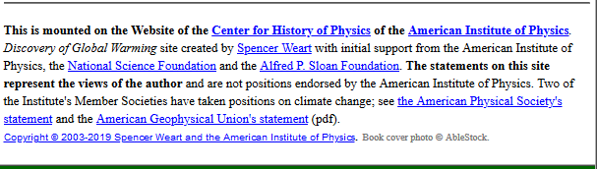

**Authority:** The website explains who wrote the information and the qualification of the person and the institute the person is from.

**Objectivity:** The information is very detailed and mostly reflects scientifically proven facts and also the website states the content is the author’s opinion.

**Currency:** The website is UpToDate and every link works and the issue addressed matches the current state.

**Coverage:** The links support the idea and are related to the context. There are some images but are not viewable correctly and the layout used is not attractive and does not invite readers.

# References

https://ccconline.libguides.com/c.php?g=242130&p=1609638

<https://medium.com/@ThunderPuff/life-before-the-internet-54cc03fd2451>

<https://insight.kellogg.northwestern.edu/article/what_has_the_internet_done_for_the_economy>

<https://www.history.com/news/who-invented-the-internet>

<https://www.computerhope.com/issues/ch001016.htm>

<https://medium.com/@TribalWorldwide/what-comes-after-the-internet-7415463e6327>

<https://www.theguardian.com/technology/2009/oct/23/internet-40-history-arpanet>

<https://www.techworm.net/2018/12/best-most-popular-news-websites-world.html>

<https://www.grafdom.com/blog/top-20-best-tech-websites-and-blogs/>

<https://www.indiatoday.in/education-today/featurephilia/story/free-education-953499-2017-01-06>

<https://www.weebpal.com/blog/11-best-looking-business-websites>

<https://www.makeuseof.com/tag/10-entertainment-websites-daily-celebrity-news-fix/>

<https://www.2dogsdesign.com/best-nonprofit-websites/>

<https://firstsiteguide.com/tools/blogging/>

<https://buffer.com/library/social-media-sites>

<https://www.wpbeginner.com/showcase/best-news-aggregator-websites-how-to-build-your-own/>

<https://brandyourself.com/blog/branding/best-personal-website-examples/>