**Lab #2**

Josue Ponce

Montgomery College

2/10/2018

Author’s Note

This lab report was prepared for CMSC 203 CRN #30672, taught by professor Ahmed Tarek

**Table of Contents**

Task #1……………………………………………………………………………………………2

Screenshots of Task #1 errors fixed………………………………………………………………3

Task #2 Code……………………………………………………………………………………...5

Task #2 Test Cases………………………………………………………………………………..7

Screenshots of All Test Cases Conducted for Task #2…………………………………………..10

Task #3 Volume of Sphere Code……………………………………………...…………………12

Task # 3 Test Cases………………………………………………………………………………13

Task #3 Screenshots of Tested Results………………………………………………………..…14

**Task #1**

The fixed errors in Numeric Types Original will be highlight down below.

1. Final int NUMBER = 2; should be final double NUMBER = 2;
2. average = score1 + score2 /NUMBER; should be average = (score1 + score2)/NUMBER;
3. fToC = 5/9 *(BOILING_IN_F - 32); should have a cast and be fToC = (double) (5/(double)9 * (BOILING_IN_F - 32));

/**

This program demonstrates how numeric types and operators behave in Java

Do Task #1 before adding Task#2 where indicated.

*/

public class NumericTypesOriginal {

public static void main (String [] args) {

//TASK #2 Create a Scanner object here

//identifier declarations

final double NUMBER = 2; // number of scores

int score1 = 100; // first test score

int score2 = 95; // second test score

final int BOILING_IN_F = 212; // boiling temperature

double fToC; // temperature in Celsius

double average; // arithmetic average

String output; // line of output to print out

average = (score1 + score2)/NUMBER;

output = score1 + " and " + score2 + " have an average of " + average;

System.out.println(output);

// Convert Fahrenheit temperatures to Celsius

fToC = (double) (5/(double)9 * (BOILING_IN_F - 32));

output = BOILING_IN_F + " in Fahrenheit is " + fToC + " in Celsius.";

System.out.println(output);

System.out.println("Goodbye"); // to show that the program is ended

}

}

**Screenshots of Task #1 errors fixed.**

*Note.* Screenshot of program’s output before all logical errors have been fixed.

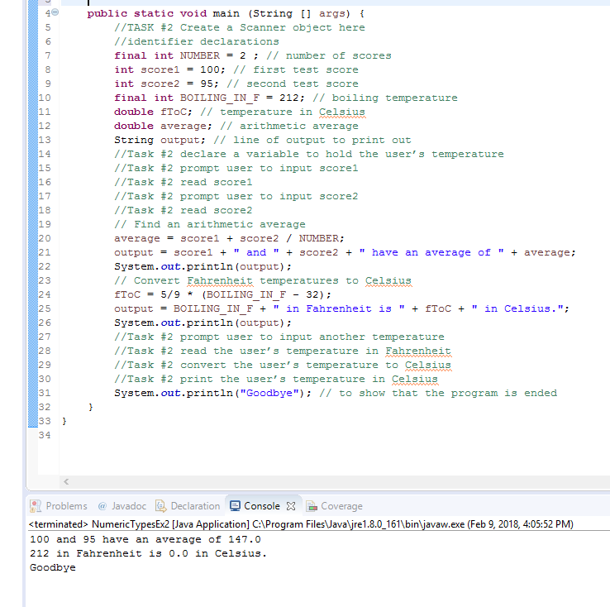

*Note.* Screenshot of program’s output after all logical errors have been fixed.

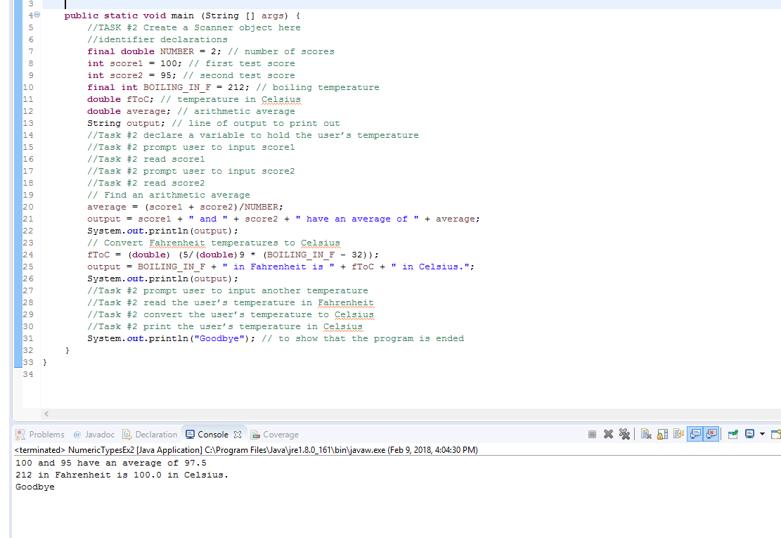

**Task #2 Code**

/**

This program demonstrates how numeric types and operators behave in Java

Do Task #1 before adding Task#2 where indicated.

*/

**import** **java.util.\*** ; // task #2 import java scanner

**public** **class** **NumericTypes** {

**public** **static** **void** **main** (String [] args) {

//TASK #2 Create a Scanner object here

Scanner scan = **new** Scanner(System.in);

//identifier declarations Task #1

//final double NUMBER = 2 ; // number of scores

//int score1 = 100; // first test score

//int score2= 95; // second test score

//final int BOILING_IN_F = 212; // boiling temperature

//double fToC; // temperature in Celsius

//double average; // arithmetic average

// String output; // line of output to print out

//Task #2 declare a variable to hold the user’s temperature

String score1;

String score2;

**double** celcius;

//TASK #2 declare variables used here

**double** fToC;

**double** cToF;

String fullName;

String output;

System.out.println("Enter your Full name: "); // prompt the user to enter their full name

fullName = scan.nextLine(); // read the user's full name

System.out.println(fullName);

System.out.println(); // extra blank line

//Task #2 prompt user to input score1

System.out.print("Enter Score 1: ");

//Task #2 read score1

score1 = scan.nextLine();

//Task #2 prompt user to input score2

System.out.print("Enter Score 2: ");

//Task #2 read score2

score2 = scan.nextLine();

System.out.println("Score 1 : " + score1);

System.out.println("Score 2 : " + score2);

// Find an arithmetic average (Task #1)

//average = (score1 + score2) / NUMBER;

//output = score1 + " and " + score2 + " have an average of " + average;

//System.out.println(output);

//Convert Fahrenheit temperatures to Celsius

//fToC = (double) (5/(double)9 * (BOILING_IN_F - 32));

//output = BOILING_IN_F + " in Fahrenheit is " + fToC + " in Celsius.";

//System.out.println(output);

//Task #2 prompt user to input another temperature

System.out.print("Enter a temperature in Celcius: ");

celcius = scan.nextDouble();

scan.close();

//Task #2 read the user’s temperature in Fahrenheit

cToF = celcius *(**9**/(**double**)**5**) + **32**;

output = celcius + " degrees Celcius is " + cToF + " degrees Fahrenheit";

System.out.print(output);

//Task #2 convert the user’s temperature to Celsius

fToC = (cToF-**32**) *(**5**/(**double**)**9**);

//Task #2 print the user’s temperature in Celsius

System.out.print("\n" + cToF + " degrees Fahrenheit is " + fToC + " degrees Celcius" );

System.out.println("\nGoodbye"); // to show that the program is ended

}

}

**Task #2 Test Cases**

The following tests were conducted to ensure that the program was free of logical errors and worked as intended. All the results were printed from the program and posted down below. The tests conducted made sure that the program worked as intended and all results were mathematically correct. The highlight numbers represent the user’s input and mathematical output in the program itself. The non-highlighted sections are nothing but headers and texts implemented within the program itself. 3 test cases were conducted to ensure the program was reliable and accurate.

**Test #1**

**---------------------------------------------------------------------------------------------------------------------**

Enter your Full name:

Josue Ponce

Josue Ponce

Enter Score 1: 100

Enter Score 2: 95

Score 1 : 100

Score 2 : 95

Enter a temperature in Celcius: 100

100.0 degrees Celcius is 212.0 degrees Fahrenheit

212.0 degrees Fahrenheit is 100.0 degrees Celcius

Goodbye

**Test #1 Hand calculated results**

C to F: 212

F to C: 100



**Test # 2**

**---------------------------------------------------------------------------------------------------------------------**

Enter your Full name:

Josue Ponce

Josue Ponce

Enter Score 1: 1

Enter Score 2: 20

Score 1 : 1

Score 2 : 20

Enter a temperature in Celcius: 0

0.0 degrees Celcius is 32.0 degrees Fahrenheit

32.0 degrees Fahrenheit is 0.0 degrees Celcius

Goodbye

**Test #2 Hand calculated results**

C to F: 32

F to C: 0

**---------------------------------------------------------------------------------------------------------------------**

**Test #3**

**---------------------------------------------------------------------------------------------------------------------**

Enter your Full name:

Josue Ponce

Josue Ponce

Enter Score 1: 0

Enter Score 2: -45

Score 1 : 0

Score 2 : -45

Enter a temperature in Celcius: -50

-50.0 degrees Celcius is -58.0 degrees Fahrenheit

-58.0 degrees Fahrenheit is -50.0 degrees Celcius

Goodbye

**Test # 3 hand calculated results**

C to F: **-58**

F to C: **-50**

**---------------------------------------------------------------------------------------------------------------------**

**Screenshots of All Test Cases Conducted for Task #2**

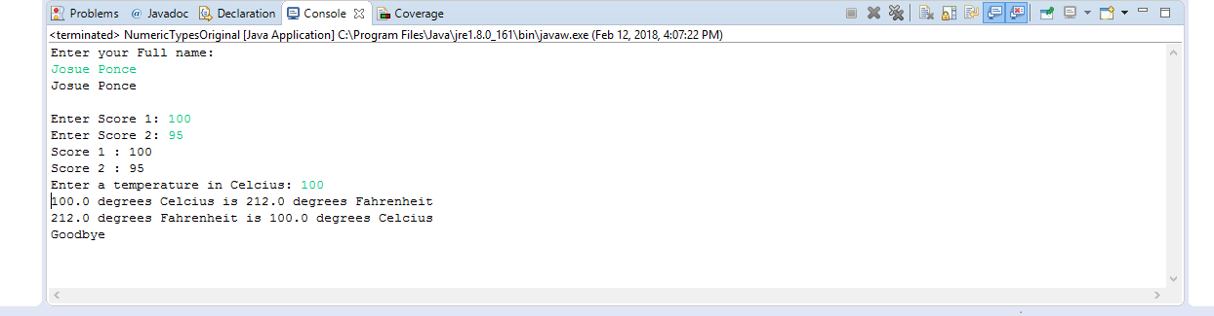

*Note.* Screenshot of the program’s output after test #1

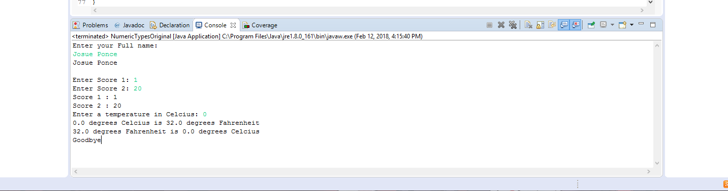

*Note.* Screenshot of the program’s output after test #2

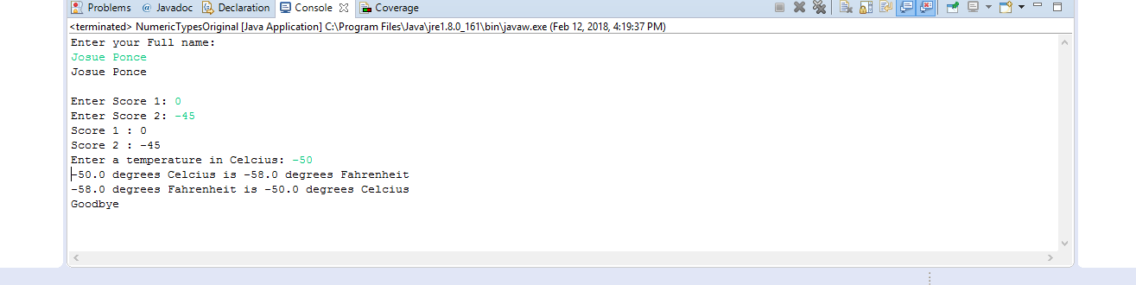

*Note.* Screenshot of the program’s output after test #3

**Task #3 Volume of Sphere Code**

|  |
| --- |
|  |

/**The java program prompts the user to input the diameter of a sphere and

calculate the volume of the sphere then print the volume*/

**import** **java.util.Scanner**; //Import Java scanner

**public** **class** **SphereVolume** {

**public** **static** **void** **main**(String[] args) {

//Declaring variables.

**double** diam;

**double** neko = **2**;

**double** volume;

String output;

//Displays the purpose of the program to user.

System.out.print("This program calculates the volume of a sphere\n");

//prompts user to input the diameter of the sphere.

System.out.print("\nPlease enter the diameter of the sphere: ");

// Scanner object

Scanner input = **new** Scanner(System.in);

//Reads user input

diam =Double.parseDouble(input.nextLine());

input.close();

//Stores the radius of a sphere in variable called "Radius"

**double** radius = diam / neko;

//Calculates Volume of sphere.

volume = (**double**) (**4**/(**double**)**3**)*Math.PI*Math.pow(radius, **3**);

//Displays results to user

output = "The volume of a sphere is:" + volume;

System.out.print(output);

}

}

**Task #3 Test Cases**

|  |  |  |
| --- | --- | --- |
| **Diameter** | **Volume (hand calculated)** | **Volume (resulting output)** |
| 2 | 4.1887902047863905 | 4.1887902047863905 |
| 25.4 | 8580.24664605096 | 8580.24664605096 |
| -5 | -65.44984694978736 | -65.44984694978736 |
| 50 | 65449.84694978735 | 65449.84694978735 |

*Note.* To ensure that the program was accurate and free of logical errors, a TI-Nspire CX calculator was used to hand calculate the results. The calculator is powerful enough to obtain all the digits without rounding. Hence why it was used to test the program for logical errors. The hand calculated volume matched the program’s resulting output. Thus, all the tests conducted were a success and the program calculated the volume of a sphere correctly. No logical errors were found during testing.

**Task #3 Screenshots of Tested Results**

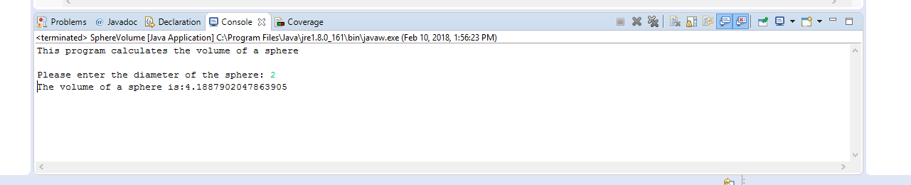

*Note.* Screenshot of the program’s output after test #1

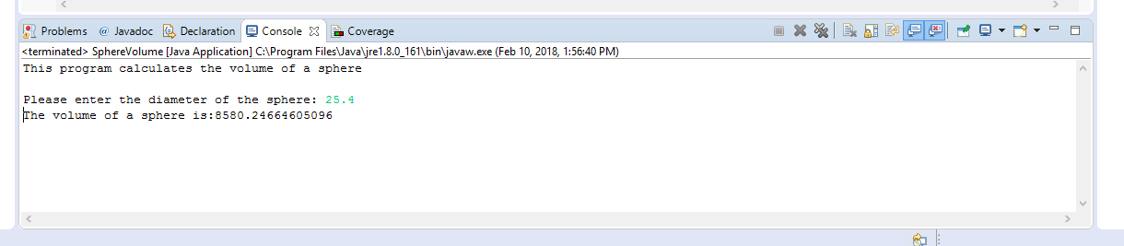

*Note.* Screenshot of the program’s output after test #2

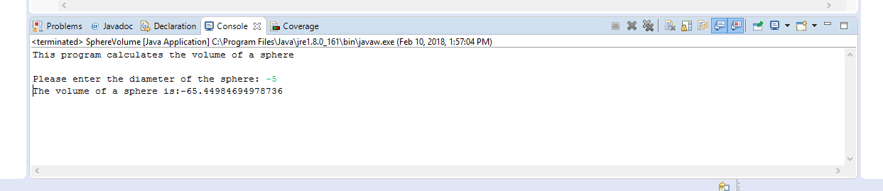

*Note.* Screenshot of the program’s output after test #3

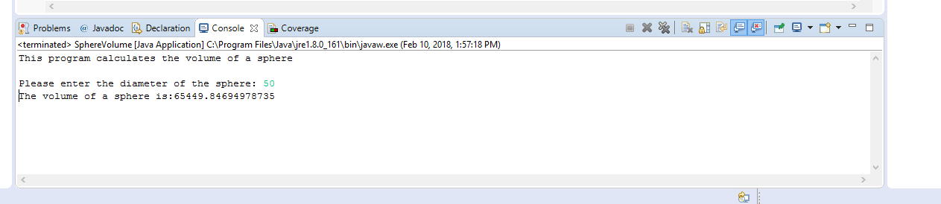

*Note.* Screenshot of the program’s output after test #4