**Lab #3**

Josue Ponce

Montgomery College

2/19/2018

Author’s Note

This lab report was prepared for CMSC203 CRN #30672, taught by professor Ahmed Tarek

**Table of Contents**

Task #1 Code…………………………………………………...…………………………………2

Task #1 Test Cases……………………………………………………………………….………..3

Task #1 Screenshots……………………………………………………………………………….4

Task #2 Code………………………………………………………………………………...……7

Task #2 Test Cases…………………………………………………………………...…………....9

Task #2 Screenshots…………………………………………………………...…………………11

**Task #1 Code**

**import** java.util.Scanner;

//Public class movie driver

**public** **class** MovieDriver {

/\*\***@param** String[]*/

**public** **static** **void** main(String[]args){

//Creating a type of Scanner object

Scanner input=**new** Scanner(System.***in***);

//Movie object

Movie data = **new** Movie();

//Declaring string variables.

String movieName;

String rating;

**int** tickets;

//prompt the user to enter the title of movie.

System.***out***.println("Enter the name of a movie:");

movieName = input.nextLine();

//set the title in the movie object.

data.setTitle(movieName);

//Prompt the user to enter the movie’s rating

System.***out***.println("Enter the rating of the movie ");

//Set the rating in the movie object

rating = input.nextLine();

//Set the title

data.setRating(rating);

//Prompt the user to enter the number of tickets sold at a (unnamed) theater

System.***out***.println("Enter the number of tickets sold for the movie: ");

//Set the number of tickets

tickets = input.nextInt();

//Set the number of tickets sold in the movie object

data.setSoldTickets(tickets);

//use toString method in Movie.java

System.***out***.println(data.toString());

input.close();

//Print out the information using the movie’s toString method

System.***out***.println("\nGoodbye!");

}

}

**Task #1 Test Cases**

The following tests were conducted to ensure that the program was free of logical errors and worked as intended. All the results were printed from the program and posted down below. The tests conducted made sure that the program worked as intended. The green words or letters represent user input and the rest of the sample output is from the program itself.

Test #1

---------------------------------------------------------------------------------------------------------------------

Enter the name of a movie:

The Force Awakens

Enter the rating of the movie

PG13

Enter the number of tickets sold for the movie:

4001

The Force Awakens (PG13): Tickets Sold: 4001

Goodbye!

---------------------------------------------------------------------------------------------------------------------

Test #2

---------------------------------------------------------------------------------------------------------------------

Enter the name of a movie:

Concussion

Enter the rating of the movie

PG13

Enter the number of tickets sold for the movie:

4321

Concussion (PG13): Tickets Sold: 4321

Goodbye!

------------------------------------------------------------------------------------------------------------------------------------------

Test #3

---------------------------------------------------------------------------------------------------------------------

Enter the name of a movie:

The Hangover

Enter the rating of the movie

R

Enter the number of tickets sold for the movie:

830123

The Hangover (R): Tickets Sold: 830123

Goodbye!

---------------------------------------------------------------------------------------------------------------------

**Task #1 Test Case Screenshots**

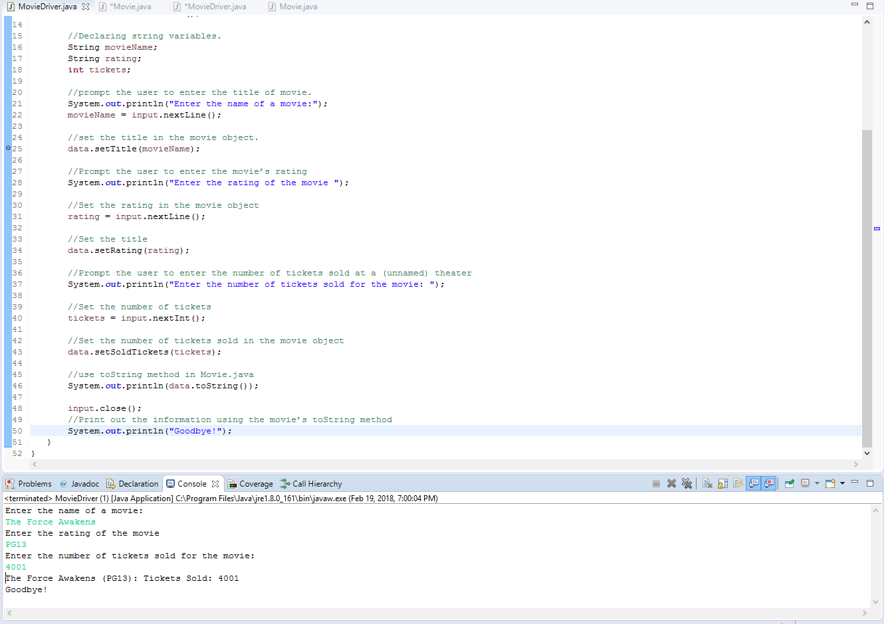

*Note.* Screenshot of the program’s output after test #1

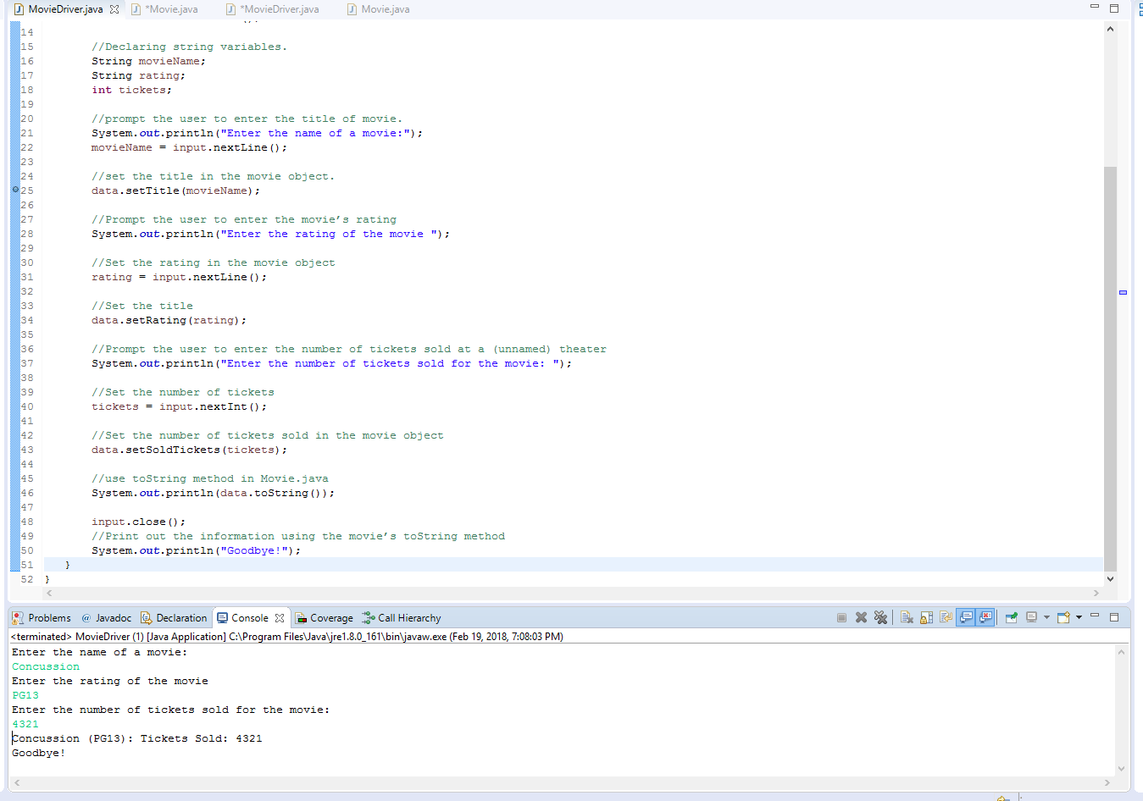

*Note.* Screenshot of the program’s output after test #2

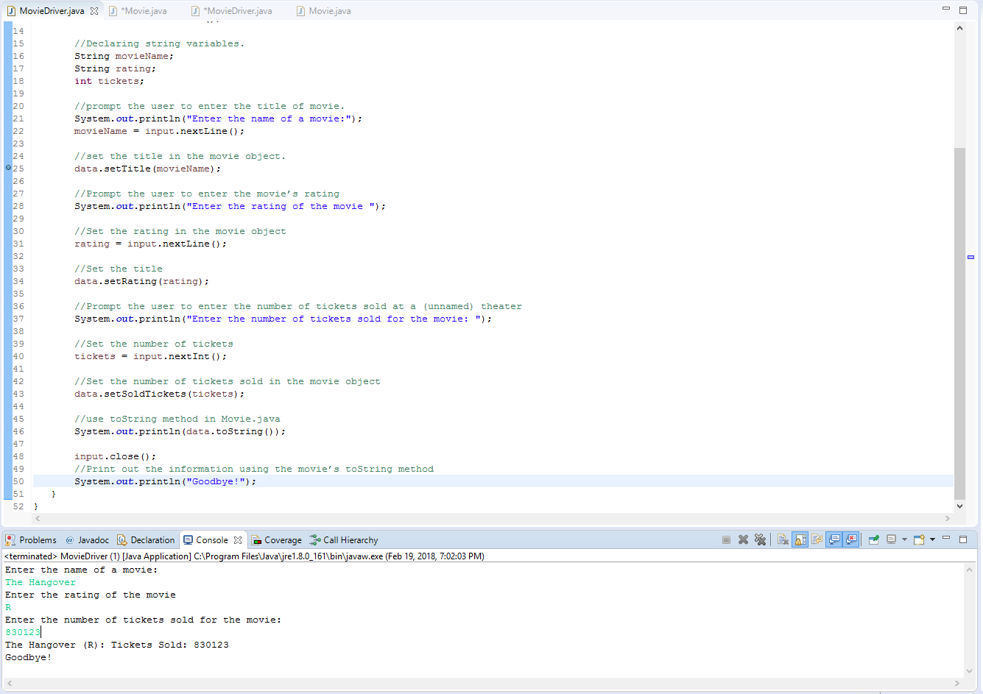

*Note.* Screenshot of the program’s output after test #3

**Task #2 Code**

**import** **java.util.Scanner**;

//Public class movie driver

**public** **class** **MovieDriver** {

/**@param String[]*/

**public** **static** **void** **main**(String[]args){

//Creating a type of Scanner object

Scanner input=**new** Scanner(System.in);

//Movie object

Movie data = **new** Movie();

//Declaring string variables.

String movieName;

String rating;

**int** tickets;

String scan;

**do**{

//prompt the user to enter the title of movie.

System.out.println("Enter the name of a movie:");

movieName = input.nextLine();

//set the title in the movie object.

data.setTitle(movieName);

//Prompt the user to enter the movie’s rating

System.out.println("Enter the rating of the movie ");

//Set the rating in the movie object

rating = input.nextLine();

//Set the title

data.setRating(rating);

//Prompt the user to enter the number of tickets sold at a (unnamed) theater

System.out.println("Enter the number of tickets sold for the movie: ");

//Set the number of tickets

tickets = input.nextInt();

//Set the number of tickets sold in the movie object

data.setSoldTickets(tickets);

//use toString method in Movie.java

//Print out the information using the movie’s toString method

System.out.println(data.toString());

System.out.println("Do you want to enter another movie? (y or n)");

scan=input.next();

input.nextLine();

}**while**(scan.equalsIgnoreCase("y"));

input.close();

// Display goodbye message to user.

System.out.println("Goodbye!");

}

}

**Task #2 Test Cases**

The following tests were conducted to ensure that the program was free of logical errors and worked as intended. All the results were printed from the program and posted down below. The tests conducted made sure that the program worked as intended. The green words or letters represent user input and the rest of the sample output is from the program itself.

Test #1

---------------------------------------------------------------------------------------------------------------------

Enter the name of a movie:

The hangover

Enter the rating of the movie

R

Enter the number of tickets sold for the movie:

4001

The hangover (R): Tickets Sold: 4001

Do you want to enter another movie? (y or n)

n

Goodbye!

---------------------------------------------------------------------------------------------------------------------

Test #2

---------------------------------------------------------------------------------------------------------------------

Enter the name of a movie:

Concussion

Enter the rating of the movie

PG13

Enter the number of tickets sold for the movie:

4321

Concussion (PG13): Tickets Sold: 4321

Do you want to enter another movie? (y or n)

y

Enter the name of a movie:

The Good dinosaur

Enter the rating of the movie

PG

Enter the number of tickets sold for the movie:

5432

The Good dinosaur (PG): Tickets Sold: 5432

Do you want to enter another movie? (y or n)

n

Goodbye!

---------------------------------------------------------------------------------------------------------------------

Test #3

---------------------------------------------------------------------------------------------------------------------

Enter the name of a movie:

The Hangover

Enter the rating of the movie

R

Enter the number of tickets sold for the movie:

100

The Hangover (R): Tickets Sold: 100

Do you want to enter another movie? (y or n)

y

Enter the name of a movie:

Concussion

Enter the rating of the movie

PG13

Enter the number of tickets sold for the movie:

0

Concussion (PG13): Tickets Sold: 0

Do you want to enter another movie? (y or n)

y

Enter the name of a movie:

The good dinosaur

Enter the rating of the movie

PG

Enter the number of tickets sold for the movie:

5

The good dinosaur (PG): Tickets Sold: 5

Do you want to enter another movie? (y or n)

n

Goodbye!

---------------------------------------------------------------------------------------------------------------------

**Task #2 Screenshots**

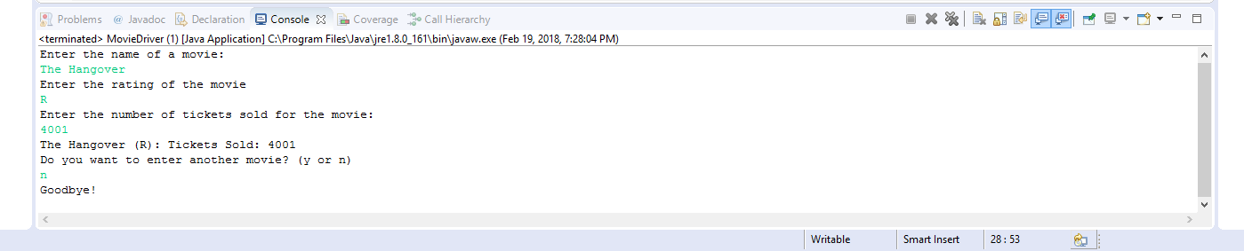

*Note.* Screenshot of the program’s output after test #1

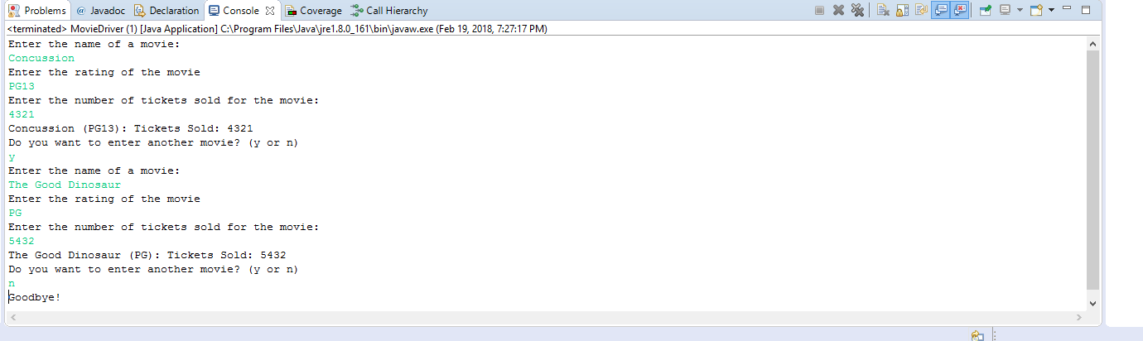

*Note.* Screenshot of the program’s output after test #2

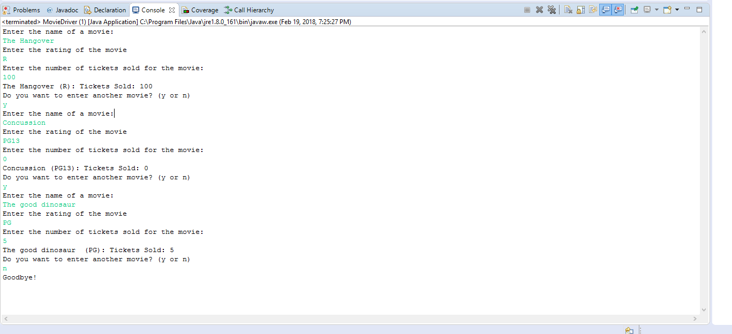

*Note.* Screenshot of the program’s output after test #3