**Lab #4**

Josue Ponce

Montgomery College

2/25/2018

Author’s Note

This lab report was prepared for CMSC 203 CRN #30672, taught by professor Ahmed Tarek

**Table of Contents**

Task #1…………………………………………………………………………………………….2

Task #1 Code……………………………………………………………………………………...3

Task #2…………………………………………………………………………………………….4

Task #2 code………………………………………………………………………………………5

Task #3…………………………………………………………………………………………….6

Task #4 Sample Output……………………………………………………………………………8

Task #5 Sample Output……………………………………………………………………………9

Task #5 Code……………………………………………………………………….……………10

**Task #1**

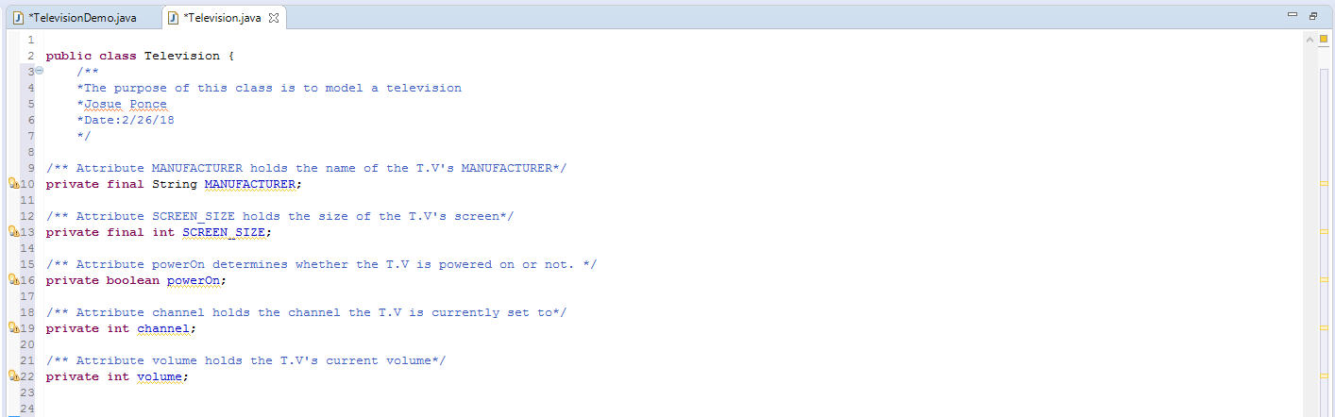

**Task #1 Code**

/**

*The purpose of this class is to model a television

*@author Josue Ponce

*Date:2/26/18

*/

**public** **class** **Television** {

/** Attribute MANUFACTURER holds the name of the T.V's MANUFACTURER*/

**private** **final** String MANUFACTURER;

/** Attribute SCREEN_SIZE holds the size of the T.V's screen*/

**private** **final** **int** SCREEN_SIZE;

/** Attribute powerOn determines whether the T.V is powered on or not. */

**private** **boolean** powerOn;

/** Attribute channel holds the channel the T.V is currently set to*/

**private** **int** channel;

/** Attribute volume holds the T.V's current volume*/

**private** **int** volume;

**Task #2**

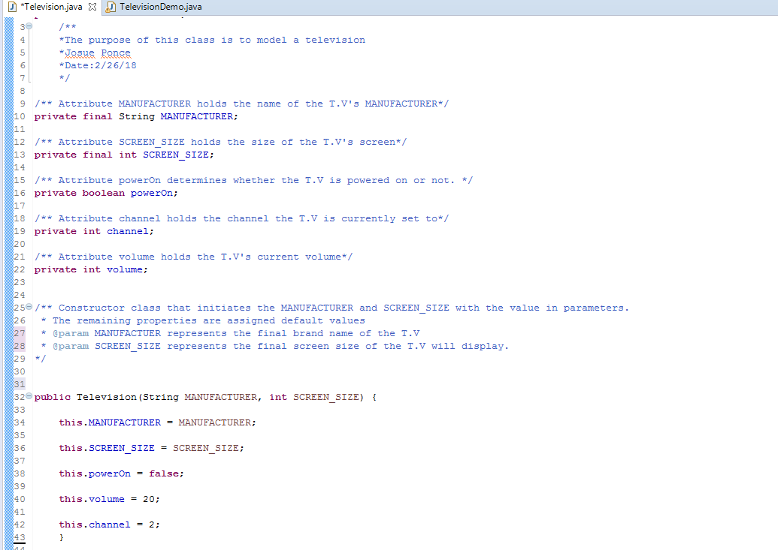

**Task #2 Code**

/**

*The purpose of this class is to model a television

*@author Josue Ponce

*Date:2/26/18

*/

**public** **class** **Television** {

/** Attribute MANUFACTURER holds the name of the T.V's MANUFACTURER*/

**private** **final** String MANUFACTURER;

/** Attribute SCREEN_SIZE holds the size of the T.V's screen*/

**private** **final** **int** SCREEN_SIZE;

/** Attribute powerOn determines whether the T.V is powered on or not. */

**private** **boolean** powerOn;

/** Attribute channel holds the channel the T.V is currently set to*/

**private** **int** channel;

/** Attribute volume holds the T.V's current volume*/

**private** **int** volume;

/** Constructor class that initiates the MANUFACTURER and SCREEN_SIZE with the value in parameters.

* The remaining properties are assigned default values

* @param MANUFACTUER represents the final brand name of the T.V

* @param SCREEN_SIZE represents the final screen size of the T.V will display.

*/

**public** **Television**(String MANUFACTURER, **int** SCREEN_SIZE) {

**this**.MANUFACTURER = MANUFACTURER;

**this**.SCREEN_SIZE = SCREEN_SIZE;

**this**.powerOn = **false**;

**this**.volume = **20**;

**this**.channel = **2**;

}

**Task #3**

/**

*The purpose of this class is to model a television

*@author Josue Ponce

*Date:2/26/18

*/

**public** **class** **Television** {

/** Attribute MANUFACTURER holds the name of the T.V's MANUFACTURER*/

**private** **final** String MANUFACTURER;

/** Attribute SCREEN_SIZE holds the size of the T.V's screen*/

**private** **final** **int** SCREEN_SIZE;

/** Attribute powerOn determines whether the T.V is powered on or not. */

**private** **boolean** powerOn;

/** Attribute channel holds the channel the T.V is currently set to*/

**private** **int** channel;

/** Attribute volume holds the T.V's current volume*/

**private** **int** volume;

/** Constructor class that initiates the MANUFACTURER and SCREEN_SIZE with the value in parameters.

* The remaining properties are assigned default values

* @param MANUFACTUER represents the final brand name of the T.V

* @param SCREEN_SIZE represents the final screen size of the T.V will display.

*/

**public** **Television**(String MANUFACTURER, **int** SCREEN_SIZE) {

**this**.MANUFACTURER = MANUFACTURER;

**this**.SCREEN_SIZE = SCREEN_SIZE;

**this**.powerOn = **false**;

**this**.volume = **20**;

**this**.channel = **2**;

}

/**mutator method stores the desired T.V channel.

* @param station will hold the desired T.V channel.

*/

**public** **void** **setChannel**(**int** station) {

**this**.channel = station;

}

/** Mutator Method toggles the power on and off. changes the boolean state from false to true

* in other words, powerOn will be set to true by declaring powerOn = !powerOn

*

*/

**public** **void** **power**() {

**this**.powerOn = !powerOn;

}

/**sets and increases the T.V's volume by one*/

**public** **void** **increaseVolume**() {

**this**.volume = volume + **1**;

}

/**sets and decreases the T.V's volume by one*/

**public** **void** **decreaseVolume**() {

**this**.volume = volume - **1**;

}

/** accessor method returns the current channel

* @return the T.V's current channel

*/

**public** **int** **getChannel**() {

**return** channel;

}

/** accessor method returns the current volume

* @return the T.V's current volume

*/

**public** **int** **getVolume**() {

**return** volume;

}

/** accessor method returns the name of the T.V's manufacturer.

* @return the name of the T.V's manufacturer.

*/

**public** String **getManufacturer**() {

**return** MANUFACTURER;

}

/** accessor method returns the T.V's Screensize.

* @return the T.V's Screensize.

*/

**public** **int** **getScreenSize**() {

**return** SCREEN_SIZE;

}

}

**Task #4**

**Program Sample output**

**---------------------------------------------------------------------------------------------------------------------**

A 55-inch Toshiba has been turned on.

What channel do you want? 56

Channel: 56, Volume: 21

Too loud!! I am lowering the volume.

Channel: 56, Volume: 15

---------------------------------------------------------------------------------------------------------------------

*Note.* Screenshot of program’s output for task #4.

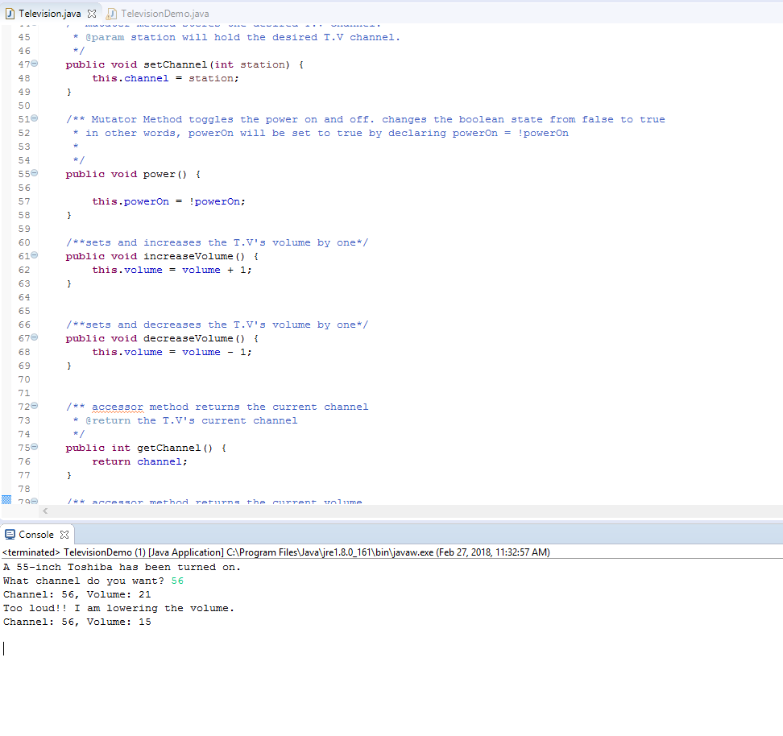

**Task #5**

**Program Sample Output**

**---------------------------------------------------------------------------------------------------------------------**

A 55-inch Toshiba has been turned on.

What channel do you want? 56

Channel: 56, Volume: 21

Too loud!! I am lowering the volume.

Channel: 56, Volume: 15

A 19 inch Sharp has been turned on.

What channel do you want? 7

Channel: 7 Volume: 18

**---------------------------------------------------------------------------------------------------------------------**

*Note.* Screenshot of sample output for task #5

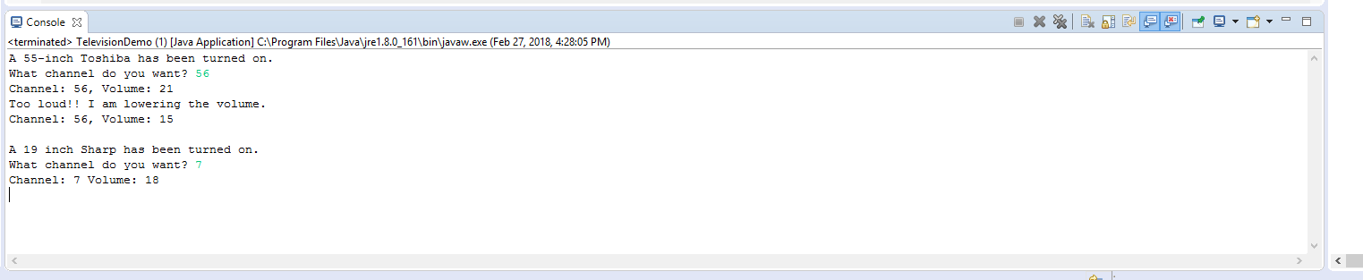

**Task #5 Code**

**import** **java.util.Scanner**;

/**

* This class tests the Television class

*/

**public** **class** **TelevisionDemo**

{

**public** **static** **void** **main**(String[] args)

{

//create a Scanner object to read from the keyboard

Scanner keyboard = **new** Scanner (System.in);

//declare variables

**int** station; //the user’s channel choice

//declare and instantiate a television object

Television bigScreen = **new** Television("Toshiba", **55**);

//turn the power on

bigScreen.power();

//display the state of the television

System.out.println("A " + bigScreen.getScreenSize() + "-inch " +

bigScreen.getManufacturer() + " has been turned on.");

//prompt the user for input and store into station

System.out.print("What channel do you want? ");

station = keyboard.nextInt();

//change the channel on the television

bigScreen.setChannel(station);

//increase the volume of the television

bigScreen.increaseVolume();

//display the the current channel and volume of the television

System.out.println("Channel: " + bigScreen.getChannel() +

", Volume: " + bigScreen.getVolume());

System.out.println("Too loud!! I am lowering the volume.");

//decrease the volume of the television

bigScreen.decreaseVolume();

bigScreen.decreaseVolume();

bigScreen.decreaseVolume();

bigScreen.decreaseVolume();

bigScreen.decreaseVolume();

bigScreen.decreaseVolume();

//display the current channel and volume of the television

System.out.println("Channel: " + bigScreen.getChannel() +

", Volume: " + bigScreen.getVolume());

System.out.println(); //for a blank line

//HERE IS WHERE YOU DO TASK #5

Television portable=**new** Television("Sharp", **19**);

portable.power();

//display the state of the television

System.out.println("A " + portable.getScreenSize() + " inch "+

portable.getManufacturer() +

" has been turned on.");

//prompt the user for input and store into station

System.out.print("What channel do you want? ");

station = keyboard.nextInt();

//change the channel on the television

portable.setChannel(station);

//decrease the volume of the television.

portable.decreaseVolume();

portable.decreaseVolume();

//display the current channel and volume of the

//television

System.out.println("Channel: " +

portable.getChannel() +

" Volume: " + portable.getVolume());

keyboard.close();

}

}