**Lab #6**

Josue Ponce

Montgomery College

3/21/2018

Author’s Note

This project report was prepared for CMSC 203 CRN #30672, taught by professor Ahmed Tarek

**Table of Contents**

Task 1……………………………………………………………………………………………2

Task 2 & 3……………………………………………………………………………….………5

Task 4……………………………………………………………………………………………9

Function.Java Code……………………………………………………………………………..11

**Task #1**

/**

*The purpose of this class is to compute different function values for a real value x

*@Author Josue Ponce

*@Date 3/19/18

*@version 1.0

*/

**public** **class** **Function**{

/**

* Holds the function's value.

*/

**private** **double** FUNCTION_CHOICE;

/**

* Holds the Description of the function

*/

**private** String description;

/**

* Regular constructor that initializes the choice of the function to compute

* @param fnChoice

*/

**public** **Function**(**int** fnChoice){

//.... body

}

/**

* returns the function choice

* @return the function of choice

*/

**public** **int** **getFunctionChoice**(){

//.... body

}

/**

* Sets the description of a function.

*/

**public** **void** **setDescription**(){

//.... body

}

/**

* returns the description with function choice

* @param fnChoice

* @return the description of the chosen function.

*/

**public** **static** String **getDescription**(**int** fnChoice){

//.... body

}

/**

* @return the description string

*/

**public** String **toString**(){

//.... body

}

/**

* evaluates the function value for the parameter x

* @param x

* @return the calculated results based on the function choice.

*/

**public** **double** **computeFunctionValue**( **double** x){

//.... body

}

}

**Task #2 & #3**

/**

*The purpose of this class is to compute different function values for a real value x

*@Author Josue Ponce

*@Date 3/19/18

*@version 1.0

*/

**public** **class** **Function**{

/**

* Holds the function's value.

*/

**private** **double** FUNCTION_CHOICE;

/**

*Holds the Description of the function

*/

**private** String description;

/**

* Regular constructor that initializes the choice of the function to compute

* @param fnChoice

*/

**public** **Function**(**int** fnChoice){

FUNCTION_CHOICE=(**double**)fnChoice;

setDescription();

}

/**

* returns the function choice.

* @return the function of choice.

*/

**public** **int** **getFunctionChoice**(){

**return** (**int**)FUNCTION_CHOICE;

}

/**

* Sets the description of a function.

*/

**public** **void** **setDescription**(){

**if**(FUNCTION_CHOICE ==**1.0**) {

description="(8x-sqrt(x))/(x^3-7x^2+15x-9)";

}

**else** **if** (FUNCTION_CHOICE ==**2.0**) {

description="sin(x)";

}

**else** **if** (FUNCTION_CHOICE ==**3.0**) {

description="(5/x)+35";

}

**else** **if** (FUNCTION_CHOICE ==**4.0**) {

description="(sqrt(x^3+16)-4)/(x^2)";

}

**else** **if** (FUNCTION_CHOICE == **5.0**) {

description="(e^x-1)/x";

}

}

/**

* returns the description with function choice

* @param fnChoice

* @return the description of the chosen function.

*/

**public** **static** String **getDescription**(**int** fnChoice){

**if**(fnChoice ==**1**) {

**return** "(8x-sqrt(x))/(x^3-7x^2+15x-9)";

}

**else** **if** (fnChoice ==**2**) {

**return** "sin(x)";

}

**else** **if** (fnChoice ==**3**) {

**return** "(5/x)+35";

}

**else** **if** (fnChoice ==**4**) {

**return** "(sqrt(x^3+16)-4)/(x^2)";

}

**else** **if** (fnChoice == **5**) {

**return** "(e^x-1)/x";

}

**else**

**return** "";

}

/**

*@return the description string

*/

**public** String **toString**(){

**return** description +" for "+FUNCTION_CHOICE;

}

/**

* evaluates the function value for the parameter x

* @param x

* @return the calculated results based on the function choice.

*/

**public** **double** **computeFunctionValue**( **double** x){

**if**(FUNCTION_CHOICE==**1.0**)

**return** (**8**\*x-Math.sqrt(x))/(Math.pow(x,**3**)-**7**\*Math.pow(x,**2**)+**15**\*x-**9**);

**else** **if** (FUNCTION_CHOICE ==**2.0**)

**return** Math.sin(x);

**else** **if** (FUNCTION_CHOICE ==**3.0**)

**return** (**5**/x)+**35**;

**else** **if** (FUNCTION_CHOICE ==**4.0**)

**return** (Math.sqrt(Math.pow(x,**3**)+**16**)-**4**)/Math.pow(x,**2**);

**else** **if** (FUNCTION_CHOICE == **5.0**)

**return** (Math.pow(Math.E,x)-**1**)/x;

**else**

**return** **0.0**;

}

}

**Task #4 – Running Application**

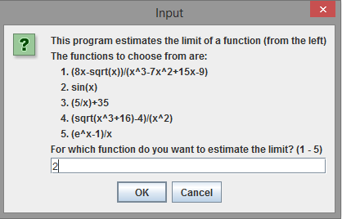 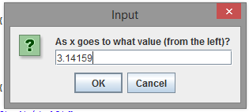

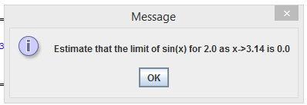 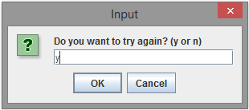

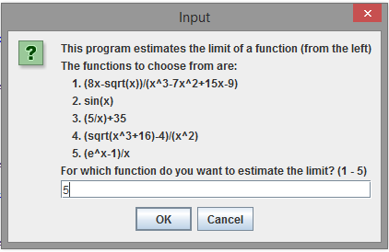 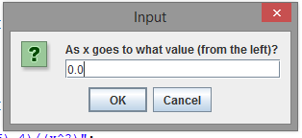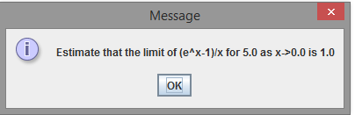

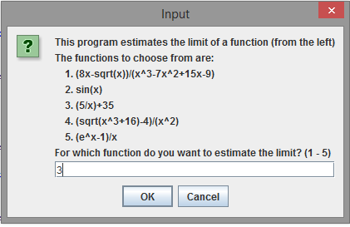 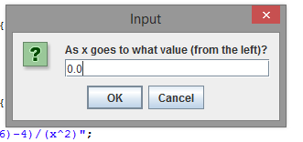

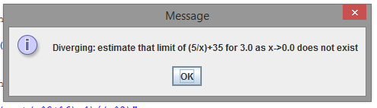

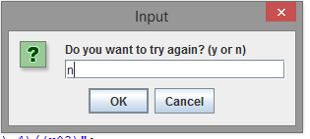

**Function.Java Code**

/**

*The purpose of this class is to compute different function values for a real value x

*@Author Josue Ponce

*@Date 3/19/18

*@version 1.0

*/

**public** **class** **Function**{

/**

* Holds the function's value.

*/

**private** **double** FUNCTION_CHOICE;

/**

*Holds the Description of the function

*/

**private** String description;

/**

* Regular constructor that initializes the choice of the function to compute

* @param fnChoice

*/

**public** **Function**(**int** fnChoice){

FUNCTION_CHOICE=(**double**)fnChoice;

setDescription();

}

/**

* returns the function choice.

* @return the function of choice.

*/

**public** **int** **getFunctionChoice**(){

**return** (**int**)FUNCTION_CHOICE;

}

/**

* Sets the description of a function.

*/

**public** **void** **setDescription**(){

**if**(FUNCTION_CHOICE ==**1.0**) {

description="(8x-sqrt(x))/(x^3-7x^2+15x-9)";

}

**else** **if** (FUNCTION_CHOICE ==**2.0**) {

description="sin(x)";

}

**else** **if** (FUNCTION_CHOICE ==**3.0**) {

description="(5/x)+35";

}

**else** **if** (FUNCTION_CHOICE ==**4.0**) {

description="(sqrt(x^3+16)-4)/(x^2)";

}

**else** **if** (FUNCTION_CHOICE == **5.0**) {

description="(e^x-1)/x";

}

}

/**

* returns the description with function choice

* @param fnChoice

* @return the description of the chosen function.

*/

**public** **static** String **getDescription**(**int** fnChoice){

**if**(fnChoice ==**1**) {

**return** "(8x-sqrt(x))/(x^3-7x^2+15x-9)";

}

**else** **if** (fnChoice ==**2**) {

**return** "sin(x)";

}

**else** **if** (fnChoice ==**3**) {

**return** "(5/x)+35";

}

**else** **if** (fnChoice ==**4**) {

**return** "(sqrt(x^3+16)-4)/(x^2)";

}

**else** **if** (fnChoice == **5**) {

**return** "(e^x-1)/x";

}

**else**

**return** "";

}

/**

*@return the description string

*/

**public** String **toString**(){

**return** description +" for "+FUNCTION_CHOICE;

}

/**

* evaluates the function value for the parameter x

* @param x

* @return the calculated results based on the function choice.

*/

**public** **double** **computeFunctionValue**( **double** x){

**if**(FUNCTION_CHOICE==**1.0**)

**return** (**8**\*x-Math.sqrt(x))/(Math.pow(x,**3**)-**7**\*Math.pow(x,**2**)+**15**\*x-**9**);

**else** **if** (FUNCTION_CHOICE ==**2.0**)

**return** Math.sin(x);

**else** **if** (FUNCTION_CHOICE ==**3.0**)

**return** (**5**/x)+**35**;

**else** **if** (FUNCTION_CHOICE ==**4.0**)

**return** (Math.sqrt(Math.pow(x,**3**)+**16**)-**4**)/Math.pow(x,**2**);

**else** **if** (FUNCTION_CHOICE == **5.0**)

**return** (Math.pow(Math.E,x)-**1**)/x;

**else**

**return** **0.0**;

}

}