Lab 02 RMD, and some more ggplot (Yeaju Diana Kim)
Diana Kim
09/17/2025
Table of Contents

PSY 503: Lab 02: R markdown, and ggplot
09/17/2025
For Lab 2, please carry out the following tasks. Make sure to install/load any relevant libraries not explictly specified below. At the end of the lab, please submit the final rmd file (important) along with other files you generated (QMD, PDF,HTML, docx, and r)

Q0. Setup Tasks
Install the package tinytex into your system using the following commented command.
#install.packages('tinytex')
#tinytex::install_tinytex()
#if you need to uninstall TinyTeX, run tinytex::uninstall_tinytex()
library(tidyverse)
Tinytex, is needed for creating pdf reports via R-markdown.

Q1. Task with YAML Header (A)
- Edit the YAML header / metadata to reflect your name.

Q2. Task with Markdown Formula
- During Monday’s class, we learned that the sum of squared deviations from mean for a given set of data SS is given by
$$SS=\sum_{i=1}^{N}{{\left(\overset{‾}{X}−x_{i}\right)}^{2}}$$
- Knowing this above definition of SS (in latex formatting), similarly, produce the full formula for variance below? Make sure it is in Bold. (Hint: Variance when we are working with a population = $SS/N$, and Variance of a sample is $SS/N−1$)
$$SS/N=\sum_{i=1}^{N}{{\left(\overset{‾}{X}−x_{i}\right)}^{2}}/N$$

Q3. Task with Rcode and chunks (functions)
Below is a function that computes sum of squares, and two defined vectors
compute_SS <- function(x) {
n <- length(x)
mean_x <- mean(x)
sum_squared_diff <- sum((x - mean_x)^2)
return(sum_squared_diff)
}
# These vectors are a sample from a population.
vector_a <- c(5, 5, 5, 5, 5)
vector_b <- c(1, 3, 5, 7, 9)
Create a new R chunk below (shortcut = Option + CMD + I), and use the defined function to calculate the variance of both vector_a, and vector_b. Print them
compute_SS(vector_a)
## [1] 0
compute_SS(vector_b)
## [1] 40

Q4. Descriptives (dplyr) and Visualization tasks
In the previous lab, we worked with a data from DataSaurus. We visualized y against x for different values of the column named “dataset”. Now, carry out this visualization but with the following changes.
- show all the different visualizations within a single graph using facets in ggplot
- make sure that each dataset is colored differently
- great, now a journal has accepted your work for publication. but they charge $10,000 for colored graphs. to save your lab some resources, redo the graph so that the colors are different shades of grey. (Hint: look at scale_colour_grey)
- you realize that given so many different conditions/datasets, it’s a bit harder to map the color to condition. to make it easy for the reader and to be robust against bad print quality, change the shape of the plotted points based on the condition. (Hint: try scale_shape_manual(values=c(3, 16, 17)) or choose an appropriate shape palette)
- out of curiosity, you also create a new plot in a different direction: this doesn’t plot data points for each condition but just creates a boxplot for each dataset (no need to facet). what does this plot look like? => a pile of boxes.. it looks quite messy
library(datasauRus)
lab2_datasaurus<- datasaurus_dozen
# a, b
ggplot(lab2_datasaurus, aes(x = x, y = y, color = dataset)) +
geom_point() +
facet_wrap(~ dataset)
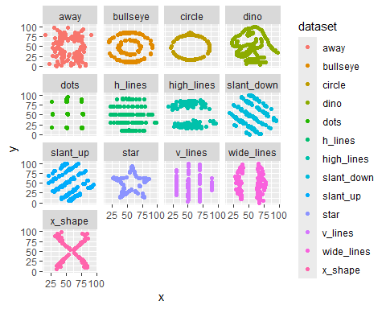
# c
ggplot(lab2_datasaurus, aes(x = x, y = y, color = dataset)) +
geom_point() +
facet_wrap(~ dataset) +
scale_colour_grey()
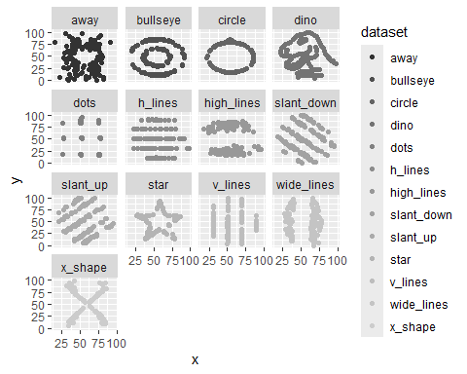
# d
ggplot(lab2_datasaurus, aes(x = x, y = y, shape = dataset)) +
geom_point() +
facet_wrap(~ dataset) +
scale_shape_manual(values=c(1:13))
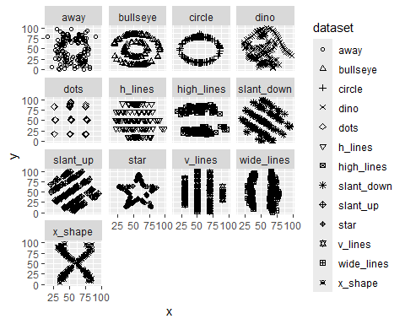
# e
ggplot(lab2_datasaurus, aes(x = x, y = y, group = dataset)) +
geom_boxplot()
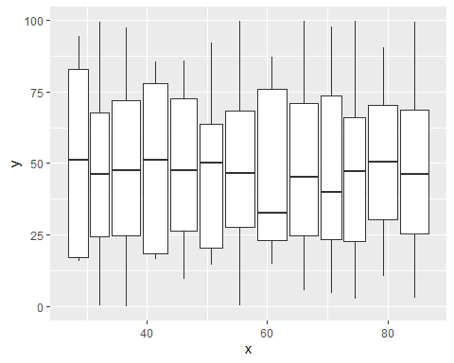
You’ve learned that looking at the data is important. But summary statistics can be useful too. The following dplyr-based code computes the mean of lab2_datasaurus for each dataset within it, for the variable x and stores it into a new dataframe.
mean_datasaurus <- lab2_datasaurus %>%
group_by(dataset) %>%
summarize(
mean_x = mean(x)
)
print (mean_datasaurus)
## # A tibble: 13 × 2
## dataset mean_x
## <chr> <dbl>
## 1 away 54.3
## 2 bullseye 54.3
## 3 circle 54.3
## 4 dino 54.3
## 5 dots 54.3
## 6 h_lines 54.3
## 7 high_lines 54.3
## 8 slant_down 54.3
## 9 slant_up 54.3
## 10 star 54.3
## 11 v_lines 54.3
## 12 wide_lines 54.3
## 13 x_shape 54.3
- produce a dataframe that has not just mean of x, but also the following summary statistics in appropriately named columns:
  - mean of y
  - median of x
  - median of y
  - variance of x
  - variance of y
  - correlation between x and y (found using the cor())
vars_datasaurus <- lab2_datasaurus %>%
group_by(dataset) %>%
summarize(
mean_x = mean(x),
mean_y = mean(y),
median_y = median(y),
var_x = var(x),
var_y = var(y),
cor_xy = cor(x,y)
)
print (vars_datasaurus)
## # A tibble: 13 × 7
## dataset mean_x mean_y median_y var_x var_y cor_xy
## <chr> <dbl> <dbl> <dbl> <dbl> <dbl> <dbl>
## 1 away 54.3 47.8 47.5 281. 726. -0.0641
## 2 bullseye 54.3 47.8 47.4 281. 726. -0.0686
## 3 circle 54.3 47.8 51.0 281. 725. -0.0683
## 4 dino 54.3 47.8 46.0 281. 726. -0.0645
## 5 dots 54.3 47.8 51.3 281. 725. -0.0603
## 6 h_lines 54.3 47.8 50.5 281. 726. -0.0617
## 7 high_lines 54.3 47.8 32.5 281. 726. -0.0685
## 8 slant_down 54.3 47.8 46.4 281. 726. -0.0690
## 9 slant_up 54.3 47.8 45.3 281. 726. -0.0686
## 10 star 54.3 47.8 50.1 281. 725. -0.0630
## 11 v_lines 54.3 47.8 47.1 281. 726. -0.0694
## 12 wide_lines 54.3 47.8 46.3 281. 726. -0.0666
## 13 x_shape 54.3 47.8 39.9 281. 725. -0.0656
What do you observe? => I don’t see much variance in each computed variable. That is, each column has mostly similar values in ther rows.

Q5. Combining two sources of data in a graph
Now let’s try overlaying the (mean of x, mean of y) point for the different datasets on this graph. To distinguish it from the other datapoints you can make this overlaid plot larger in size. (Hint: remember that ggplot works with layers. I am asking you add a new layer here overlaid on the previous ones)
ggplot(lab2_datasaurus, aes(x = x, y = y, color = dataset)) +
geom_point() +
facet_wrap(~ dataset) +
scale_shape_manual(values=c(1:13)) +
geom_point(data = vars_datasaurus, aes(x = mean_x, y = mean_y), color = "blue", size = 3)
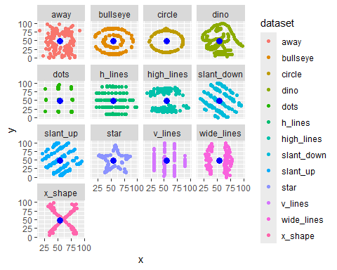

Q6. RMD vs. Quarto (QMD)
Open a new Quarto document. Attempt translating from this document into Quarto the first 3 markdown and code chunks of this document. What differences do you notice?
=> I don’t actually see much difference between the two..?? The header looks a little different??

Q7. Tasks with YAML Header (B)
You know that the output type is indicated in the YAML header. By changing the header or using the knit dropdown, create outputs in Pdf, html, and docx.

Q8. Extracting the code back to r
On some occasions you have an r markdown file, but you may want to get ride of the markdown and yaml, and extract just the r-code. This is possible by using the following command
knitr::purl(“filename.Rmd”)
#knitr::purl("Lab_02_YeajuDianaKim.Rmd")
As an exercise, use this command to save your current rmd file contents as an R file.

End of lab

