Stroke Classification and SHAP Explanation
  - WQF7009 Explainable Artificial Intelligence: Assignment 1 Report
Exploratory data analysis, local and global explanations, audience communication, and a second black box model.
Student name: Yeap Jie Shen
Student ID: 22062548
Course and programme: WQF7009 Explainable Artificial Intelligence; Master of Artificial Intelligence
Lecturer: Prof. Dr. Loo Chu Kiong
Submission date: 8 November 2026
Repository URL and commit: https://github.com/YeapJieShen/WQF7009-Assignment1, commit bdc8d63

Abstract
This report applies SHapley Additive exPlanations (SHAP) to stroke classifiers trained on the Kaggle Stroke Prediction dataset (5,110 patients, 249 with a recorded stroke). The provided pipeline (one-hot encoding, zero-filled missing BMI, random oversampling and a 100-tree random forest) was reproduced and modified in two respects: missing BMI was imputed with the training median and indicated by a missingness flag, and the decision threshold was set to 0.09 by maximising Youden’s J over 5-fold cross-validated training scores. On 1,022 held-out patients (50 strokes), the modified forest achieved a recall of 0.58, a precision of 0.11 and an area under the receiver operating characteristic curve (ROC AUC) of 0.75, compared with 4 detected strokes for the provided model at the default threshold of 0.5. TreeExplainer, with 100 training patients as the background, identified age as the dominant feature, with approximately four times the mean absolute attribution of the next variable, and showed that the provided model used zero-filled BMI as a stroke indicator. For a representative true positive (Patient ID 43717), glucose, age and smoking raised the predicted probability from a base value of 0.08 to 0.16. A multilayer perceptron (MLP) explained with Deep SHAP achieved a higher ROC AUC (0.79) and produced the same three leading attributions for this patient. The principal limitation is the data: the dataset is small, retrospective and undocumented, so the scores support ranking but not risk estimation.

Report map
Assignment component | Report location
Task 1 Exploratory data analysis | Section 1, Section 2 and Appendix A
Task 2 Create a SHAP explainer | Section 3
Task 3 Local force plot | Section 4
Task 4 Global summary plot | Section 5
Task 5 Three audience slides | Section 6
Task 6 Deep SHAP or Kernel SHAP | Section 7 and Section 8
References, reproducibility and checklist | Section 9
Supplementary figures | Appendix A

1 Study Context and Dataset

1.1 Background and objective
Stroke was the second leading cause of death worldwide in 2019, accounting for approximately 11% of all deaths (World Health Organization [WHO], 2020). A classifier that flags stroke-like records is of limited clinical use unless the basis of each flag can be inspected. SHapley Additive exPlanations (SHAP; Lundberg & Lee, 2017) address this by decomposing each prediction into additive feature contributions.
The objectives of this work are:
- To reproduce and improve the provided stroke classifier and evaluate it on a held-out test set.
- To explain its predictions at the local and global level with SHAP.
- To communicate one explanation to a data scientist, a clinician and a patient.
- To assess whether the explanation is consistent for a different black-box model.
Outcome definition. stroke = 1 denotes a recorded history of stroke and stroke = 0 its absence. The dataset has no follow-up period; model outputs are therefore classification scores, not estimates of future stroke risk.

1.2 Data source and variables
- Dataset: Stroke Prediction Dataset (fedesoriano, 2021), retrieved from Kaggle on 2 November 2026.
- File: healthcare-dataset-stroke-data.csv, 5,110 rows × 12 columns (SHA-256 644d473b…707420).
- Population, collection period and provenance: undocumented; the source is stated to be confidential.
Table 1. Data dictionary. Column names and category labels verified against the file.
Attribute | Meaning or values (as in the file) | Analytical role
id | Unique patient identifier | Index for traceability; not a predictor
gender | Male, Female, Other (1 patient) | Categorical predictor (one-hot)
age | Years, 0.08–82 | Numeric predictor
hypertension | 0 = no; 1 = yes | Binary predictor
heart_disease | 0 = no; 1 = yes | Binary predictor
ever_married | No, Yes | Categorical predictor (one-hot)
work_type | children, Govt_job, Never_worked, Private, Self-employed | Categorical predictor (one-hot)
Residence_type | Rural, Urban | Categorical predictor (one-hot)
avg_glucose_level | Average blood glucose, 55.1–271.7; units not stated, mg/dL assumed | Numeric predictor
bmi | Body mass index in kg/m², 10.3–97.6; 201 values missing (N/A) | Numeric predictor
smoking_status | formerly smoked, never smoked, smokes, Unknown | Categorical predictor (one-hot)
stroke | 0 = no recorded stroke; 1 = recorded stroke | Target

The category given as “Govt_jov” in the assignment brief appears as Govt_job in the file. The smoking status Unknown (30.2% of patients) denotes unavailable information and is retained as a separate category rather than merged with “never smoked”.

2 Task 1 Exploratory Data Analysis (EDA)

2.1 Code download and execution
- Source code: obtained as xai-series-master.zip (deepfindr, 2021) and imported into the scripts/ directory of the repository YeapJieShen/WQF7009-Assignment1; this report refers to commit bdc8d63.
- Environment: Python 3.14.10 on Windows 11 (conda), with pandas 2.3.3, NumPy 2.5.4, scikit-learn 1.9.1, imbalanced-learn 0.14.2, SHAP 0.54.1, PyTorch 2.14.1, Matplotlib 3.11.2 and SciPy 1.18.1; dependencies are declared in pyproject.toml.
- Execution: python 00_data_exploration.py, run from scripts/ by notebook 01 on 7 November 2026; exit code 0, first output line (5110, 12). Figures are written to figures/.
- Modifications required: two changes to the shared utils.py: the data path is resolved from the repository root, and one-hot columns are cast to 0/1 integers, as pandas 2 returns booleans. The script is otherwise unchanged; notebook 01 extends the analysis.

2.2 Data quality and descriptive results
Table 2. Data-quality summary. Percentages refer to all 5,110 patients unless stated otherwise.
Check or statistic | Observed result | Action or interpretation
Rows and columns | 5,110 rows; 12 columns | One row per patient; id excluded from the predictors
Duplicates | 0 duplicate IDs; 0 duplicate records (excluding id) | None removed
Missing values | bmi: 201 (3.9%); smoking_status = Unknown: 1,544 (30.2%); all other columns: 0 (0%) | Missing BMI is associated with a 4.7-fold stroke share (Figure 3); Unknown smoking retained as a category
Stroke classes | No stroke: 4,861 (95.1%); stroke: 249 (4.9%) | Imbalance of approximately 20 : 1; evaluation by recall, precision and area under the ROC curve (ROC AUC) rather than accuracy
Age (years) | Mean 43.2 ± 22.6; median 45.0 (IQR 25.0–61.0); range 0.08–82 | Plausible; 856 patients (16.8%) under 18
Average glucose (mg/dL) | Mean 106.1 ± 45.3; median 91.9 (IQR 77.2–114.1); range 55.1–271.7 | Bimodal; 627 values (12.3%) above 169 are IQR outliers forming a diabetic-range mode; retained
BMI (kg/m²) | Mean 28.9 ± 7.9; median 28.1 (IQR 23.5–33.1); range 10.3–97.6 | 110 values (2.2% of recorded) above 47.5 are IQR outliers but physiologically possible; retained
Rare categories | gender = Other: 1 (<0.1%); work_type = Never_worked: 22 (0.4%), none with a stroke; all other categories ≥ 5% | Retained, so that the 80/20 split matches the provided baseline; too sparse to affect the model

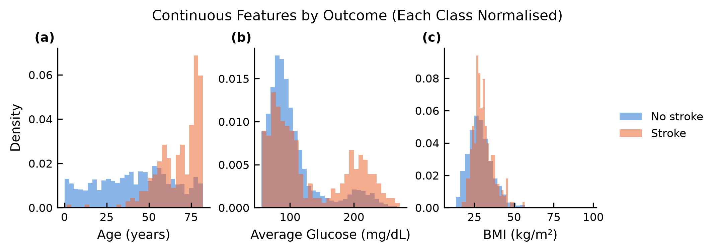
Figure 1. Continuous features by outcome. Class-normalised density histograms of (a) age, (b) average glucose and (c) BMI for patients without (blue, n = 4,861) and with a recorded stroke (orange, n = 249). Strokes concentrate above approximately 50 years and in the high-glucose mode; the BMI distributions largely overlap.
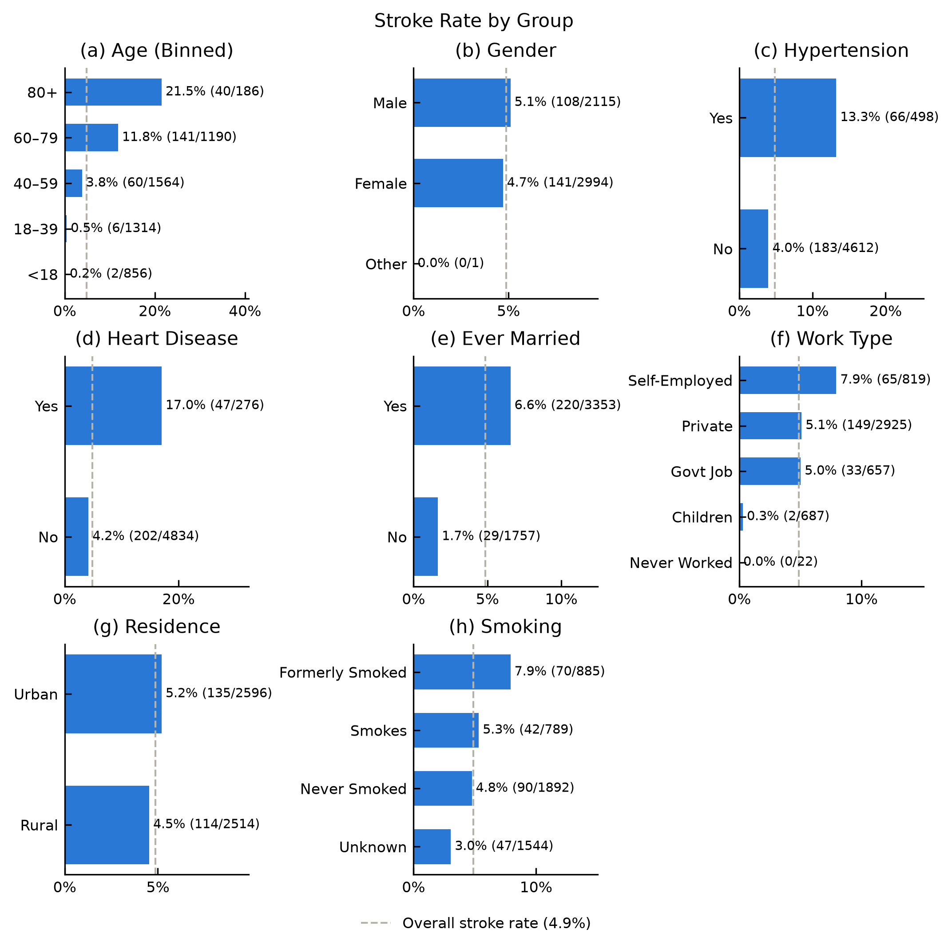
Figure 2. Stroke rate by group. Proportion of patients with a recorded stroke per category, annotated with the rate and strokes / patients; the dashed line marks the overall rate (4.9%). The rate varies most with age, from 0.2% under 18 to 21.5% at 80 and over. Hypertension (13.3% vs 4.0%) and heart disease (17.0% vs 4.2%) are associated with 3–4-fold rates; gender and residence show little difference.
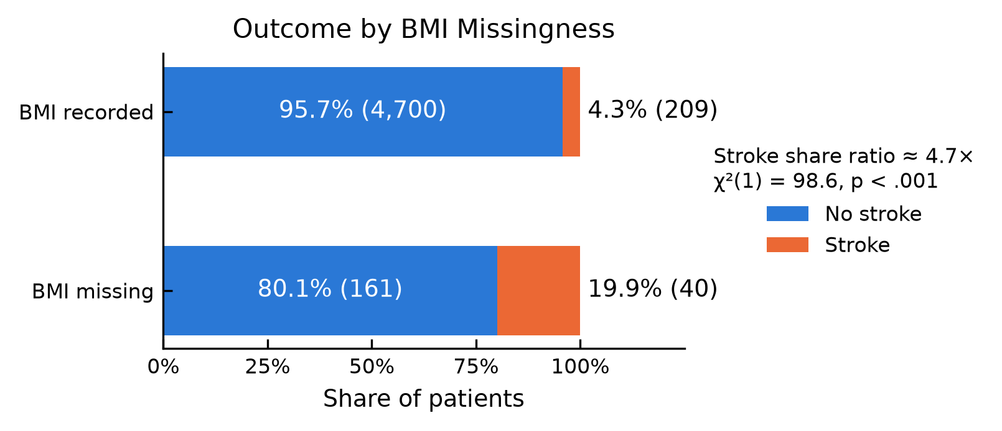
Figure 3. Outcome by BMI missingness. Proportion of patients with and without a recorded stroke by BMI availability. Strokes account for 19.9% of the 201 patients with missing BMI and 4.3% of the remainder (χ²(1) = 98.6, p < .001).

2.3 Interpretation and preprocessing decisions
Three findings inform the modelling; all are associations rather than causal effects.
- Age is the dominant correlate. Age has the strongest association with stroke (point-biserial r = 0.245; Figure A1) and the widest variation in stroke rate (Figure 2). Marital status and work type act largely as proxies for age: the median age is 54 for ever-married and 18 for never-married patients (Figure A2), with a Spearman correlation of ρ = 0.66 (Figure A3). Attribution may therefore be distributed across these features.
- Hypertension and heart disease are associated with stroke independently of age. Within age bands from 40 years upward, either condition is associated with a 1.3–2.1-fold stroke rate (Figure A4).
- Missingness is informative. Patients with missing BMI form a high-prevalence group (Figure 3), and the provided zero imputation creates a physiologically impossible value that a model can exploit as a stroke indicator. Unknown smoking status is also age-dependent: these patients have a median age of 23, and 44% are under 18 (Figure A5).
Modelling plan. The provided split and model serve as the baseline. Missing BMI is imputed with the training median and flagged; the decision threshold is tuned for the class imbalance; and models are compared on recall, precision and ROC AUC. Outliers are retained as physiologically plausible. Tree-based splits depend only on the ordering of feature values, so the random forest is invariant to feature scale and unaffected by extreme magnitudes; the neural network (a multilayer perceptron, MLP; Section 7) is scale-sensitive, and its inputs are standardised with the training mean and standard deviation. Two strokes in children (aged 1.3 and 14, without risk factors) are retained and noted as possible label noise.
Leakage control. The 80/20 split precedes all fitting, and the test set is used once, for final evaluation. The BMI median, oversampler and scaler are fitted on training data only and, within cross-validation, refitted on each fold’s training partition. id is not used as a predictor; stroke is the target.

3 Task 2 Model and SHAP Explainer

3.1 Model development
- Classifier: the provided RandomForestClassifier (100 trees, scikit-learn defaults) preceded by RandomOverSampler. It is retained so that the baseline reproduces the provided code, and because SHAP values can be computed exactly for tree ensembles.
- Predictors: 10 input variables, of which 5 categorical variables are one-hot encoded (21 columns); the improved pipeline adds bmi_missing (22 columns).
- Seeds: the provided code does not seed the oversampler or the forest; both use random_state=2021 here.
The data are partitioned into 4,088 training and 1,022 test patients (80/20, random_state=2021). Both partitions match the overall prevalence (4.9%), so stratification was not required. In the training data, stroke patients are randomly duplicated until both classes are equal in size; no hyperparameters were tuned. The decision threshold maximises Youden’s J statistic (Youden, 1950):
$$J=\frac{TP}{TP+FN}+\frac{TN}{TN+FP}−1$$
equivalently, sensitivity + specificity − 1. It is computed from 5-fold stratified cross-validation on the training set: each fifth of the 4,088 training patients is scored by a model fitted on the other four fifths, and the pooled scores are used. The resulting threshold is 0.09.
Table 3. Pipelines. Both pipelines share the test set and differ only in BMI handling and threshold.
Step | Baseline (deepfindr, 2021) | Improved
Missing BMI (201 rows) | Filled with 0 | Training median (27.9) plus a bmi_missing flag
Split, oversampling, model | 80/20; RandomOverSampler; 100-tree random forest | Same as baseline
Decision threshold | 0.5 | 0.09 (maximum Youden’s J, training set only)

Table 4. Test-set performance. The average precision of a random ranking equals the prevalence (0.05). ROC AUC and average precision are threshold-independent.
Test metric (50 strokes, 1,022 patients) | Baseline, 0.5 | Improved, 0.5 | Improved, 0.09
Accuracy / balanced accuracy | 0.94 / 0.53 | 0.94 / 0.54 | 0.76 / 0.67
Recall / precision / F1 (stroke = 1) | 0.08 / 0.25 / 0.12 | 0.10 / 0.26 / 0.14 | 0.58 / 0.11 / 0.19
ROC AUC / average precision | 0.73 / 0.12 | 0.75 / 0.14 | 0.75 / 0.14
TN / FP / FN / TP | 960 / 12 / 46 / 4 | 958 / 14 / 45 / 5 | 747 / 225 / 21 / 29

Accuracy is uninformative under this imbalance: a constant “no stroke” prediction attains 95.1%, exceeding the baseline. At the default threshold of 0.5, both forests fail to detect 45–46 of the 50 strokes. Oversampling copies the 199 training stroke patients many times over, and fully grown trees learn these copies almost exactly, so the stroke cases end up in small leaves that hold only those patients. A new stroke patient rarely matches them closely; most trees therefore place the patient in large leaves made up mostly of non-stroke patients, and the averaged score rarely exceeds 0.5. The BMI modification raises ROC AUC from 0.73 to 0.75, and the tuned threshold detects 29 strokes at the cost of 225 false positives (Figure 4). The scores are poorly calibrated: in the highest-scoring quintile, the mean score is approximately 0.26 against an observed stroke proportion of 0.12 (Brier score, the mean squared error of the scores, 0.052; Figure A6). Scores are therefore used for ranking only.
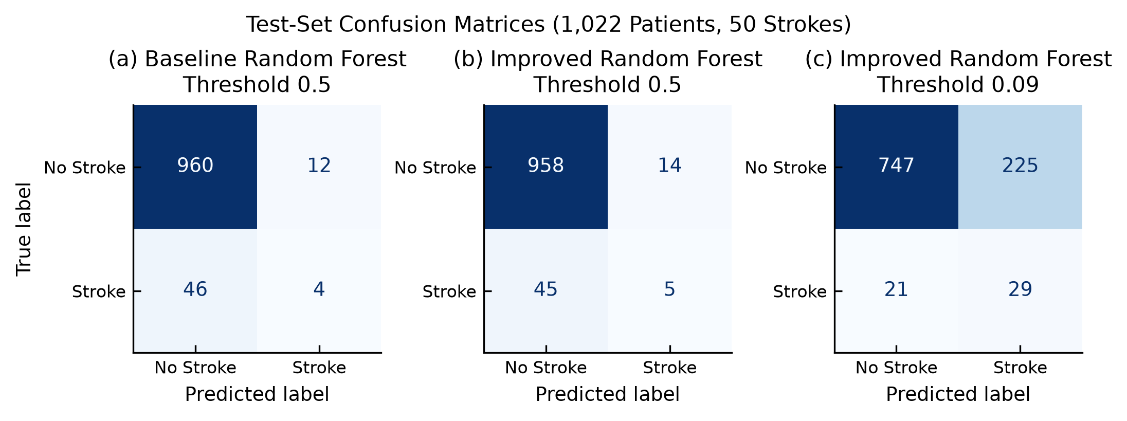
Figure 4. Test-set confusion matrices. 1,022 test patients, 50 with a recorded stroke: (a) baseline random forest at 0.5, (b) improved random forest at 0.5, (c) improved random forest at the tuned threshold of 0.09. Only (c) detects more than 5 strokes.

3.2 Explainer specification
- Explainer: shap.TreeExplainer (Lundberg et al., 2020), which computes exact SHAP values for tree ensembles (SHAP 0.54.1, scikit-learn 1.9.1). It is applied to the fitted forest, the final pipeline step, on the 22-column improved input; the oversampler acts during fitting only.
- Output explained: predicted probability of stroke, class index 1 (rf.classes_[1] == 1 is asserted).
- Background: interventional (a feature is “removed” by substituting values from reference patients); 100 training patients sampled before oversampling (random_state=2021); base value 0.081.
- Patients explained: all 1,022 test patients.
Attributions are computed directly on the probability scale, not the log-odds scale, so that for each patient they sum exactly to the predicted probability:
$$f(x)=φ_{0}+\sum_{j=1}^{M}{φ_{j}}$$
where f(x) is the predicted probability, φ₀ the base value (the mean prediction over the background) and φⱼ the attribution of feature j, with M = 22. SHAP’s default for trees (tree path-dependent) instead uses the oversampled training data, half of which are strokes, as its reference, giving a base value of 0.50; against this reference, all leading attributions of a typical stroke patient become negative. The interventional background of real patients is therefore preferred.

3.3 Verification and interpretation
Table 5. Explainer verification.
Verification item | Recorded evidence
Input feature names, order and dimensions match | 22 columns in the order of rf.feature_names_in_ (asserted); SHAP array 1,022 × 22
Correct class and output scale selected | Class index 1 (stroke = 1); probability scale
Base value + sum of SHAP values | Patient ID 43717: 0.081 + 0.054 + 0.033 + 0.017 − 0.025 (other 19 features) = 0.16
Model output and reconstruction residual | Patient ID 43717: output 0.16, residual < 10⁻⁶. Test set: 1,015 of 1,022 patients have residuals < 10⁻⁶; the remaining 7 have residuals of at most 0.03 (baseline: 12 patients, at most 0.02). Input rounding was excluded as a cause; the discrepancy is attributed to SHAP’s interventional implementation. None of the 7 patients is used as an example.

A positive attribution increases the predicted probability relative to the base value, and a negative attribution decreases it. Attributions characterise the model’s use of each feature relative to the background; they do not establish causal effects on stroke.

4 Task 3 Local Explanation Using a Force Plot

4.1 Selected held-out case
The case was selected by a rule fixed before any explanation was inspected: among true positives with a recorded BMI, the patient with the median predicted probability, i.e. a representative rather than an extreme detection. One patient from each remaining confusion-matrix cell (false negative, false positive and true negative) is shown in Figures A7–A9.
- Row reference: Patient ID 43717 (dataset id; test set).
- Actual class: 1 (recorded stroke). Predicted class: 1 at the 0.09 threshold (true positive).
- Score: 0.16, predicted probability of stroke (uncalibrated). Base value: 0.081 on the same scale.
- Patient: male, 57 years, hypertension, no heart disease, ever married, private sector, urban residence, average glucose 212.08 mg/dL, BMI 44.2, current smoker.
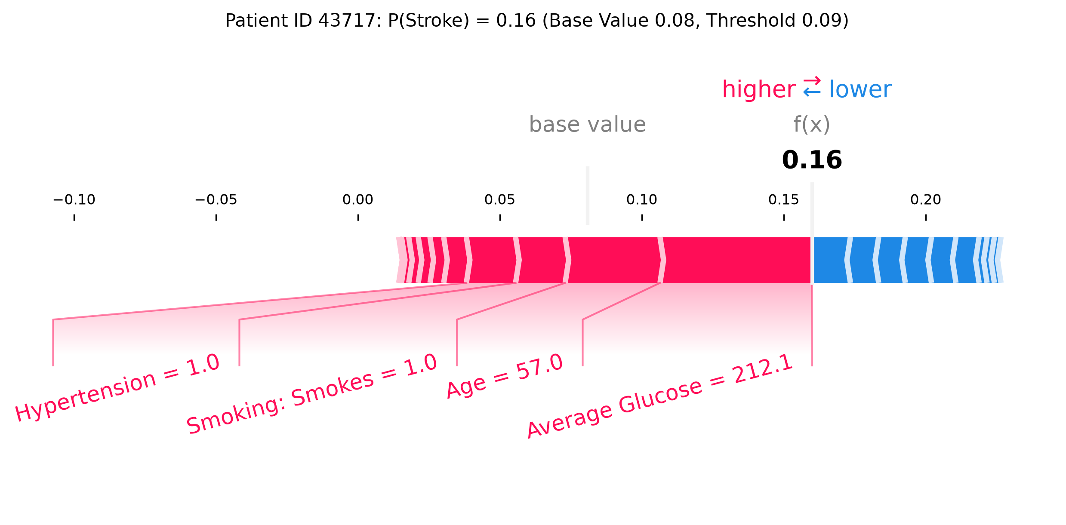
Figure 5. Local SHAP force plot, Patient ID 43717. Improved random forest; output is the predicted probability of stroke. Red features increase the output from the base value (0.08, the mean over the 100 background patients) to f(x) = 0.16; blue features decrease it. Only contributions of at least 10% of the total effect are labelled. Average glucose and age contribute most.

4.2 Feature contributions
Table 6. Main-case contributions. The SHAP values sum to the output minus the base value (0.16 − 0.08).
Feature | Patient value | SHAP value | Direction for stroke output
Average glucose | 212.08 mg/dL | +0.054 | Increases
Age | 57 years | +0.033 | Increases
Smoking: smokes | Yes | +0.017 | Increases
Remaining 19 features combined | — | −0.025 | Net decrease (includes hypertension +0.017)

4.3 Interpretation of this prediction
The predicted probability increases from the base value of 0.08 to 0.16, above the 0.09 threshold. The largest positive contributions are from average glucose (212 mg/dL, +0.054), which lies in the diabetic-range mode identified in the EDA, and age (57 years, +0.033), followed by current smoking and hypertension (+0.017 each). No feature contributes a substantial decrease: the largest negative contribution is from BMI (44.2, approximately −0.01), and the remaining 19 features jointly contribute −0.025.
The explanation is clinically plausible: glucose, age, smoking and hypertension are associated with stroke in the EDA and are established risk factors. BMI is recorded for this patient, so the missingness signal does not contribute. The small negative contribution of a BMI of 44.2 is clinically counter-intuitive and reflects the weak and inconsistent BMI effect learned by the forest (Section 5). The score of 0.16 is not a 16% risk. A false negative would leave a stroke patient unflagged, as occurred for 21 of the 50 test strokes; a false positive would prompt an unnecessary review. The explanation describes model behaviour and constitutes neither a diagnosis nor a treatment recommendation.

5 Task 4 Global Explanation Using a Summary Plot

5.1 Population and plotting settings
- Model and output: improved random forest; predicted probability of stroke.
- Sample: all 1,022 test patients (50 strokes), without subsampling; beeswarm layout seeded with 2021.
- Displayed: the 12 encoded columns with the largest mean absolute SHAP value (mean |SHAP|).
The beeswarm (Figure 6) displays encoded columns, since a one-hot group has no single value for the colour scale. Figure 7 and Table 7 rank the original variables: the signed attributions of each variable’s one-hot columns are summed per patient before the absolute value is averaged. BMI Missing is reported separately from BMI.
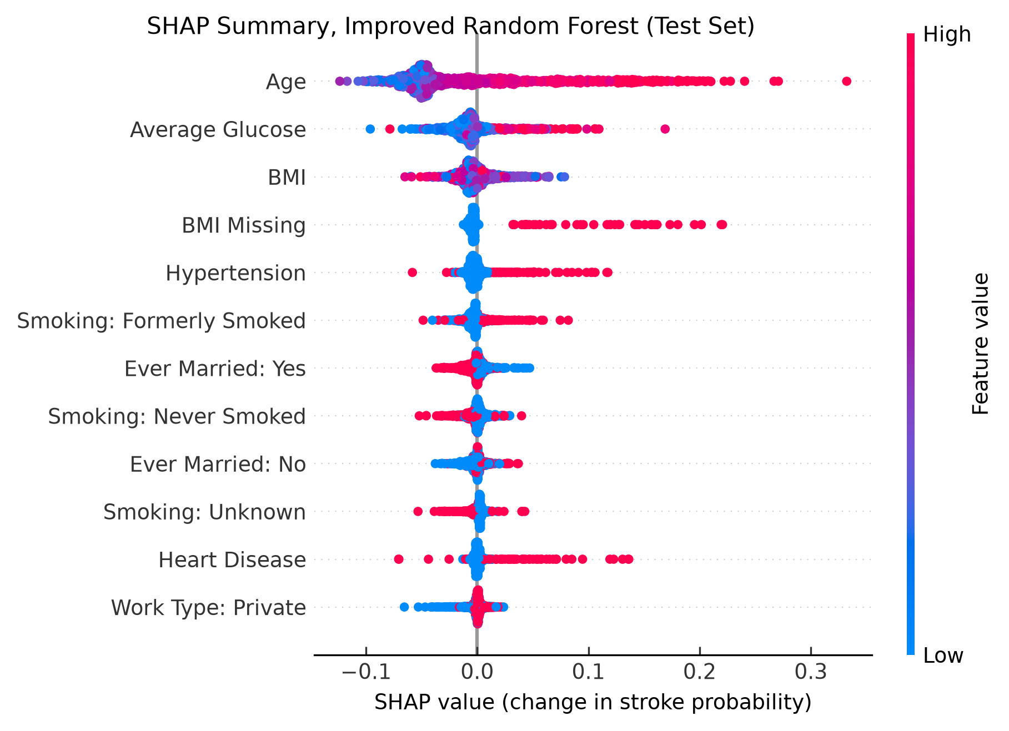
Figure 6. Global SHAP summary plot, improved random forest. 1,022 test patients, one point per patient; x-axis: SHAP value (change in predicted stroke probability); colour: feature value (red = high or yes, blue = low or no); features ordered by mean |SHAP|. Older age increases and younger age decreases the output; missing BMI, hypertension and heart disease increase it when present.
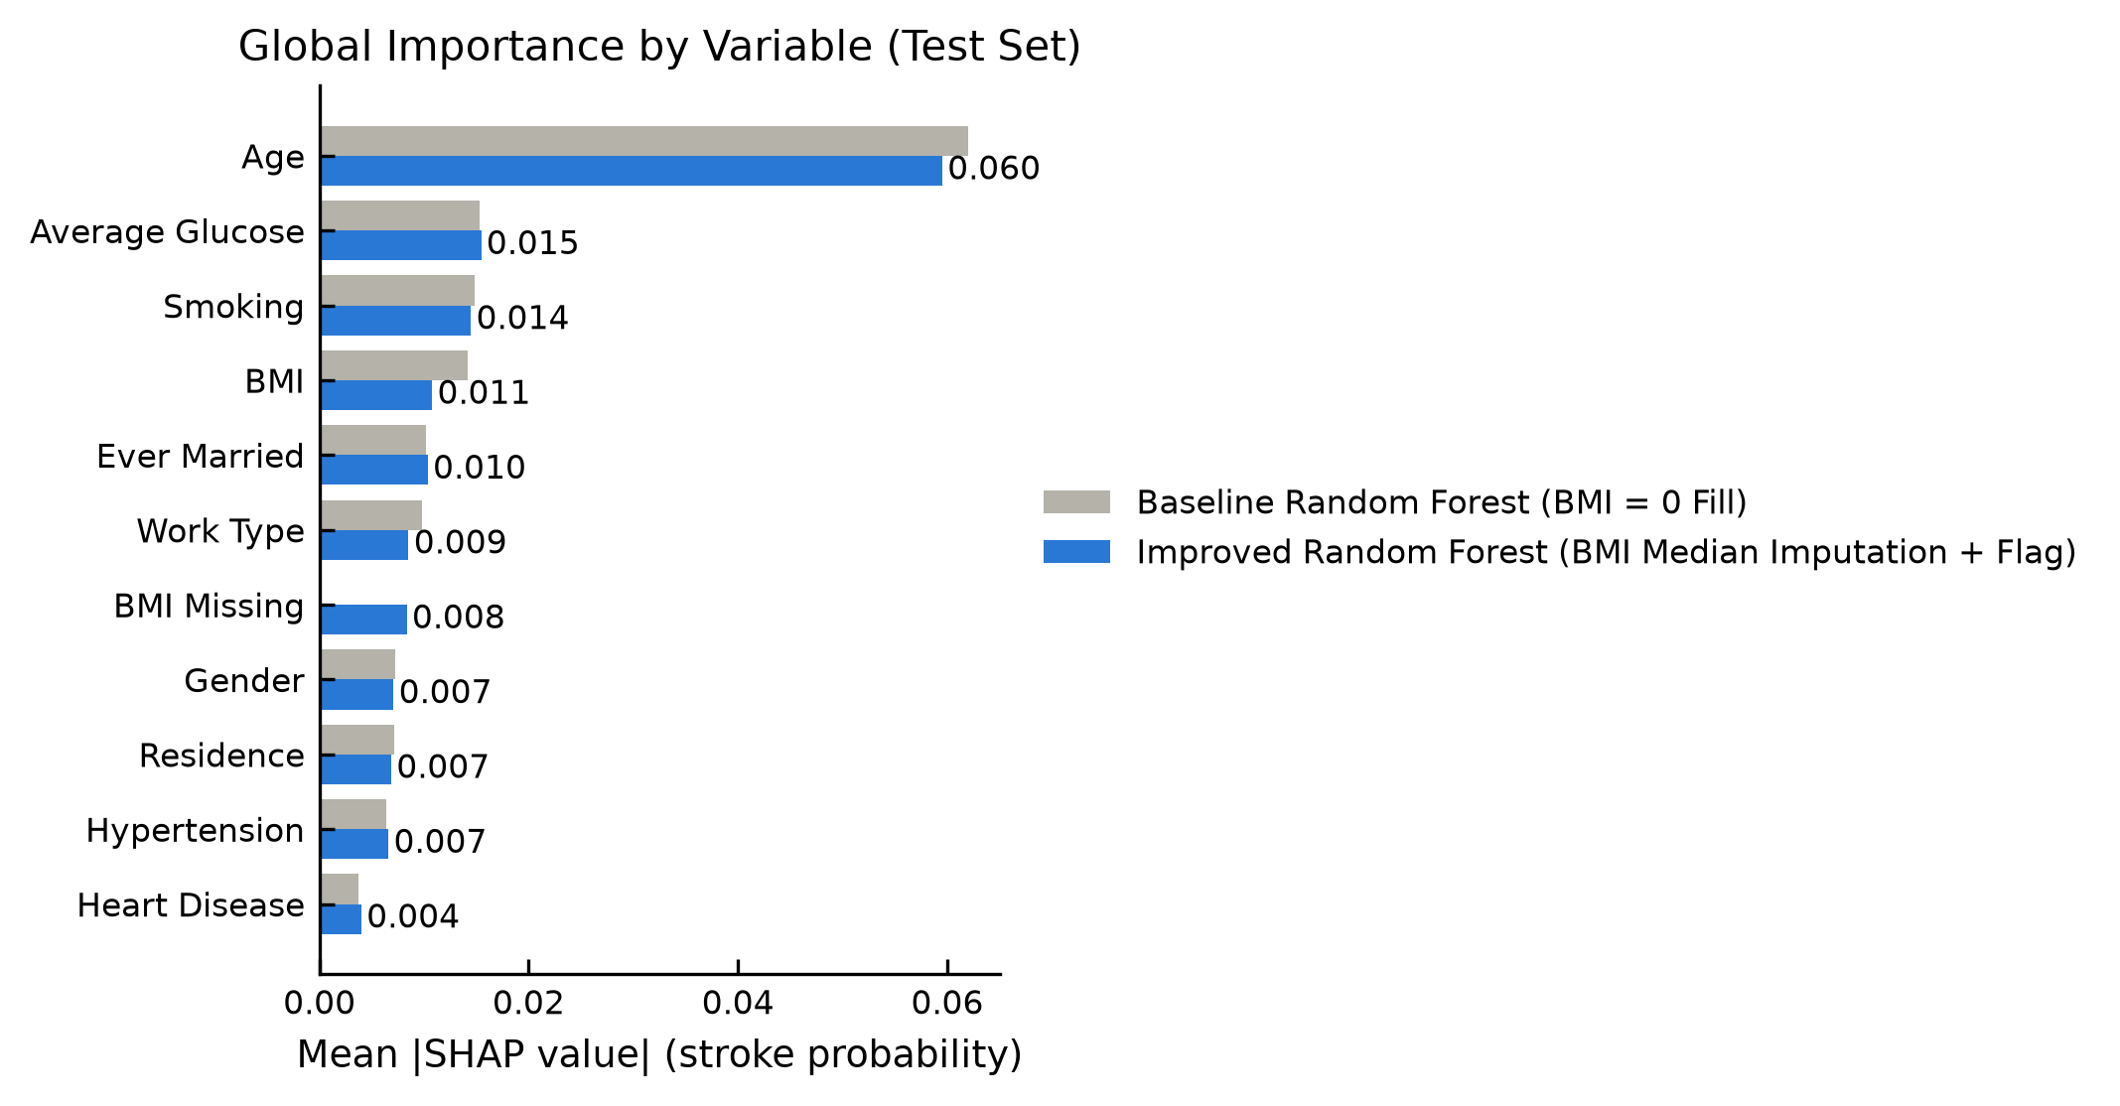
Figure 7. Global importance by variable. Mean |SHAP| per original variable (one-hot levels summed per patient), test set, for the baseline (grey, zero-filled BMI) and improved random forest (blue, median imputation plus flag). Age dominates both models; in the improved model the missingness signal is isolated as BMI Missing.

5.2 Global importance and patterns
Table 7. Global top five variables, improved random forest. Directions from Figure 6 and the dependence plots in Figures A10 and A11.
Rank | Feature | Mean |SHAP| | Observed pattern
1 | Age | 0.060 | Negative below approximately 50 years, positive above approximately 55, increasing steeply after 60
2 | Average glucose | 0.015 | Predominantly positive in the upper mode (above approximately 170 mg/dL)
3 | Smoking | 0.014 | Formerly smoked predominantly positive; Unknown predominantly negative, consistent with its association with young patients
4 | BMI | 0.011 | Small, without a consistent direction
5 | Ever married | 0.010 | Small and mixed; large values confined to older patients, consistent with an age proxy

Age has approximately four times the mean |SHAP| of any other variable. Hypertension (0.007) and heart disease (0.004) rank low despite crude stroke-rate ratios of 3.3 and 4.0, owing to their low prevalence (9.7% and 5.4%) and to attribution shared with age. Colour in Figure 6 encodes feature value, not severity; for binary columns, red denotes presence.
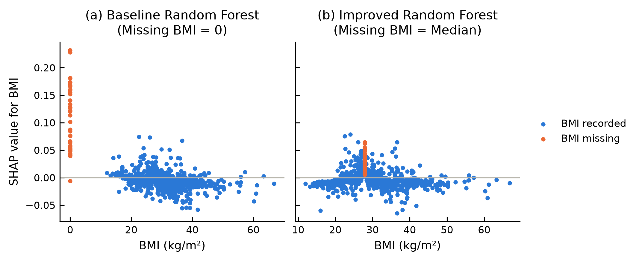
Figure 8. BMI SHAP values under both pipelines. Test set; orange points denote missing BMI. (a) Baseline: zero-filled BMI receives SHAP values of up to +0.23, exceeding those of any recorded BMI. (b) Improved: the same patients are imputed at the median and receive small positive values.
Figure 8 confirms the artefact anticipated in the EDA: the baseline model associates BMI = 0 with stroke. Missingness is a genuine association in this dataset (19.9% vs 4.3% stroke prevalence) but reflects data collection rather than physiology. The modification does not remove the signal; it isolates it in a named feature (BMI Missing, mean |SHAP| 0.008) that can be audited or excluded.

5.3 Link local and global findings
The main case is consistent with the global pattern: its two largest contributors, glucose and age, are the two highest-ranked variables globally and act in their typical direction. Hypertension illustrates the distinction between global importance and local contribution: it ranks tenth globally because of its low prevalence (10%), yet for this patient its contribution equals that of smoking. Correlated predictors share attribution; age, marital status and work type carry a common age signal that SHAP distributes among them (Aas et al., 2021), and they should be interpreted jointly.

6 Task 5 Plan for Three Audience Slides
The slides are delivered as three single-slide decks, one per audience: Stroke_SHAP_Slide1_DataScientist.pptx, Stroke_SHAP_Slide2_Doctor.pptx and Stroke_SHAP_Slide3_Patient.pptx. All three are based on the improved random forest and Patient ID 43717, and are reproduced in Figures 9–11.

Slide 1 Explanation as a data scientist
- Title: Age drives the improved random forest, which catches 29 of 50 strokes.
- Visual: the global beeswarm (Figure 6) with a performance panel (recall 0.58, precision 0.11, ROC AUC 0.75, each against the baseline).
- Content: model, split, positive class and output scale; TreeExplainer with an interventional background of 100 training patients (base value 0.08); threshold from 5-fold cross-validation; additivity check.
- Limitations: uncalibrated scores, the missingness signal, attribution shared among age proxies, recall of 0.32 under age 60, and no external validation. Agreement with the MLP on the leading attributions for the main case is reported as a robustness check.

Slide 2 Explanation as a doctor
- Title: Patient ID 43717 was flagged mainly for high glucose, age and smoking.
- Visual: the force plot of Figure 5 with plain-language labels and the four positive contributions with units.
- Content: the score (0.16) relative to the threshold (0.09) and base value (0.08), presented as a ranking score rather than a 16% risk; sensitivity in clinical terms (21 of 50 strokes missed, 15 of them under 60; 1 in 9 flagged patients had a stroke).
- Caveats: attributions describe model behaviour rather than causation, and the data are retrospective and externally unvalidated; the flag is positioned as a prompt for review of history, examination and tests.

Slide 3 Explanation as a patient
- Title: What the computer’s result means for you.
- Visual: a build-up chart from the average starting point (0.08) to the patient’s result (0.16), with each factor’s reading and SHAP value: blood sugar 212 mg/dL (+0.054), age 57 (+0.033), smoking (+0.017), high blood pressure (+0.017) and all other details (−0.043). A dashed line marks the alert level of 0.09.
- Content: addressed to the patient: what the system did (compared the record with approximately 4,000 others and flagged it for the doctor), why, and what the result does not mean (neither a diagnosis nor a probability of stroke). It states that 0.16 is a score for ranking, not a 16% chance of stroke, and gives the error rate in plain terms: 21 of 50 people who had a stroke were missed, and most flagged people have not had one. The doctor interprets the result alongside check-ups and tests.
- Tone: no attribution of blame, causal claims or medication advice.

Slide consistency check
Table 8. Slide consistency check.
Item | Report | Slides
Model and output | Improved random forest; predicted probability of stroke (Sections 3–5) | All three
Case | Patient ID 43717, true positive (Section 4.1) | Slides 2 and 3 (and the slide 1 footer)
Score, base value, threshold | 0.16; 0.08; 0.09 (Section 4) | Slides 2 and 3
Top contributions | Glucose +0.054, age +0.033, smoking +0.017; hypertension +0.017 (Table 6) | Slides 2 and 3 (values; slide 3 adds “all other details” −0.043)
Performance | Recall 0.58, precision 0.11, ROC AUC 0.75; 21 of 50 strokes missed (Table 4) | Slides 1–3
Source credits | fedesoriano (2021); SHAP TreeExplainer | Footer of every slide

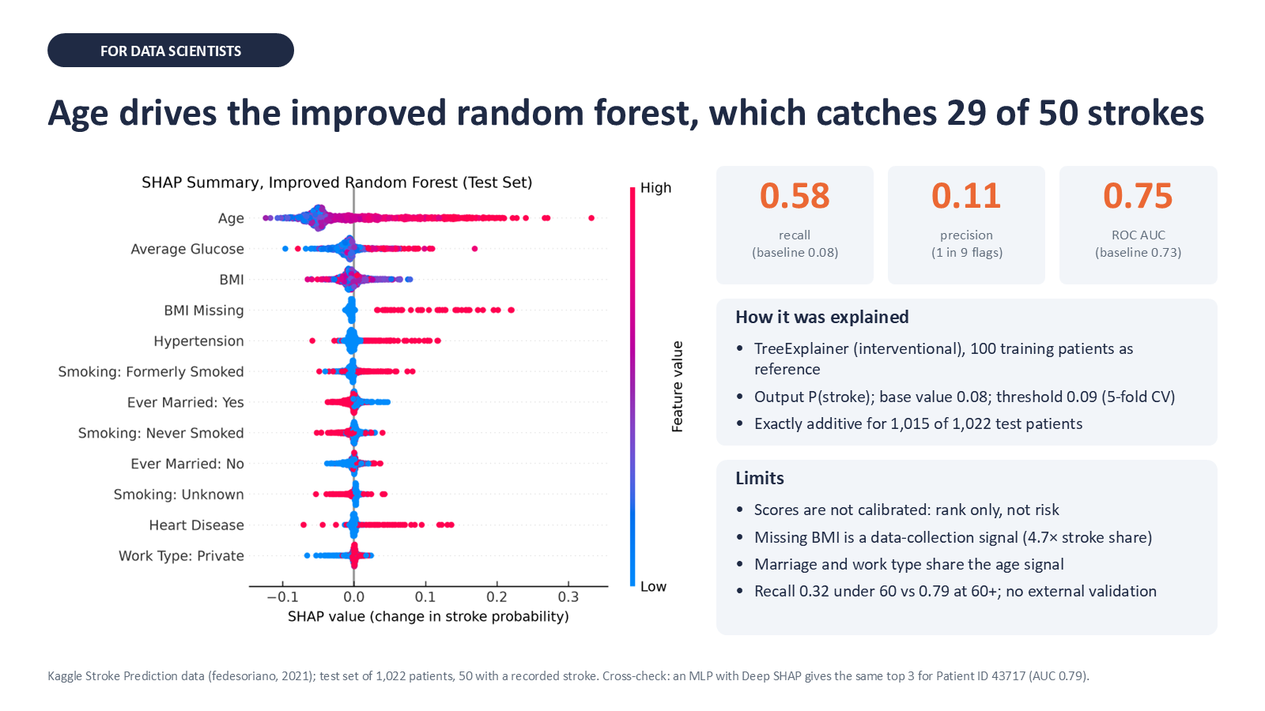
Figure 9. Slide 1, data scientist audience. Global beeswarm, test-set performance, explainer configuration and limitations.
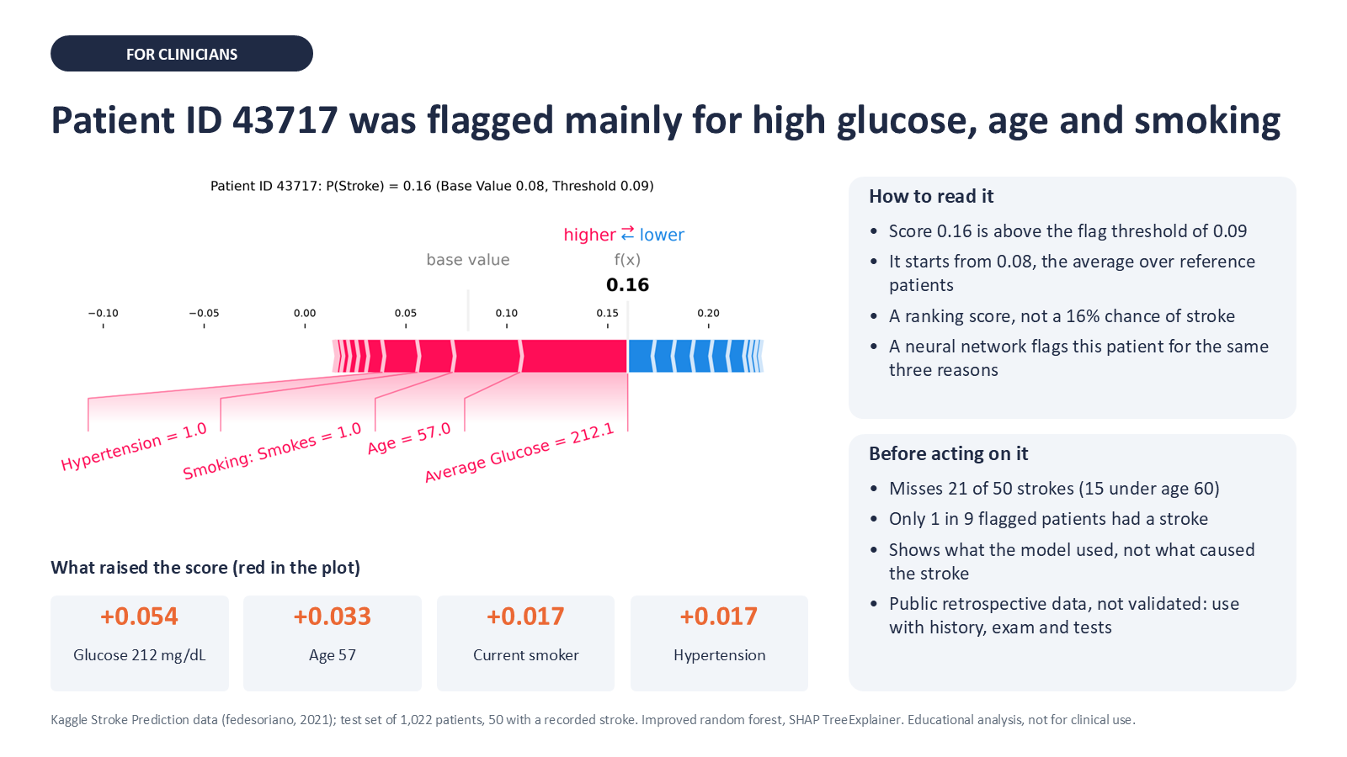
Figure 10. Slide 2, doctor audience. Force plot for Patient ID 43717, positive contributions and guidance on use of the flag.
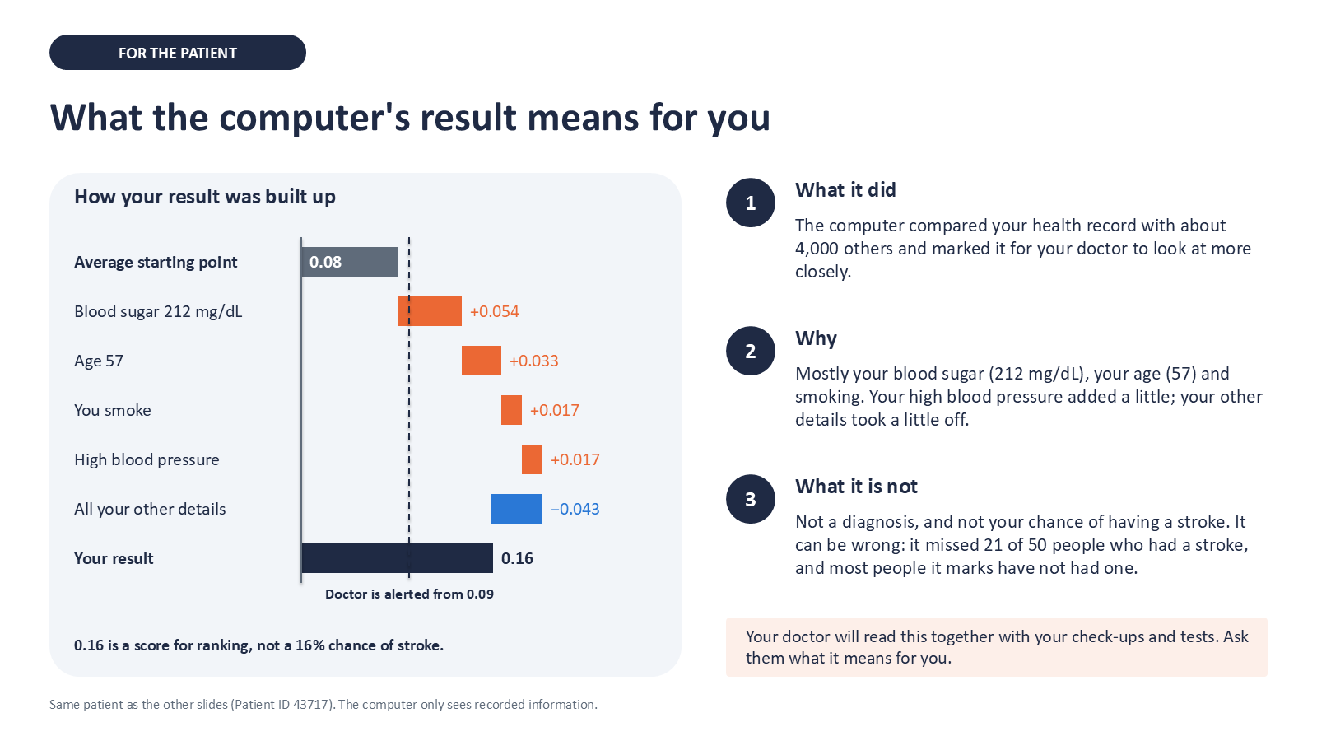
Figure 11. Slide 3, patient audience. Build-up of the result from the starting point through each factor, and its limits.

7 Task 6 Explain a Different Black Box Model

7.1 Alternative model and rationale
- Task 2 model: improved random forest.
- Task 6 model: multilayer perceptron (MLP), PyTorch 2.14.1, 22 → 32 → 16 → 1 units, ReLU activations, dropout 0.2, sigmoid output; Adam (learning rate 0.001, weight decay 0.0001), binary cross-entropy, 20 epochs, batch size 128; untuned.
- Rationale: a different kind of black box, with no rules or decision paths to inspect; because the network is differentiable, Deep SHAP can be applied.
For comparability, the MLP shares the split, BMI handling, oversampling, threshold rule (maximum Youden’s J on 5-fold out-of-fold training scores, yielding 0.48), background and main case with the forest. Inputs are standardised with the training mean and standard deviation, fitted before oversampling.

7.2 Explainer: Deep SHAP
Table 9. Deep SHAP specification.
Record | Deep SHAP route
Explained model | The trained network, fed by the fitted scaler; shap.DeepExplainer (SHAP 0.54.1), which extends DeepLIFT (Shrikumar et al., 2017)
Output and class | Single sigmoid output = predicted probability of stroke = 1; same scale as the forest
Background | The same 100 training patients as the forest (random_state=2021), standardised; base value 0.302
Computation settings | Network in evaluation mode (dropout disabled); all 1,022 test patients explained in 2.3 s (TreeExplainer: 38.1 s)
Input consistency | Tensor 1,022 × 22 in the scaler’s column order; SHAP array 1,022 × 22 (asserted); plots show unscaled values

All outputs are reconstructed to float32 precision (maximum residual 2.3 × 10⁻⁷). Deep SHAP is an approximation (exact only for linear models), so it was checked against Kernel SHAP (Lundberg & Lee, 2017), a slower method that works with any model. The comparison used the same background, Patient ID 43717 and 49 test patients sampled with random_state=2021, and 2,048 model evaluations per patient. Per-patient Pearson correlation between the 22 Deep SHAP and 22 Kernel SHAP values had a median of 0.986 (minimum 0.836); the leading feature agreed for all 50 patients; and the maximum absolute difference was 0.113 (0.026 for Patient ID 43717; Figure 15).

7.3 Required evidence for the chosen model
At its tuned threshold of 0.48, the MLP detected 31 of the 50 test strokes with 235 false positives (recall 0.62, precision 0.12, F1 0.20, balanced accuracy 0.69). Its ranking performance exceeded that of the forest (ROC AUC 0.79 vs 0.75; average precision 0.21 vs 0.14).
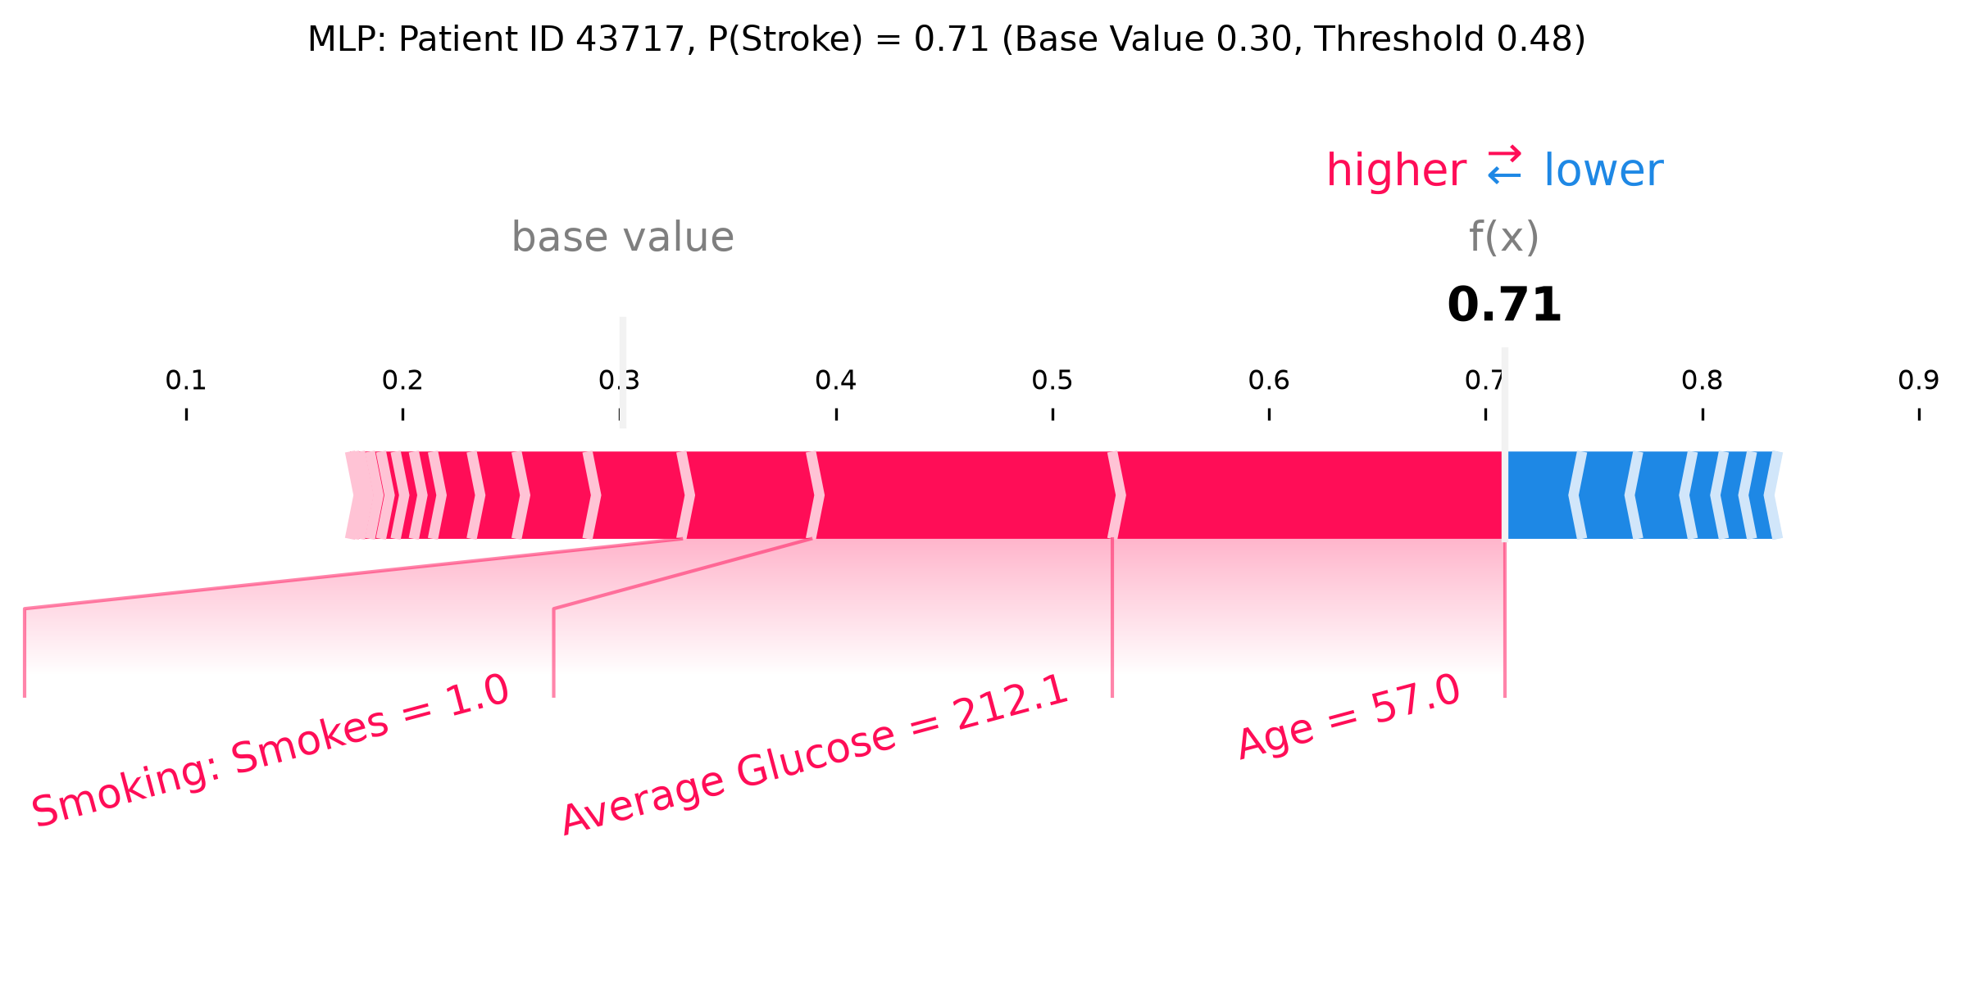
Figure 12. Local Deep SHAP force plot, Patient ID 43717, MLP. Output is the predicted probability of stroke; base value 0.30 (mean over the same 100 background patients); output 0.71, above the MLP threshold of 0.48. Age (+0.181), average glucose (+0.139) and current smoking (+0.060) contribute positively.
For Patient ID 43717, both models yield the same three leading contributions, all positive. The MLP ranks age first (+0.181) and the forest glucose (+0.054). The remaining features contribute a small net increase for the MLP (+0.027) and a small net decrease for the forest (−0.025).
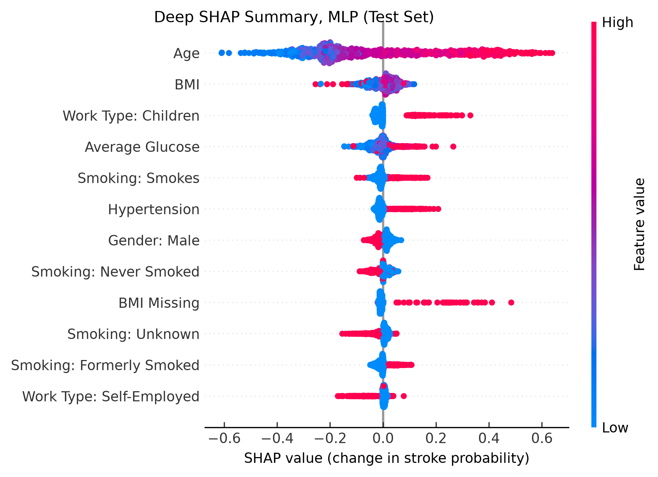
Figure 13. Global Deep SHAP summary plot, MLP. 1,022 test patients; axes and colours as in Figure 6. Age dominates, with attributions increasing smoothly with age. BMI Missing contributes strongly positively, and Work Type: Children contributes positively, offsetting the large negative age attributions of children.
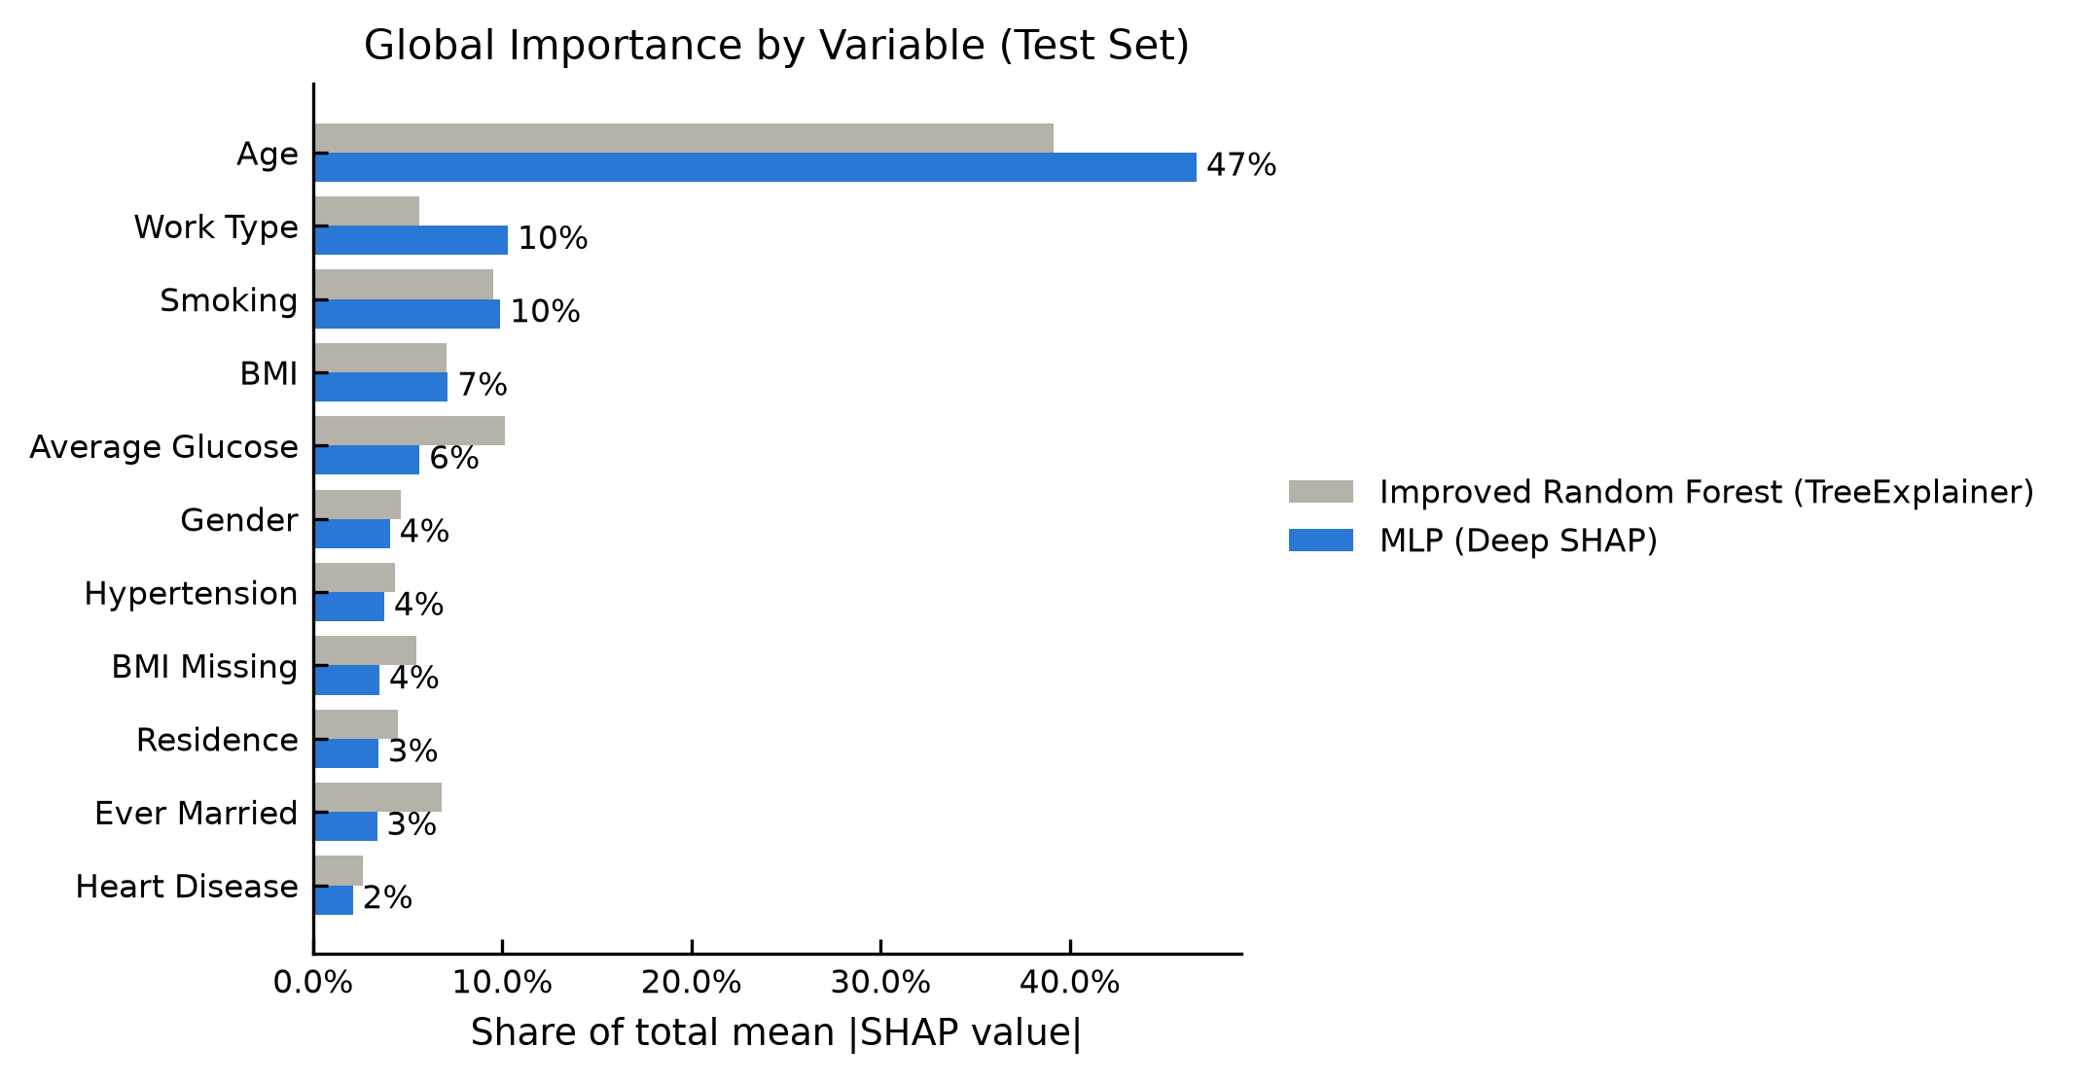
Figure 14. Global importance by variable, random forest vs MLP. Mean |SHAP| per original variable as a share of each model’s total, test set. Shares are compared because the absolute scale of attributions differs between the models.
Table 10. Global top five variables, MLP. Directions from Figure 13. Shares are of the MLP’s total mean |SHAP| (Figure 14).
Rank | Feature | Mean |SHAP| (share) | Observed pattern
1 | Age | 0.235 (47%) | Increases steadily with age, from approximately −0.6 for the youngest to +0.6 for the oldest patients
2 | Work type | 0.052 (10%) | Children strongly positive (up to approximately +0.3), offsetting the negative age attributions of children; self-employed mostly negative
3 | Smoking | 0.050 (10%) | Current and former smoking positive; never smoked and Unknown mostly negative
4 | BMI | 0.036 (7%) | Near zero for most patients; the highest BMIs negative (to approximately −0.25)
5 | Average glucose | 0.028 (6%) | High glucose positive (up to approximately +0.27); low glucose slightly negative

Age is the leading variable in both models (47% of the MLP’s total mean |SHAP|), and four of the five highest-ranked variables are shared. The fifth is a different age proxy in each case: work type for the MLP and marital status for the forest. The MLP also gives missing BMI large positive attributions (up to approximately +0.5; Figure 13), but because few patients lack BMI it ranks only eighth (4% share), against 5% for the forest.
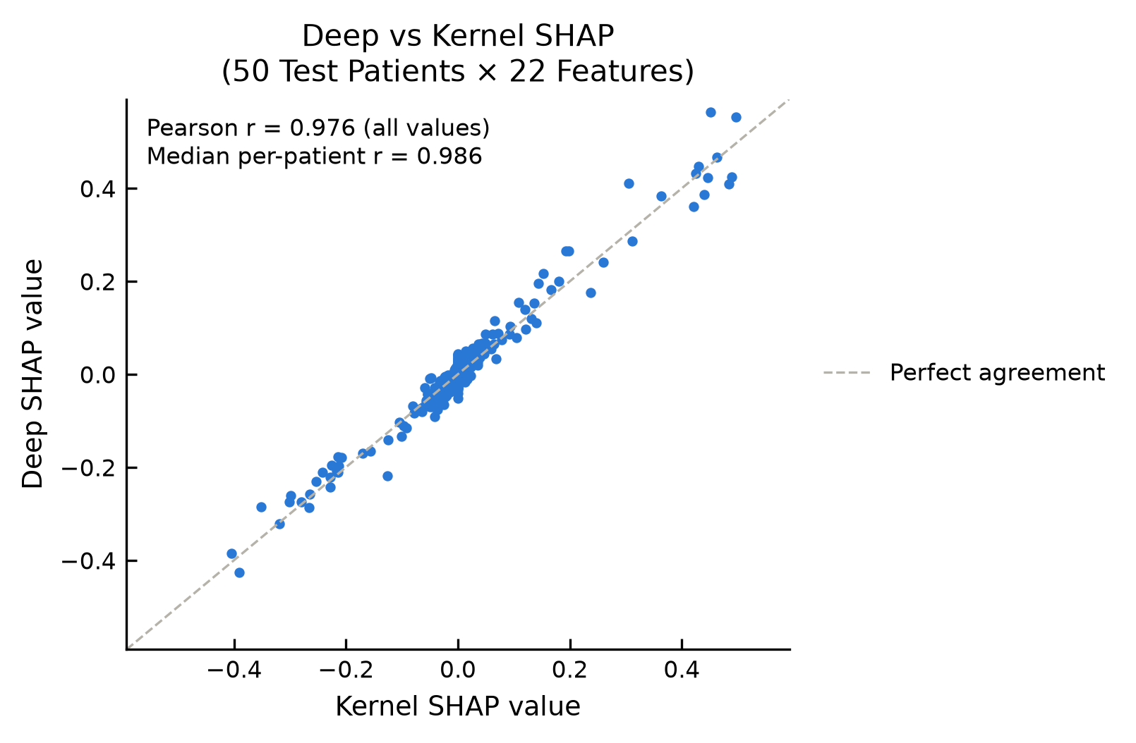
Figure 15. Deep SHAP vs Kernel SHAP, MLP. 50 test patients × 22 features; the dashed line denotes perfect agreement. Pooled Pearson r = 0.976; median per-patient r = 0.986.

8 Comparison Discussion and Conclusion

8.1 Compare the two models
Table 11. Model comparison. Test set; each model at its own tuned threshold.
Comparison item | Task 2 model | Task 6 model
Model and explainer | Improved random forest; TreeExplainer (interventional) | MLP; Deep SHAP
Positive class recall and precision | 0.58 / 0.11 (29 detected, 225 false positives) | 0.62 / 0.12 (31 detected, 235 false positives)
F1, balanced accuracy, ROC AUC | 0.19 / 0.67 / 0.75 | 0.20 / 0.69 / 0.79
Average precision and prevalence | 0.14; prevalence 0.05 (50 / 1,022) | 0.21; same prevalence
Case score and explained scale | 0.16 (threshold 0.09, base 0.08); probability | 0.71 (threshold 0.48, base 0.30); probability
Top three global features | Age, average glucose, smoking | Age, work type, smoking
Explanation sample and runtime | 1,022 test patients; 38.1 s | 1,022 test patients; 2.3 s
Reconstruction residual | < 10⁻⁶ for 1,015 of 1,022; maximum 0.03 | Maximum 2.3 × 10⁻⁷ (all patients)

The models agree at the operating point: both flag the main case and detect a similar number of strokes, with the MLP ranking patients more effectively. The attributions agree on the principal findings: the same three leading contributions for Patient ID 43717, age as the dominant global variable, and smoking, glucose and BMI among the five highest-ranked variables in both models. They differ in emphasis, the MLP weighting age and work type more heavily and the forest glucose and marital status. These differences arise from model structure (a smooth function versus threshold splits on one feature at a time) and preprocessing (standardised inputs, and Deep SHAP treating each 0/1 category column as a continuous number), not from the background, which is shared. Raw attribution magnitudes are not compared because the base values differ (0.30 vs 0.08); Figure 14 compares normalised shares instead.

8.2 Limitations and responsible interpretation
Data. The dataset is public but its source, population and collection period are undocumented. The label records history without follow-up, precluding prospective or external validation. With 50 test strokes, all metrics carry substantial uncertainty. Missing BMI is informative, Unknown smoking status is concentrated in children, and two paediatric strokes may be label noise.
Calibration and subgroups. The forest overestimates the probability for its highest-scoring patients (Brier score 0.052; Figure A6), as expected after oversampling to class parity; no recalibration was applied, and scores are used for ranking only. Recall was 0.53 for women and 0.65 for men (30 and 20 strokes), a difference compatible with chance. The difference in performance by age is larger: recall was 0.32 under 60 and 0.79 at 60 and over, where 66% of non-stroke patients are also flagged. The model therefore functions largely as an age-based screen.
Attribution. Correlated features share attribution, and the interventional background replaces each feature independently of the others, so SHAP may evaluate implausible combinations, such as a married child.
Stability. Repeating the forest explanation with two further background samples (random_state=2022 and random_state=2023) changed the base value (0.06–0.09) but neither the five highest-ranked variables (BMI and marital status exchanged rank once) nor the signs of the main case’s three leading contributions. The tree path-dependent reference (base value 0.50) preserved the same five variables but reversed the sign of those contributions. Rankings are thus robust, whereas signs depend on the stated reference.

8.3 Conclusion
The MLP ranked patients slightly better than the random forest (ROC AUC 0.79 vs 0.75; average precision 0.21 vs 0.14) and detected a similar share of stroke patients at its tuned threshold: stroke-class recall 0.62 vs 0.58, i.e. 31 vs 29 of the 50 test strokes. Both remain weak screening tools, missing 19 and 21 of the 50 strokes respectively. Global SHAP identified age as the dominant variable in both models and exposed an artefact of the provided pipeline, in which zero-filled BMI acted as a stroke indicator. Local SHAP attributed the flag for Patient ID 43717 to glucose, age and smoking, consistently across both models and between Deep and Kernel SHAP (median r = 0.986). The choice of model altered the relative emphasis, with greater weight on age and work type in the MLP, but not the principal findings. The main constraint is the dataset, which is small, retrospective and undocumented; the scores support ranking but not risk estimation.

8.4 Work contributions
Individual work by Yeap Jie Shen (22062548), covering all tasks. The study design, analytical decisions and all revisions were the author’s own. Claude Code (Anthropic) assisted with code, figures and drafting. All results are generated by the notebooks in the repository, and all outputs were reviewed and verified by the author.

9 References and Submission Checklist

9.1 References
Aas, K., Jullum, M., & Løland, A. (2021). Explaining individual predictions when features are dependent: More accurate approximations to Shapley values. Artificial Intelligence, 298, 103502. https://doi.org/10.1016/j.artint.2021.103502
Cohen, J. (1988). Statistical power analysis for the behavioral sciences (2nd ed.). Lawrence Erlbaum Associates.
deepfindr. (2021). xai-series [Computer software]. GitHub. https://github.com/deepfindr/xai-series
fedesoriano. (2021). Stroke prediction dataset [Data set]. Kaggle. https://www.kaggle.com/datasets/fedesoriano/stroke-prediction-dataset
Lundberg, S. M., Erion, G., Chen, H., DeGrave, A., Prutkin, J. M., Nair, B., Katz, R., Himmelfarb, J., Bansal, N., & Lee, S.-I. (2020). From local explanations to global understanding with explainable AI for trees. Nature Machine Intelligence, 2(1), 56–67. https://doi.org/10.1038/s42256-019-0138-9
Lundberg, S. M., & Lee, S.-I. (2017). A unified approach to interpreting model predictions. Advances in Neural Information Processing Systems, 30, 4765–4774.
Shrikumar, A., Greenside, P., & Kundaje, A. (2017). Learning important features through propagating activation differences. Proceedings of the 34th International Conference on Machine Learning, PMLR 70, 3145–3153.
World Health Organization. (2020, December 9). The top 10 causes of death [Fact sheet]. https://www.who.int/news-room/fact-sheets/detail/the-top-10-causes-of-death
Youden, W. J. (1950). Index for rating diagnostic tests. Cancer, 3(1), 32–35. https://doi.org/10.1002/1097-0142(1950)3:1<32::AID-CNCR2820030106>3.0.CO;2-3

9.2 Reproducibility appendix
- Environment: Python 3.14.10 on Windows 11; package versions are given in Section 2.1 and dependencies in pyproject.toml.
- Seeds: 2021 for the split, oversampler, forest, MLP, cross-validation folds, background sample and Kernel SHAP; 2022 and 2023 for the stability backgrounds.
- Data: healthcare-dataset-stroke-data.csv, 5,110 × 12, SHA-256 644d473b05d2797006bd94865e4f8bb057f0c721617911613c82c8fcfc707420. The file is not redistributed; download it from Kaggle into data/.
- Configuration: the src/stroke_shap package (modules data, models, mlp, explain and plotting).
- Evidence files: in the repository, notebooks/01_eda.ipynb (Task 1), notebooks/02_shap_rf.ipynb (Tasks 2–4) and notebooks/03_deep_shap_mlp.ipynb (Task 6) are saved with all outputs, and scripts/ holds the provided code. Figures are written to figures/ when the notebooks run; trained models and SHAP arrays are recomputed rather than stored.
- Slides: Stroke_SHAP_Slide1_DataScientist.pptx, Stroke_SHAP_Slide2_Doctor.pptx and Stroke_SHAP_Slide3_Patient.pptx.

9.3 Final submission check
☑ Task 1 Repository recorded and 00_data_exploration.py executed; EDA results interpreted.
☑ Task 2 Model evaluated and SHAP explainer specified with class, background and output scale.
☑ Task 3 Readable force plot included and linked to one held-out case.
☑ Task 4 Readable summary plot included and global patterns explained.
☑ Task 5 Three slides prepared for the data scientist, doctor and patient audiences.
☑ Task 6 Different black box model explained using Deep SHAP or Kernel SHAP.
☑ All placeholders replaced; figures captioned; sources cited; code and versions supplied.
☑ No invented results, data leakage, unsupported causal claims or unvalidated future risk claims.

Appendix A Supplementary Figures
These figures support statements made in the main text; each is referenced where it is used.
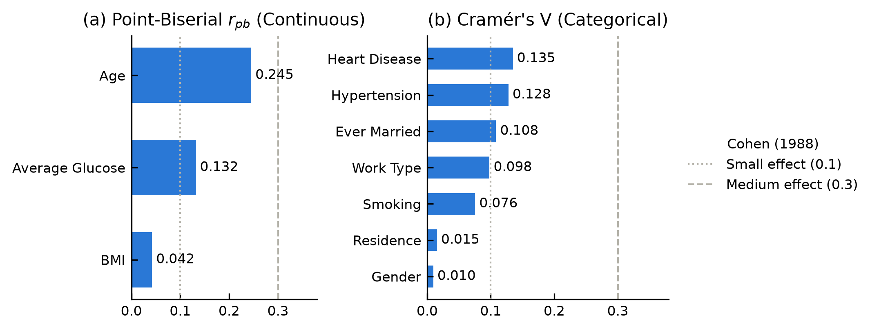
Figure A1. Strength of association with stroke. (a) Point-biserial correlation r between each continuous feature and stroke; (b) Cramér’s V between each categorical feature and stroke. Dotted and dashed lines mark Cohen’s (1988) small (0.1) and medium (0.3) effects. Age has the largest association (r = 0.245); every association is small to modest, and BMI, residence and gender carry almost none.
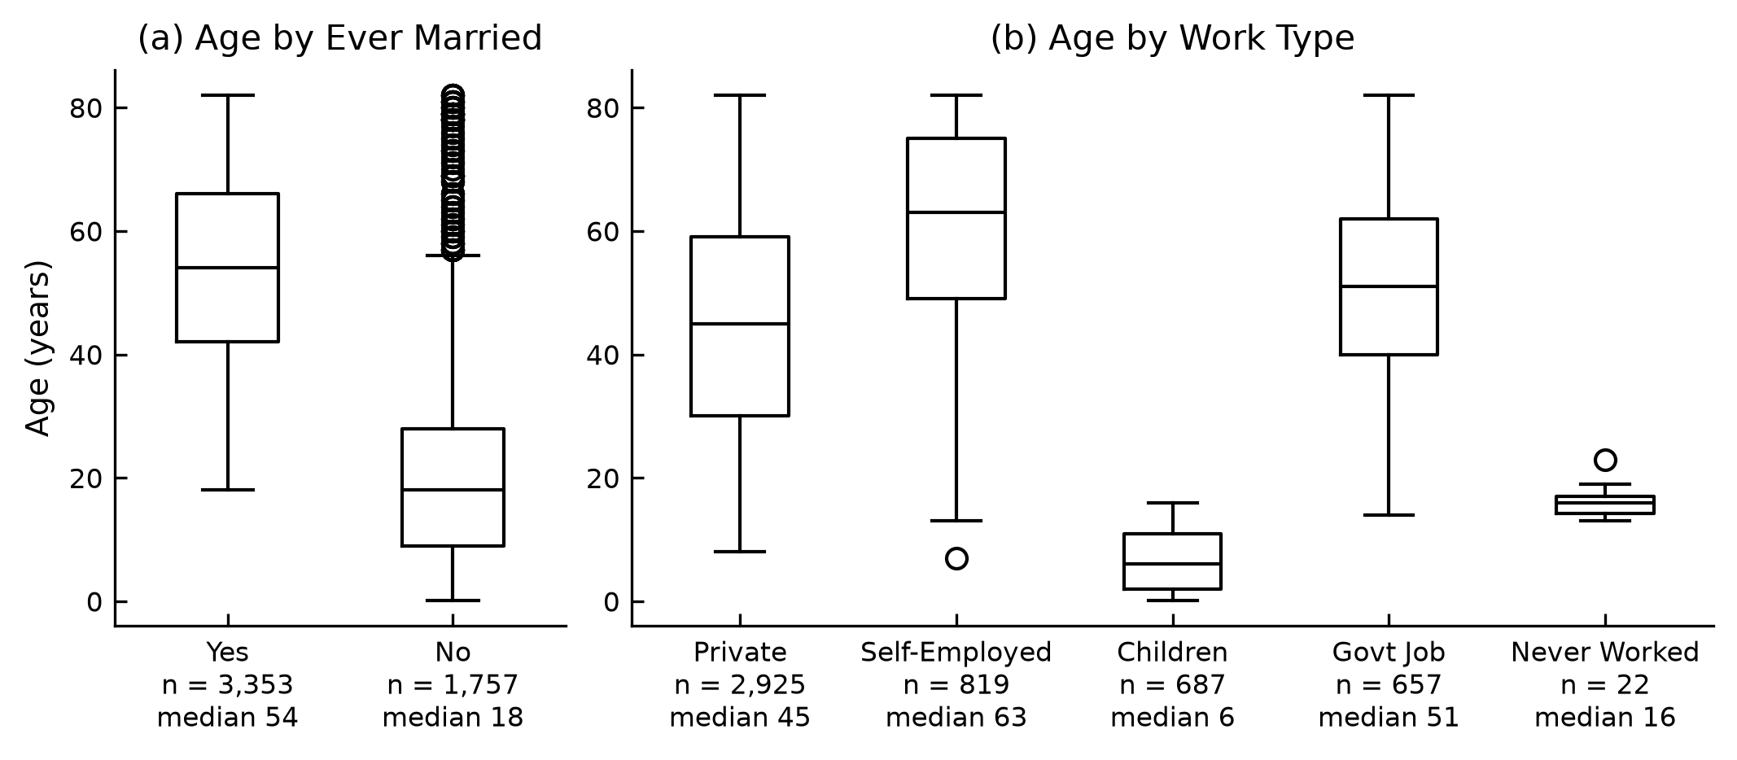
Figure A2. Age by marital status and work type. Age distribution by (a) ever married and (b) work type, with group sizes and medians. Ever-married patients have a median age of 54 against 18 for never-married patients, and self-employed patients 63 against 6 for children. The higher crude stroke rates of these groups (Figure 2) therefore largely reflect age (Section 2.3).
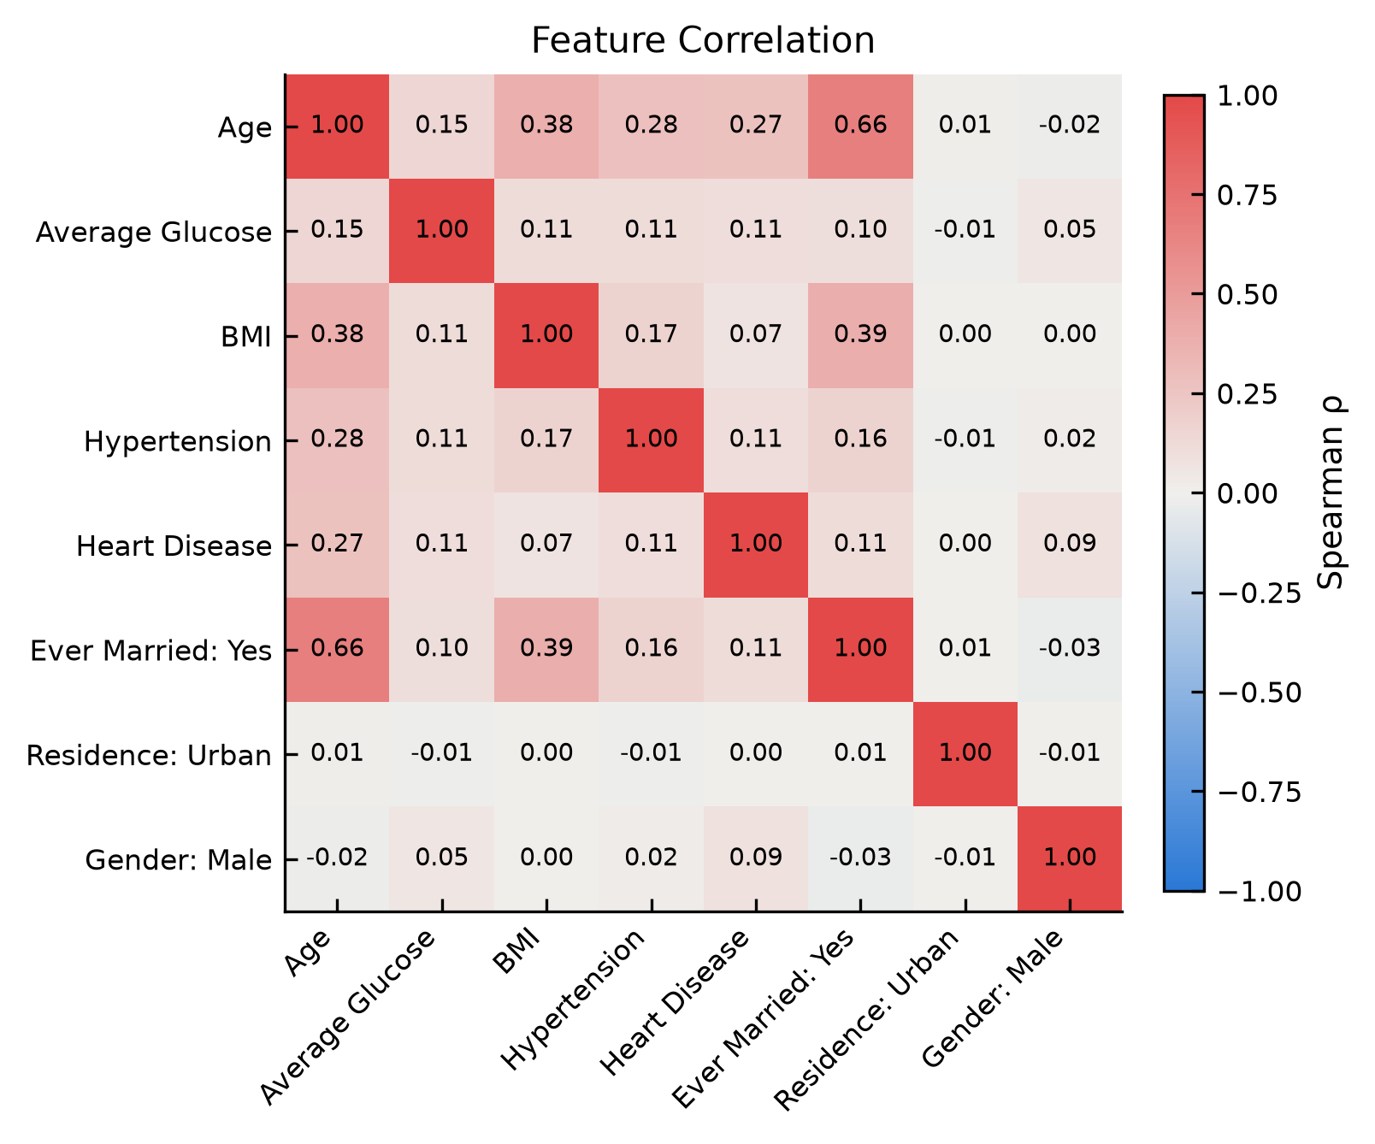
Figure A3. Spearman correlation between features. Spearman’s ρ for the continuous features and the binary features coded 0/1 (ever married: Yes = 1; residence: Urban = 1; gender: Male = 1, with the single Other patient excluded). Multi-category features have no order and are excluded, and missing BMI is excluded pairwise. The only strong pair is age and ever married (ρ = 0.66); BMI is moderately related to age and marriage (about 0.4).
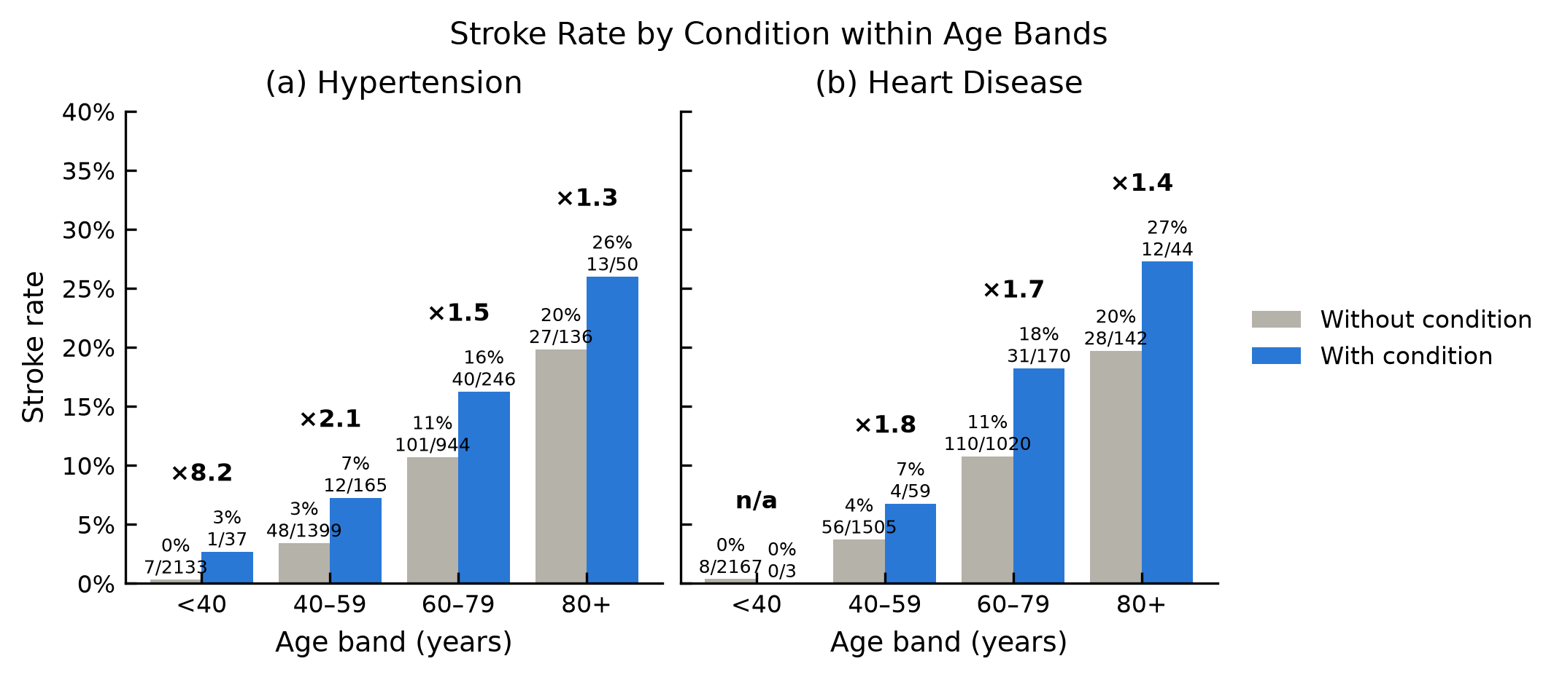
Figure A4. Stroke rate by condition within age bands. Stroke rate with and without (a) hypertension and (b) heart disease within each age band, labelled with the rate and strokes / patients; the factor above each pair is the rate ratio (with ÷ without). From 40 years upward, both conditions are associated with a 1.3–2.1 times higher stroke rate. Under 40 there are too few strokes to judge.
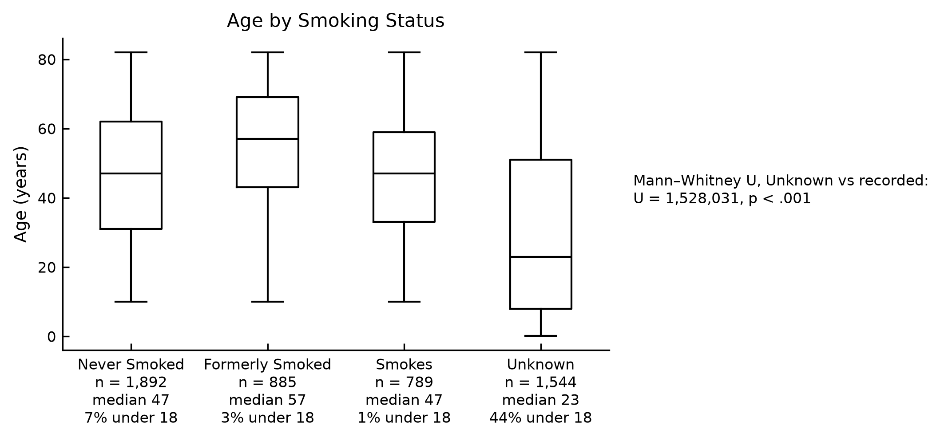
Figure A5. Age by smoking status. Patients with Unknown smoking status have a median age of 23, and 44% are under 18, against 1–7% in the other groups (Mann–Whitney U test, Unknown vs recorded, p < .001). Unknown therefore partly marks being young.
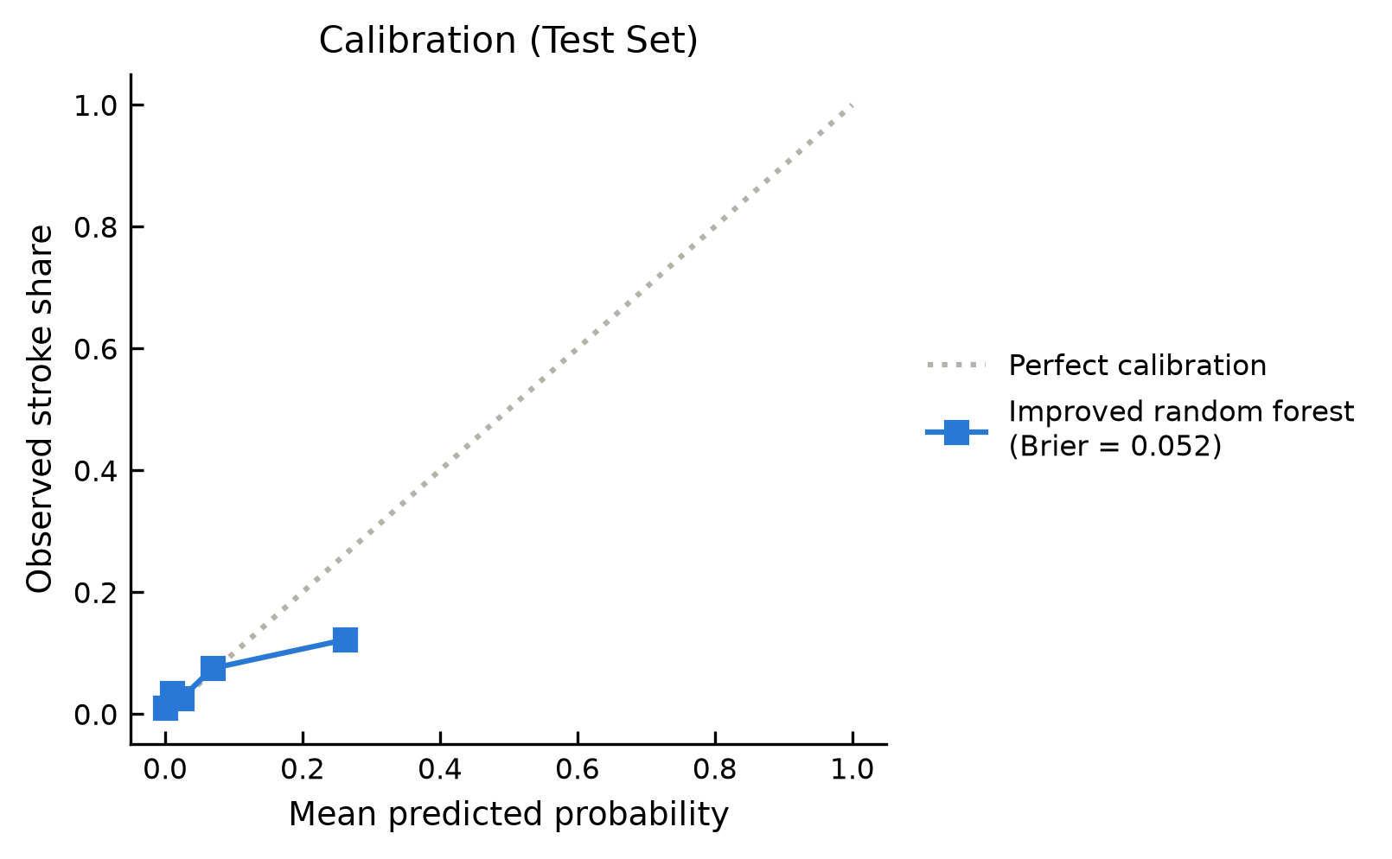
Figure A6. Calibration of the improved random forest. Test set, 5 quantile bins. Points below the diagonal mean the model overstates the probability: in the top bin, the mean score is about 0.26 but the observed stroke share is about 0.12. Brier score 0.052.
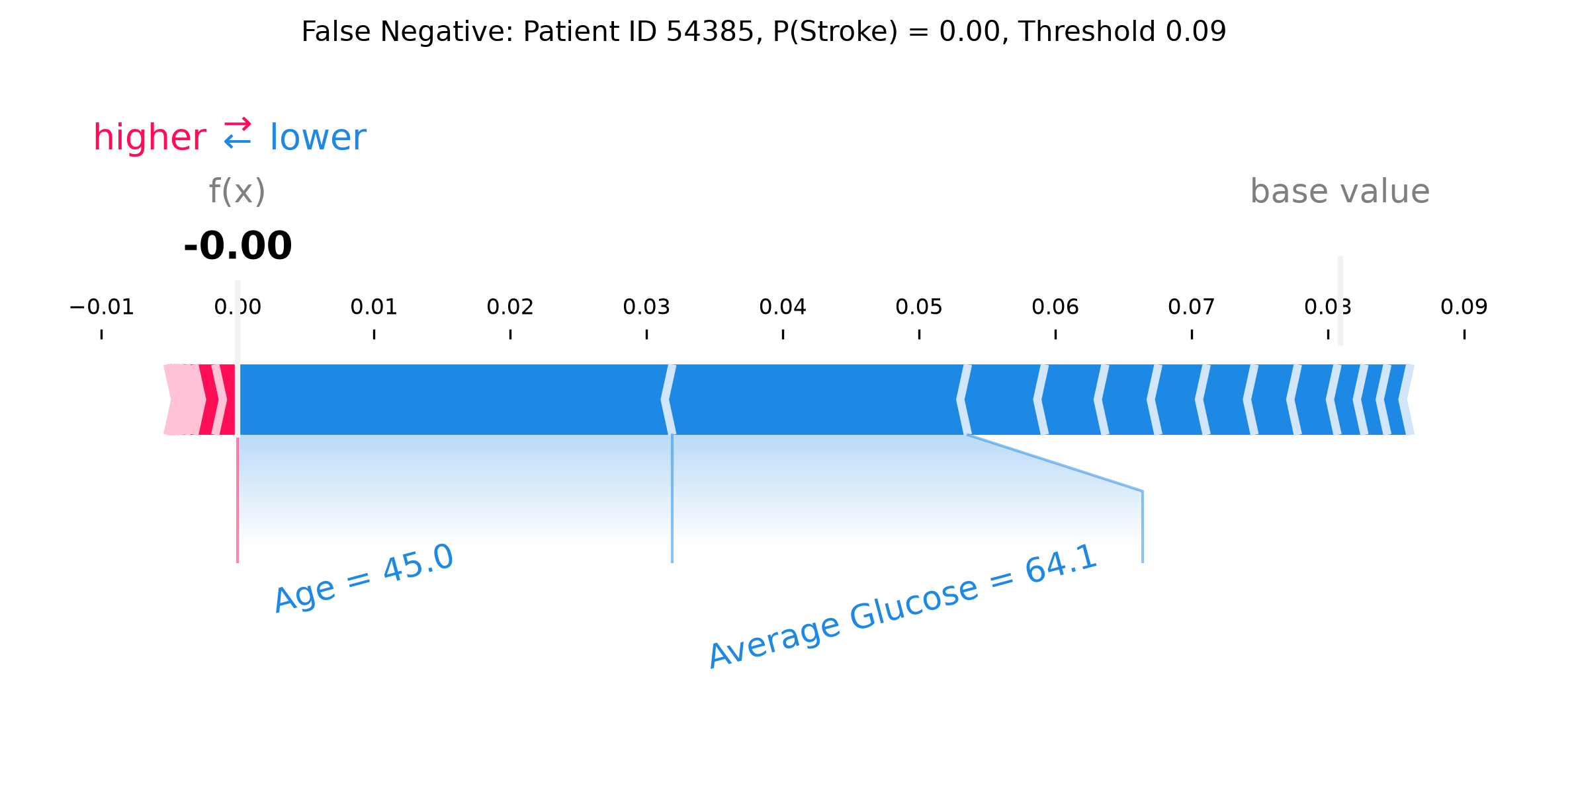
Figure A7. False negative, Patient ID 54385. Improved random forest, threshold 0.09; predicted probability 0.00. This is the lowest-scoring stroke patient. Age 45 and a low glucose level (64.1 mg/dL) push the score from the base value of 0.08 down to 0.00, so the model misses this stroke.
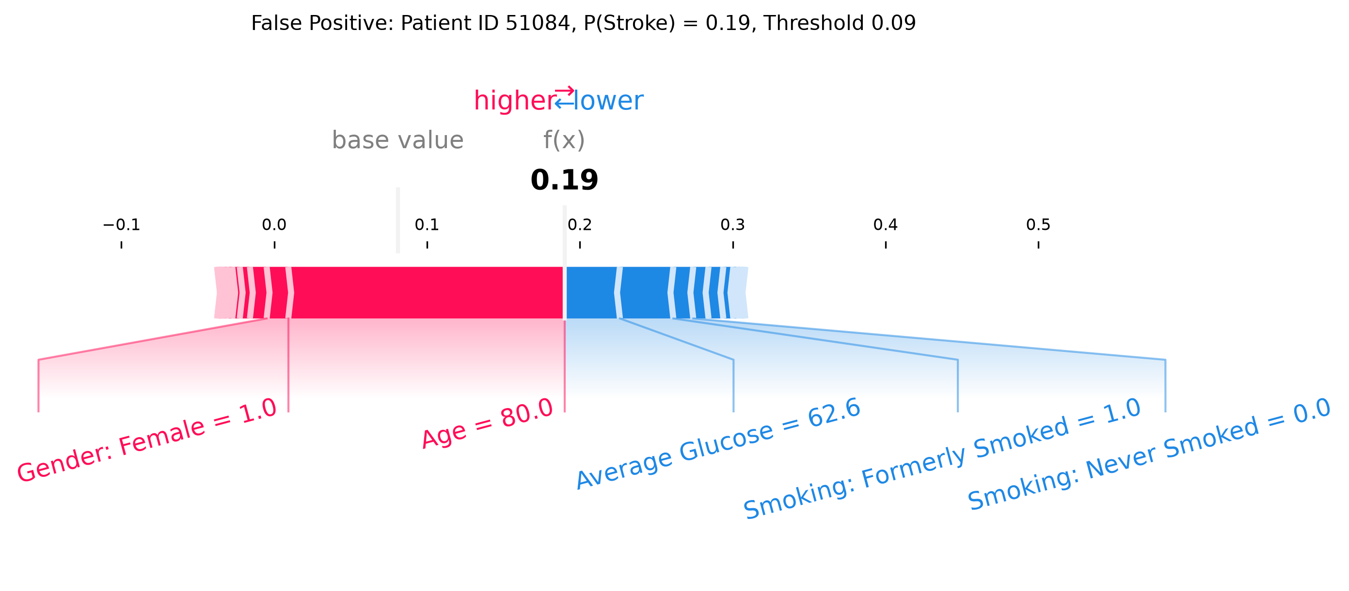
Figure A8. False positive, Patient ID 51084. Improved random forest, threshold 0.09; predicted probability 0.19. This is the median-scoring patient among those flagged without a stroke. Age 80 alone pushes the score far above the threshold, even though a low glucose level (62.6 mg/dL) and her smoking history push it down; this is the age-filter behaviour described in Section 8.2.
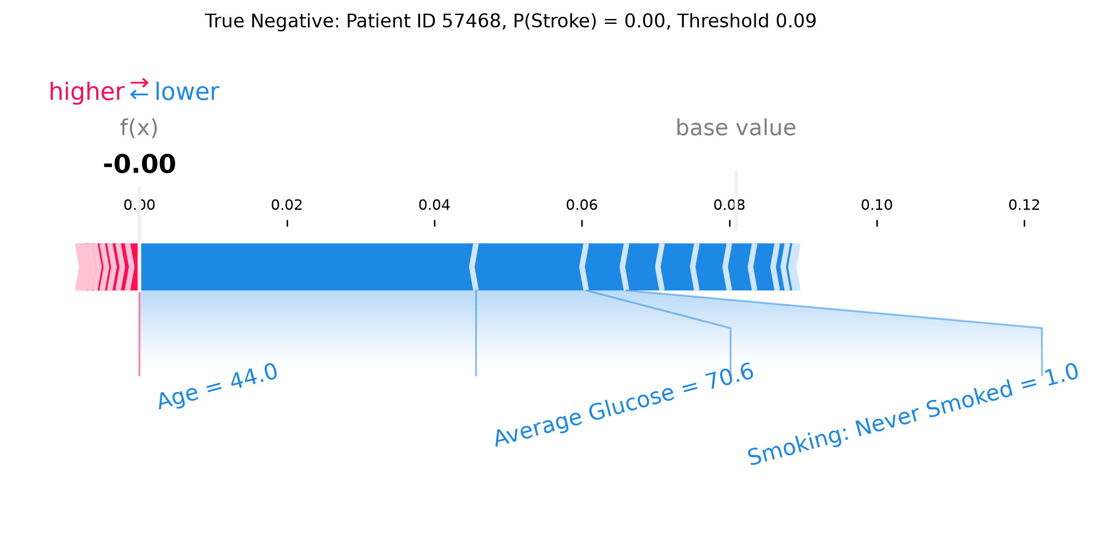
Figure A9. True negative, Patient ID 57468. Improved random forest, threshold 0.09; predicted probability 0.00. This is the median-scoring patient among those correctly cleared. Age 44, a low glucose level (70.6 mg/dL) and never smoking push the score down to 0.00.
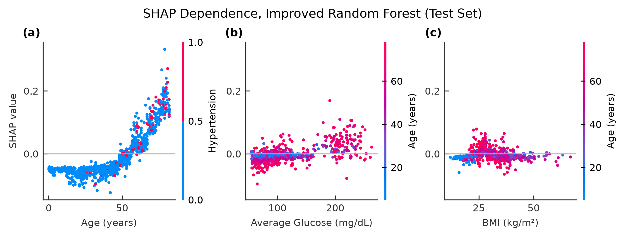
Figure A10. SHAP dependence plots, improved random forest. Test set. Each panel plots a feature’s value (x) against its SHAP value (y), coloured by a second feature: (a) age, coloured by hypertension; (b) average glucose and (c) BMI, both coloured by age. Age pushes down below about 50 and up above about 55, with no visible interaction with hypertension. The upper glucose peak (above about 170 mg/dL) mostly pushes up, and BMI effects are small and appear mainly in older patients.
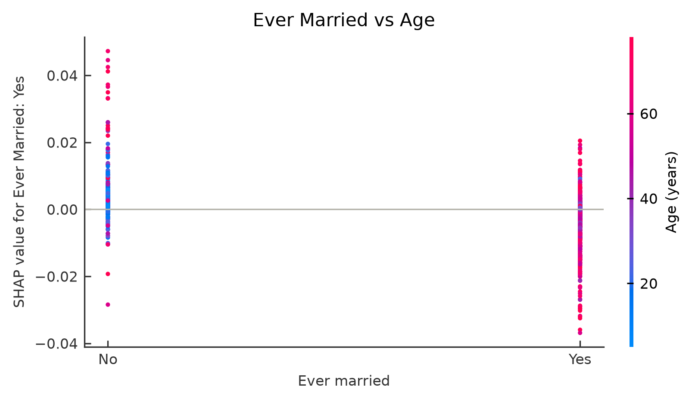
Figure A11. Ever married SHAP values, coloured by age. Test set. Young patients (blue) sit near zero in both groups, while large values belong to older patients (red): mostly upward for the unmarried and slightly downward for the married. This pattern is consistent with ever married acting as a proxy for age rather than having an effect of its own.

