导航方面:

显示串口: ls -l /dev |grep ttyUSB

串口通信: roslaunch my_serial_node Run_car.launch

导航配置: roslaunch navigation navigation.launch

航点导航: rosrun navigation WayPoints_Navigation.py

键盘控制: rosrun teleop_twist_keyboard teleop_twist_keyboard.py

web与ros连接:

roslaunch rosbridge_server rosbridge_websocket.launch

坐标变换：rosrun tf2_web_republisher tf2_web_republisher

视频流：rosrun web_video_server web_video_server

web_rviz:node server.js

机器视觉：

颜色识别：roslaunch robot_vision color_detection.launch

缺陷检测：roslaunch robot_vision defection.launch

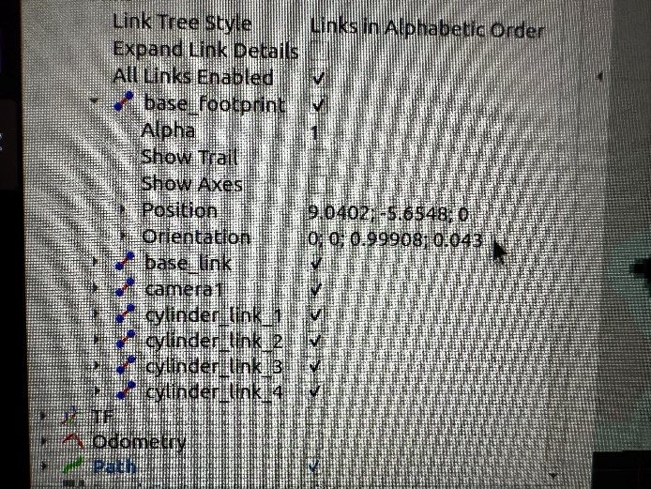**起始点设置如图：**

