**Date: 11/13/2023**

**Goal: XDAQ troubleshooting**

**Mouse: R3(anes)**

**Probe: 12187**

**Important notes:**

1. New heatpad
2. New probe

**Recording time:3pm-5pm**

**After recording notice:**

1. Channel A17,A18, A20 in probe12187 seem dead
2. Nice spike with OE
3. Do see signal with XDAQ, but too noisy to see clearly compared to OE. Sipke sorting also not works for them

Steps:

1. Anesthetized mouse on rig
2. Add new heatpad
3. Clean craniotomy
4. Record with OE
   1. Connect ground pin
   2. Put the probe onto the adaptor
   3. Insert the probe into the brain - record
   4. Disconnect probe + ground pin
   5. Switch to XDAQ adaptor
5. Switch to record with XDAQ
   1. Connect ground pin
   2. Put the probe onto the adaptor
   3. Insert the probe into the brain - record
   4. Disconnect probe + ground pin

**Mouse injection**

K+x 1hr

Redose 23min

Redose2 -does not work well, mouse not fully put down (whiskering all the time)

**Openephys** Bandpass: 300-6000Hz

fileR3_2023-11-13_15-57-00_002

1087um

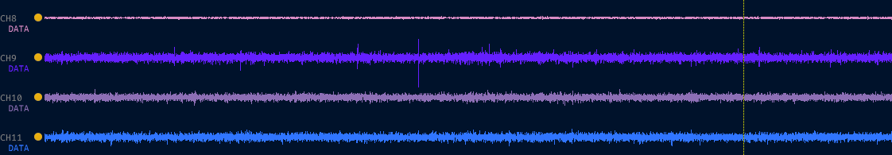

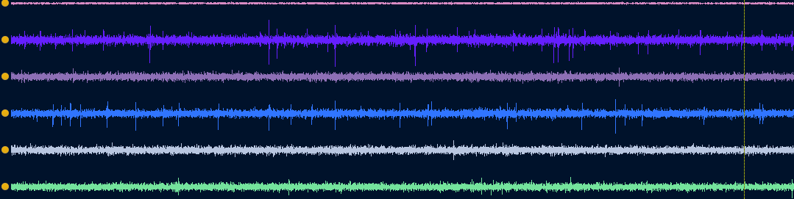

File –003

851um

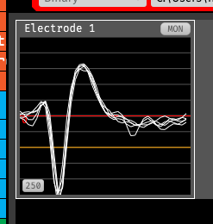



**XDAQ** Bandpass: 300-6000Hz

FILE allego_0__uid1113-16-56-23_data

851um

