**Date:12/28/2023**

**Goal: DiI**

**Mouse: R8**

**Probe: 11DD1, XDAQ**

**Recording time: 10am-11am**

Left FN

000- central - 5000 um 10x DiI

**Date:01/02/2024**

**Goal: DiI**

**Mouse: R8**

**Probe: 11DD1, XDAQ**

**Recording time: 10am-11am**

Left FN

X=150, Y=0, Z TO 5000 with 10x DiI

000 - 2715 um CH 7,8,27 CH3,4,5,6

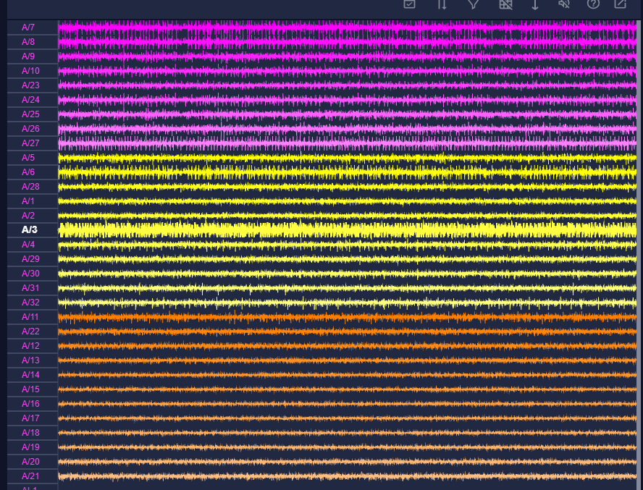

001 -3557um CH11,22,1,2, CH4

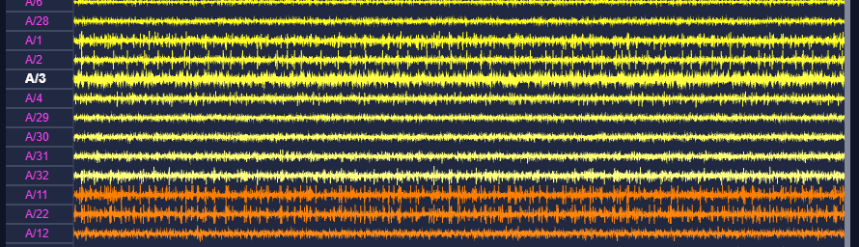

002 4109um CH15,16,17,18

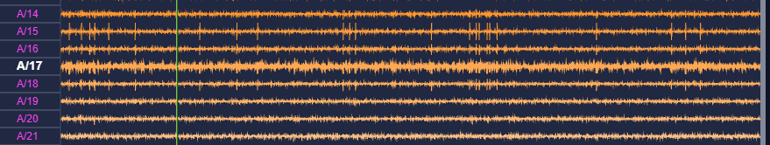

003 4441 um CH3,31 CH15

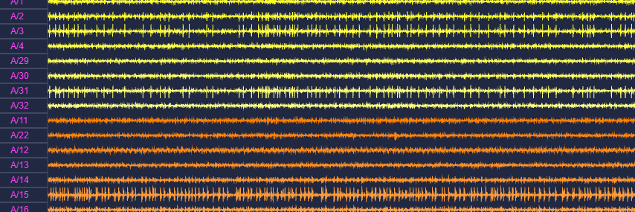

End at 5000 um

—----------------------------------------------------------------------