**Date: 1/10/2024**

**Goal: awake recording practice**

**Mouse: R5**

**Probe: 11DD1**

**Recording time: 3:30PM-4:30PM**

Behavior note: mouse stay head fixed ~1hr and start to scream

Video recording: from strat to end, ~50min

Ephys recording

Right FN (x=0, y=0)

File 000 - 2000 um X

File 001 - 3000 um, 300 s, Channel A15,16,17; A22,11,21 X

File 002 - 4122 um X

File 003 - 5215 um Channel A32,1,22,2,11

Max depth to 5215 um

note:

In most of shallow depth (~1000 um), identical large waveform of all channel when mouse lick for water

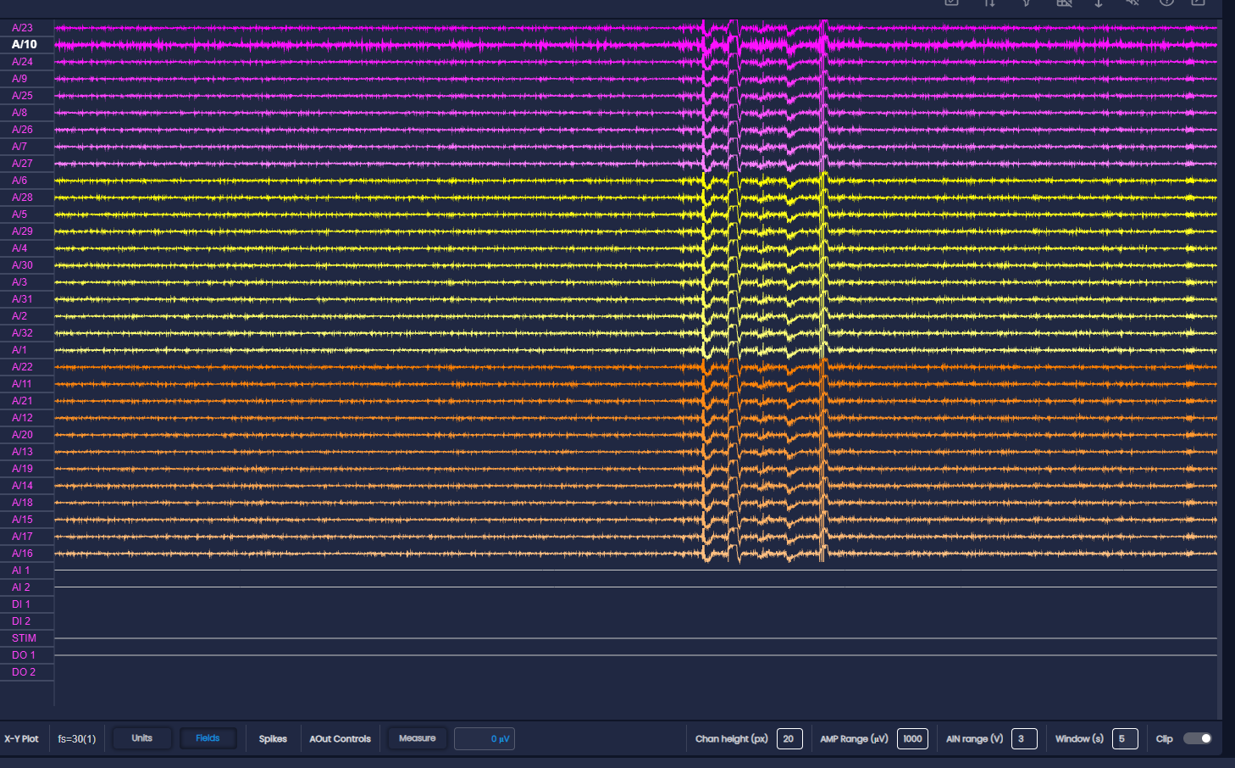

Irregular waveform from all channel from all depth (muscle movement?)