**Date: 3/25/2024**

**Goal: stim and draw a map around 7N**

**Mouse: R17**

**Condition: anes**

**Probe: 1197F (A4x8)**

**Recording time: 10-12PM**

right craniotomy, FN

Shank1- shank 4:( left to right) to 5300 um with undiluted DiI

Probe center 1250 um lateral to central FN landmark

MAPPING:

Stim protocol: for each channel- single pulse, 2 uA, 1000 us negative, 1000 us positive

Video 000

| Depth range (um) | Shank 1 | Shank 2 | Shank 3 | Shank 4 |
| --- | --- | --- | --- | --- |
| 3500-3850 | Eye  Ear  Nose  Whisker **  Mouth | Eye  Ear *  Nose  Whisker *  Mouth | Eye  Ear  Nose  Whisker *  Mouth | Eye  Ear  Nose  Whisker *  Mouth |
| 4000-4350 | Eye  Ear **  Nose  Whisker **  Mouth | Eye  Ear *  Nose  Whisker *  Mouth | Eye  Ear *  Nose  Whisker *  Mouth | Eye  Ear *  Nose  Whisker **  Mouth |
| 4500-4850 | Eye  Ear **  Nose *  Whisker **  Mouth | Eye  Ear **  Nose *  Whisker **  Mouth | Eye  Ear *  Nose  Whisker **  Mouth | Eye  Ear *  Nose  Whisker **  Mouth |
| 4950-5300 | Eye  Ear **  Nose *  Whisker **  Mouth | Eye  Ear **  Nose *  Whisker **  Mouth | Eye  Ear **  Nose *  Whisker **  Mouth | Eye  Ear **  Nose *  Whisker **  Mouth |

RECORDING:

Rig1 computer:

Video folder: C:\Users\houlab\Documents\Behavior video\20240325_R17_rec_rig1

Ephys folder: C:\Users\houlab\Desktop\Ephys_Data\20240325_R17

Grid:

Z:\Behavior\20240325_R17_rec_rig1

Ephys 1- Video 001

Time: 30s

Depth: 4850 um

Active channel:

Stim: all channels, single pulse, 2 uA, 1000 us negative, 1000 us positive

Respond channel: /

Behavior: ear, whisker

Ephys 3- Video 003

Time: 30s

Depth: 5300 um

Active channel:

Stim: all channels, single pulse, 2 uA, 1000 us negative, 1000 us positive

Respond channel: /

Behavior: ear, whisker

Ephys 4- Video 004

Time: 300s

Depth: 5300 um

Active channel:

Stim: none, recording only

Respond channel: /

Behavior: whiskering (waking up from anes)

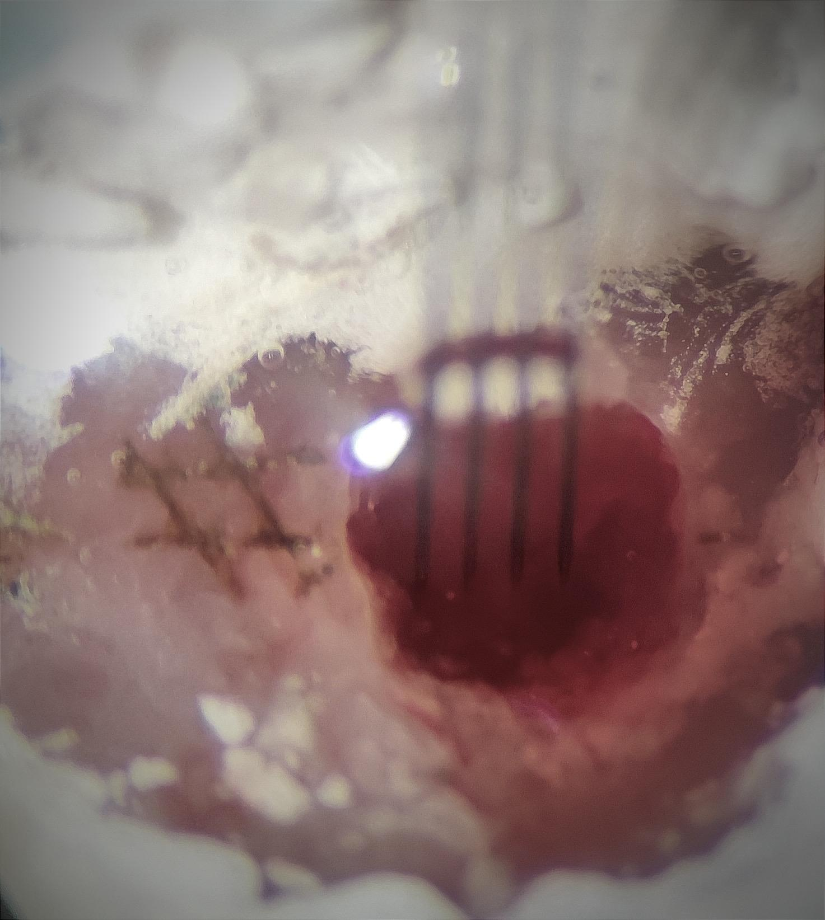

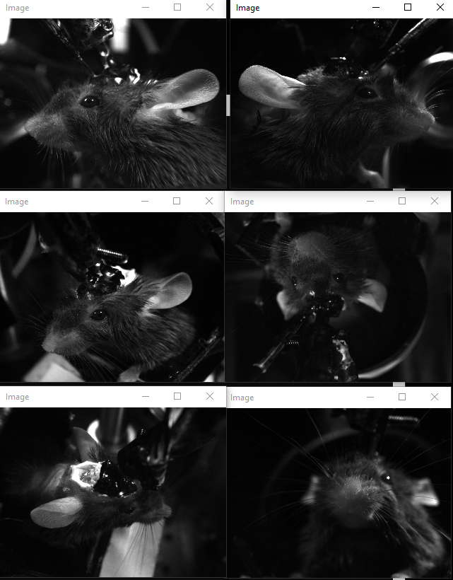

**Date: 3/25/2024**

**Goal: stim and draw a map around 7N**

**Mouse: R17**

**Condition: anes**

**Probe: 1197F (A4x8)**

**Recording time: 4-6PM**

right craniotomy, FN

Shank1- shank 4: left to right , probe center 250 um posterior, 1250 um lateral to central landmark

MAPPING:

Stim protocol: for each channel- single pulse, 2 uA, 1000 us negative, 1000 us positive

Video 005

| Depth range (um) | Shank 1 | Shank 2 | Shank 3 | Shank 4 |
| --- | --- | --- | --- | --- |
| 3500-3850 | Eye  Ear  Nose  Whisker  Mouth | Eye  Ear  Nose  Whisker  Mouth | Eye  Ear  Nose  Whisker  Mouth | Eye  Ear  Nose  Whisker  Mouth |
| 4000-4350 | Eye  Ear  Nose  Whisker  Mouth | Eye  Ear  Nose  Whisker *  Mouth | Eye  Ear  Nose  Whisker *  Mouth | Eye  Ear  Nose  Whisker *  Mouth |
| 4500-4850 | Eye  Ear  Nose  Whisker  Mouth | Eye  Ear  Nose  Whisker  Mouth | Eye  Ear  Nose  Whisker  Mouth | Eye  Ear  Nose  Whisker  Mouth |
| 4950-5300 | Eye  Ear  Nose  Whisker  Mouth | Eye  Ear  Nose  Whisker  Mouth | Eye  Ear  Nose  Whisker  Mouth | Eye  Ear  Nose  Whisker  Mouth |

RECORDING:

Rig1 computer:

Video folder: C:\Users\houlab\Documents\Behavior video\

Ephys folder: C:\Users\houlab\Desktop\Ephys_Data\\

Grid:

Z:\Xinyan\ephys_data\ (ephys and video by each trial)

(or Z:\Behavior\ for just video recording)

right craniotomy, FN

Shank1- shank 4: left to right , probe center 250 um anterior, 1250 um lateral to central landmark

to 5300 um with undiluted DiO

MAPPING:

Stim protocol: for each channel- single pulse, 2 uA, 1000 us negative, 1000 us positive

Video 006

| Depth range (um) | Shank 1 | Shank 2 | Shank 3 | Shank 4 |
| --- | --- | --- | --- | --- |
| 3500-3850 | Eye  Ear **  Nose **  Whisker **  Mouth | Eye  Ear **  Nose **  Whisker **  Mouth | Eye  Ear *  Nose  Whisker *  Mouth | Eye  Ear *  Nose  Whisker *  Mouth |
| 4000-4350 | Eye  Ear *  Nose  Whisker *  Mouth | Eye  Ear **  Nose  Whisker *  Mouth | Eye  Ear *  Nose  Whisker *  Mouth | Eye  Ear *  Nose  Whisker *  Mouth |
| 4500-4850 | Eye  Ear  Nose  Whisker  Mouth | Eye  Ear *  Nose  Whisker *  Mouth | Eye  Ear *  Nose  Whisker *  Mouth | Eye  Ear *  Nose  Whisker *  Mouth |
| 4950-5300 | Eye  Ear  Nose  Whisker  Mouth | Eye  Ear  Nose  Whisker  Mouth | Eye  Ear **  Nose  Whisker  Mouth | Eye  Ear *  Nose  Whisker  Mouth |

PS. FOR 4950-5300, the mouse starts to move whisker and wakes up. Not 100% sure I did not see whisker move on right site when stim, or just I cannot see it clearly enough

RECORDING:

Rig1 computer:

Video folder: C:\Users\houlab\Documents\Behavior video\

Ephys folder: C:\Users\houlab\Desktop\Ephys_Data\\

Grid:

Z:\Xinyan\ephys_data\ (ephys and video by each trial)

(or Z:\Behavior\ for just video recording)

Ephys 5- Video 007

Time: 300s

Depth: 5300 um

Active channel: A7,2, A11,15,9

Stim: /

Respond channel: /

Behavior: whiskering(waking up from anes)

Notice:

when the mouse wakes up, it starts with moving left side whisker- no right side at all! After around 5 min it starts to whisker both sides. Could this because of multiple times of stim on the right whisker or it’s just a strange habit of R17?

When stim on right FN that trigger nose move, for a single pulse it always makes nose to move from center to right

