RECORDING:

Rig1 computer:

Video folder: C:\Users\houlab\Documents\Behavior video\20240326_R17_rec_rig1

Ephys folder: C:\Users\houlab\Desktop\Ephys_Data\20240326_R17

Grid:

Video: Z:\Behavior\20240326_R17_rec_rig1

Ephys: Z:\Xinyan\20240326_R17

**Date: 3/26/2024**

**Goal: awake recording from 7N**

**Mouse: R17**

**Condition: awake**

**Probe: 1197F (A4x8)**

**Recording time: 10-12PM**

right craniotomy, 7N

Shank1- shank 4:( left to right)

Probe center 1250 um lateral to central FN landmark

For all the video:

Z:\Behavior\20240325_R17_rec_rig1

Ephys 0- Video 000

Time: 200 s

Depth: 3850 um

Active channel: A5,A20,A22

Stim: none, just recording

Respond channel: /

Behavior: just let the mouse stay there

Ephys 1- Video 001

Time: 200 s

Depth:4350 um

Active channel: a6, a22,a19, a31, a21

Stim: none, just recording

Respond channel: /

Behavior: just let the mouse stay there

Ephys 2- Video 002

Time: 200 s

Depth: 4850 um

Active channel: A5,A4,A13,A12,A15,A16

Stim: none, just recording

Respond channel: /

Behavior: just let the mouse stay there

Ephys 3 - Video 003

Time: 300s

Depth: 5250 um (CANNOT GO FURTHER- shank4 reaches bottom)

Active channel: A4,A6,A13,A12,A14,A20,A22

Stim: none, just recording

Respond channel: /

Behavior: just let the mouse stay there

Note:

R17 was doing good during awake recording- though still struggle and scream from time to time. Rig time about 40 min is okay, though I’m not very sure if mouse can stay there longer for a next site of recording. For a 1 mm craniotomy the headpost is good to keep the head stable and not affected by mouse struggling.

Also, to apply CAR for ephys recording can erase most of the artifact when mouse struggle . Spikes are very clear.

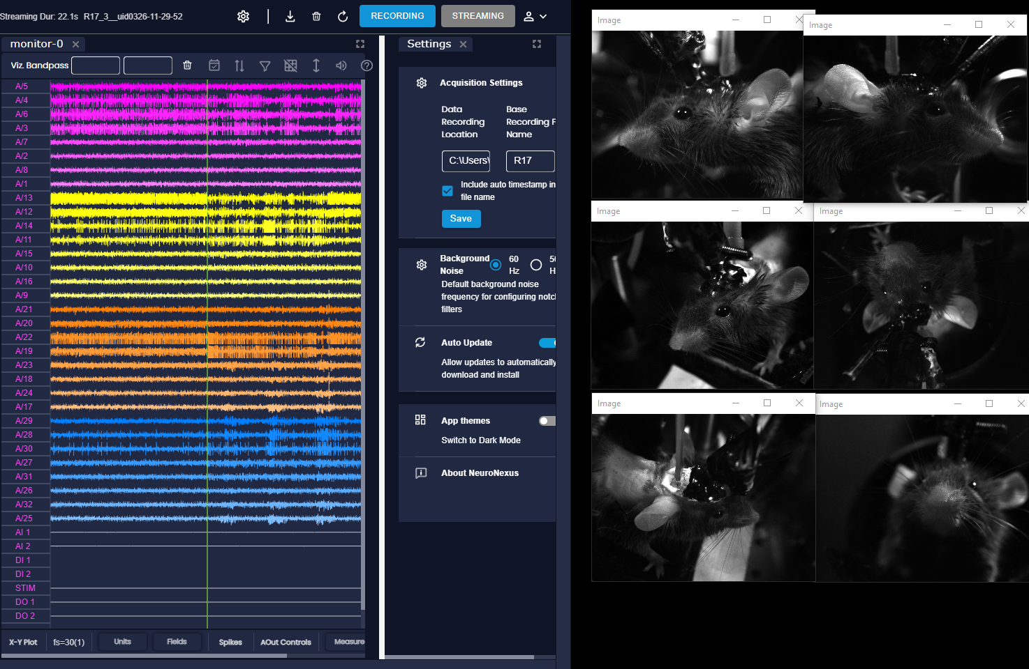

**Date: 3/26/2024**

**Goal: stim and draw a map around 5N**

**Mouse: R17**

**Condition: anes**

**Probe: 1197F (A4x8)**

**Recording time: 4-6PM**

right craniotomy, 5N

Shank1- shank 4:( left to right) to 5300 um with undiluted DiI

Probe center 1650 um lateral, 550 um anterior to central FN landmark

(CANNOT GO FURTHER)

MAPPING:

Stim protocol: for each channel- single pulse, 2 uA, 1000 us negative, 1000 us positive

Stim one shank(8 channels) at one time

Video 004

| Depth range (um) | Shank 1 | Shank 2 | Shank 3 | Shank 4 |
| --- | --- | --- | --- | --- |
| 3150-3400 | Eye  Ear  Nose  Whisker  Mouth | Eye  Ear  Nose  Whisker  Mouth | Eye  Ear  Nose  Whisker  Mouth | Eye  Ear  Nose  Whisker  Mouth |
| 3450-3800 | Eye  Ear  Nose  Whisker *  Mouth | Eye  Ear  Nose  Whisker  Mouth | Eye  Ear  Nose  Whisker  Mouth | Eye  Ear  Nose  Whisker  Mouth |
| 3850-4200 | Eye  Ear **  Nose **  Whisker **  Mouth | Eye  Ear **  Nose **  Whisker **  Mouth | Eye  Ear  Nose  Whisker *  Mouth | Eye  Ear  Nose  Whisker *  Mouth |
| 4500-4850 | Eye  Ear  Nose  Whisker  Mouth | Eye  Ear  Nose  Whisker *  Mouth | Eye  Ear  Nose  Whisker *  Mouth | Eye  Ear  Nose  Whisker *  Mouth |
| 4950-5300 | Eye  Ear  Nose  Whisker  Mouth | Eye  Ear  Nose  Whisker  Mouth | Eye  Ear  Nose  Whisker  Mouth | Eye  Ear  Nose  Whisker  Mouth |

Note:

Initially this anes stim is to try 5N. But because metabond blocks the way, cannot go all the way to 900 um anterior to around 5N.

So, this stim did not trigger mouth to move nor get ear/whisker move when down to 5300 um. But very constantly around 4000 um there’s something that can trigger ear/ whisker to move (also see [20240325_R17](https://docs.google.com/document/d/1cswSMMCetan_963g0XI8tJonA1YY8OJA_pybnV8j64Y/edit) ‘s second one)

-according to brain atlas this is very likely to be PCRtA- parvocellular reticular nucleus, which has projection to FN