RECORDING:

Rig1 computer:

Video folder: C:\Users\houlab\Documents\Behavior video\20240327_R17_rec_rig1

Ephys folder: C:\Users\houlab\Desktop\Ephys_Data\20240327_R17

Grid:

Video: Z:\Behavior\20240327_R17_rec_rig1

Ephys: Z:\Xinyan\20240327_R17

**Date: 3/27/2024**

**Goal: stim and draw a map around FN**

**Mouse: R17**

**Condition: anes**

**Probe: 1197F (A4x8)**

**Recording time: 10-12PM**

left craniotomy, 7N

Shank1- shank 4:( left to right)

Probe center 1100 um lateral, 100 um posterior to central FN landmark

MAPPING:

Stim protocol: for each channel- single pulse, 5 uA, 1000 us negative, 1000 us positive

Stim one shank(8 channels) at one time

Video 000

| Depth range (um) | Shank 1 | Shank 2 | Shank 3 | Shank 4 |
| --- | --- | --- | --- | --- |
| 3500-3850 | Eye  Ear  Nose  Whisker  Mouth | Eye  Ear  Nose  Whisker  Mouth | Eye  Ear  Nose  Whisker  Mouth | Eye  Ear  Nose  Whisker  Mouth |
| 4000-4350 | Eye  Ear  Nose  Whisker  Mouth | Eye  Ear  Nose  Whisker  Mouth | Eye  Ear  Nose  Whisker  Mouth | Eye  Ear  Nose  Whisker  Mouth |
| 4500-4850 | Eye *  Ear  Nose  Whisker  Mouth | Eye *  Ear  Nose  Whisker  Mouth | Eye *  Ear  Nose  Whisker **  Mouth | Eye *  Ear  Nose  Whisker **  Mouth |
| 5000-5350 | Eye *  Ear  Nose  Whisker *  Mouth | Eye *  Ear  Nose  Whisker *  Mouth | Eye *  Ear  Nose  Whisker **  Mouth | Eye *  Ear  Nose  Whisker **  Mouth |

PS. very slight eye move by looking at slight light change around lower eyelid

**Date: 3/27/2024**

**Goal: stim and draw a map around FN**

**Mouse: R17**

**Condition: anes**

**Probe: 1197F (A4x8)**

**Recording time: 3-5PM**

left craniotomy, 7N

Shank1- shank 4:( left to right)

Probe center 1250 um lateral, 150 um anterior to central FN landmark

MAPPING:

Stim protocol: for each channel- single pulse, 5 uA, 1000 us negative, 1000 us positive

Stim one shank(8 channels) at one time

Video 001

| Depth range (um) | Shank 1 | Shank 2 | Shank 3 | Shank 4 |
| --- | --- | --- | --- | --- |
| 3500-3850 | Eye  Ear  Nose  Whisker  Mouth | Eye  Ear  Nose  Whisker  Mouth | Eye  Ear  Nose  Whisker  Mouth | Eye  Ear  Nose  Whisker  Mouth |
| 4000-4350 | Eye  Ear  Nose  Whisker  Mouth | Eye  Ear  Nose  Whisker  Mouth | Eye  Ear  Nose  Whisker *  Mouth | Eye  Ear  Nose  Whisker *  Mouth |
| 4500-4850 | Eye  Ear  Nose  Whisker *  Mouth | Eye  Ear  Nose  Whisker *  Mouth | Eye  Ear  Nose  Whisker *  Mouth | Eye  Ear  Nose  Whisker ***  Mouth |
| 4950-5300 | Eye *  Ear **  Nose *  Whisker **  Mouth | Eye *  Ear **  Nose *  Whisker *  Mouth | Eye  Ear  Nose *  Whisker **  Mouth | Eye  Ear  Nose *  Whisker **  Mouth |

Stim protocol: one channel each time single, 25 uA, 1000 us negative, 1000 us positive

Try some of single channel stim: 4950-5300:

| Shank 1 | Shank 2 |
| --- | --- |
| Eye *  Ear  Nose  Whisker *  Mouth | Eye *  Ear *  Nose  Whisker *  Mouth |
| Eye *  Ear  Nose  Whisker *  Mouth | Eye *  Ear *  Nose  Whisker *  Mouth |
| Eye *  Ear  Nose  Whisker *  Mouth | Eye*  Ear *  Nose  Whisker *  Mouth |
| Eye *  Ear  Nose  Whisker *  Mouth | Eye *  Ear *  Nose  Whisker *  Mouth |

From top to bottom, each gap is 50 um

| Eye *  Ear  Nose  Whisker *  Mouth | Eye *  Ear *  Nose  Whisker *  Mouth |
| --- | --- |
| Eye *  Ear  Nose  Whisker *  Mouth | Eye *  Ear *  Nose  Whisker *  Mouth |
| Eye *  Ear  Nose  Whisker *  Mouth | Eye *  Ear *  Nose  Whisker  Mouth |
| Eye *  Ear  Nose  Whisker  Mouth | Eye *  Ear  Nose  Whisker  Mouth |

Recording: use this as a control group to awake stim

Ephys 0- Video 002

Time: 60 s

Depth: 5300 um

Active channel:

Stim: all, single, 1000 us,5 uA

Respond channel: /

Behavior: whisker, ear, eye blink

left craniotomy, 7N

Shank1- shank 4:( left to right)

Probe center 1250 um lateral, 400 um anterior to central FN landmark

Down to 5000 um with undiluted DiI

MAPPING:

Stim protocol: for each channel- single pulse, 5 uA, 1000 us negative, 1000 us positive

Stim one shank(8 channels) at one time

Video 003, 005

| Depth range (um) | Shank 1 | Shank 2 | Shank 3 | Shank 4 |
| --- | --- | --- | --- | --- |
| 3500-3850 | Eye  Ear  Nose  Whisker  Mouth | Eye  Ear  Nose  Whisker  Mouth | Eye  Ear  Nose  Whisker  Mouth | Eye  Ear  Nose  Whisker  Mouth |
| 4000-4350 | Eye  Ear *  Nose  Whisker *  Mouth | Eye  Ear *  Nose  Whisker *  Mouth | Eye  Ear *  Nose  Whisker *  Mouth | Eye  Ear *  Nose  Whisker *  Mouth |
| 4500-4850 | Eye *  Ear *  Nose  Whisker *  Mouth | Eye *  Ear *  Nose  Whisker *  Mouth | Eye *  Ear *  Nose  Whisker *  Mouth | Eye *  Ear *  Nose  Whisker *  Mouth |
| -5000 | Eye **  Ear *  Nose *  Whisker **  Mouth | Eye **  Ear *  Nose *  Whisker **  Mouth | Eye **  Ear *  Nose *  Whisker **  Mouth | Eye *  Ear*  Nose *  Whisker **  Mouth |

* 4860 and 5000 um stim trigger both ear move-
* could because the mouse is waking up and this stim causes the body to move. But eye and whisker only move at left side

Shank1 reach bottom at 5000 um

Recording

Ephys 1- Video 004

Time: 60 s

Depth: 4850 um

Active channel:

Stim: shank 3, single, 1000 us,5 uA

Respond channel:

Behavior: left whisker, eye blink, both left and right ear

Ephys 2- Video 006

Time: 200 s

Depth: 5000 um

Active channel: A27,A29,A19,A11,14

Stim: none, just recording

Respond channel:

Behavior: whisker (waking up)

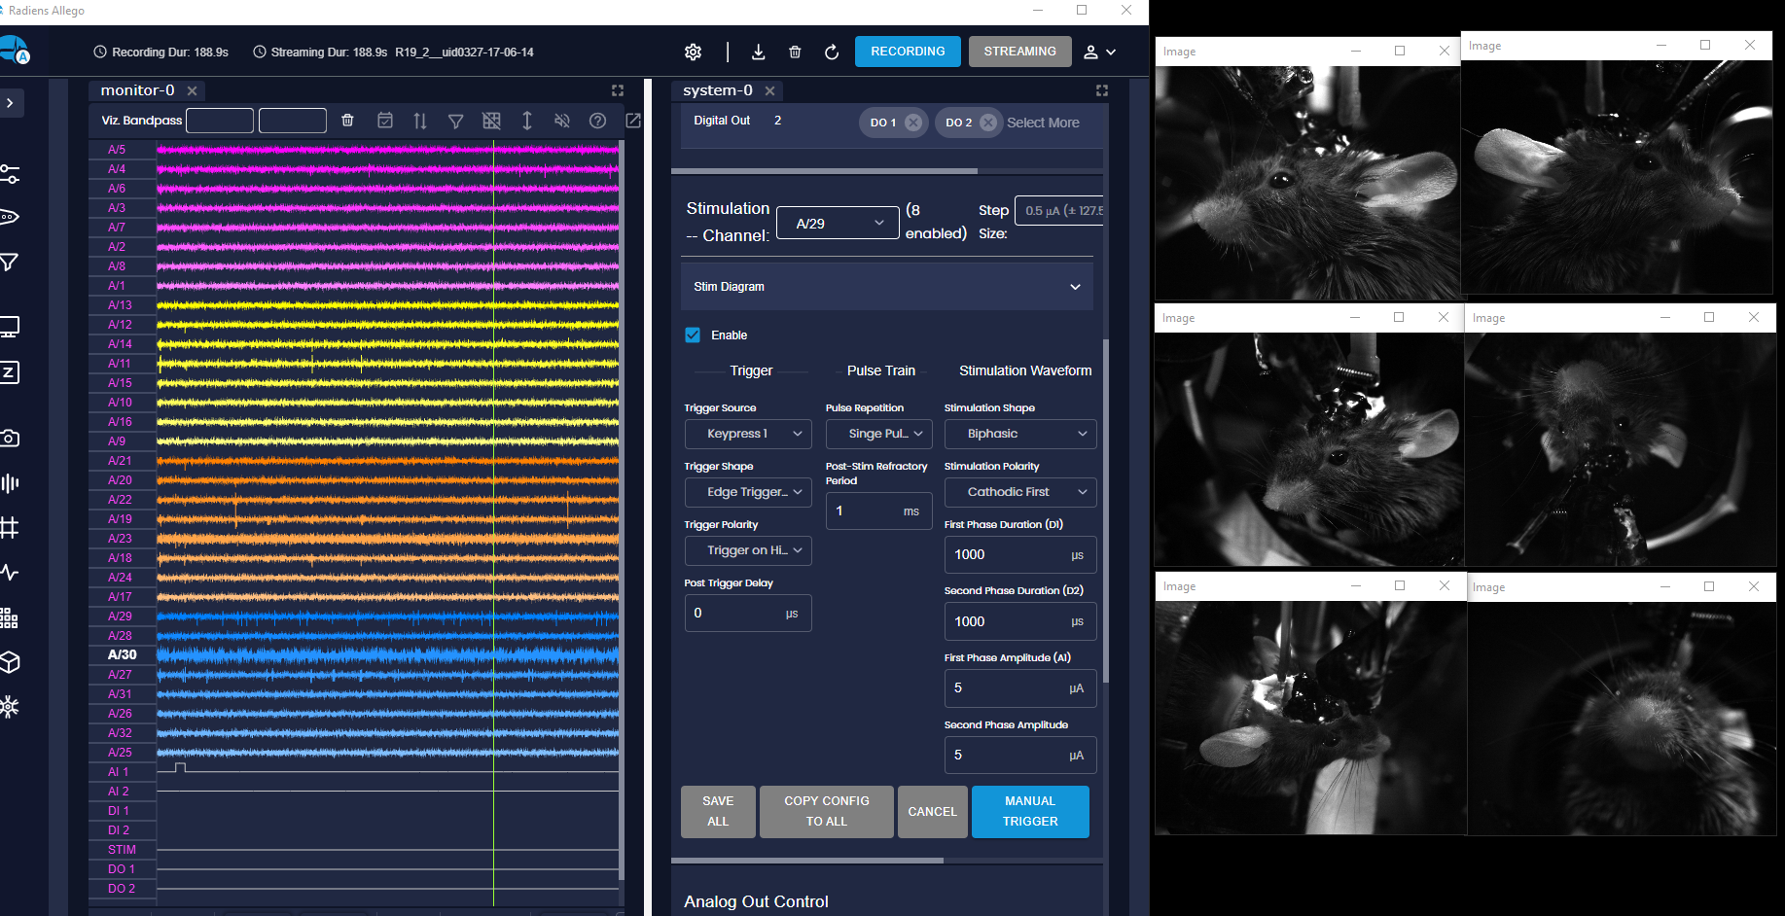

Note:

For left side, start to use a bit larger stim protocol- start be able to trigger some eye move

It seems that the minimal protocol for different parts of the face can be different. Just my guess- for example, muscle fiber that controls the whisker (or ear) is less and smaller than that which controls eyes. So a current small enough may only trigger visible whisker move but no eye move- even if the probe is at the correct place.

Notice again that mouse start to only move left whisker (see video at Z:\Behavior\20240327_R17_rec_rig1\20240327_R17_rec_anes_006_BC_fullres_17-06-09.avi, there is no e-stim, just mouse waking up )

Tried some of single channel stim

Track 3 : 4860 and 5000 um stim trigger both ear move

-could because the mouse is waking up and this stim causes the body to move. But eye and whisker only move at left side