RECORDING:

Rig1 computer:

Video folder: C:\Users\houlab\Documents\Behavior video\20240328_R17_rec_rig1

Ephys folder: C:\Users\houlab\Desktop\Ephys_Data\20240328_R17

Grid:

Video: Z:\Behavior\20240328_R17_rec_rig1

Ephys: Z:\Xinyan\20240328_R17

**Date: 3/28/2024**

**Goal: awake recording from 7N**

**Mouse: R17**

**Condition: awake**

**Probe: 1197F (A4x8)**

**Recording time: 8.30-9.30AM**

left craniotomy, 7N

Shank1- shank 4:( left to right)

Probe center 1250 um lateral, 200 um anterior to central FN landmark

To 5250 um with undiluted DiO

Ephys 0- Video 000

Time: 200 s

Depth: 3850 um

Active channel:

Stim: none, just recording

Respond channel: /

Behavior: just let the mouse stay there

Ephys 1- Video 001

Time: 200 s

Depth:4350 um

Active channel: A16

Stim: none, just recording

Respond channel: /

Behavior: just let the mouse stay there

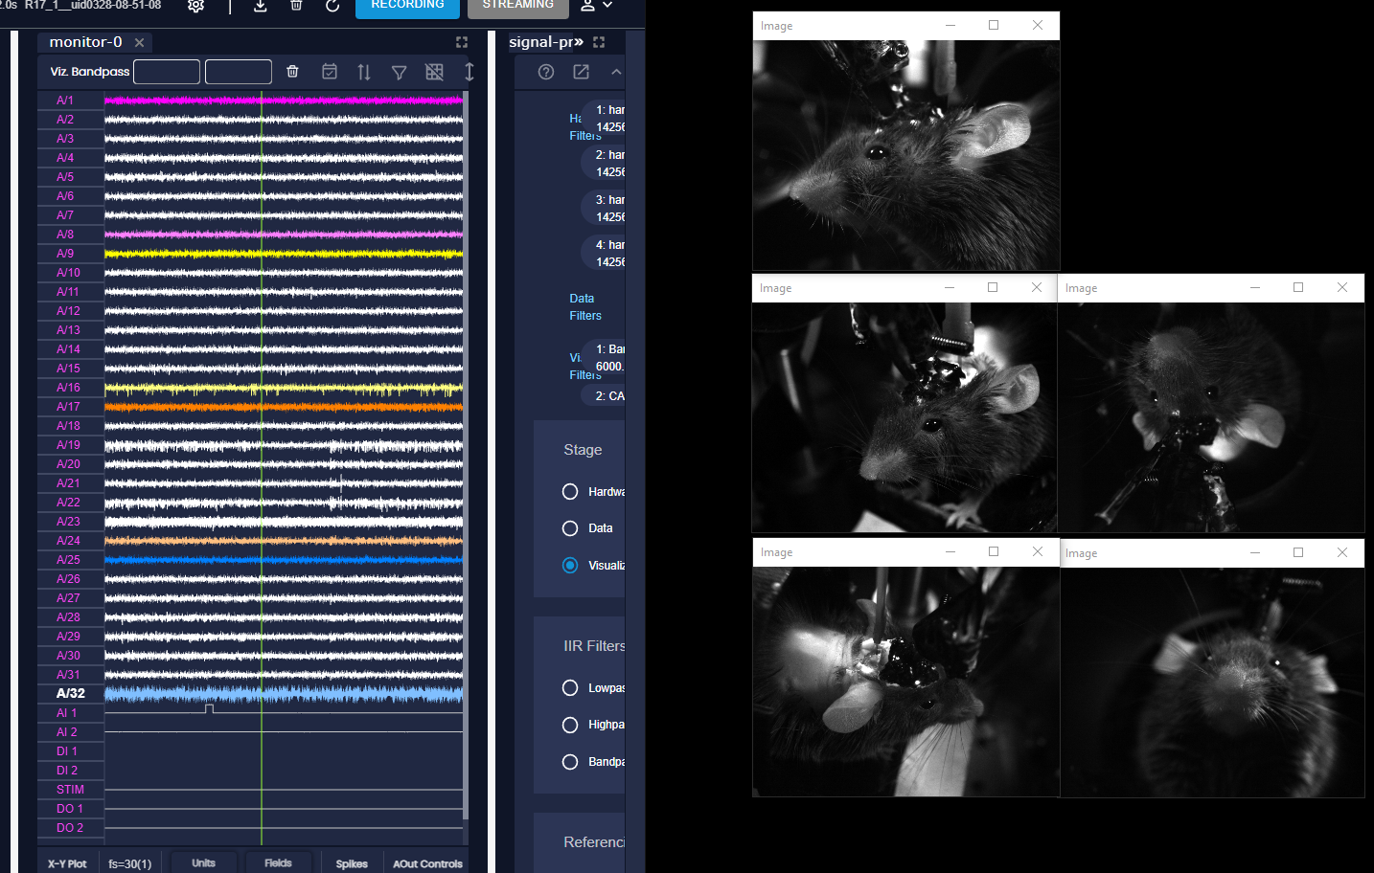

Ephys 2- Video 002

Time: 200 s

Depth: 4850 um

Active channel:

Stim: none, just recording

Respond channel: /

Behavior: just let the mouse stay there

Ephys 3- Video 003

Time: 200 s

Depth: 5250 um

Active channel:

Stim: none, just recording

Respond channel: /

Behavior: just let the mouse stay there

Ephys 4- Video 004

Time: 200 s

Depth: 5250 um

Active channel:

Stim: all 32 channels, single pulse, 5 uA, 1000 us negative, 1000 us positive

Respond channel: /

Behavior: see video analysis

**Date: 3/28/2024**

**Goal: mapping 5N**

**Mouse: R17**

**Condition: anes**

**Probe: 1197F (A4x8)**

**Recording time:3-5pM**

right craniotomy, 5N

Shank1- shank 4:( left to right)

Probe center 1500 um lateral, 750 um anterior to central FN landmark

Video 005,007

Stim protocol: one shank each time, single pulse, 5 uA 1000 us negative, 1000us positive

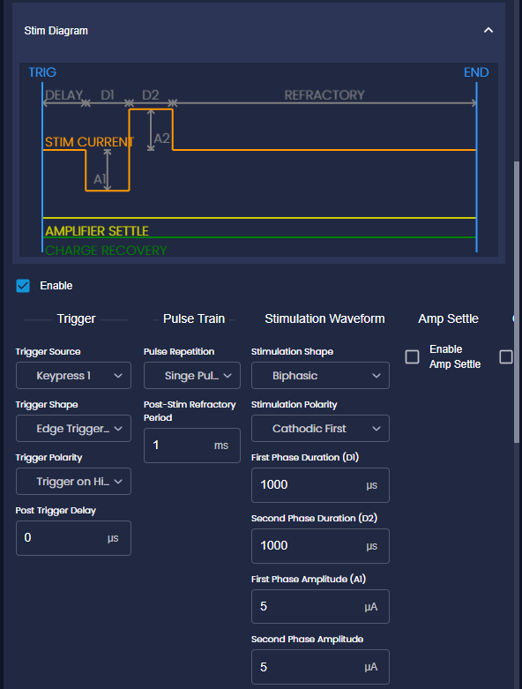

| Depth range (um) | Shank 1 | Shank 2 | Shank 3 | Shank 4 |
| --- | --- | --- | --- | --- |
| 3100-3450 | Eye  Ear **  Nose **  Whisker **  Mouth | Eye  Ear **  Nose **  Whisker **  Mouth | Eye  Ear  Nose  Whisker  Mouth | Eye  Ear  Nose  Whisker  Mouth |
| 3450-3800 | Eye **  Ear **  Nose **  Whisker **  Mouth | Eye **  Ear **  Nose **  Whisker **  Mouth | Eye *  Ear **  Nose **  Whisker **  Mouth | Eye *  Ear **  Nose **  Whisker **  Mouth |
| 3800-4150 | Eye  Ear  Nose  Whisker  Mouth | Eye  Ear  Nose  Whisker  Mouth | Eye  Ear  Nose  Whisker  Mouth | Eye  Ear  Nose  Whisker  Mouth |

Ephys 5- Video 006

Time: 40 s

Depth: 3800 um

Active channel:

Stim: shank 3, single pulse, 5 uA 1000 us negative, 1000us positive

Respond channel: /

Behavior: ear, whisker, nose (move to right)

Ephys 6- Video 008

Time: 40 s

Depth: 3850 um

Active channel:

Stim: all , single pulse, 10 uA 1000 us negative, 1000us positive

Respond channel: /

Behavior: ear(both ears, but right side move larger ), right eye, whisker, nose (move to right)

right craniotomy, 5N

Shank1- shank 4:( left to right)

Probe center 1500 um lateral, 750 um anterior to central FN landmark

With undiluted DiO to 4150 um

Video 009

Stim protocol: one shank each time, single pulse, 5 uA 1000 us negative, 1000us positive

| Depth range (um) | Shank 1 | Shank 2 | Shank 3 | Shank 4 |
| --- | --- | --- | --- | --- |
| 3100-3450 | Eye  Ear **  Nose  Whisker **  Mouth | Eye  Ear **  Nose  Whisker **  Mouth | Eye  Ear  Nose  Whisker *  Mouth | Eye  Ear  Nose  Whisker *  Mouth |
| 3450-3800 | Eye **  Ear **  Nose **  Whisker **  Mouth | Eye **  Ear **  Nose **  Whisker **  Mouth | Eye *  Ear **  Nose **  Whisker **  Mouth | Eye  Ear  Nose  Whisker *  Mouth |
| 3800-4150 | Eye  Ear **  Nose **  Whisker **  Mouth | Eye  Ear **  Nose **  Whisker **  Mouth | Eye  Ear **  Nose **  Whisker **  Mouth | Eye  Ear **  Nose **  Whisker **  Mouth |

Ephys 7- Video 009

Time: 60 s

Depth: 4150 um

Active channel:

Stim: all , pulse train(20 times), 25 Hz,, 10 uA 1000 us negative, 1000us positive

Respond channel: /

Behavior: ear(both ears, but right side move larger ), right eye only, both whisker, nose (move to right), jaw open a lilttle