Assignment #2

ME135-02L-Spring2018

Feb/8/2018

By Yeash Patel

**Problem 1.**

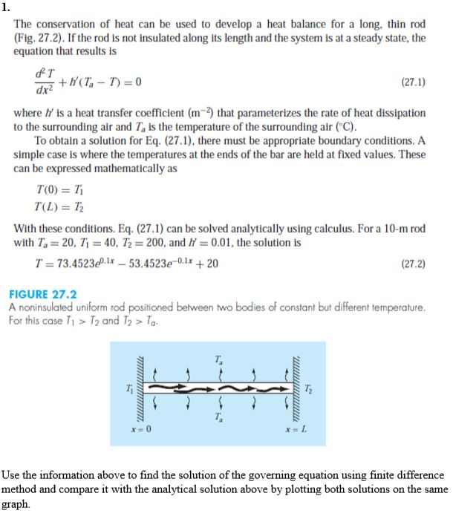

To solve this problem, we needed to use the finite difference method. To get a better comparison between the method and solution I created two figures one with both the graphs on the same figure and one with both of them side by side. The code is available the appendix and on GitHub [https://github.com/Yeash96/Eng135.FEA/tree/master/Assigment_2].

**Matlab input and output**

>>pr1

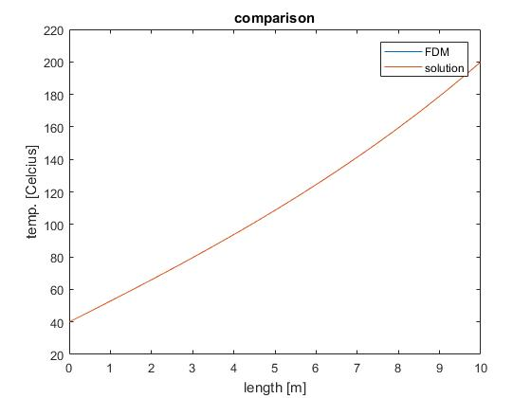

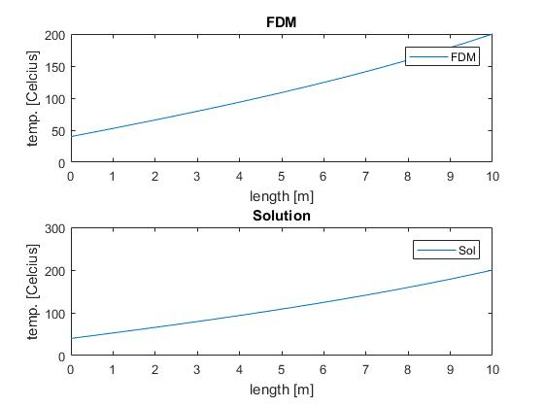

**Problem 2.**

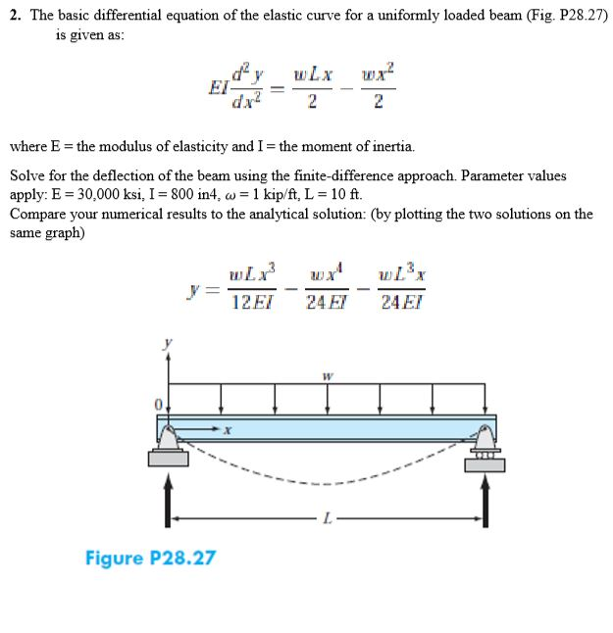

To solve this problem, we needed to use the finite difference method. To get a better comparison between the method and solution I created two figures one with both the graphs on the same figure and one with both of them side by side. The code is available the appendix and on GitHub [https://github.com/Yeash96/Eng135.FEA/tree/master/Assigment_2].

**Matlab input and output**

>>pr2

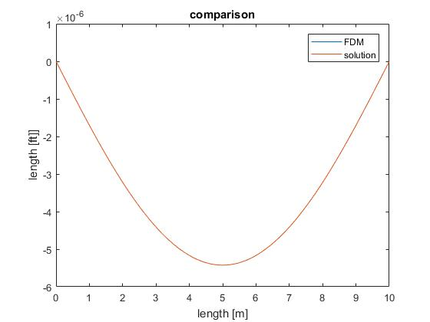

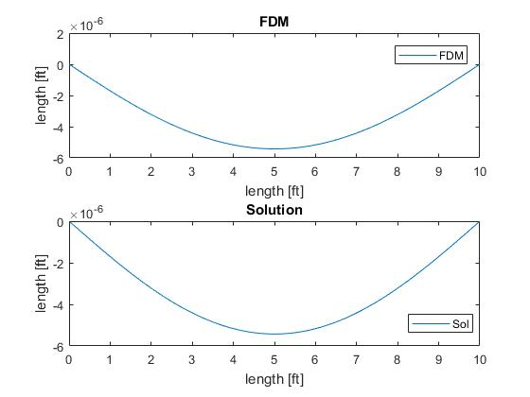

Appendix

Pr.1.m

clc

clear all

close all

format long

%given constants

hco=0.01;

ta=20;

%ODE using finite difference

% parameters

x_i=0;

x_f=10;

dx=0.01;

x=x_i:dx:x_f;

%initializing the matrices

A=zeros(length(x),length(x));

c(1:length(x),1)=-hco*ta;

%Boundary conditons

A(1,1)=1;

c(1,1)=40;

A(length(x),length(x))=1;

c(length(x),1)=200;

%internal points

for i=2:length(x)-1

A(i,i+1)=1/(dx^2);

A(i,i)=(-2/dx^2)+(-hco);

A(i,i-1)=1/dx^2;

end

U=A\c; %A inverse *c

figure(1)

plot(x,U,x,73.4523*exp(0.1*x)-53.4523*exp(-0.1*x)+20);

legend('FDM','solution')

xlabel('length [m]')

ylabel('temp. [Celcius]')

title('comparison')

figure(2)

subplot(2,1,1)

plot(x,U)

legend('FDM','solution')

xlabel('length [m]')

ylabel('temp. [Celcius]')

title('FDM')

subplot(2,1,2)

plot(x,73.4523*exp(0.1*x)-53.4523*exp(-0.1*x)+20);

legend('Sol','solution')

xlabel('length [m]')

ylabel('temp. [Celcius]')

title('Solution')

Pr2.m

clc

clear all

close all

format long

%given constants

E=30000;

I=800;

w=1;

l=10;

%ODE using finite difference

% parameters

x_i=0;

x_f=l;

dx=0.01;

x=x_i:dx:x_f;

%initializing the matrices

A=zeros(length(x),length(x));

c(1:length(x),1)=(w*l*x./2)-(w*x.^2/2);

%Boundary conditons

A(1,1)=1;

c(1,1)=0;

A(length(x),length(x))=1;

c(length(x),1)=0;

%internal points

for i=2:length(x)-1

A(i,i+1)=E*I/(dx^2);

A(i,i)=(-2*E*I/dx^2);

A(i,i-1)=E*I/dx^2;

end

U=A\c; %A inverse *c

figure(1)

plot(x,U,x,(w*l*x.^3./(12*E*I))-(w*x.^4./(24*E*I))-(w*l^3*x./(24*E*I)));

legend('FDM','solution')

legend('FDM','solution')

xlabel('length [m]')

ylabel('length [ft]]')

title('comparison')

figure(2)

subplot(2,1,1)

plot(x,U)

legend('FDM','solution')

xlabel('length [ft]')

ylabel('length [ft]')

title('FDM')

subplot(2,1,2)

plot(x,(w*l*x.^3./(12*E*I))-(w*x.^4./(24*E*I))-(w*l^3*x./(24*E*I)));

legend('Sol','solution')

xlabel('length [ft]')

ylabel('length [ft]')

title('Solution')