Assignment #3

ME135-02L-Spring2018

Feb/19/2018

By Yeash Patel

**Problem 1.**

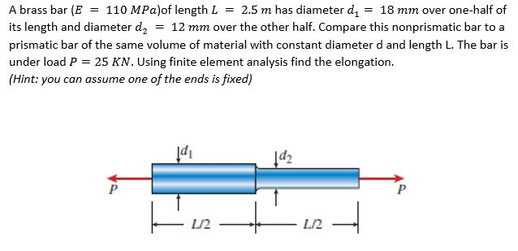

To solve this problem, we needed to use the finite element direct formulation We fixed the left-hand side of the bar. We found the displacement to be large. However, when considering the given the amount of stress and force the bar was exposed it seems more reasonable. The code used is available the appendix and on GitHub[https://github.com/Yeash96/Eng135.FEA/tree/master/Assigment_3]

**Matlab input and output**

>>Pr1

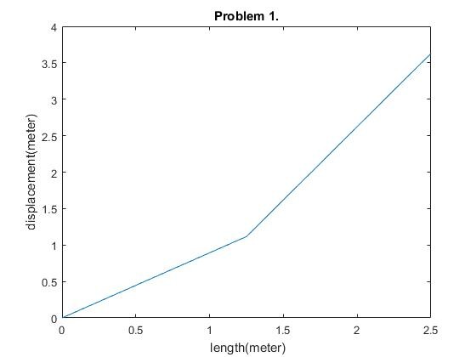

Appendix

**Pr1.m**

clc

clear all

close all

%Given prameters

E=110*10^6;

L=2.5;

A1=pi()/4*(18*10^-3)^2;

A2=pi()/4*(12*10^-3)^2;

F=25*10^3;

%step size

dx=0.01;

%discretizes bar

x=0:dx:L;

%matrices initializataion

S= zeros(length(x),length(x)); %stiffness matrix

C=zeros(length(x),1); % load

% calculating K

for i=1:length(x)-1

if (x(i)<L/2) % we have two areas at diffrent ends

k(i)=E*A1/(x(i+1)-x(i));

else

k(i)=E*A2/(x(i+1)-x(i));

end

end

%boundary conditions and filling the ends of the stiffnes matrics

S(1,1)=1;

S(length(x),length(x)-1)=-k(length(x)-1);

S(length(x),length(x))=k(length(x)-1);

C(length(x),1)=F;

for i=2:length(x)-1 % filling out the rest of the matrix

S(i,i-1)=-k(i-1);

S(i,i)=k(i-1)+k(i);

S(i,i+1)=-k(i);

end

U=S\C

plot(x,U)

title('Problem 1.')

xlabel(' length(meter)')

ylabel('displacement(meter)')